29/3/22

**SECOND GRAPHICAL ANALYSIS OF HAILSTORM EVENTS**:extended dataset, with OT top, LJ index, eswd/unipol reports and some of the sphera proxies:

New set of hailstorms (OT data received from Kris), first comments:

* 7 October 2018, Melpignano (Lecce Salento): 1 eswd report, event missed both by OT max probability detection (even if a localized dTmin is visible) and by LJ index, while SPHERA simulates well the LI daily minimum peak, or the Kindex daily maximum, while the maximum of %vv700 fails at giving a useful information (at least on the daily basis):

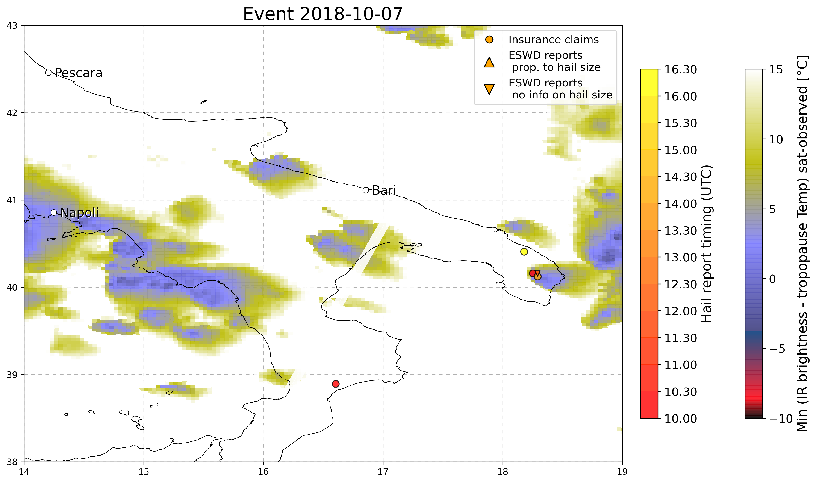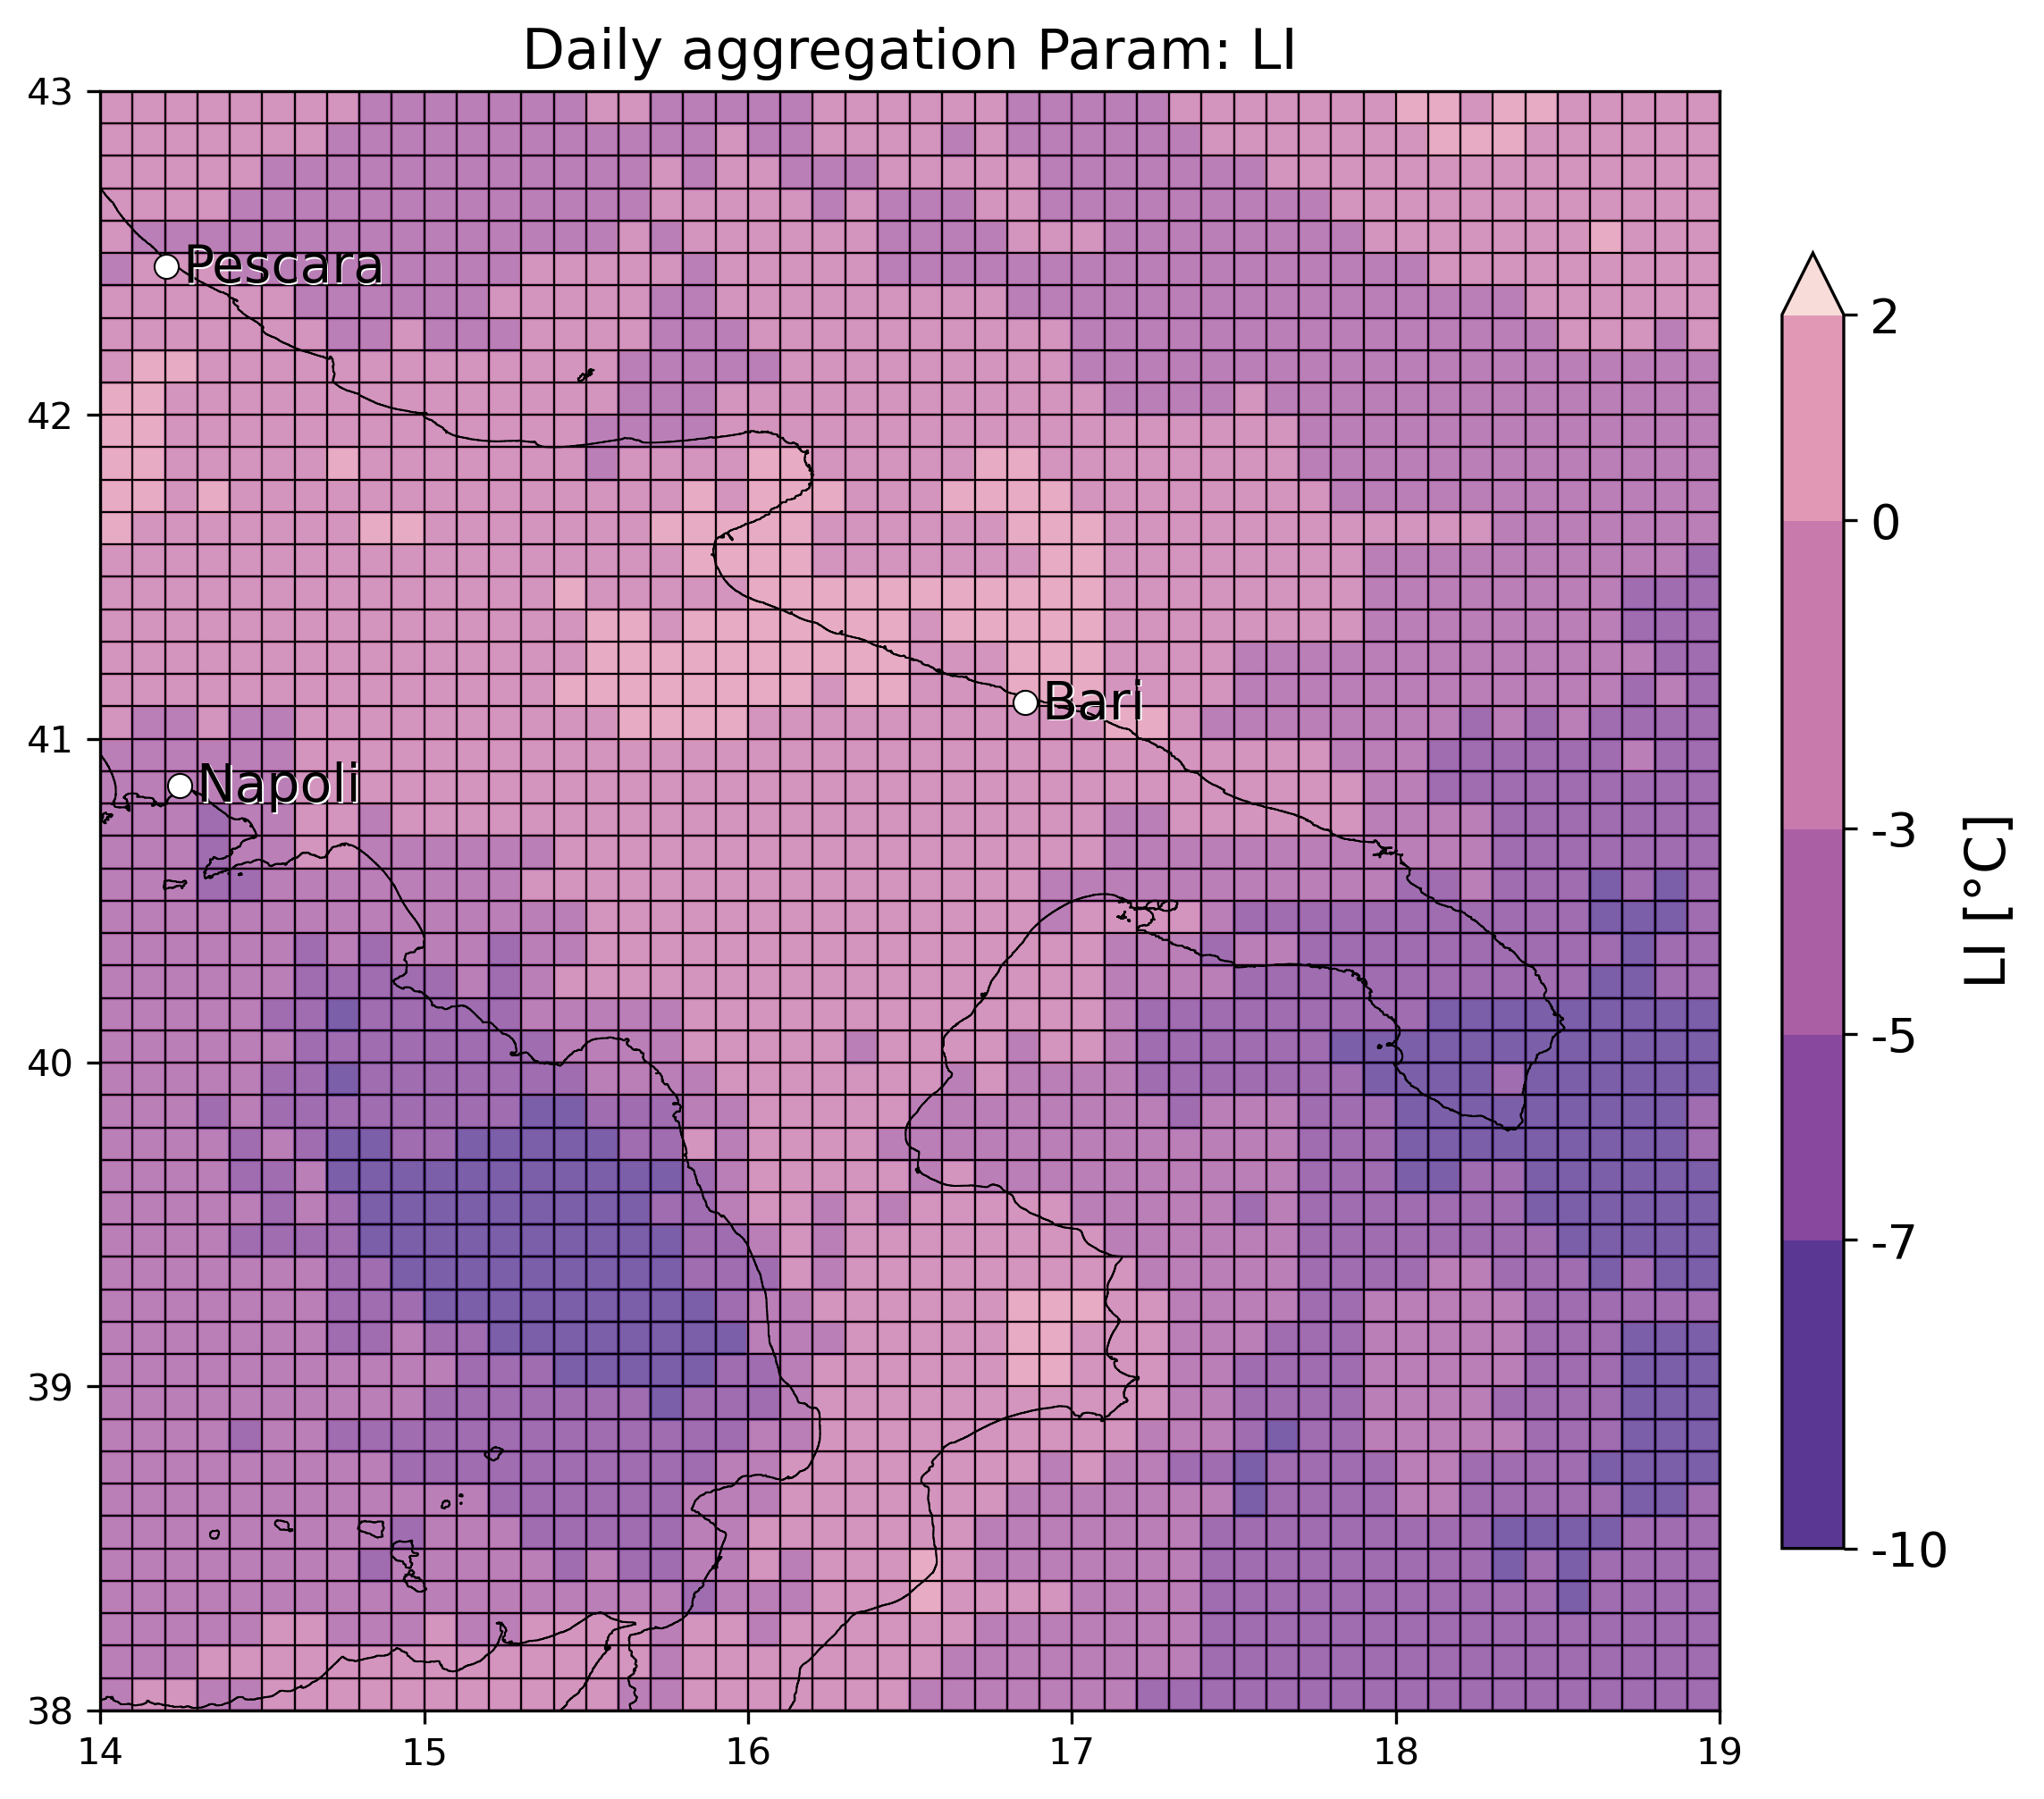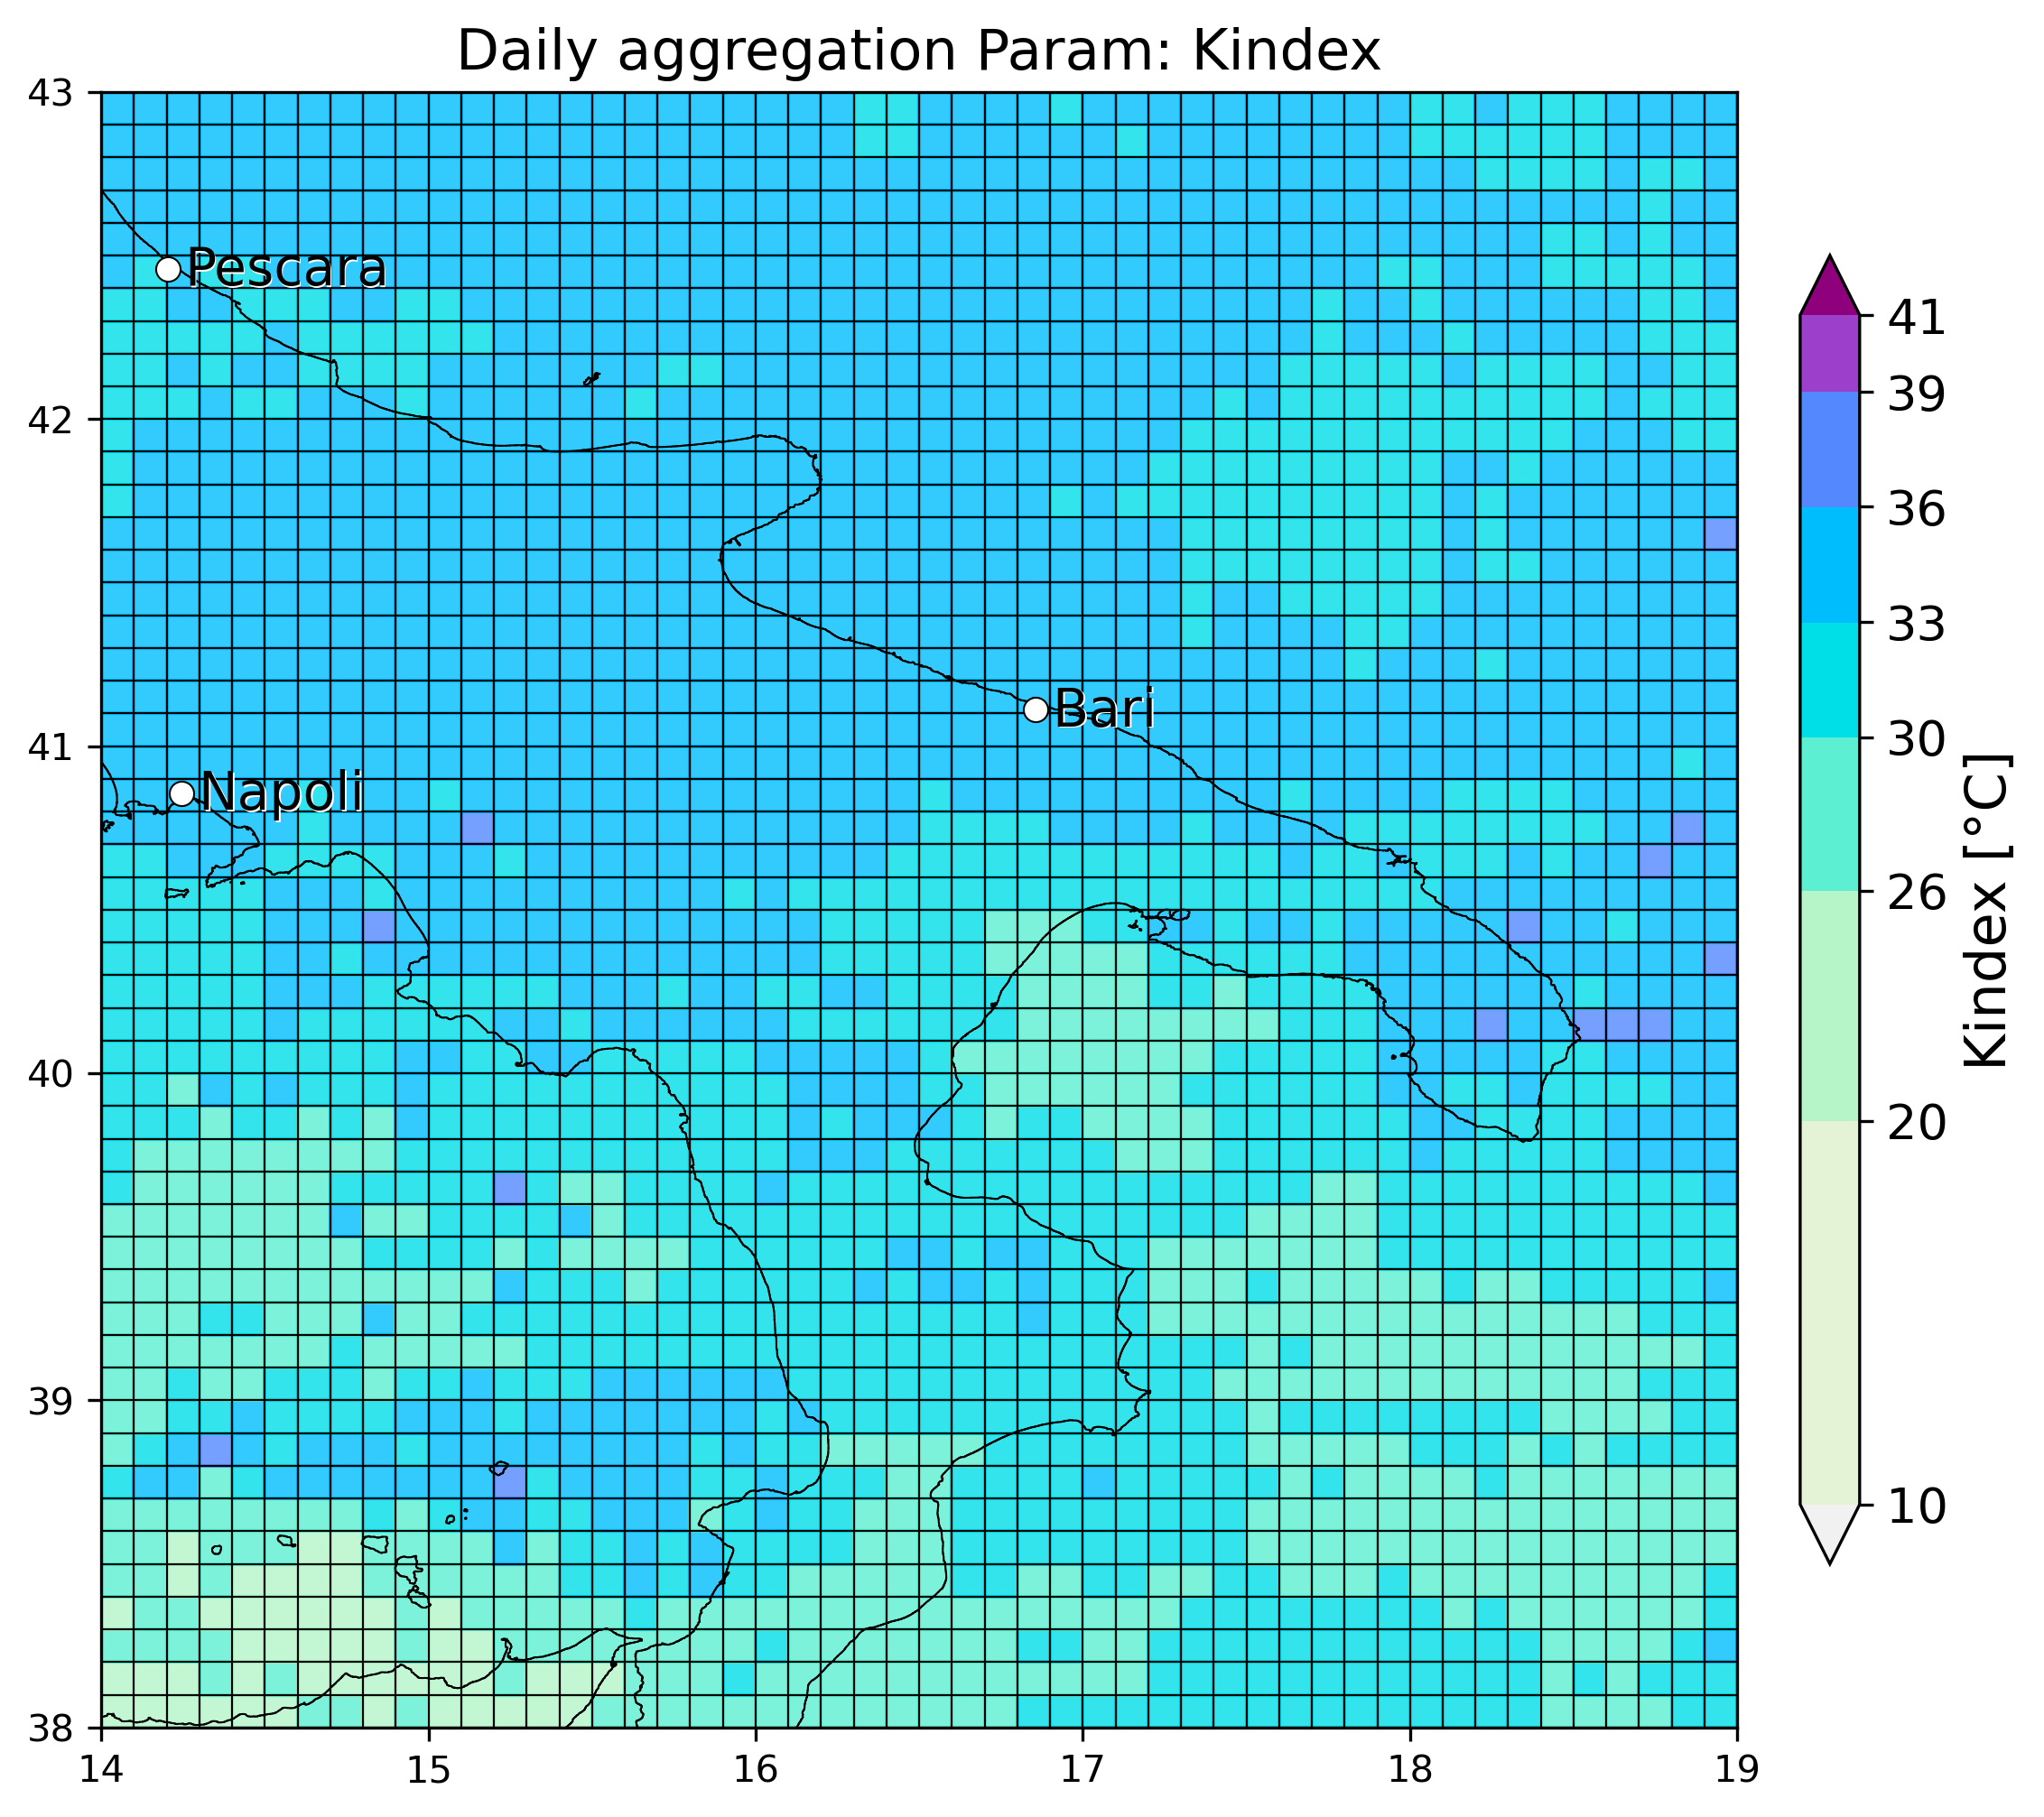

* 7 September 2018 (Carapelle/Orta Nova - Foggia): 2 eswd reports 5cm, event almost missed by OT max probability while also here a dTmin is well visible, while LJ index miss event near Foggia but see well the hourly evolution of organized convection offshore. SPHERA miss in finding a daily min of LI, or max of Kindex in the area of the reports:
* 2 September 2018 (Pescara):various eswd/unipol reports, good matching with OT max prob, OT dTmin and also LJ index, SPHERA LI daily min detected offshore but close to the reports location, while Kindex fails in giving useful indication:

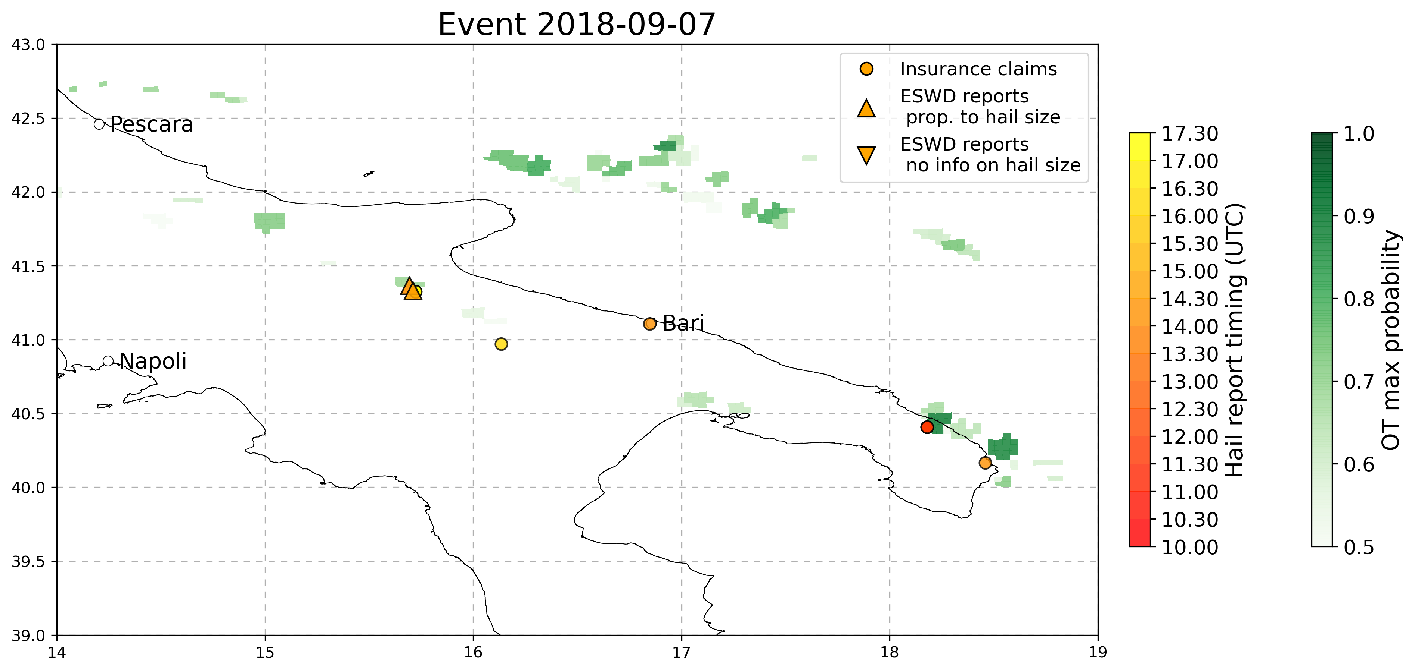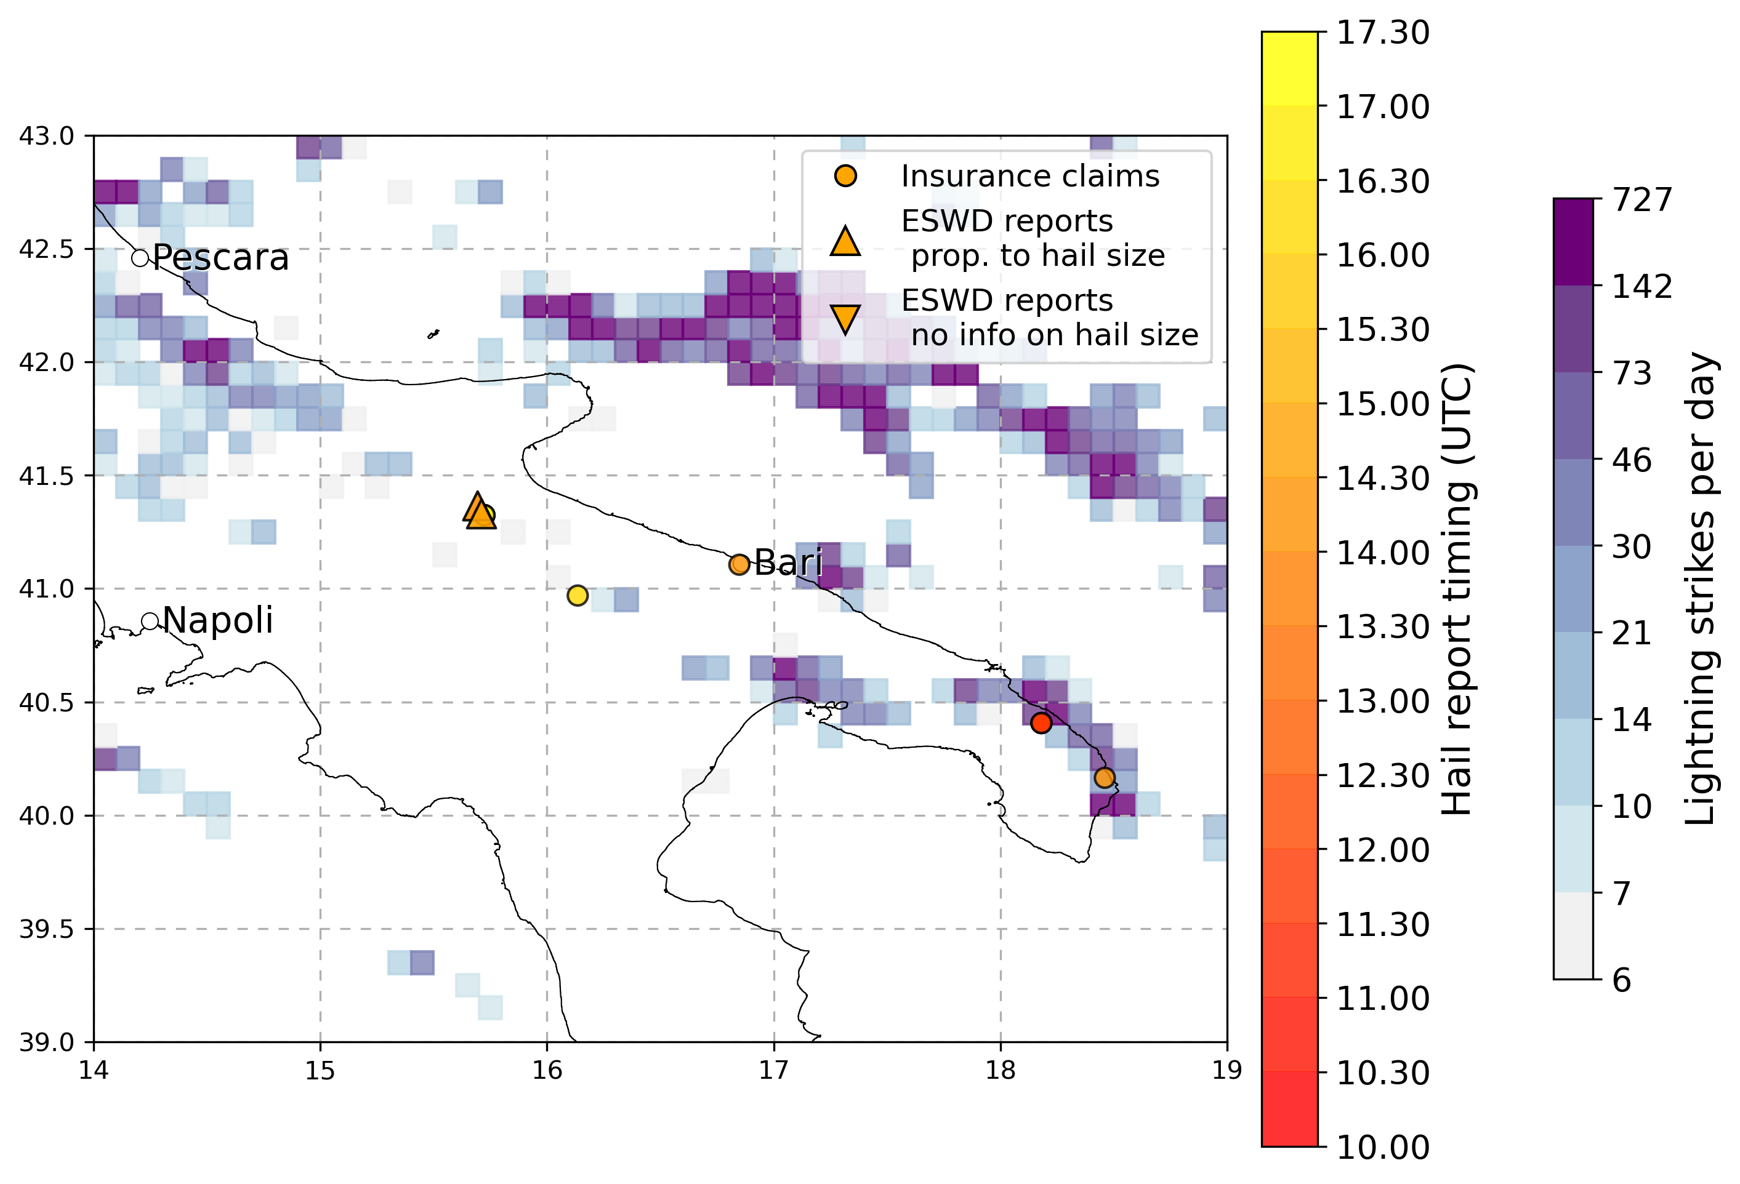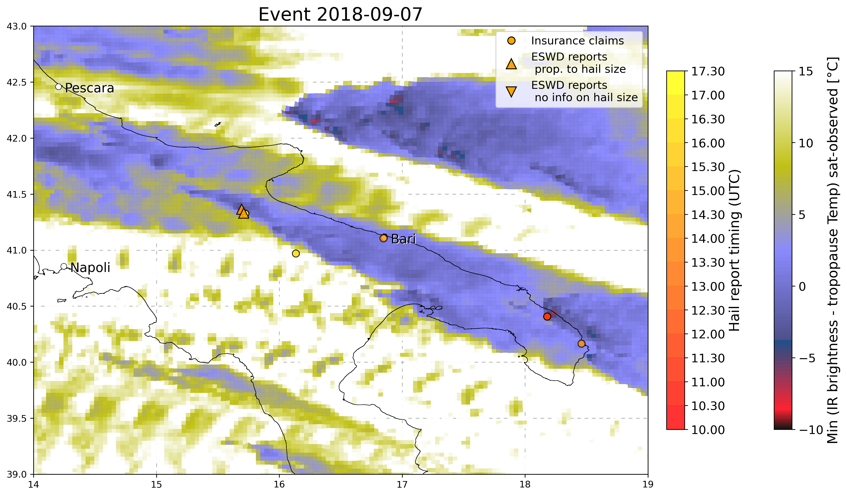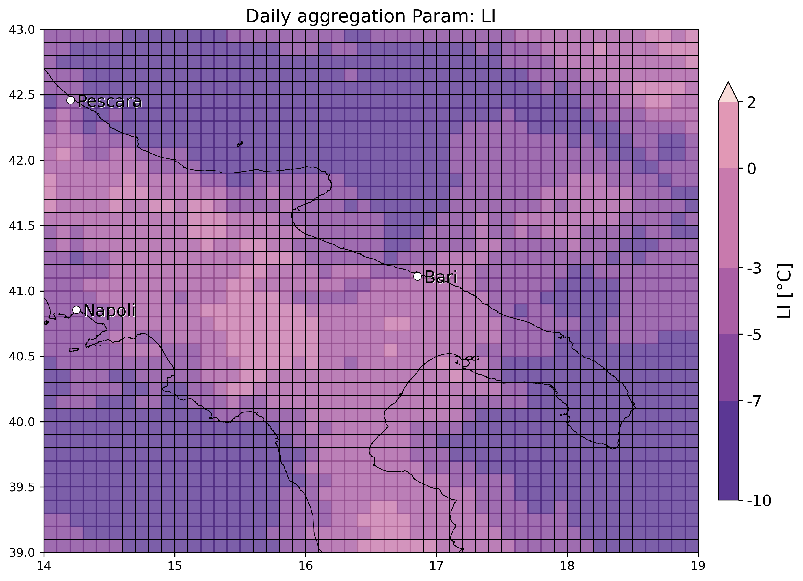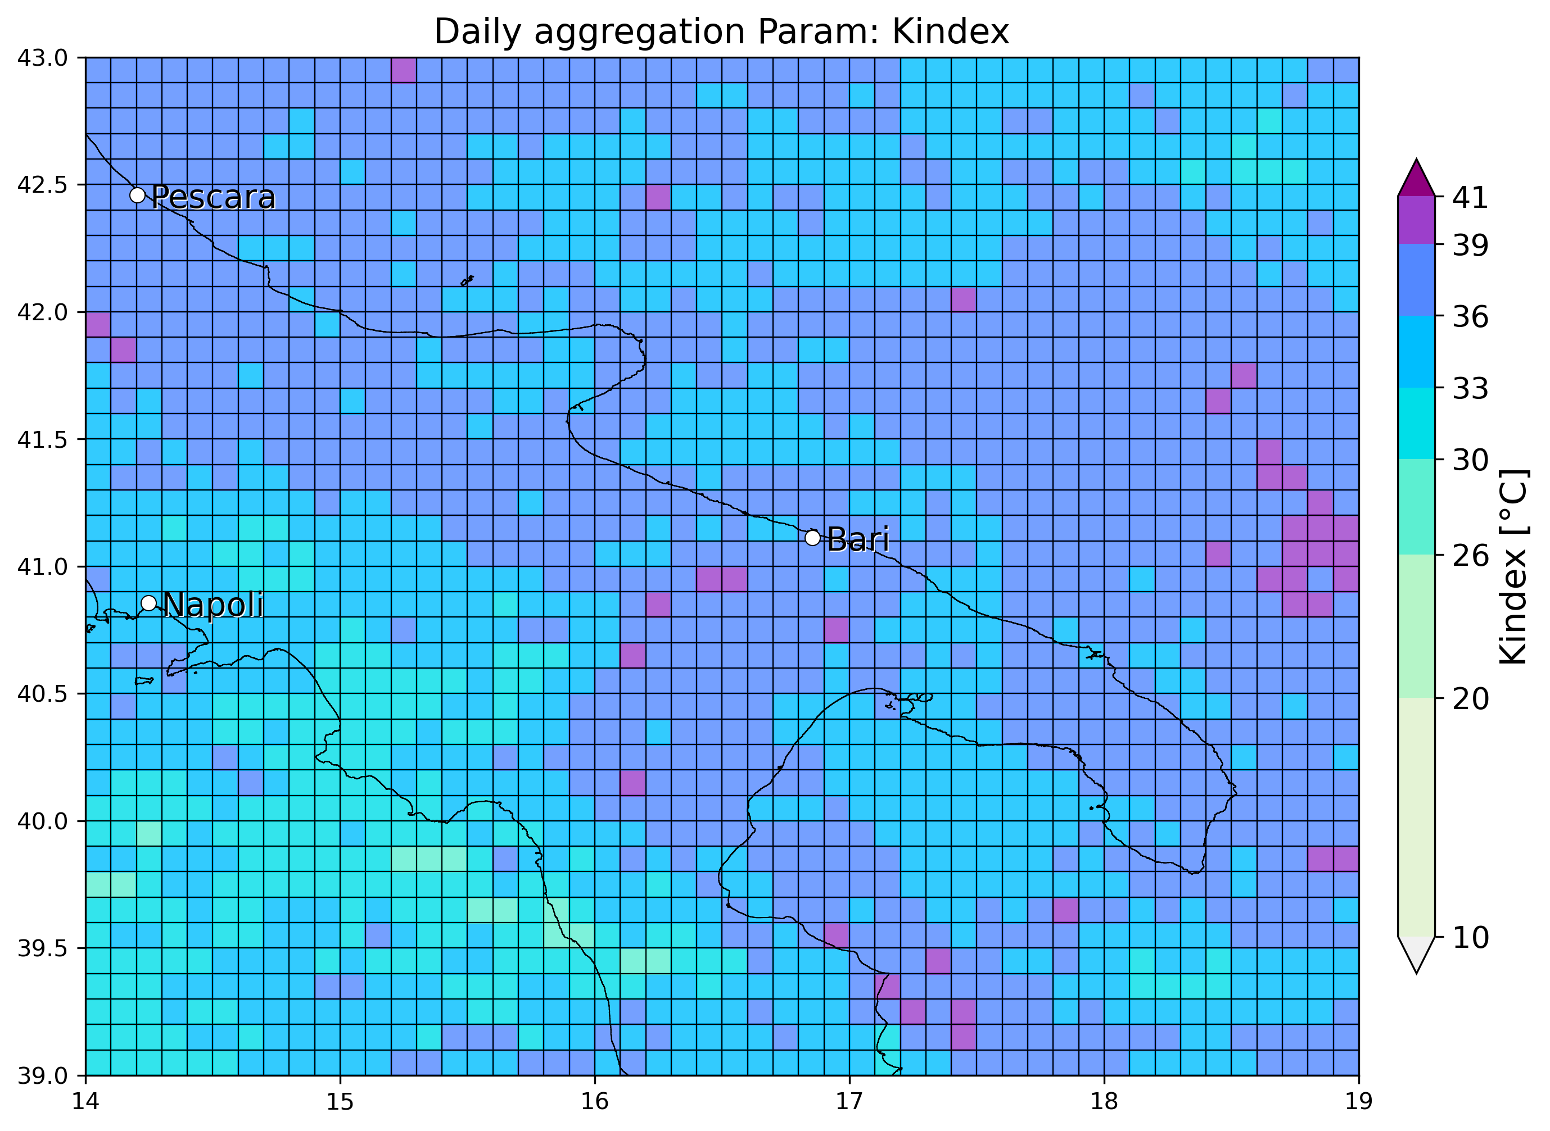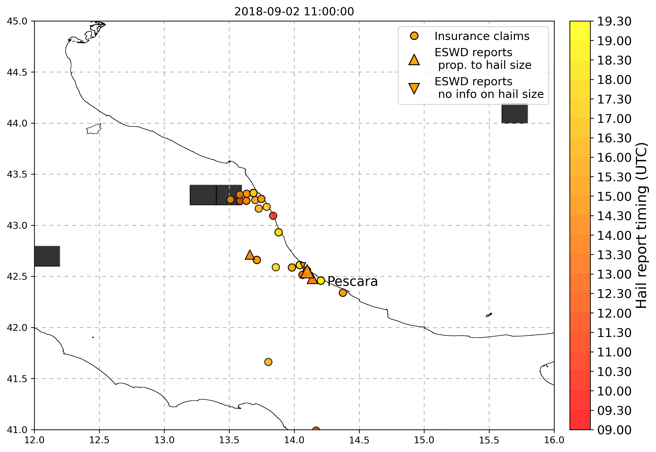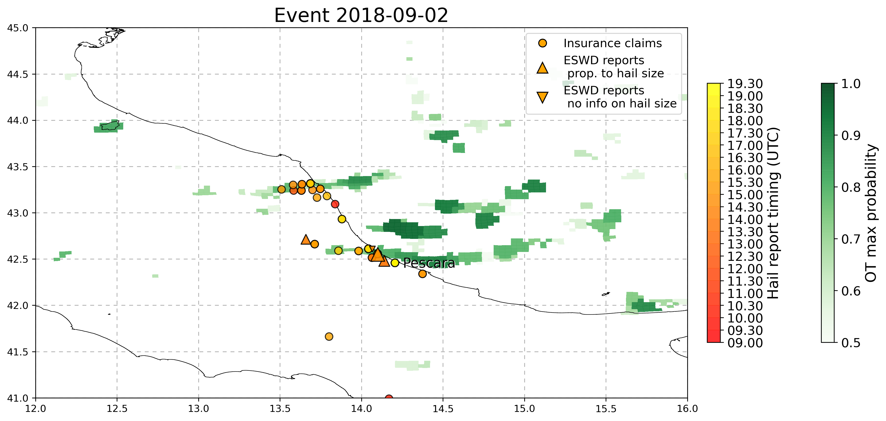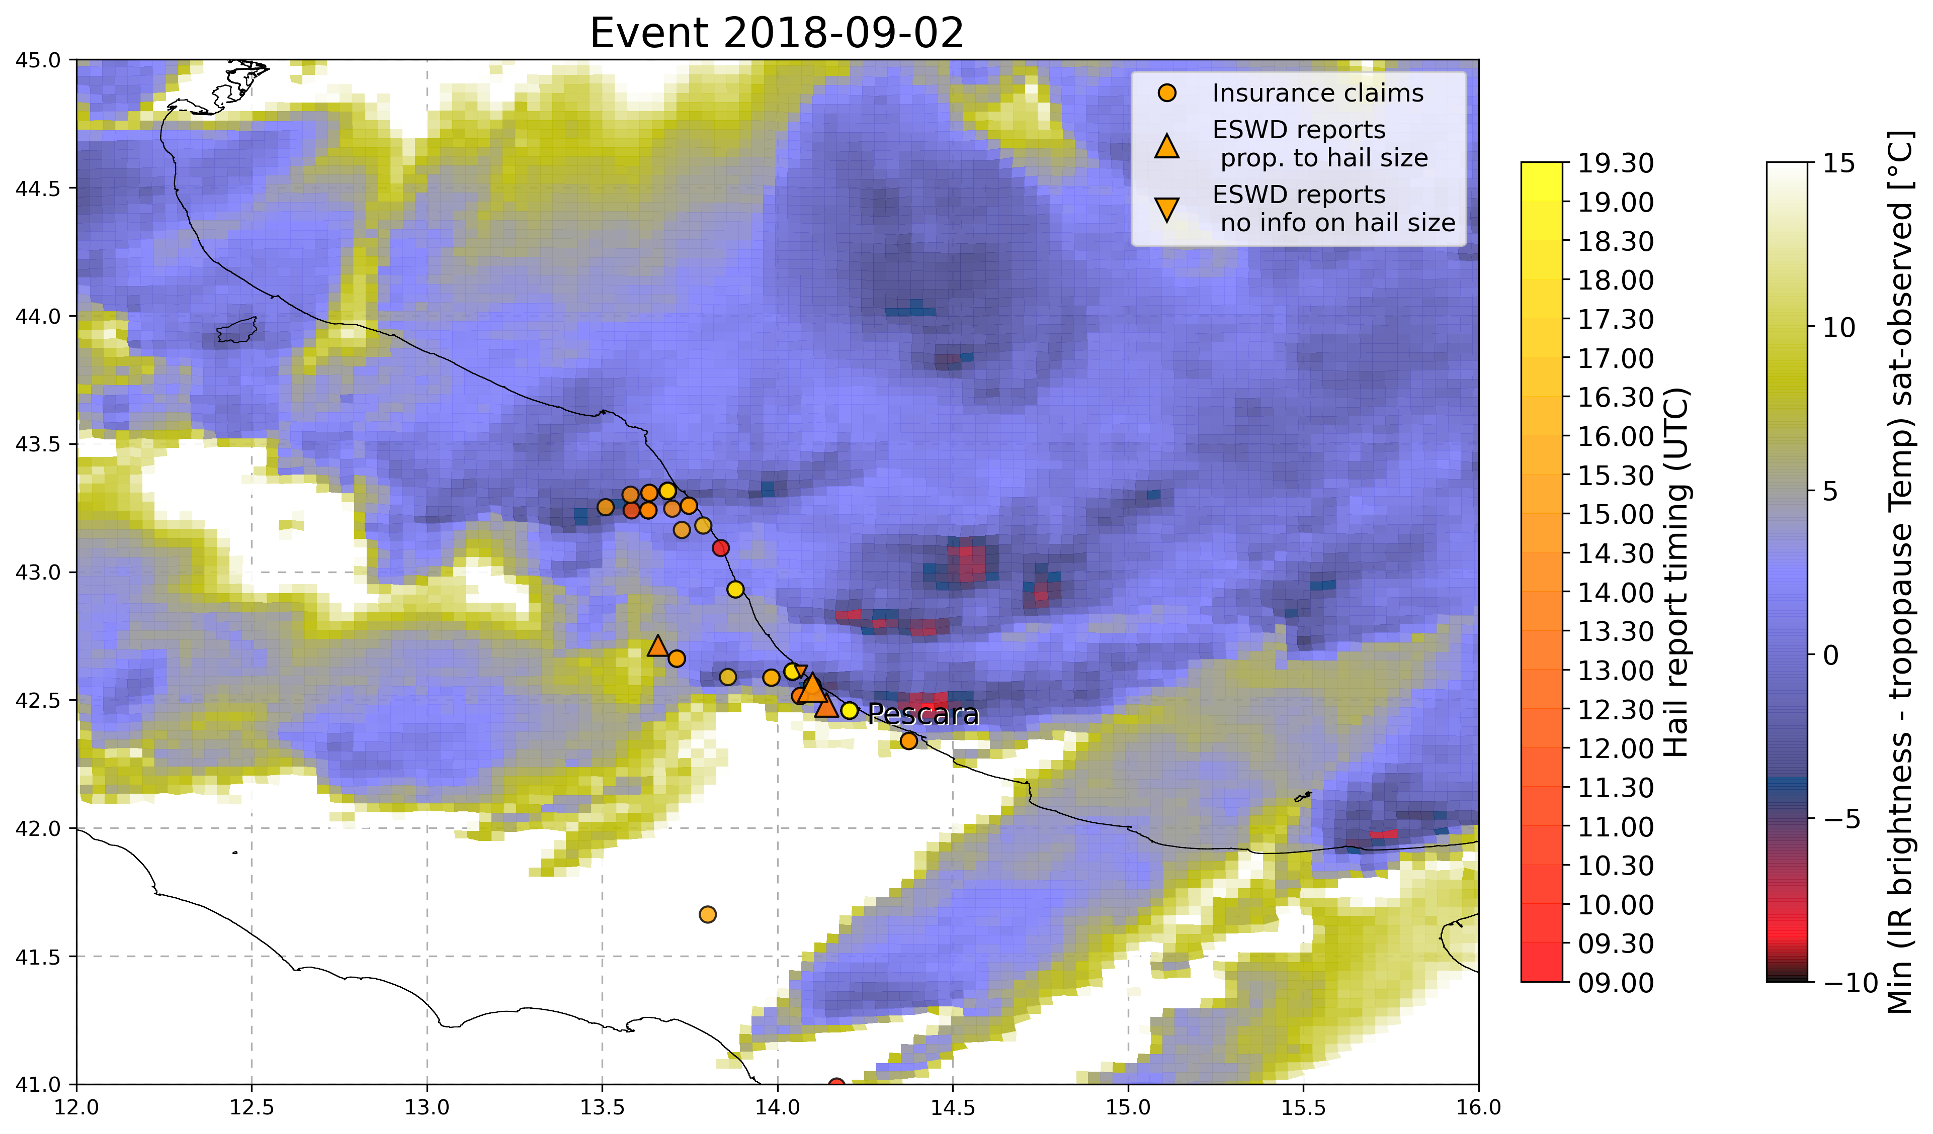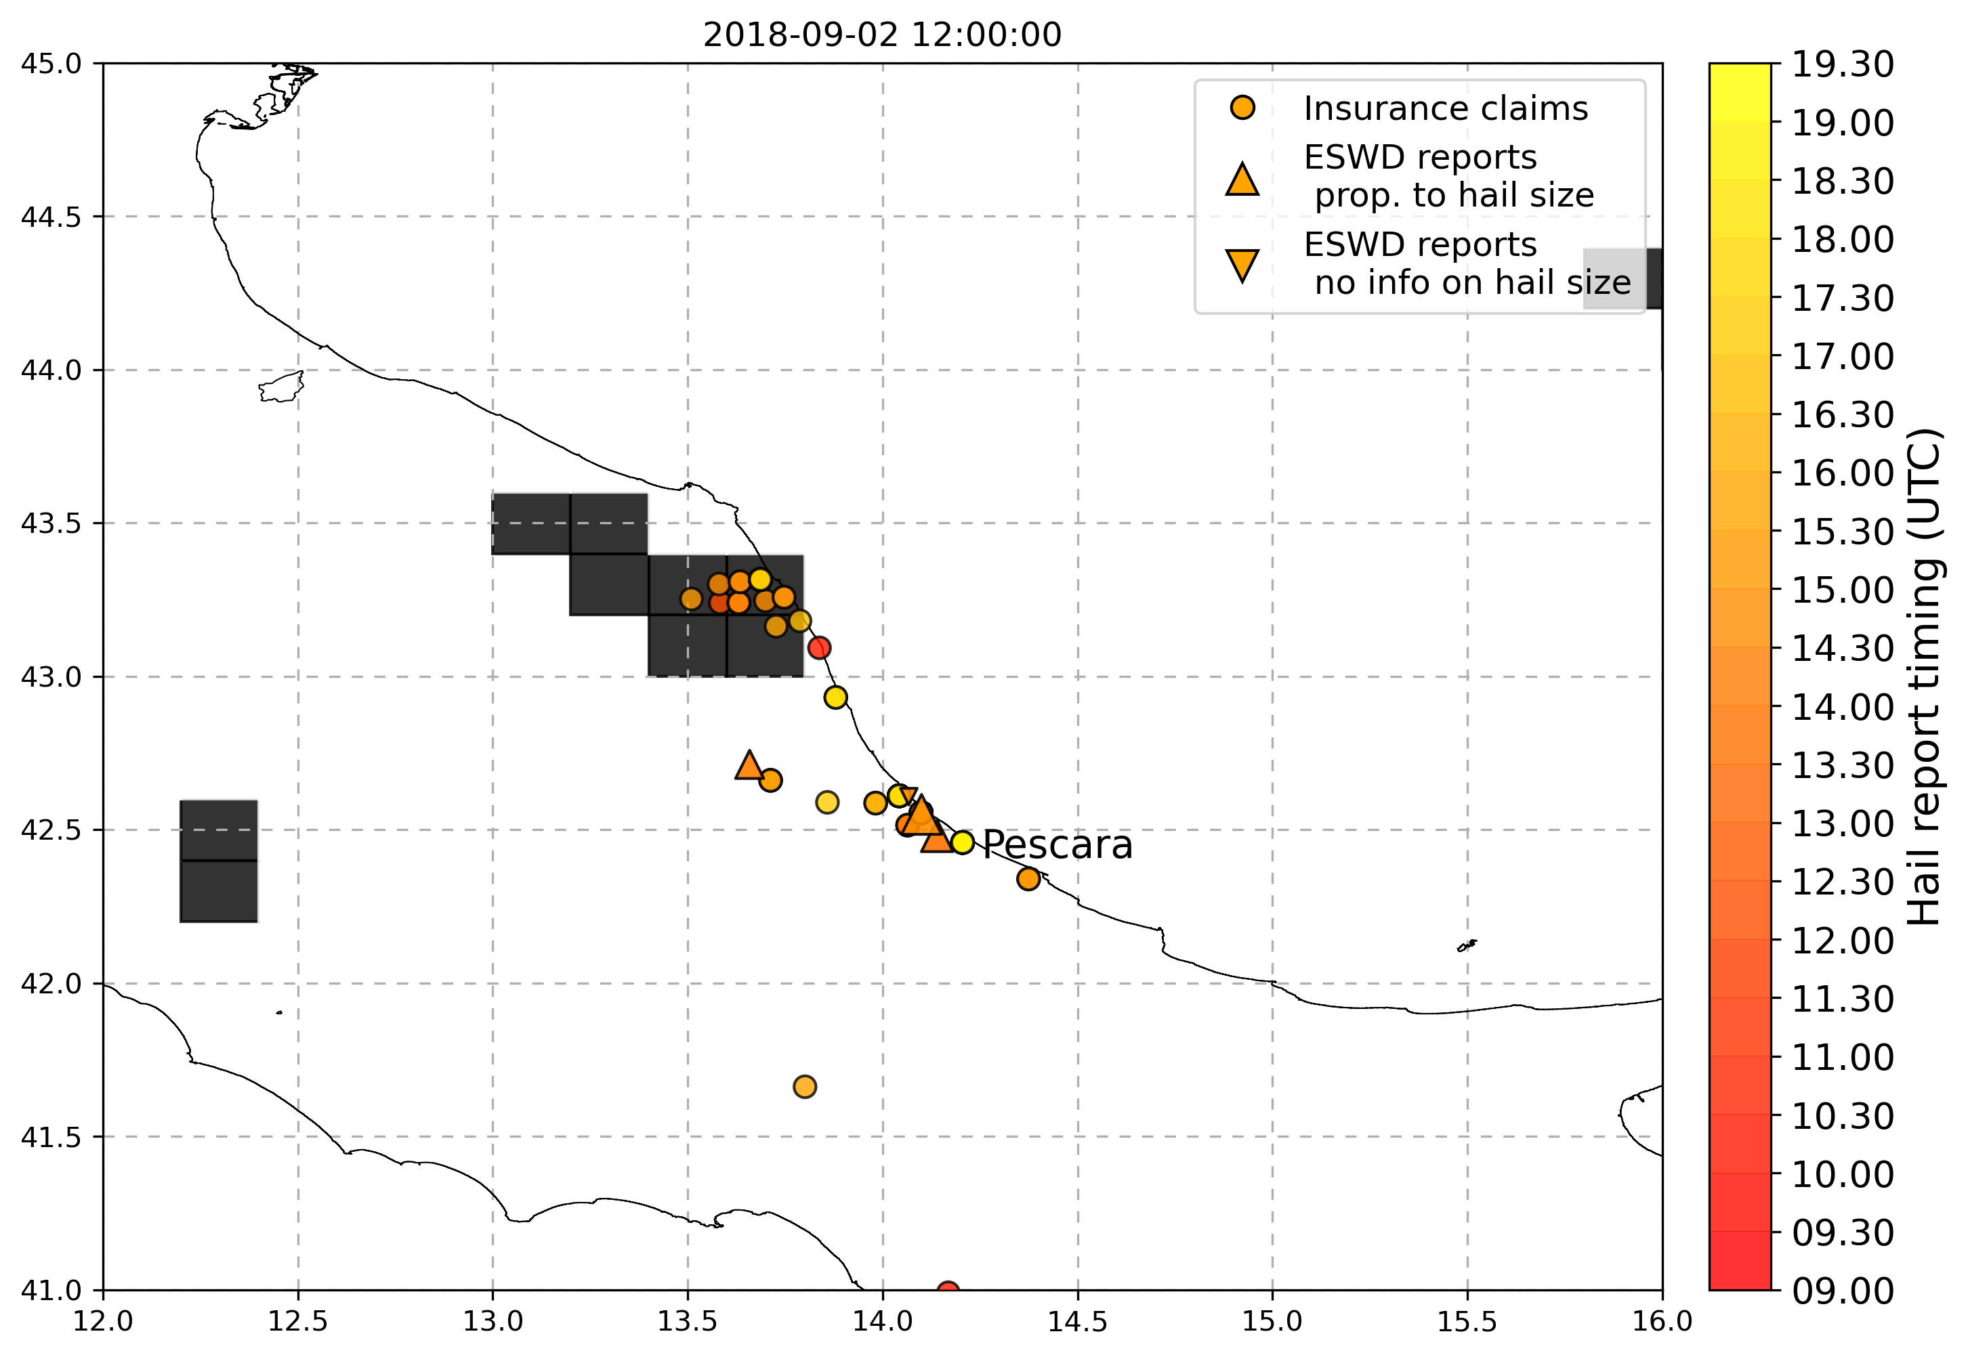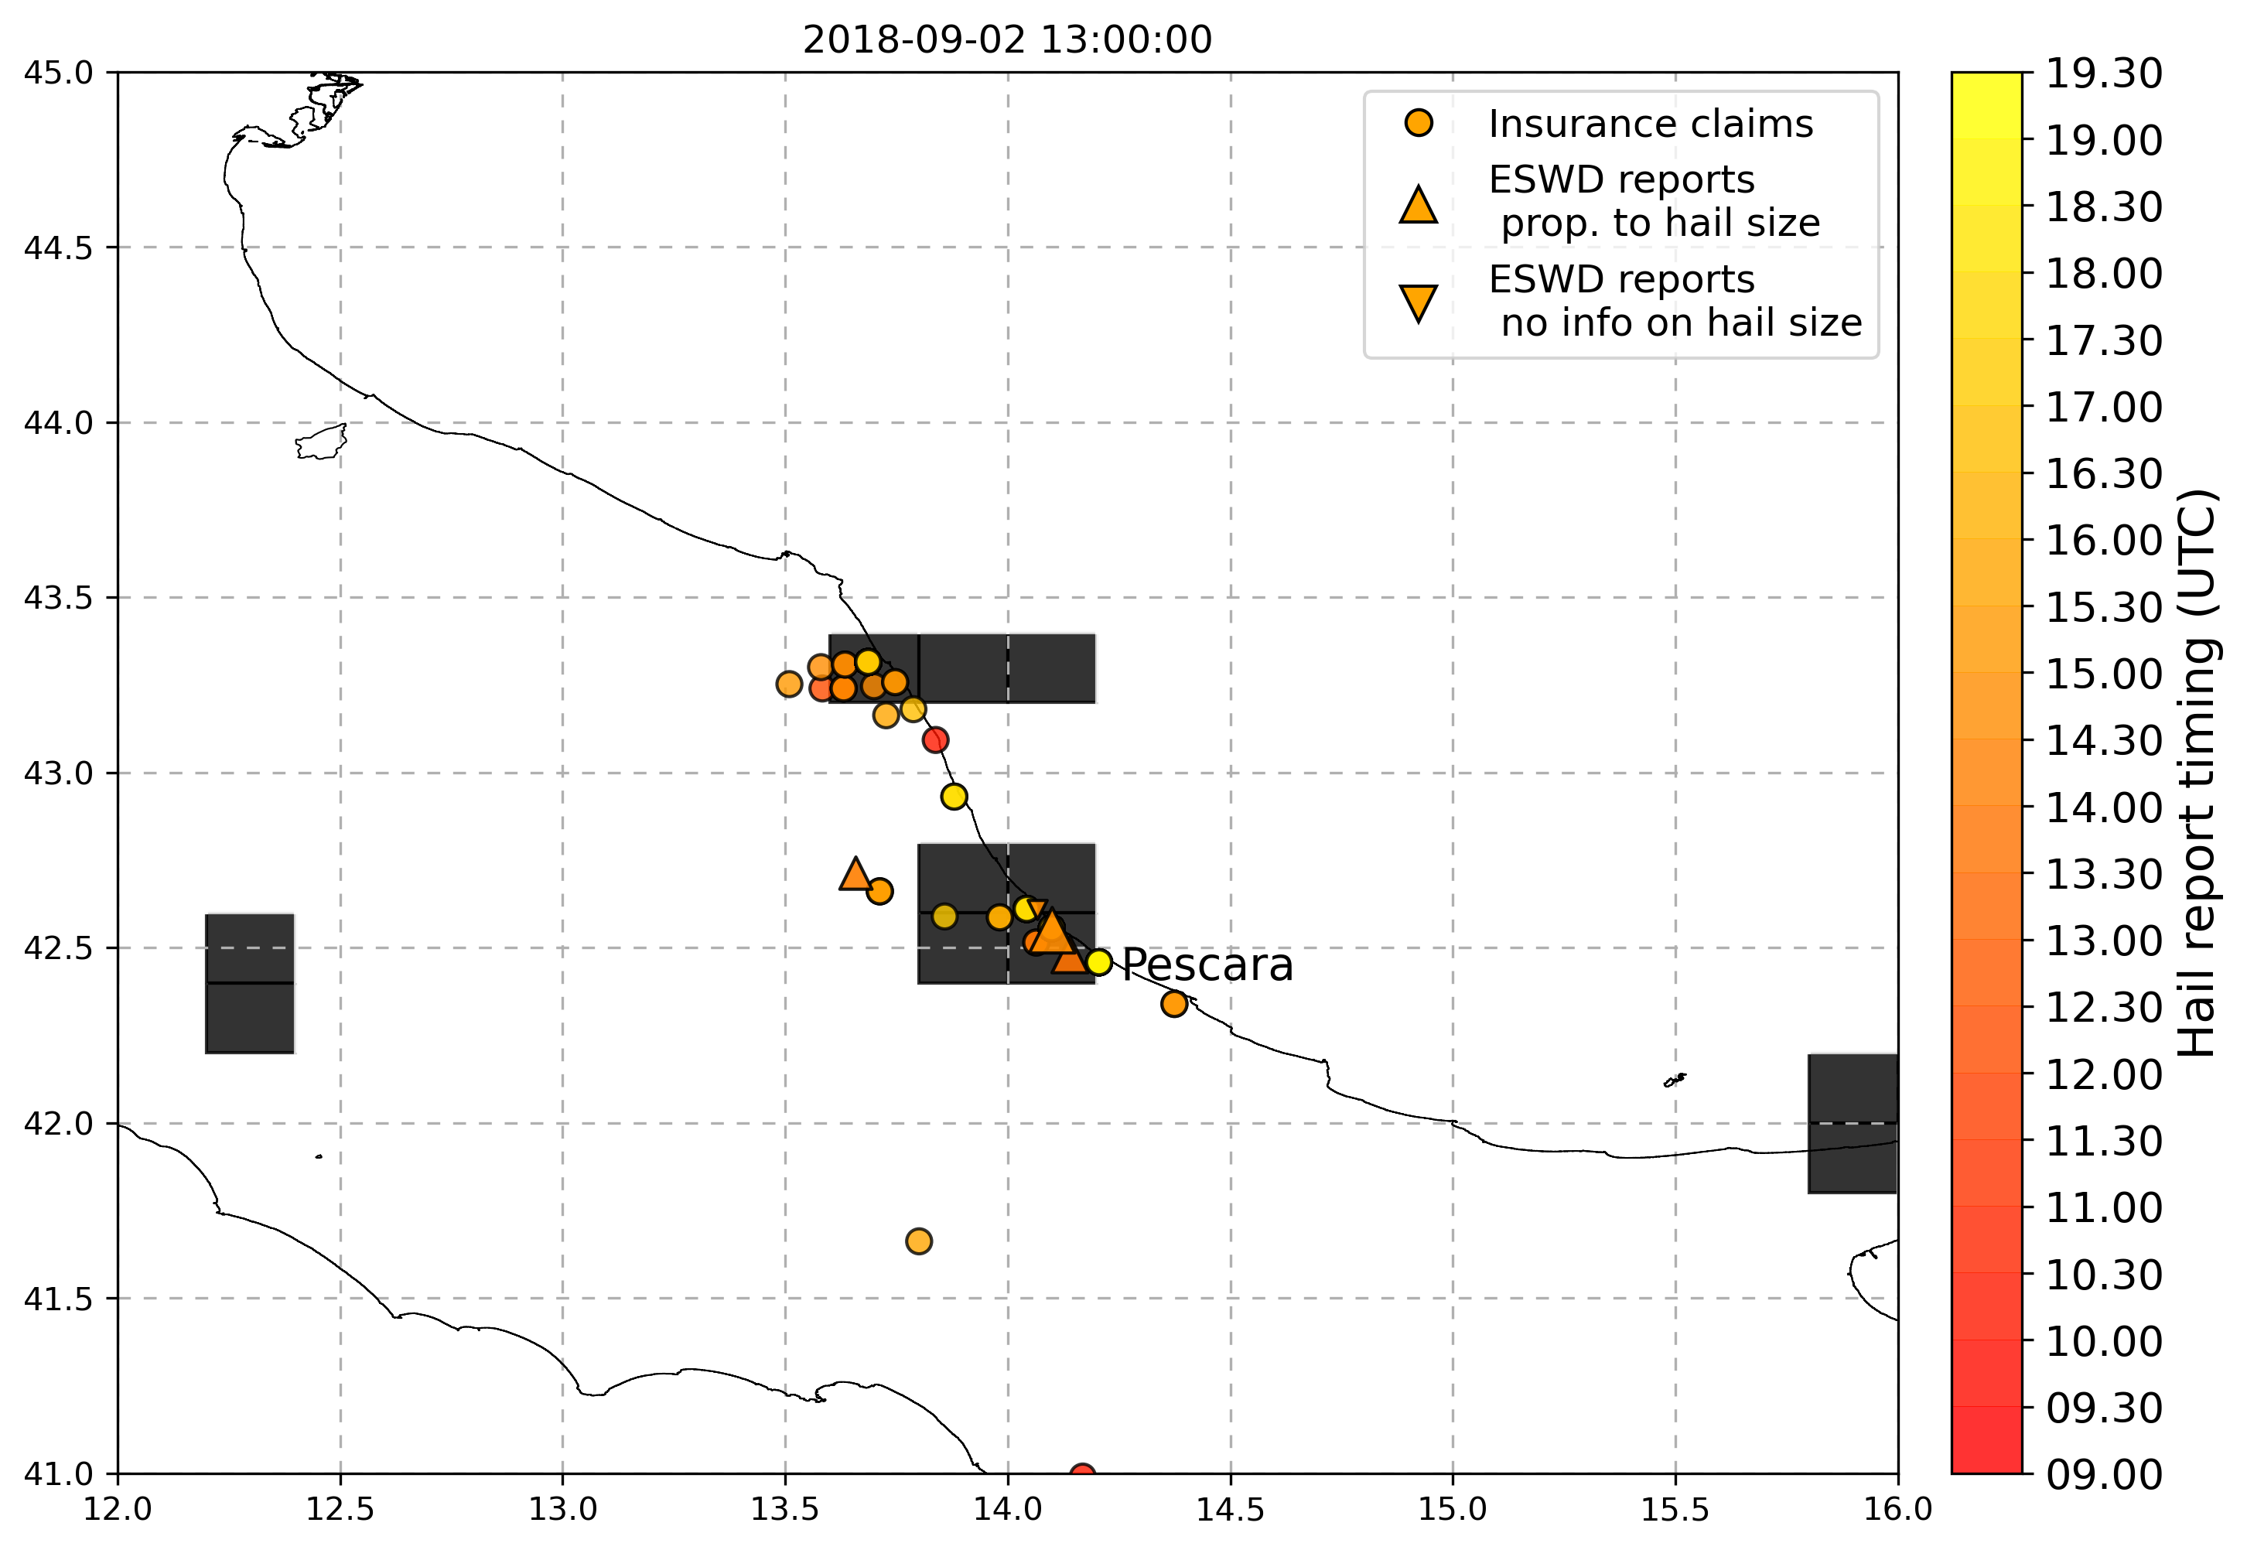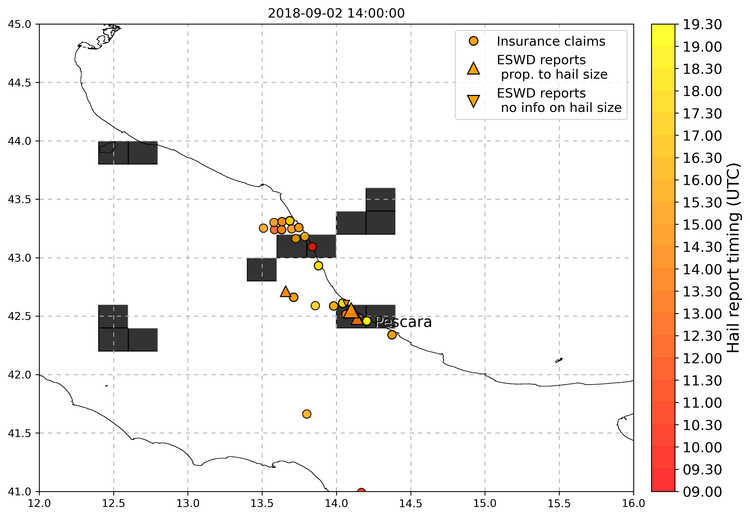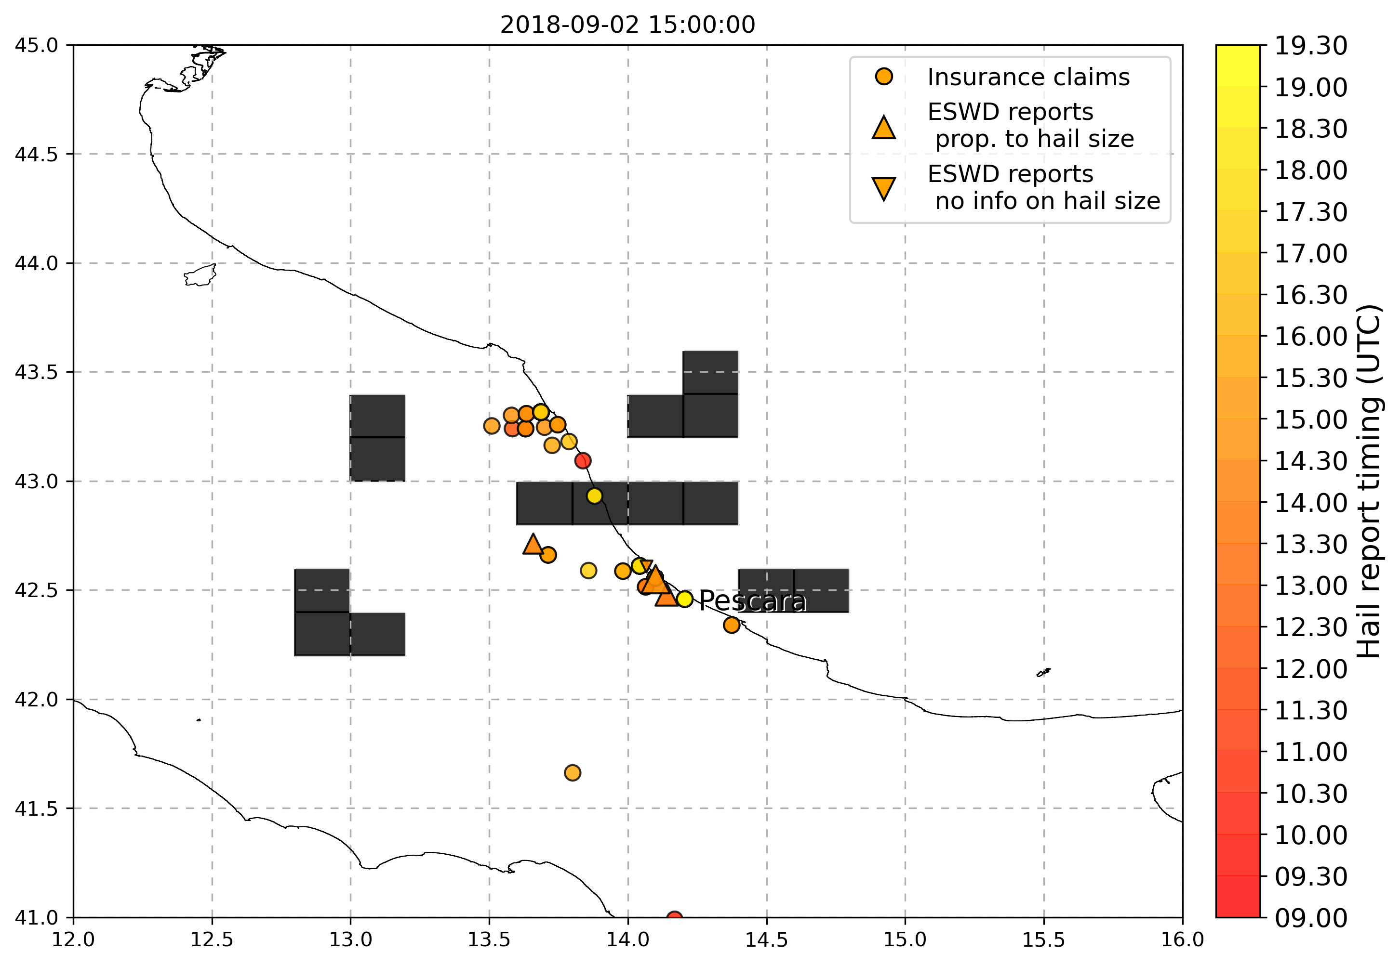

* 23 July 2018 (Bari): various eswd/unipol reports, good match with OT max prob and OT dTmin, and also with LJ index, SPHERA LI daily min instead does not match with hailstorm event location, while Kindex is a little better but both params present peaks associated to hail in a large region nearby the event but not specifically in the location of the event

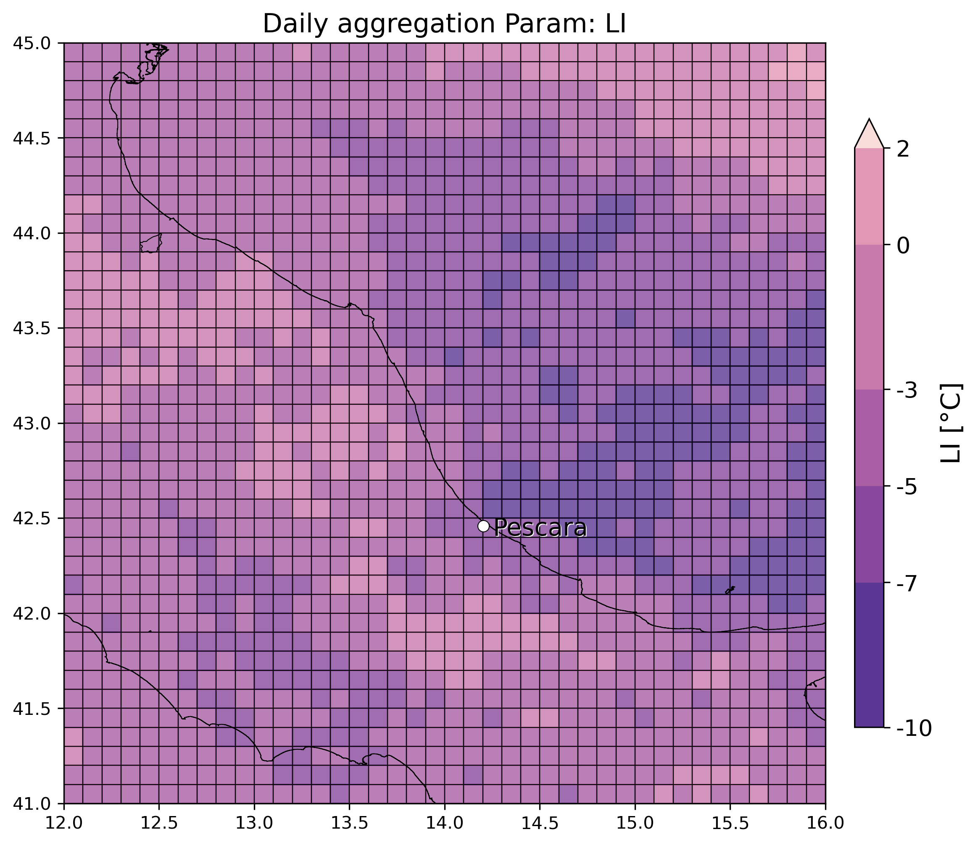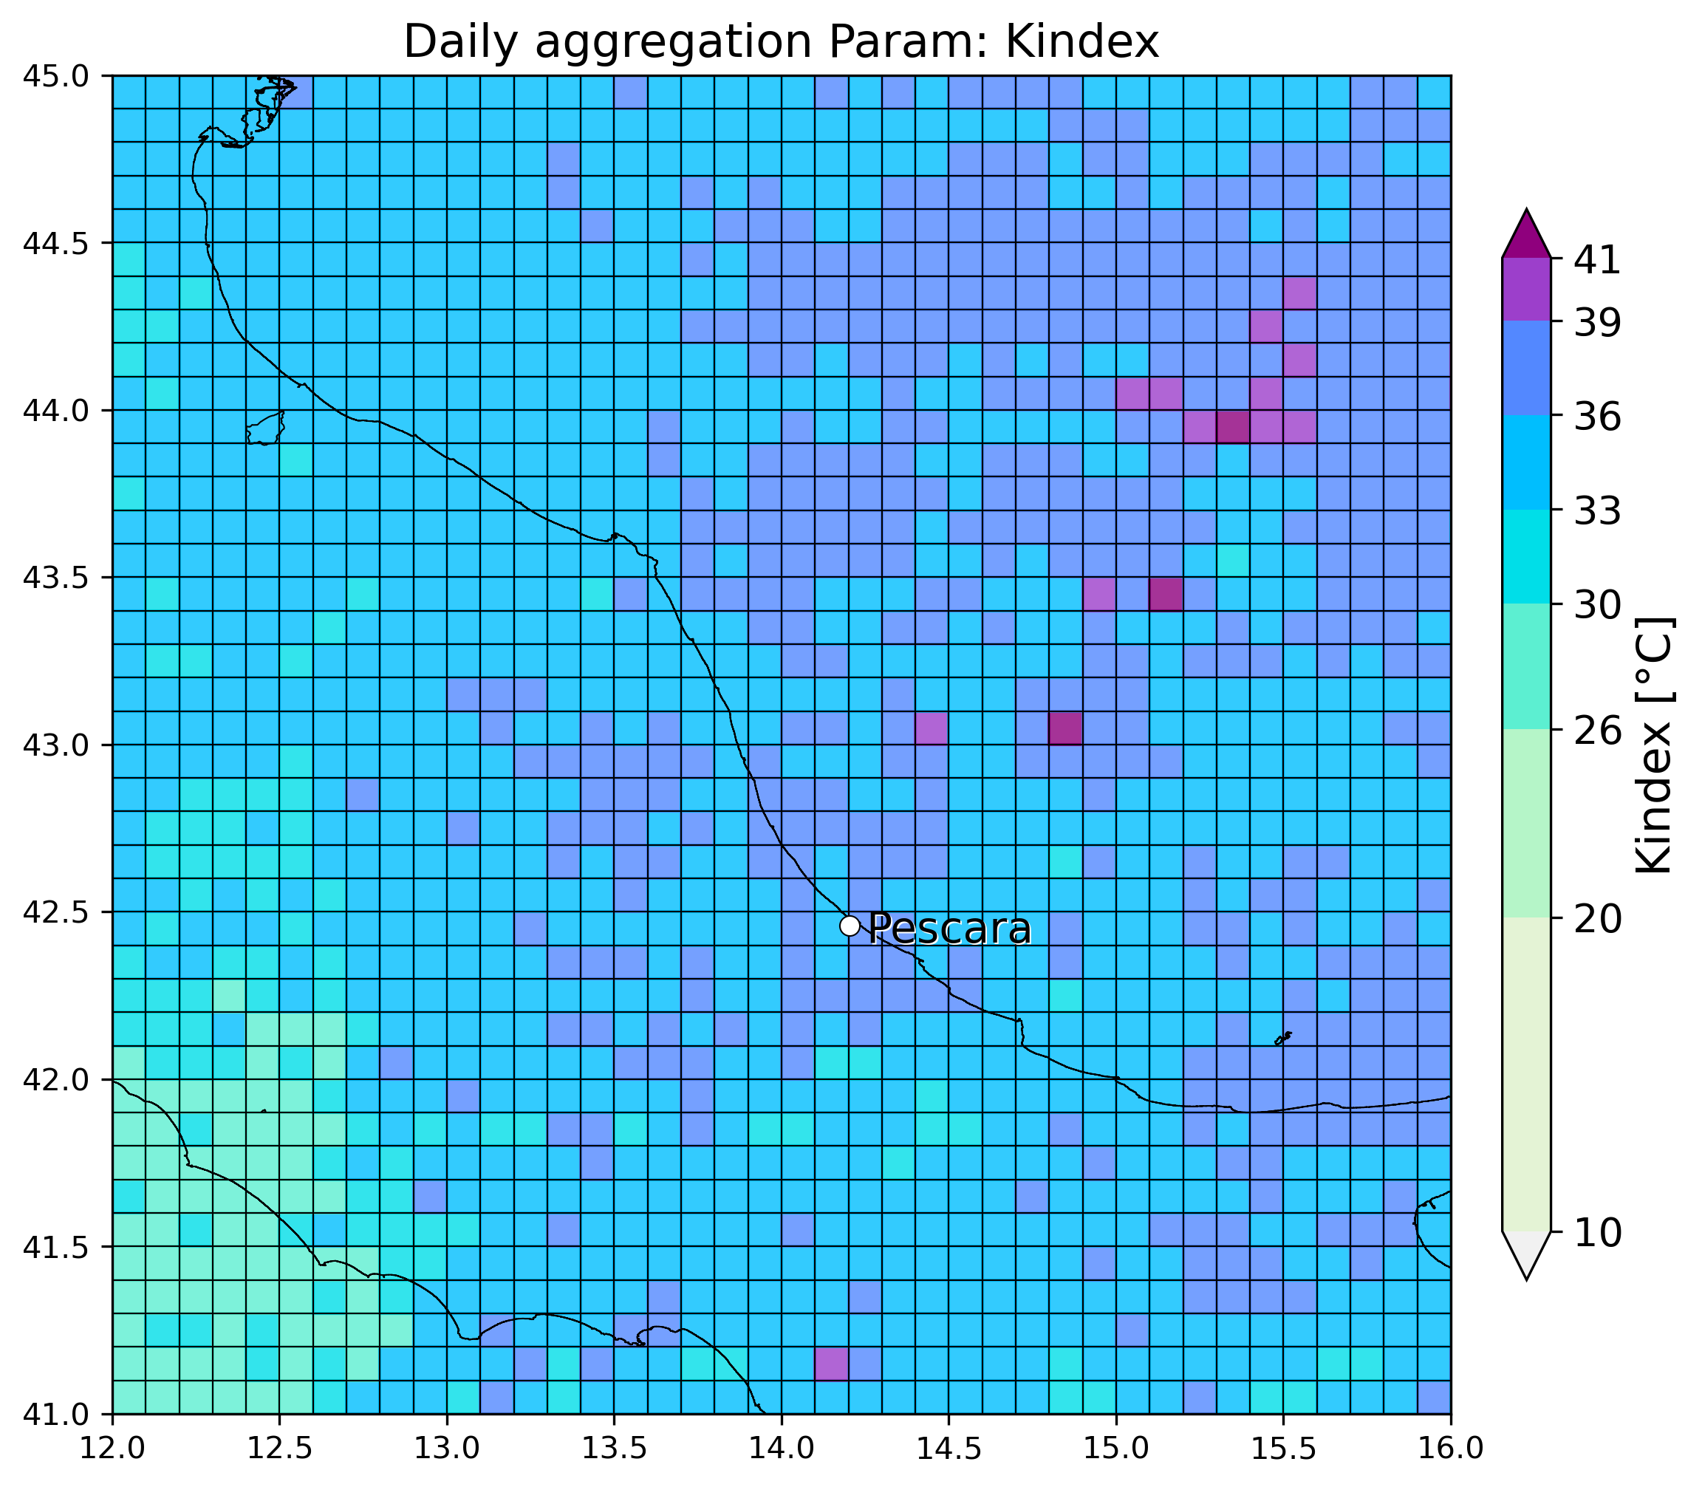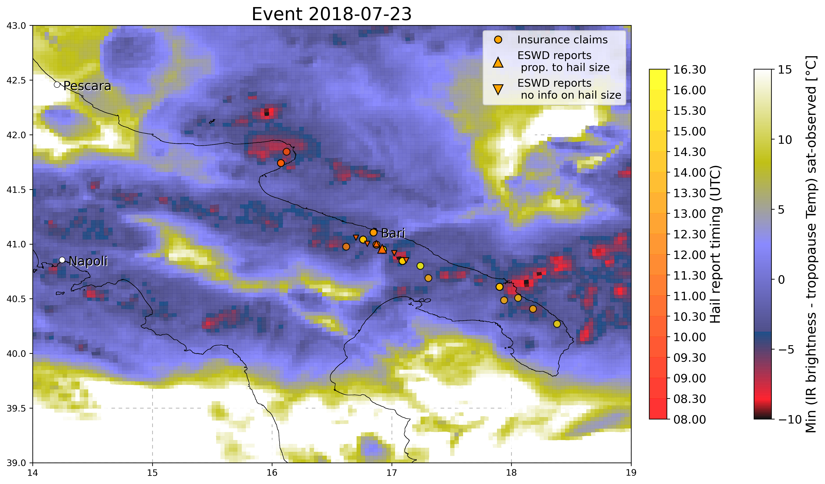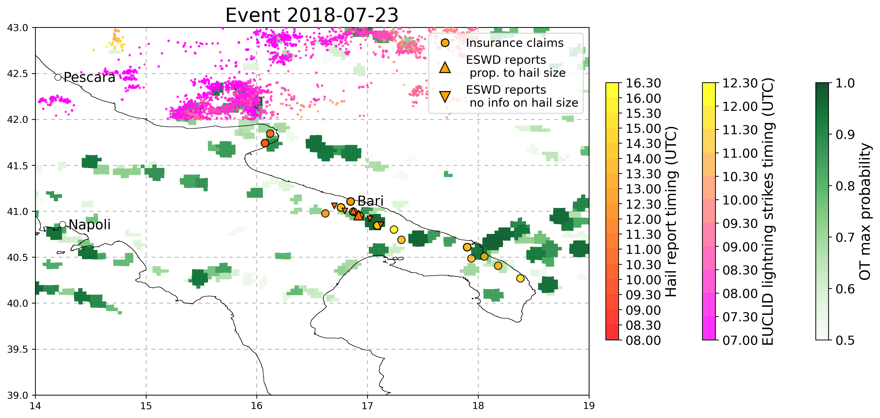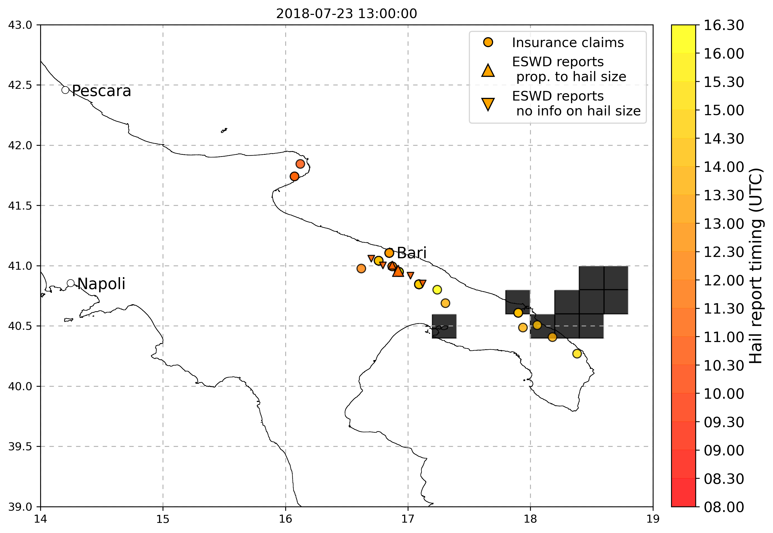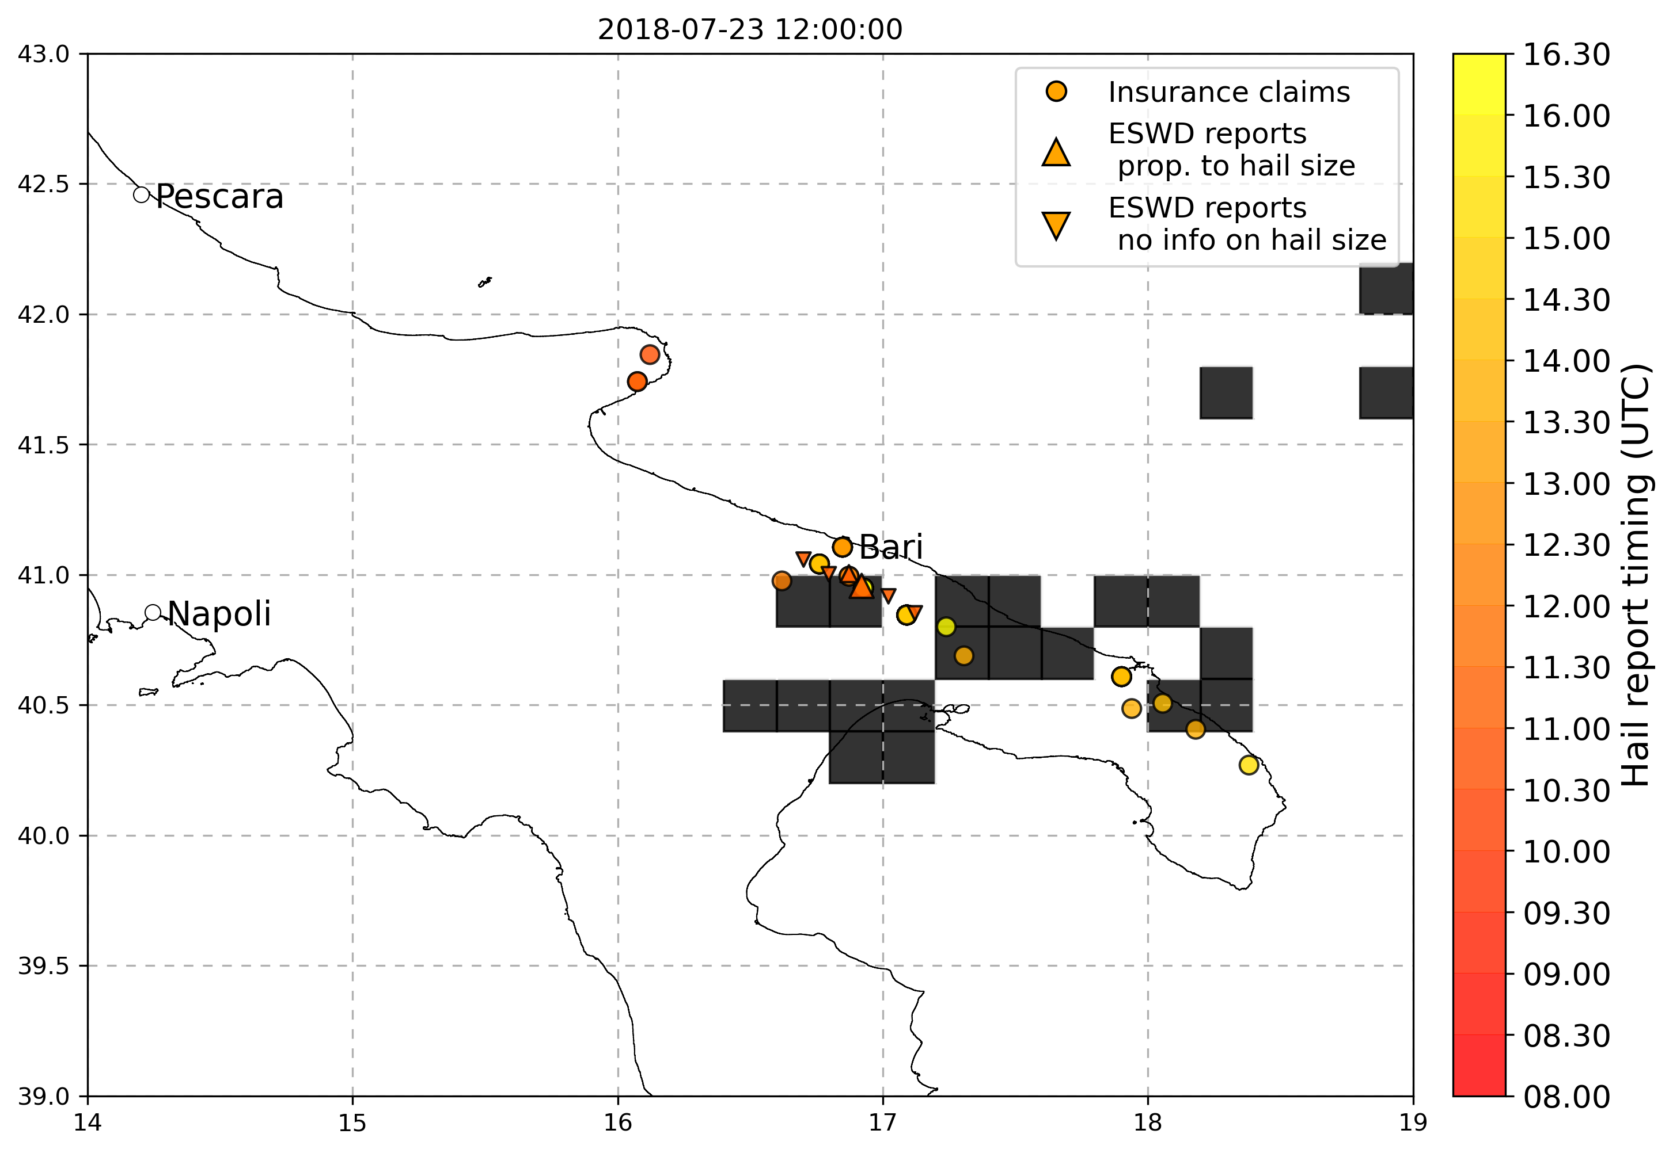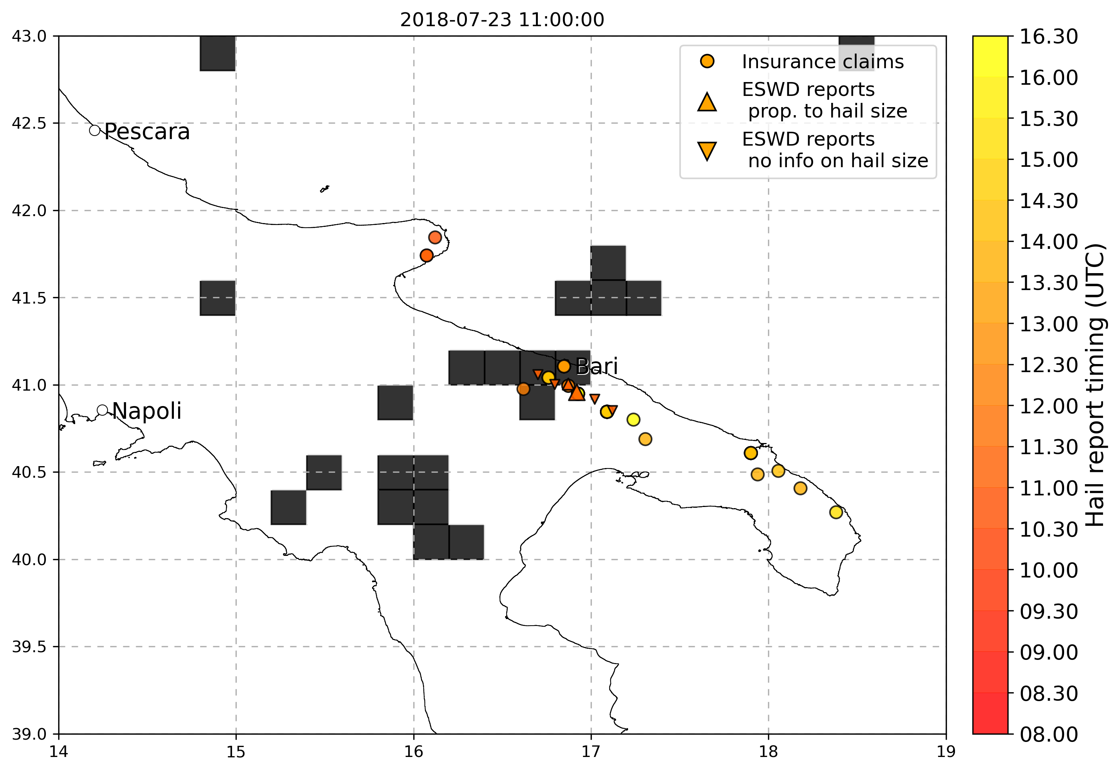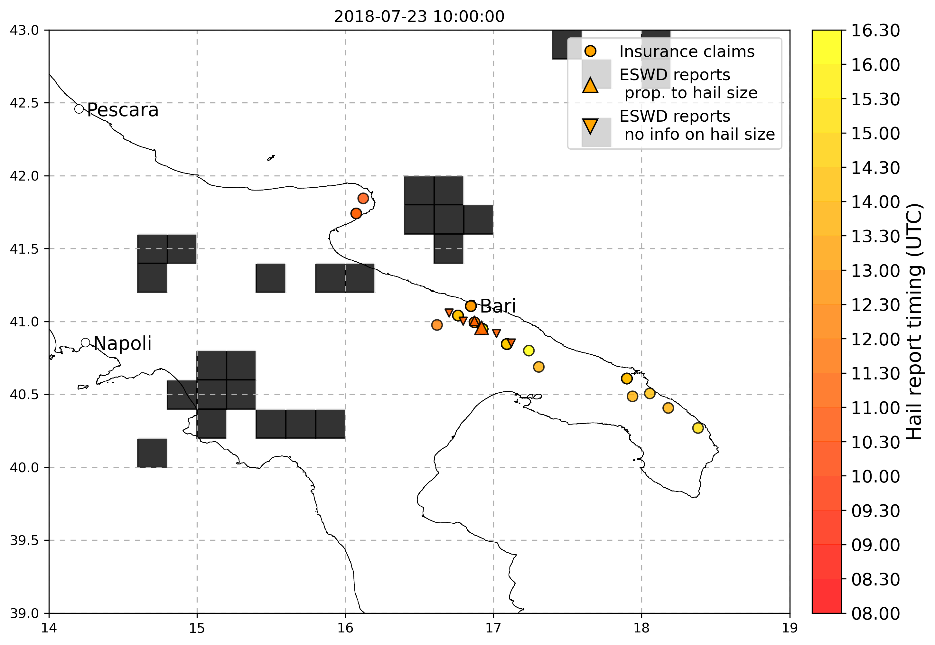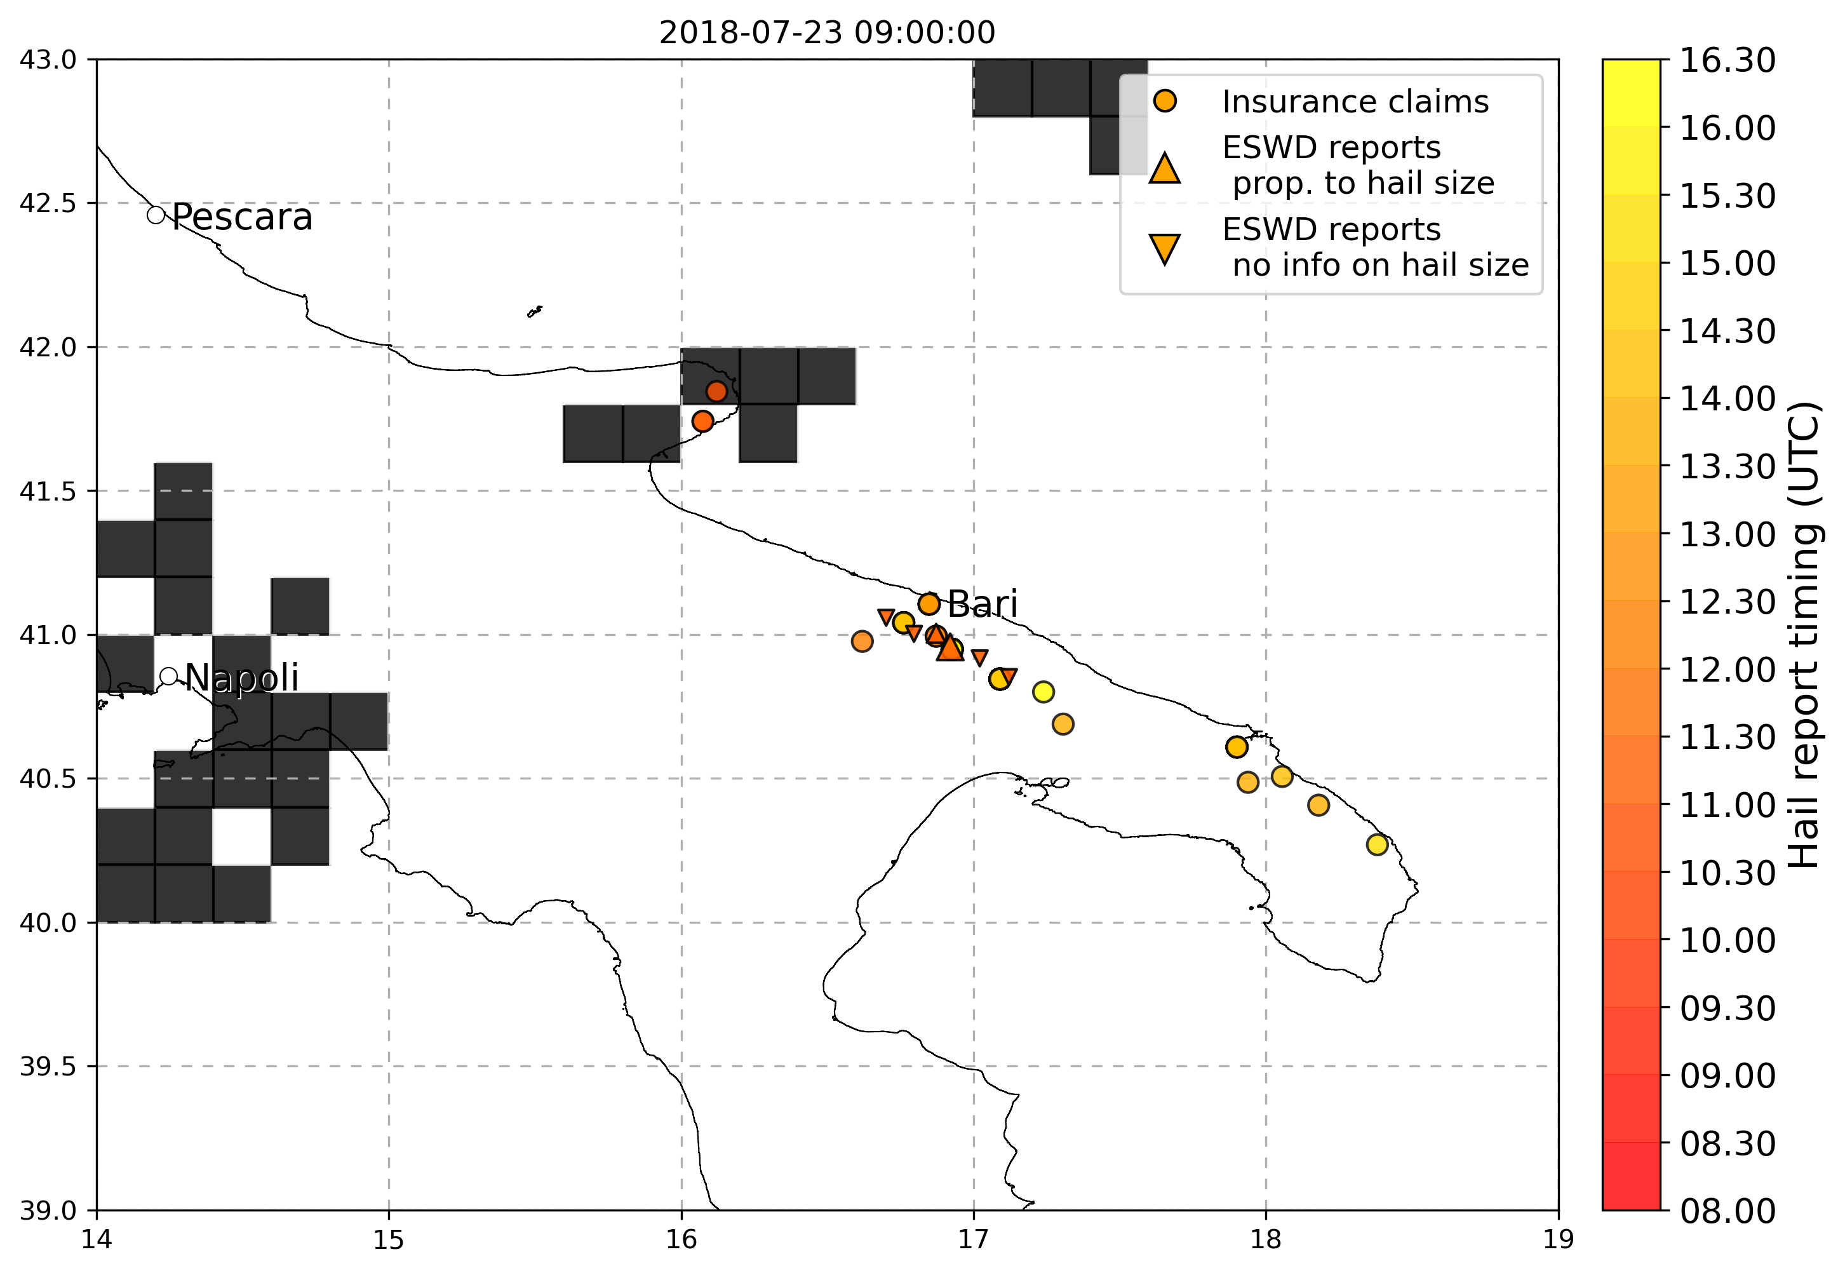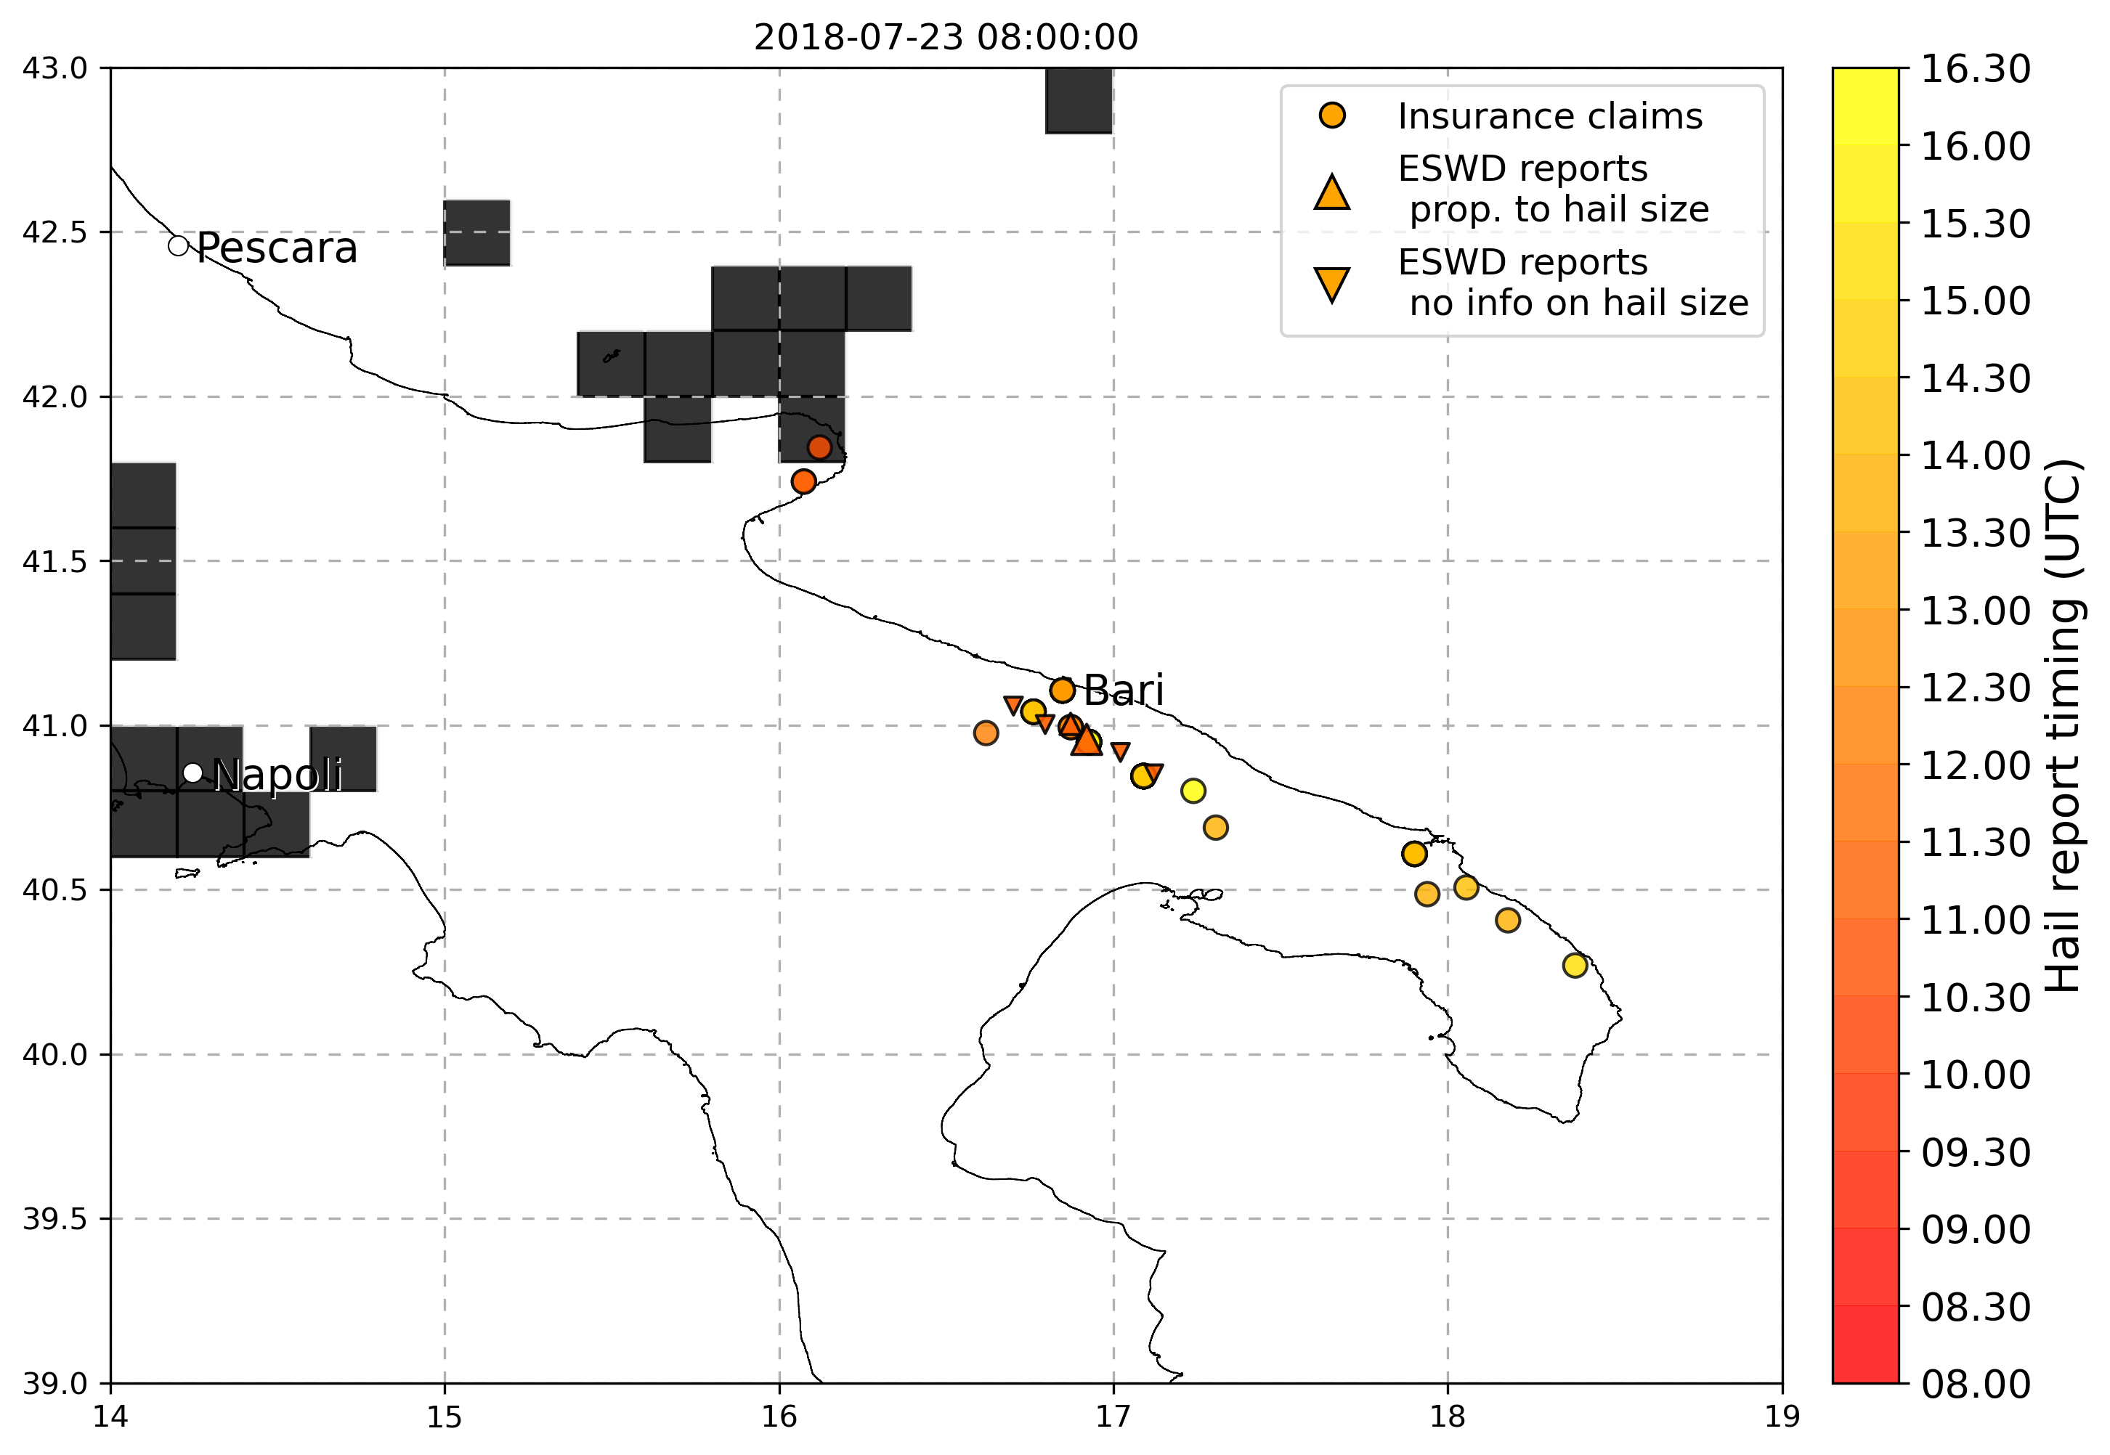

* 9-10 August 2017 Trentino: various eswd/unipol reports in both days, good match with OT max prob and dTmin (better on the 9th), good match with LJ index on the 9th while no LJ occurrences detected during the 10th. SPHERA LI index shows a peak in daily minimum well matched with hail reports on the 9th while on the 10th is a little lower, similarly the Kindex:

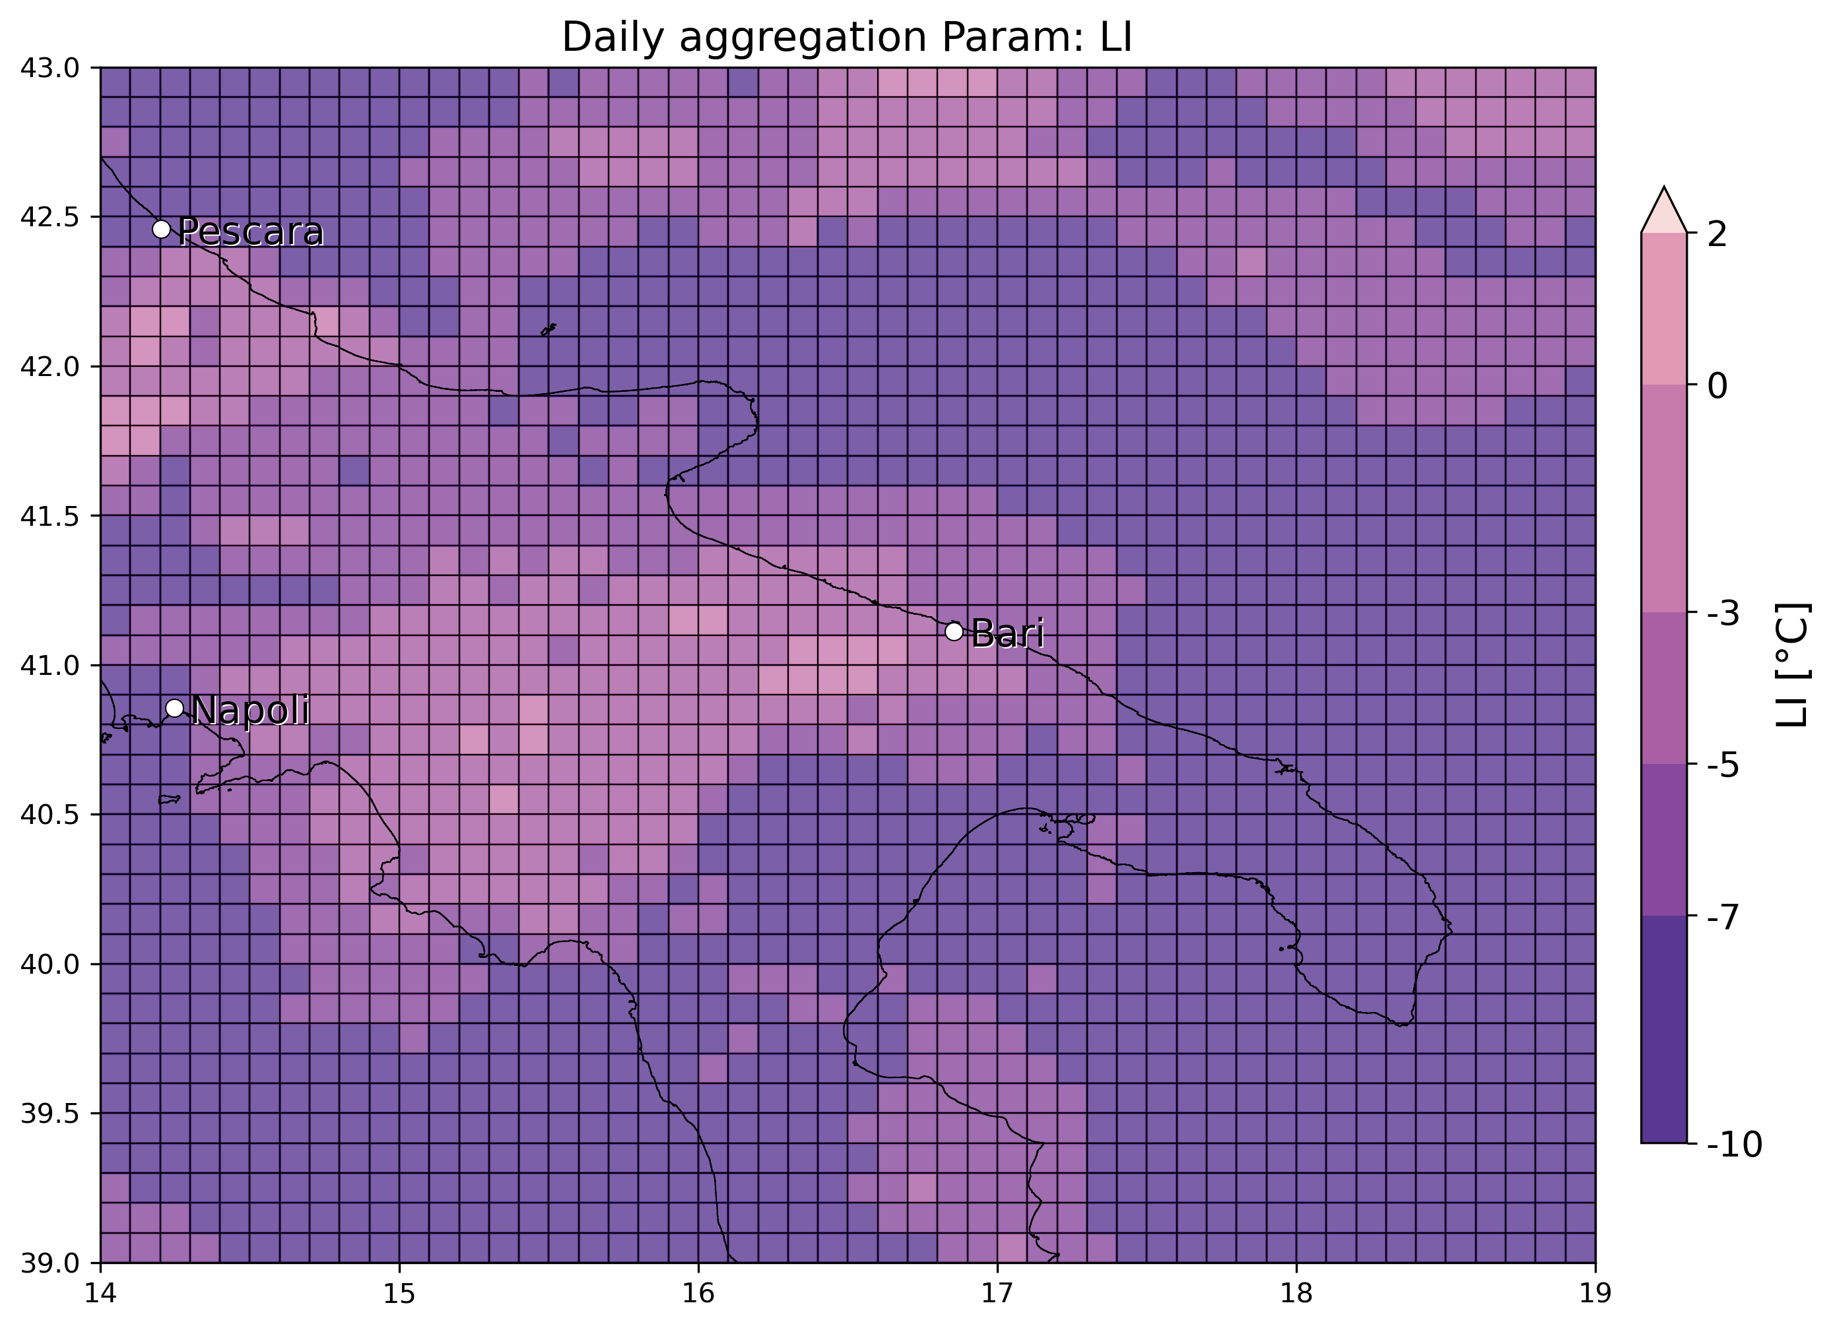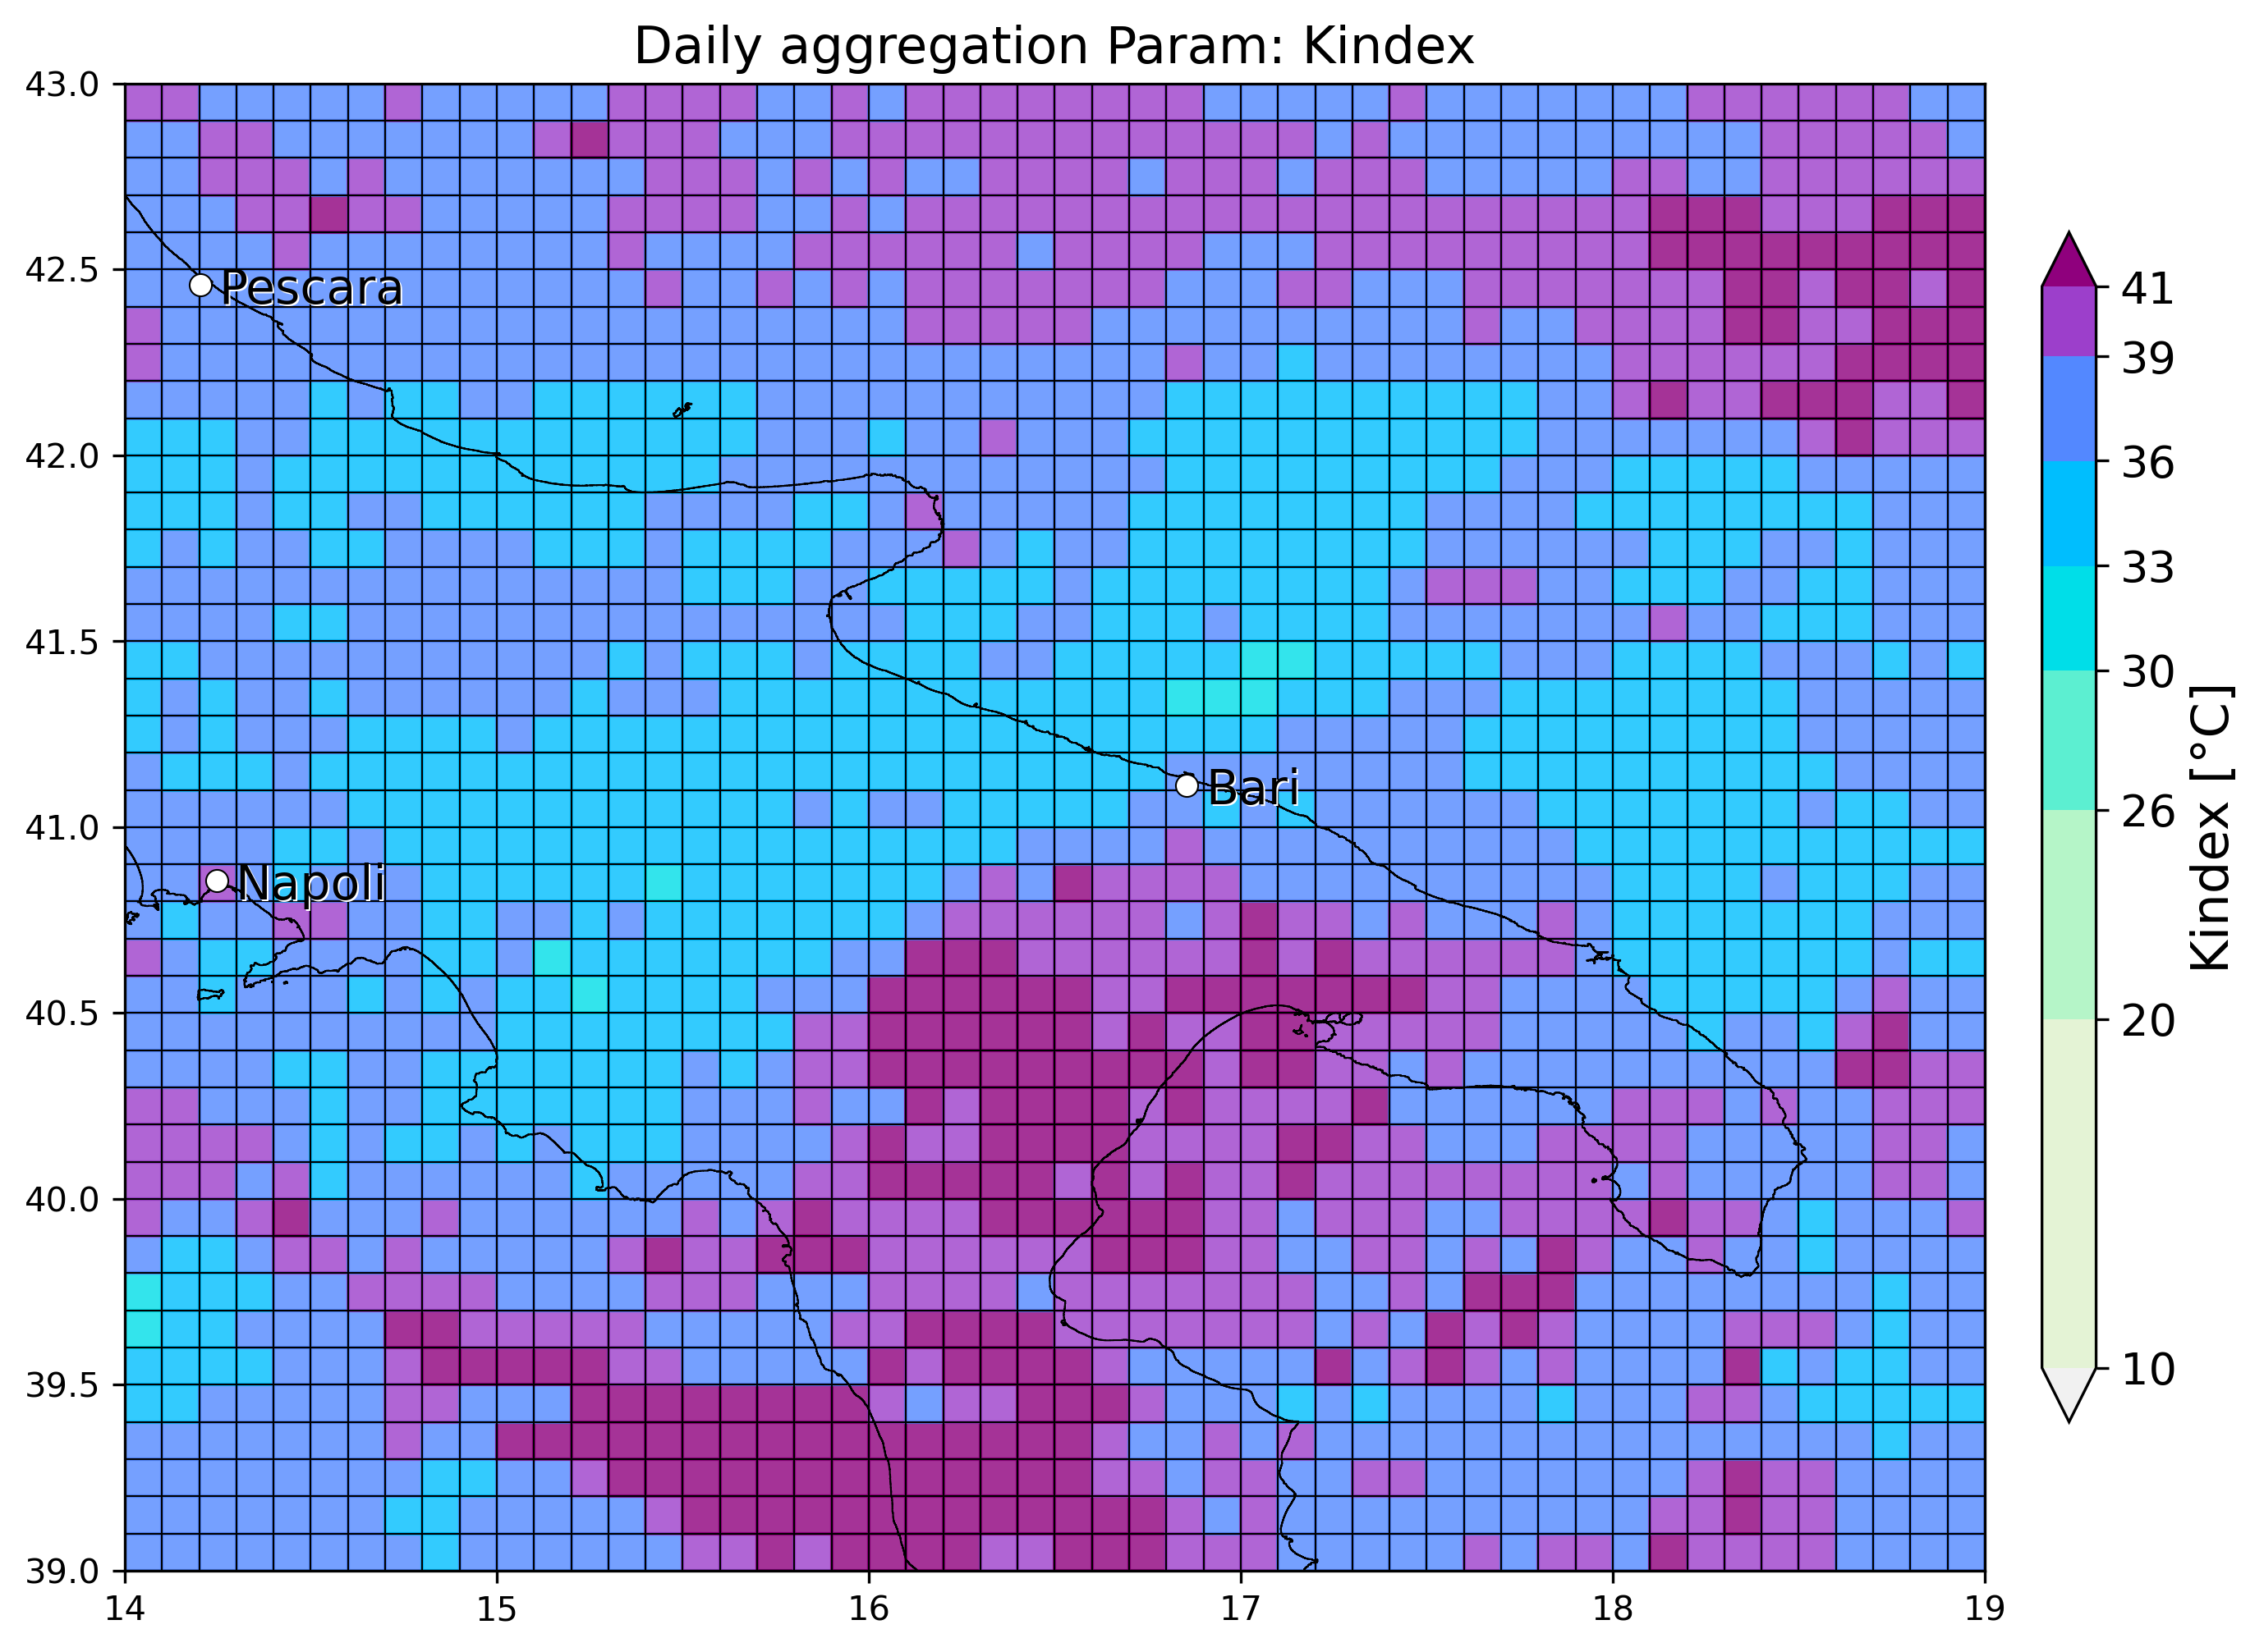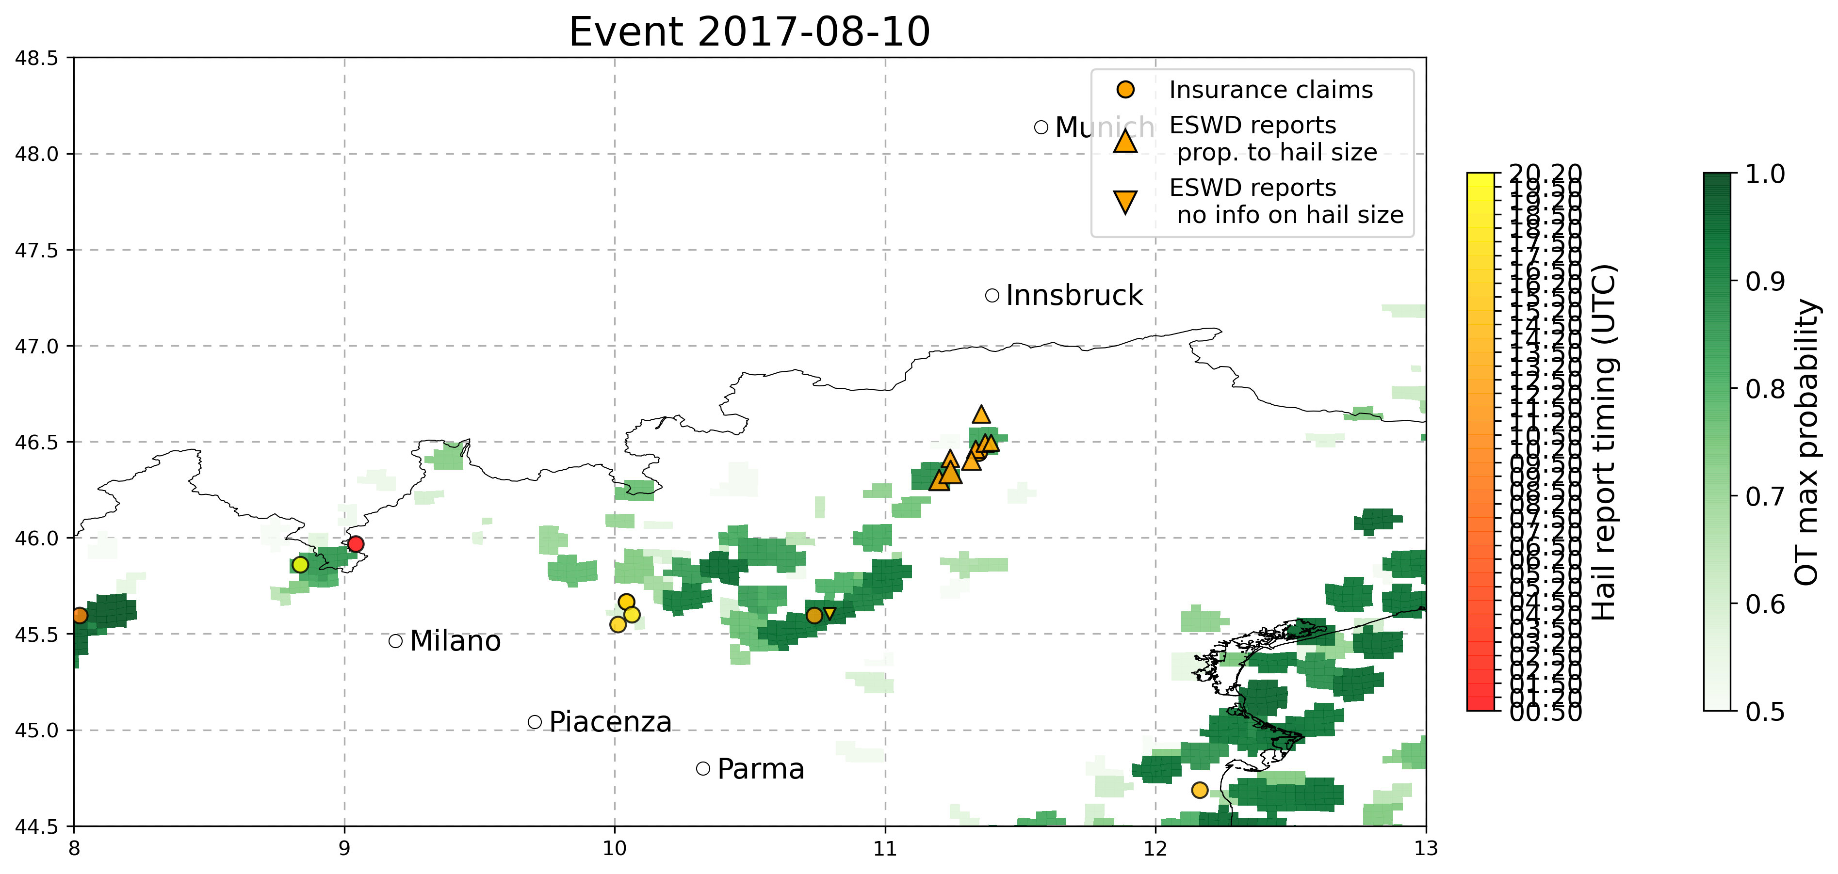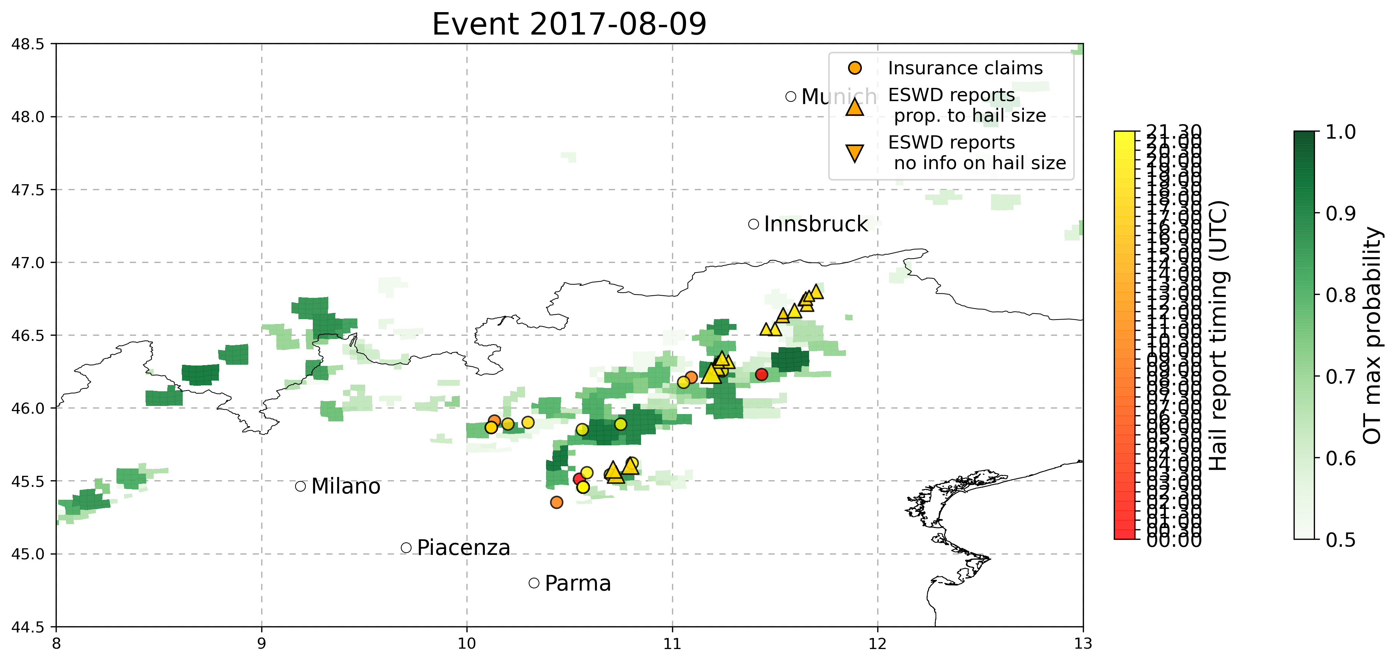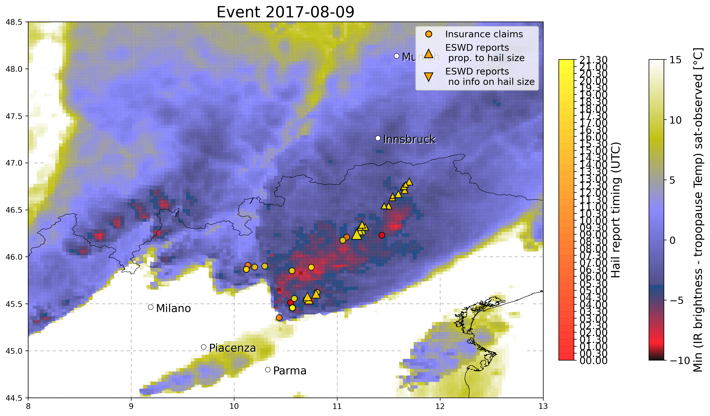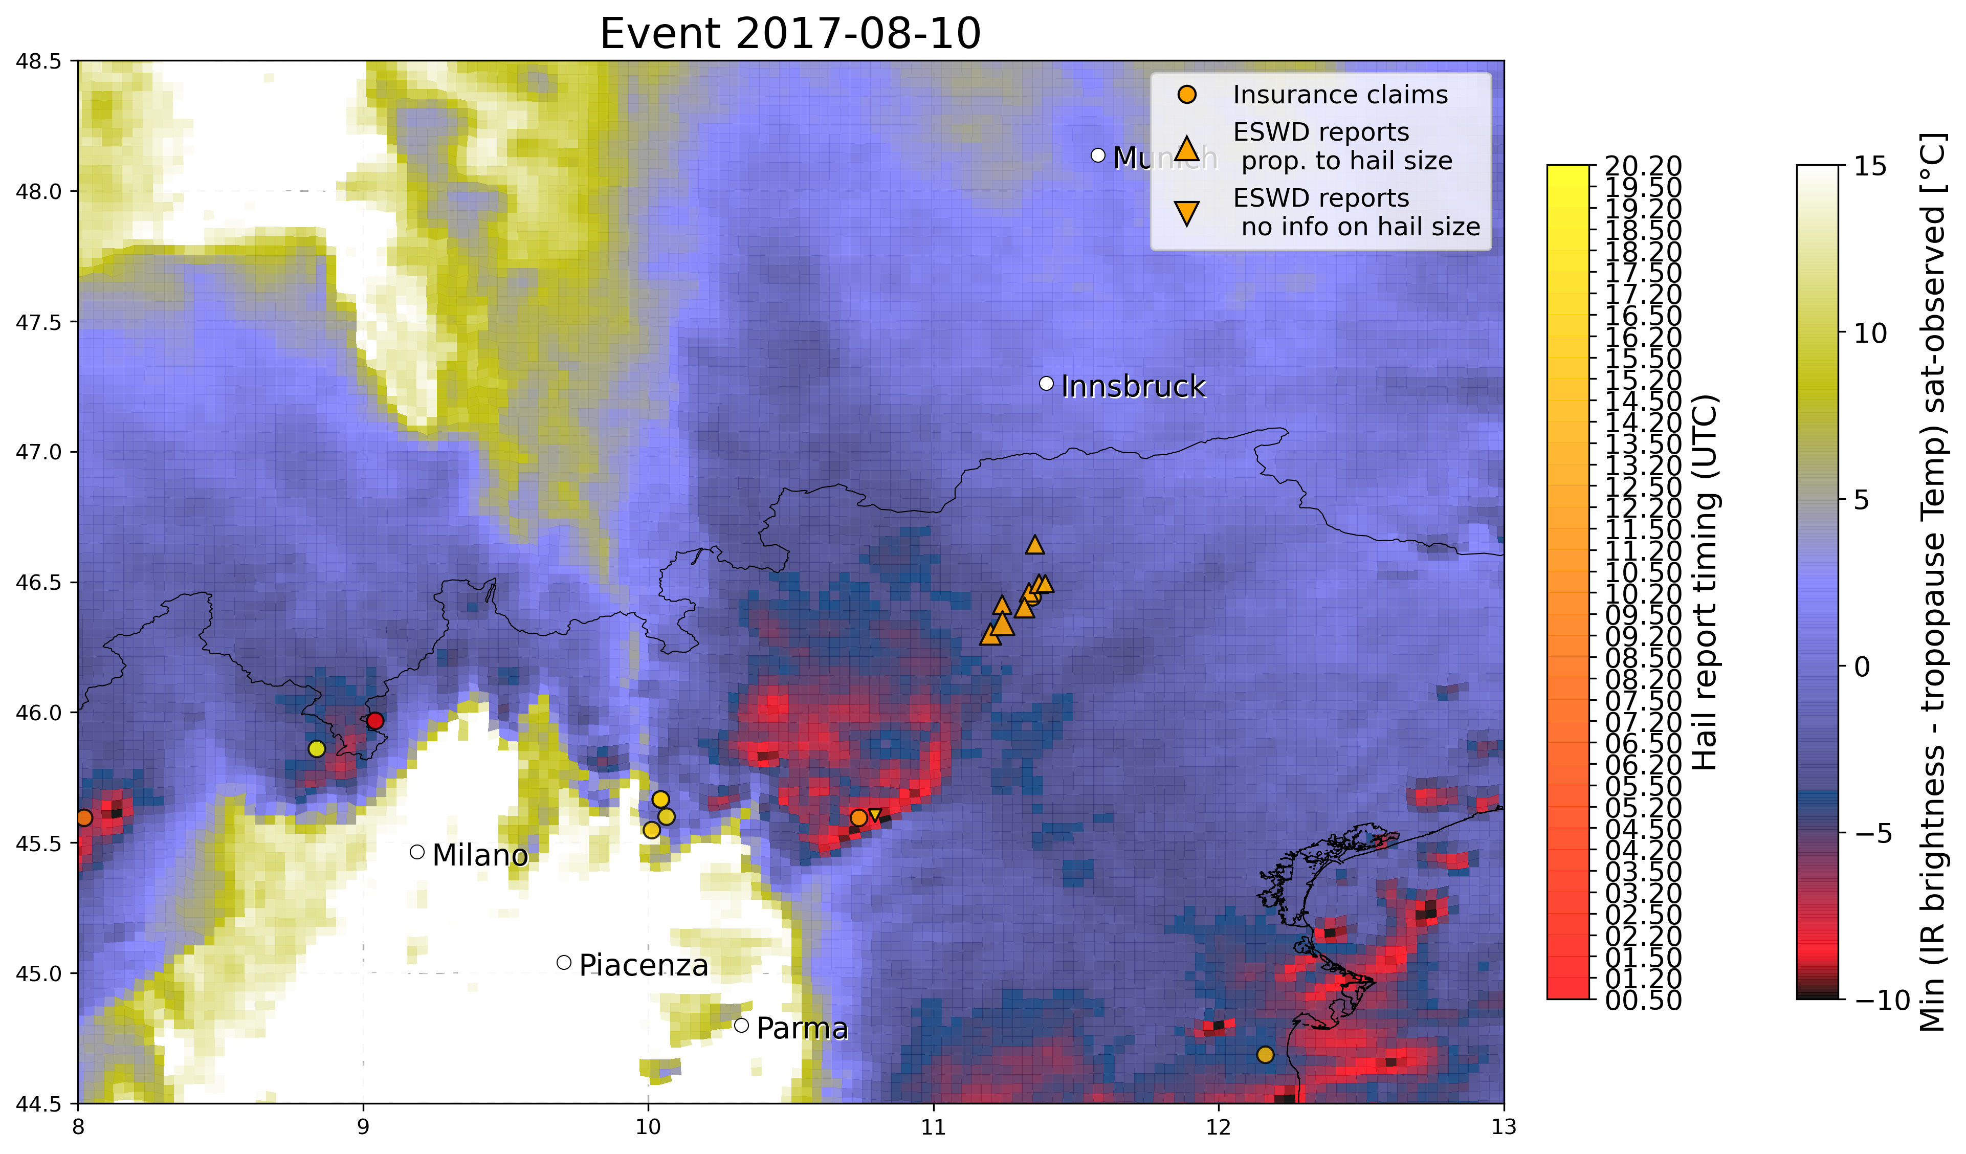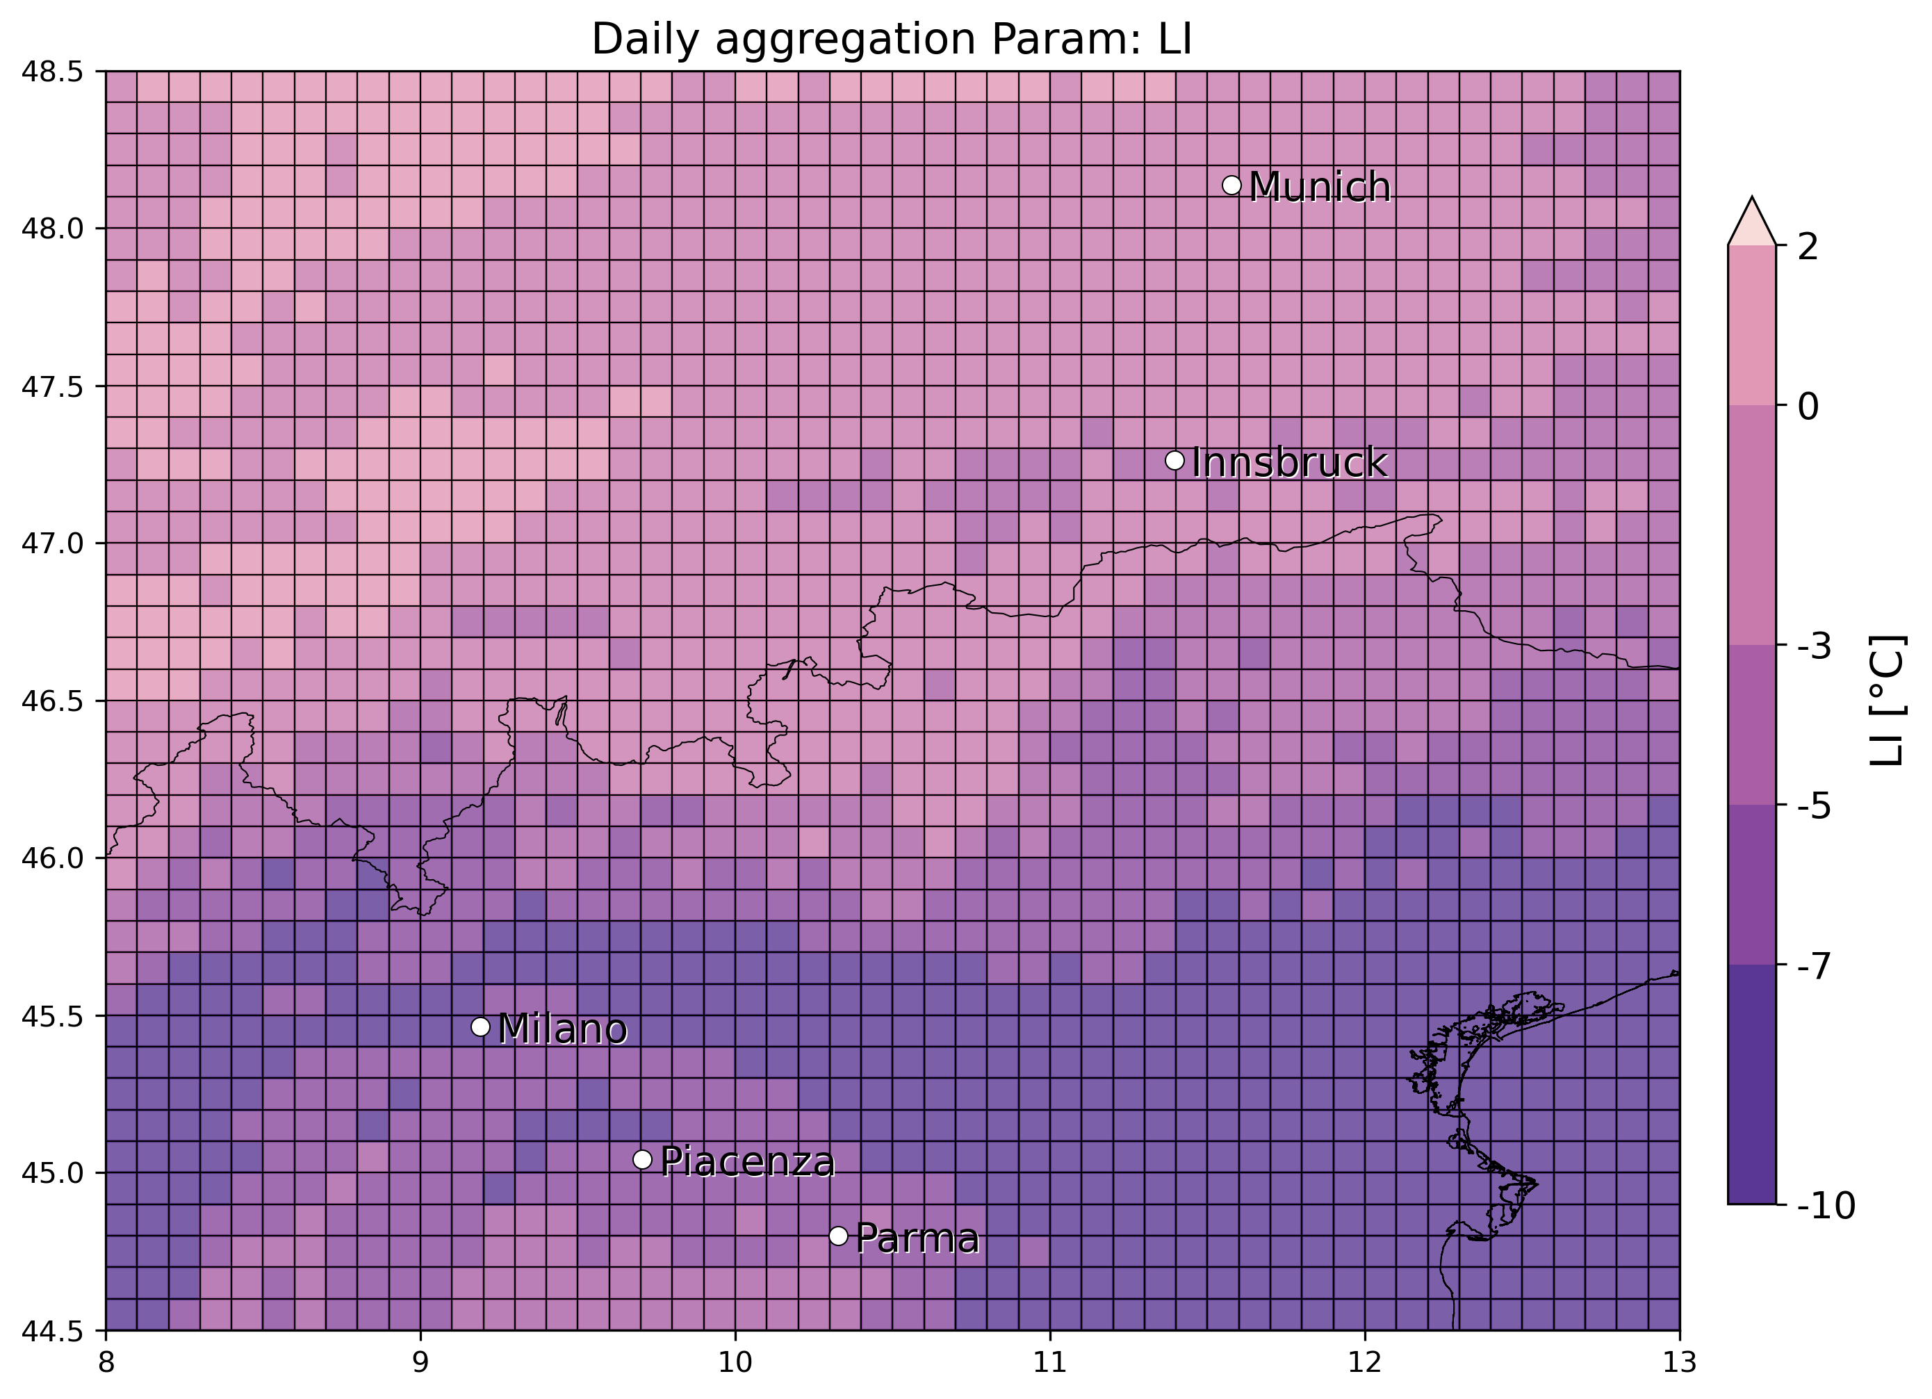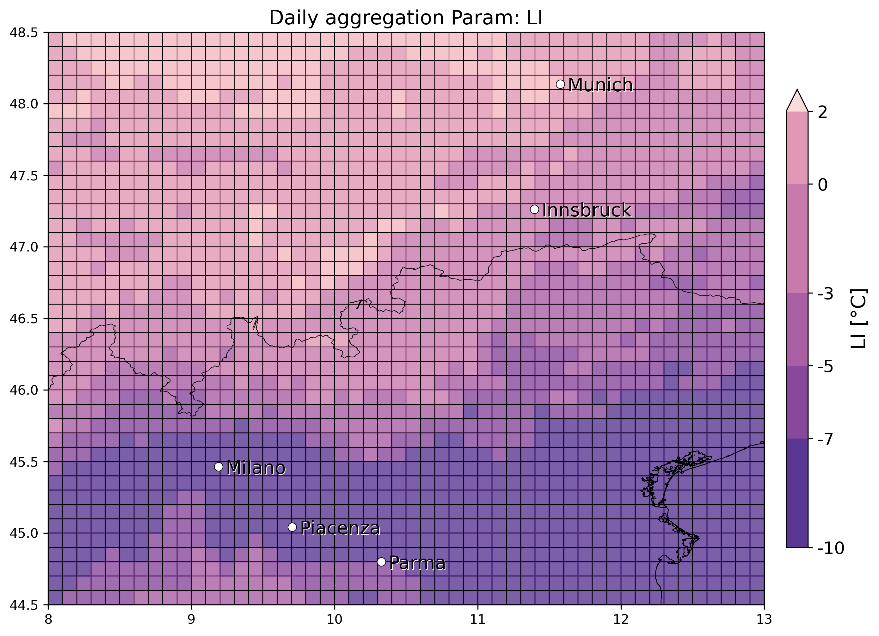

* 28 June 2017 Nord Italy (multiple hailstorms): several eswd/unipol reports in many locations, good match with OT max prob, less with OT dTmin especially for the largest hailstones reported in Vicenza, good match also with LJ index. SPHERA daily LI/Kindex min/max peaks detected in the vicinity of all the hail reports considered.

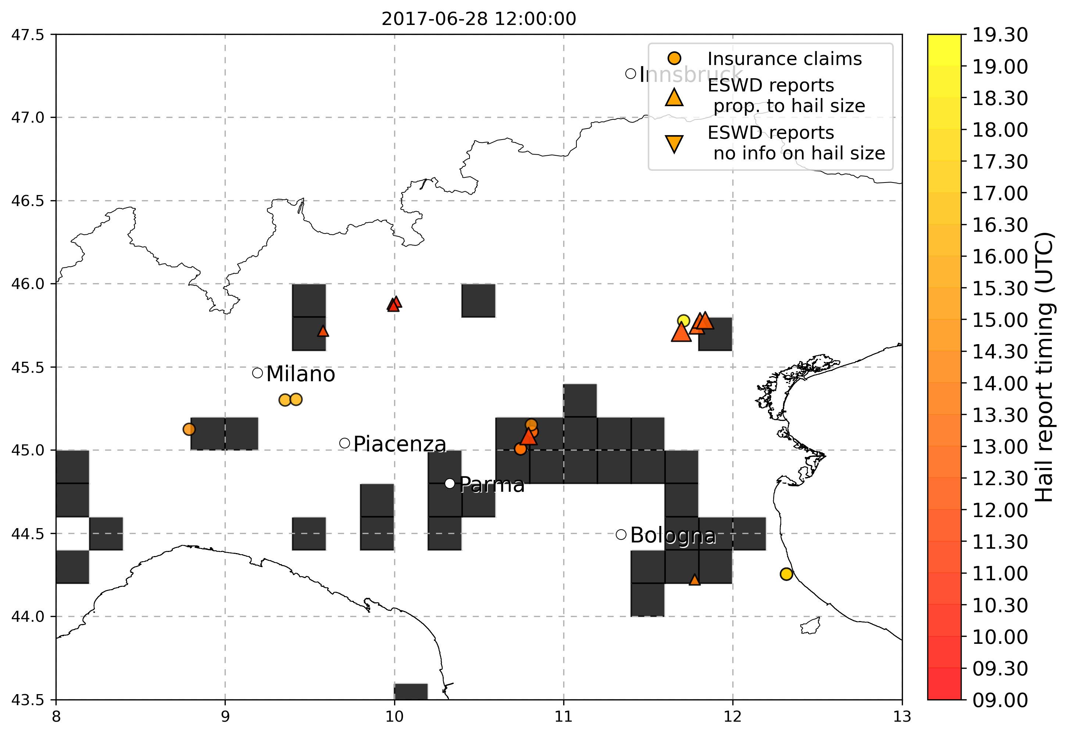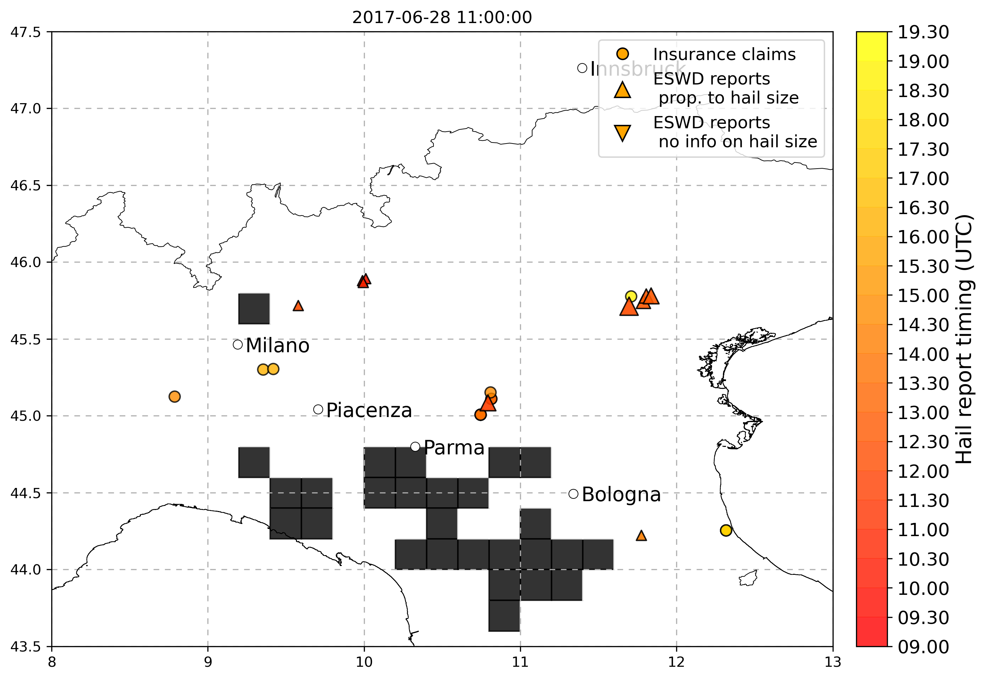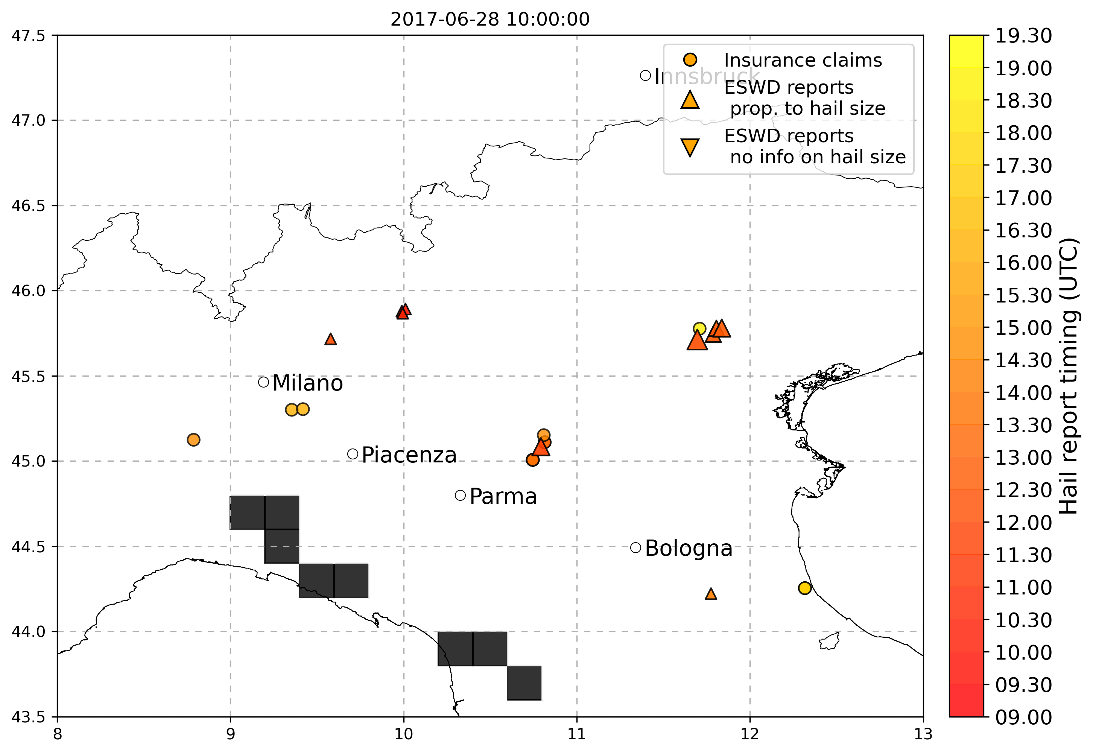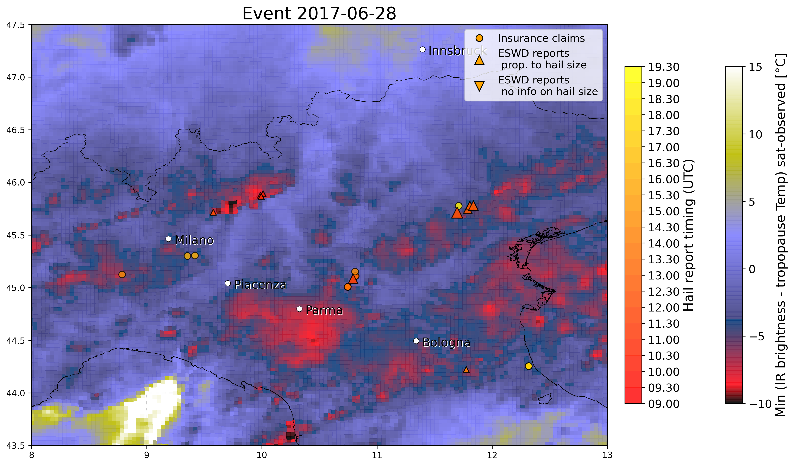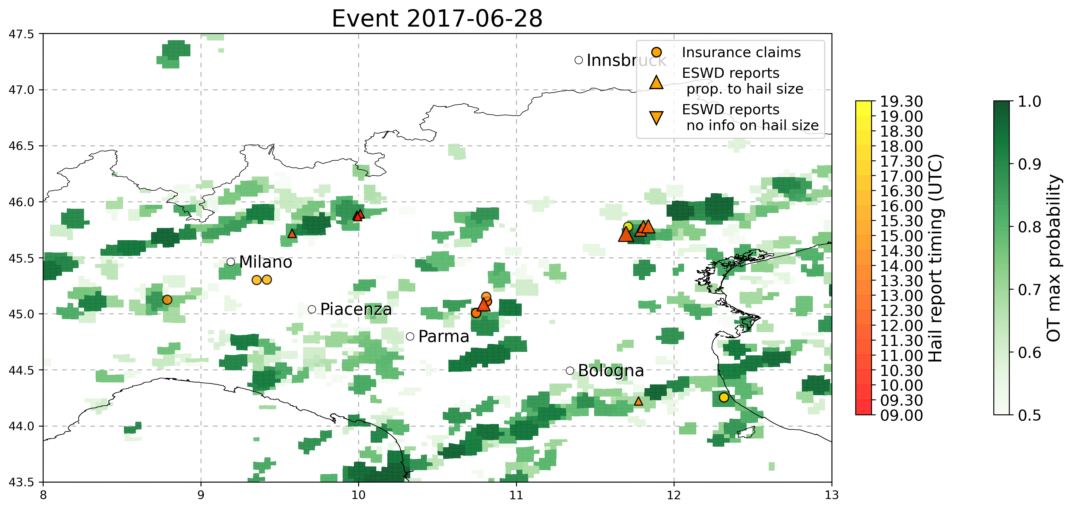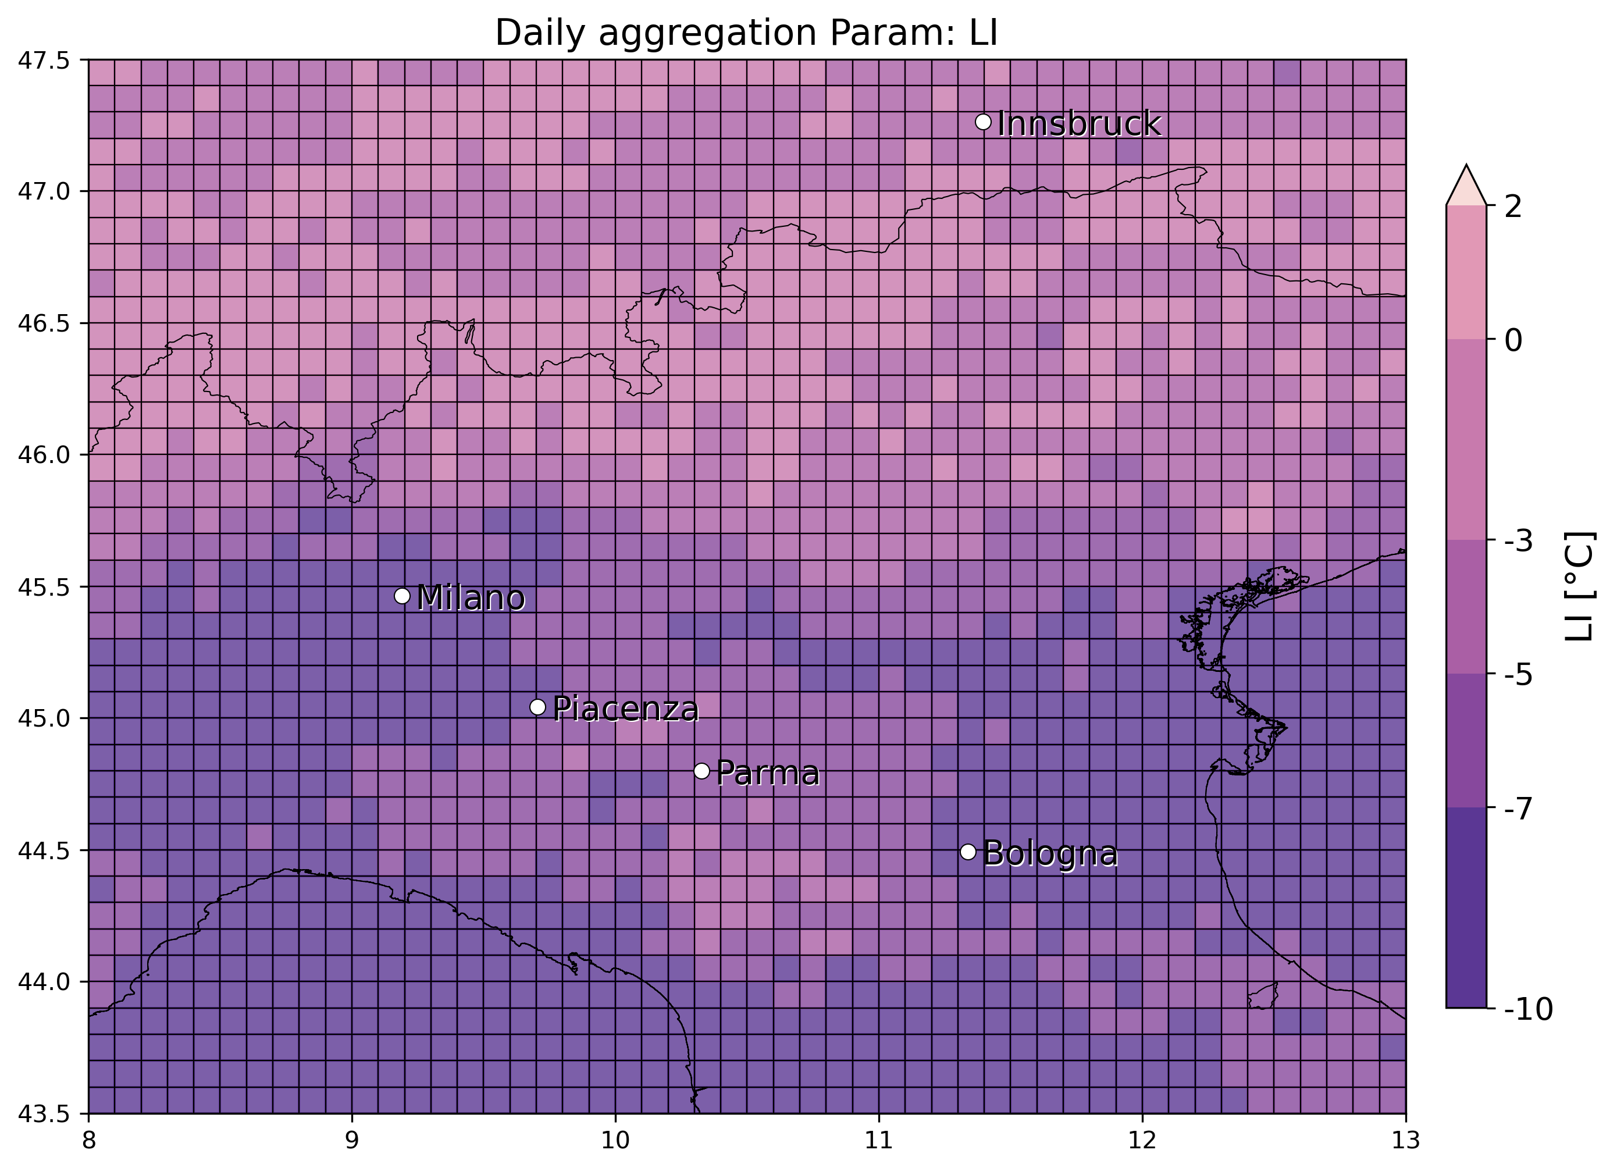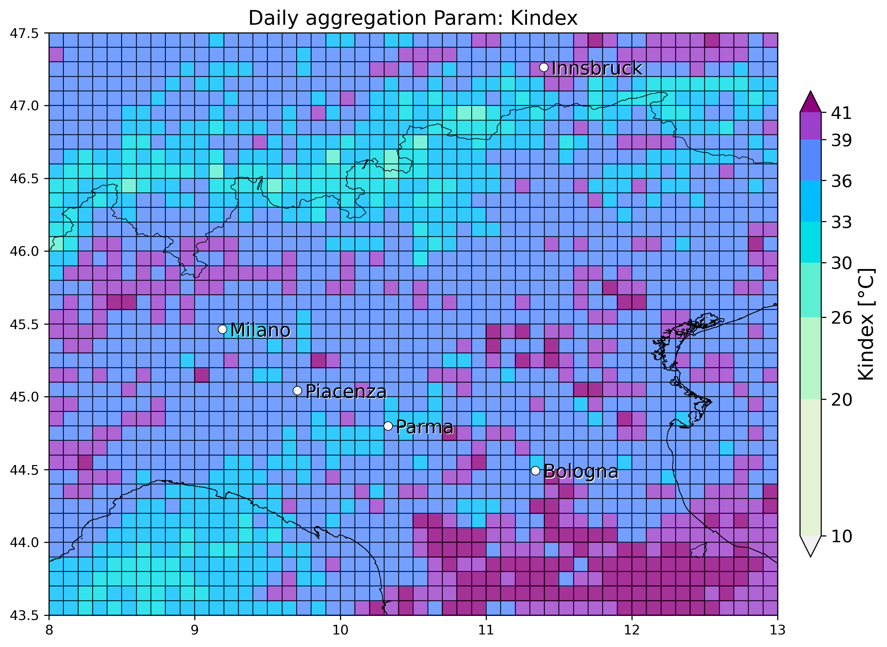

* 27 June 2017, Asti: 1 eswd (8cm) and some unipol reports, match with OT max prob and dTmin with unipol reports but miss eswd one, while very good agreement with LJ index. SPHERA reports a blob in LI/Kindex min/max daily values associated to the event, with significant match withKindex near the event location

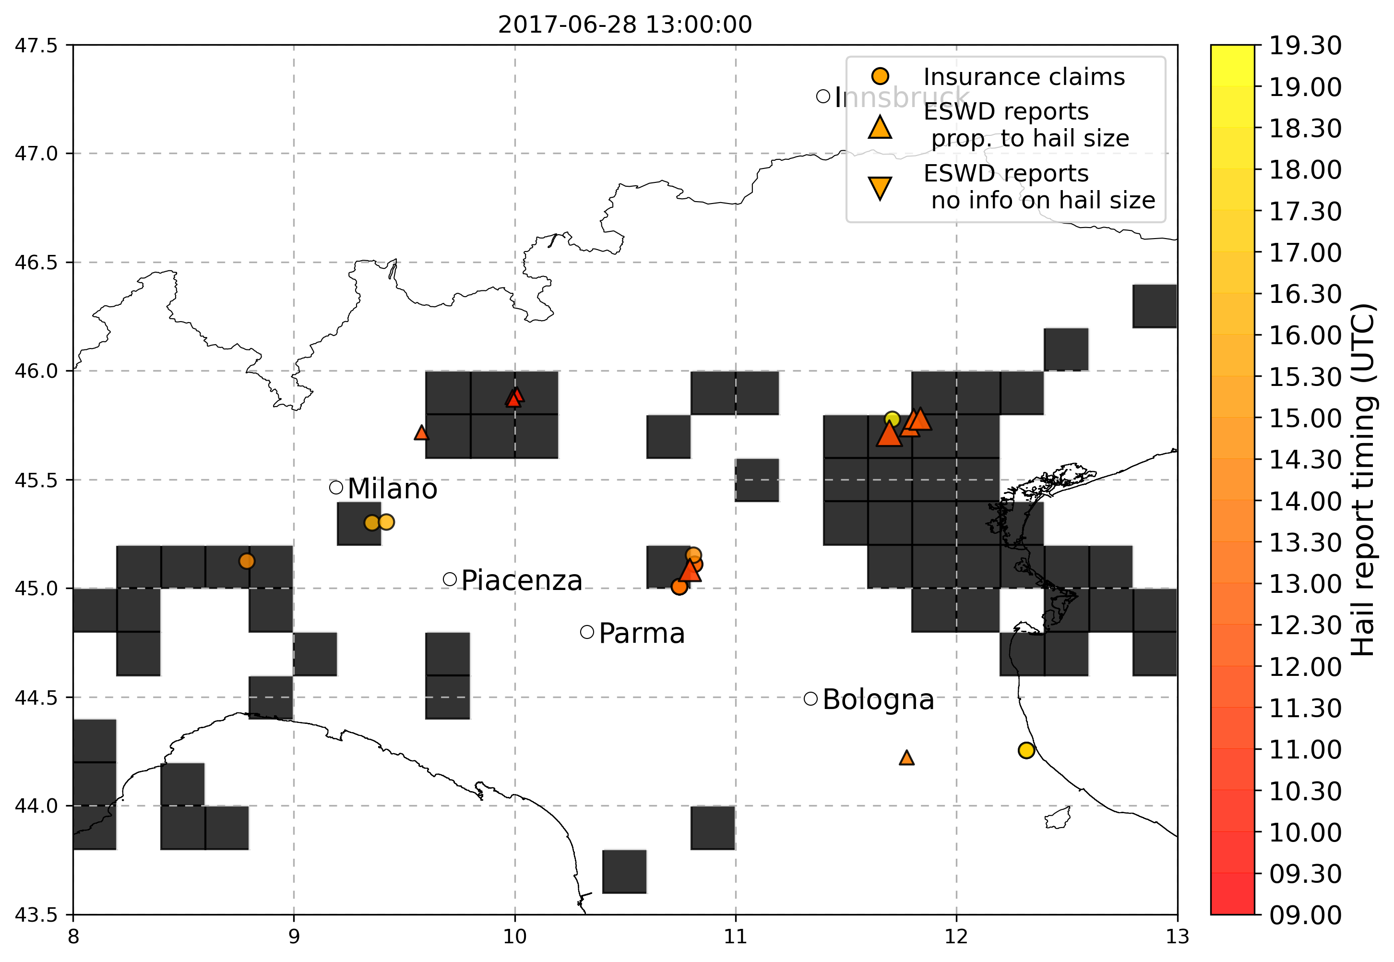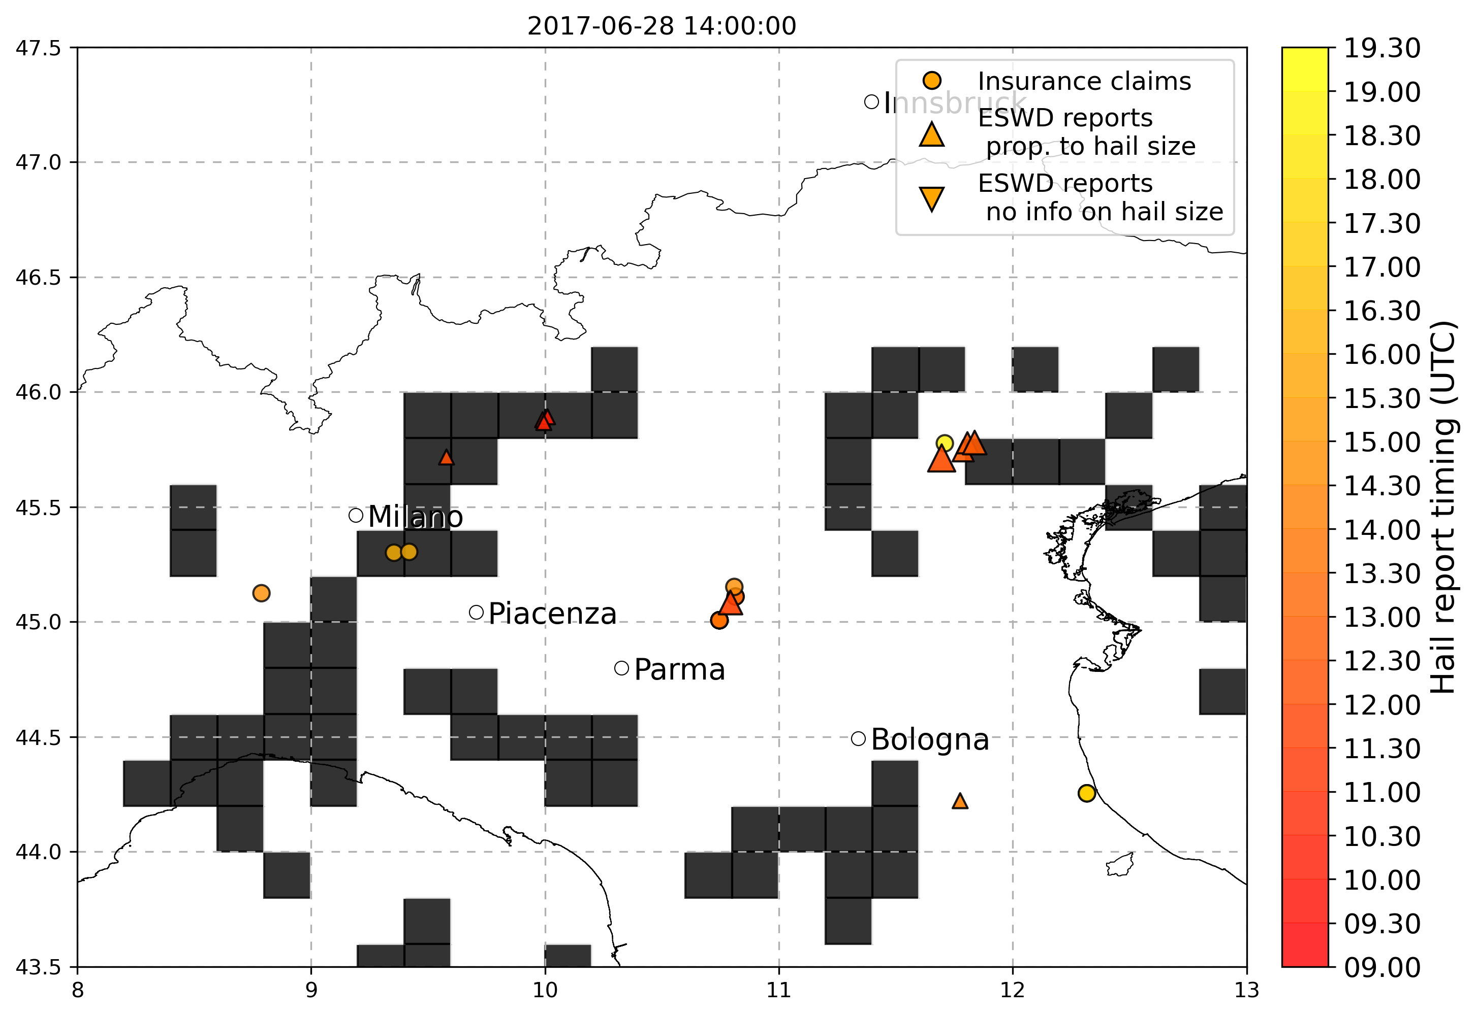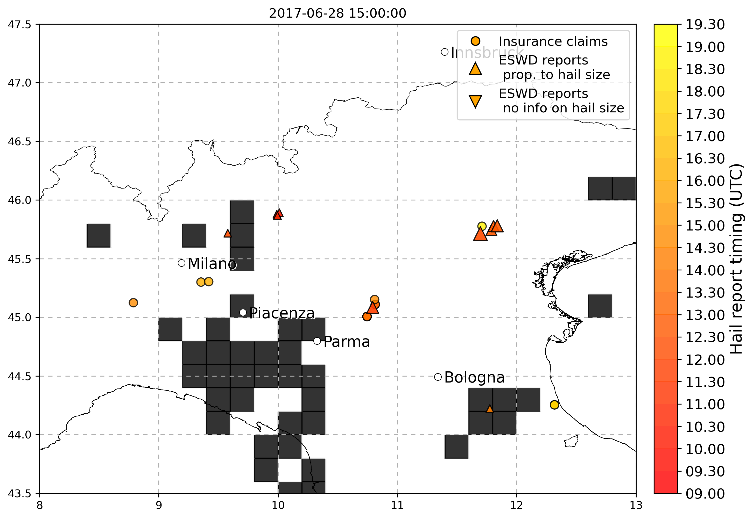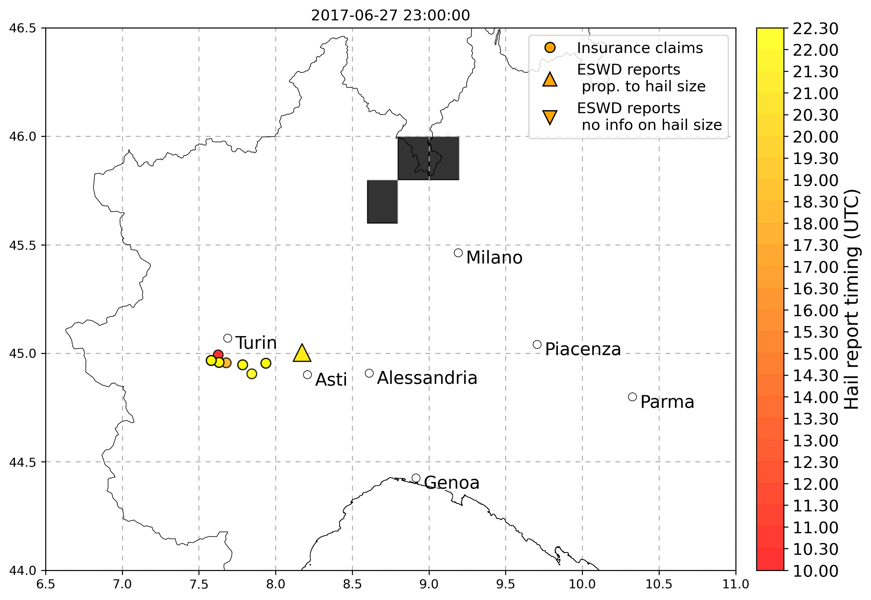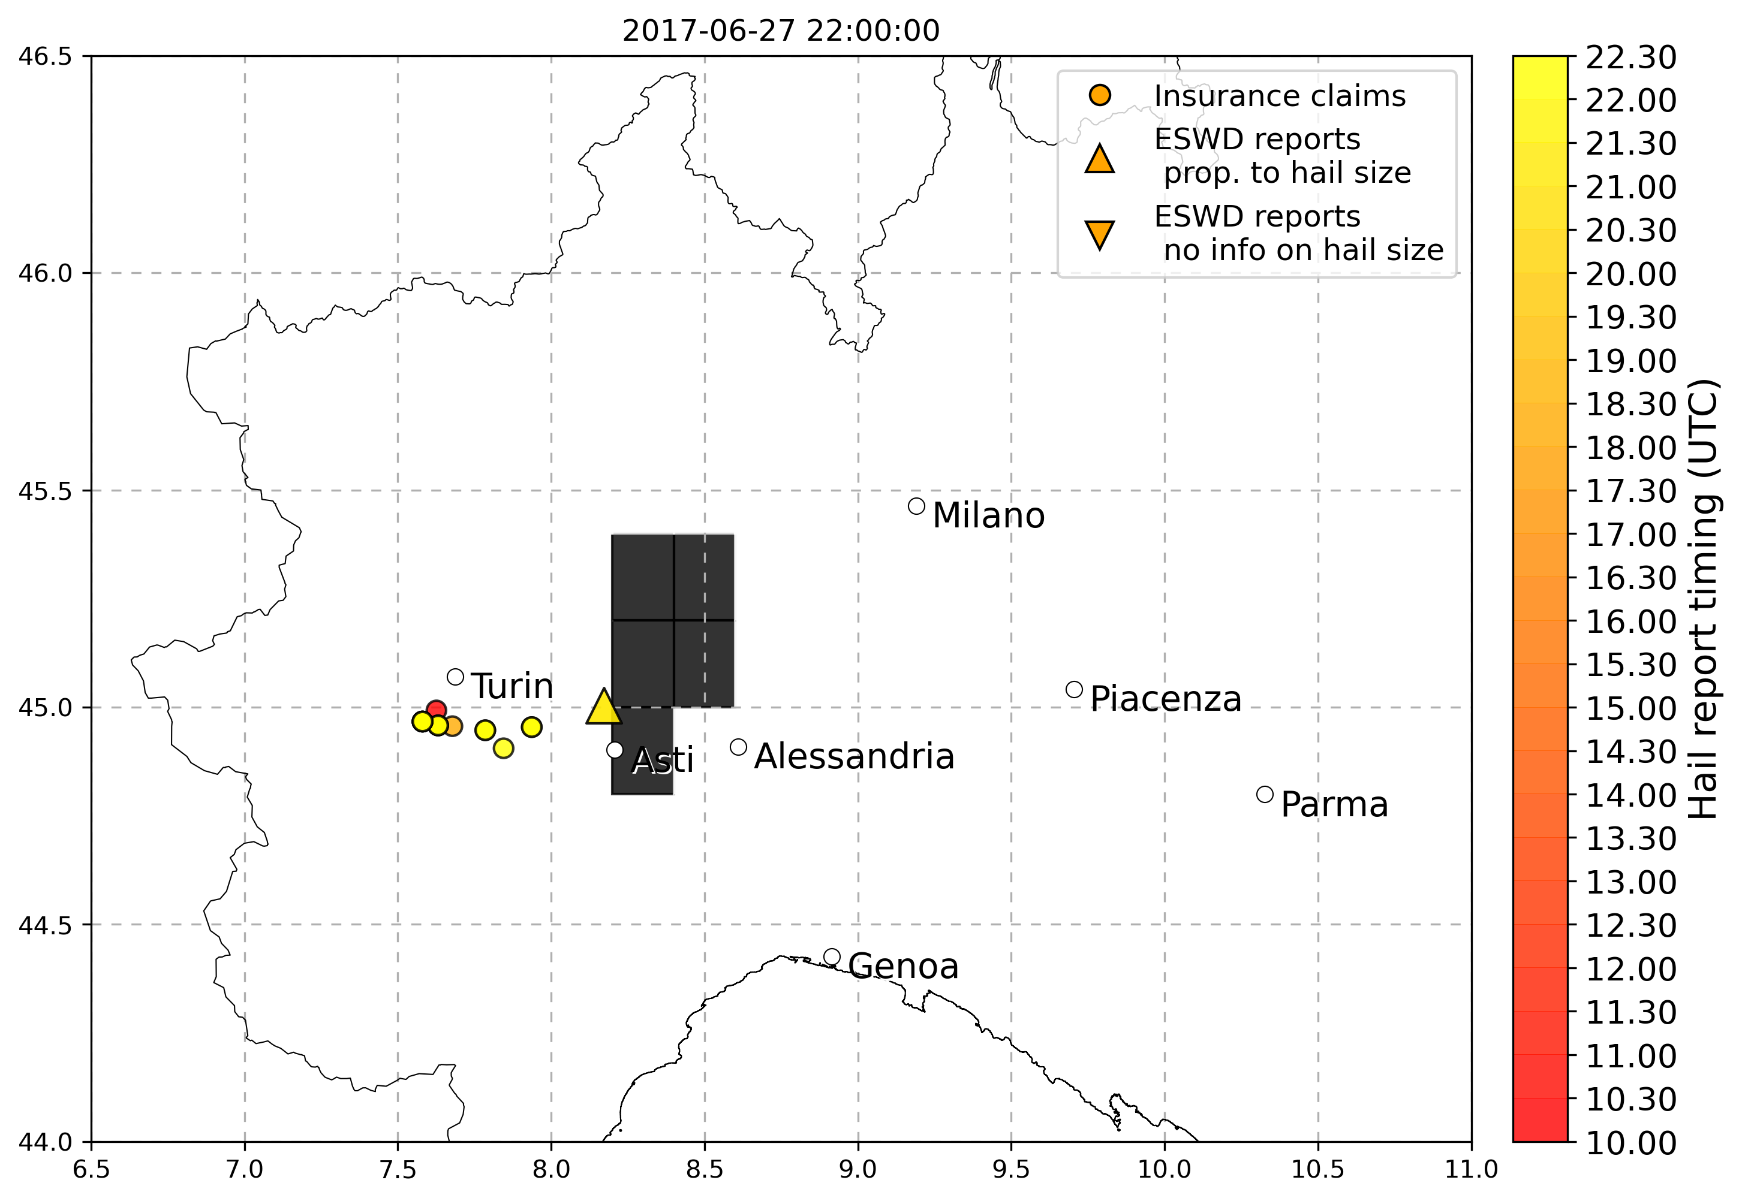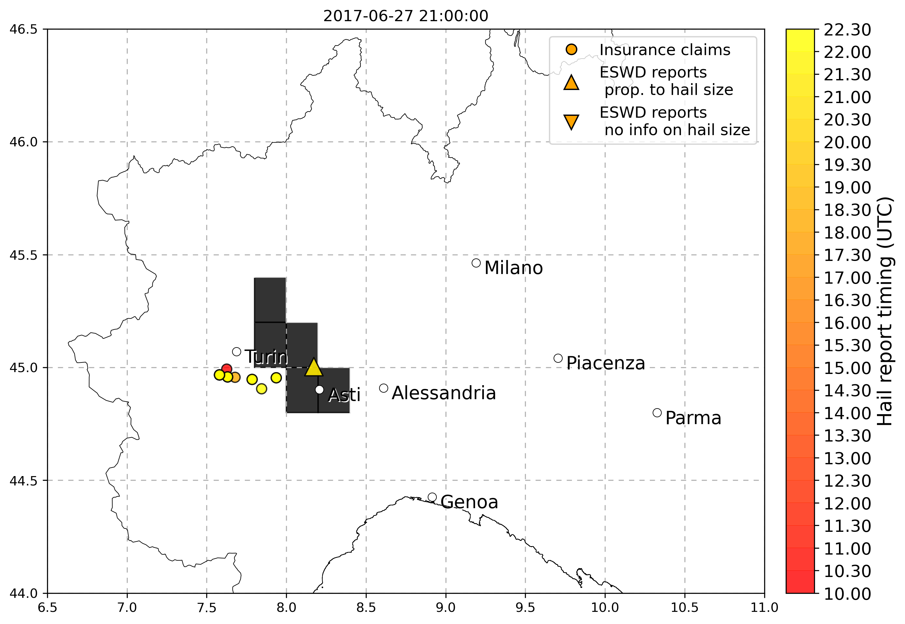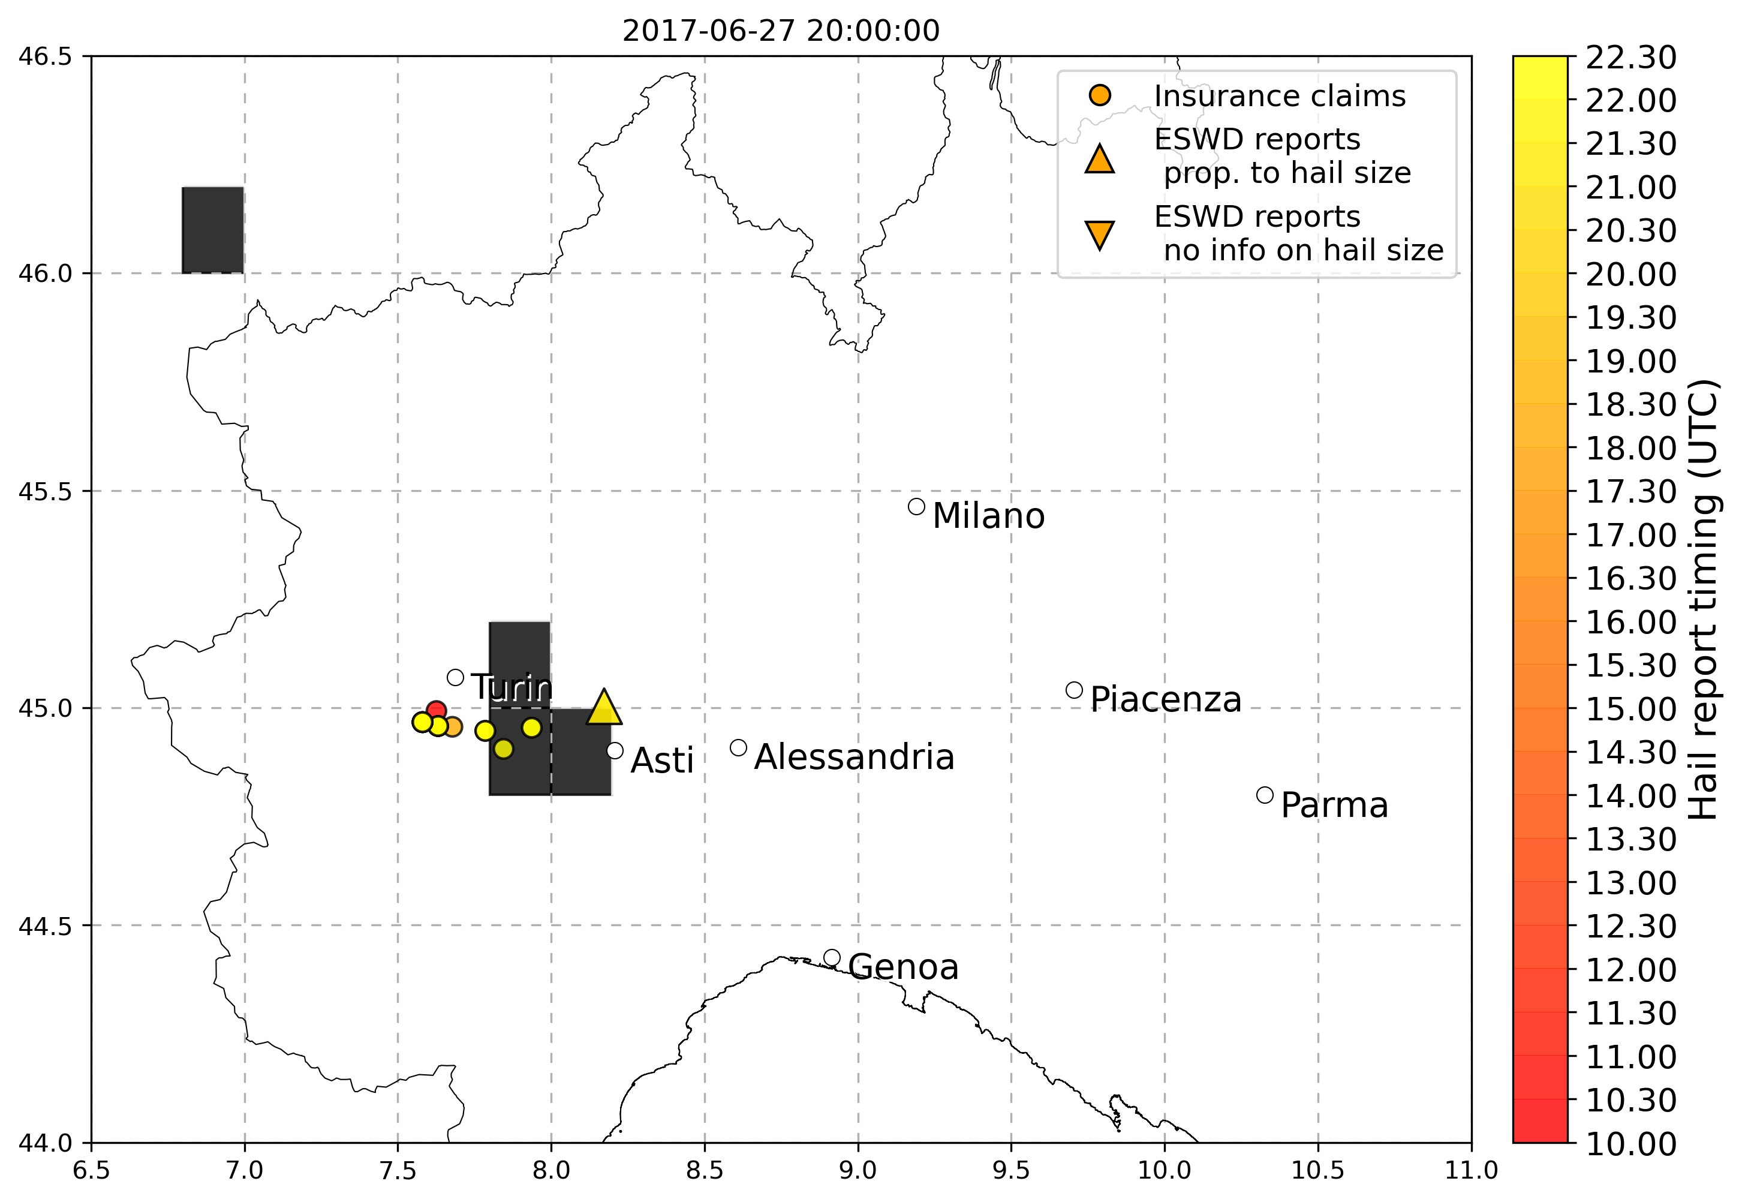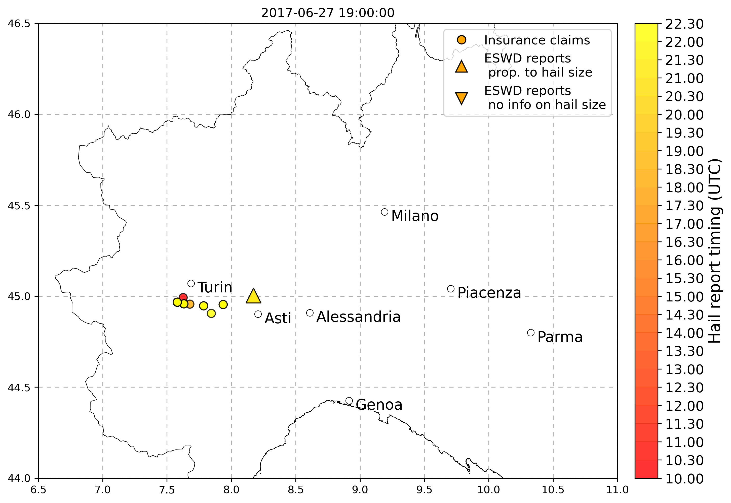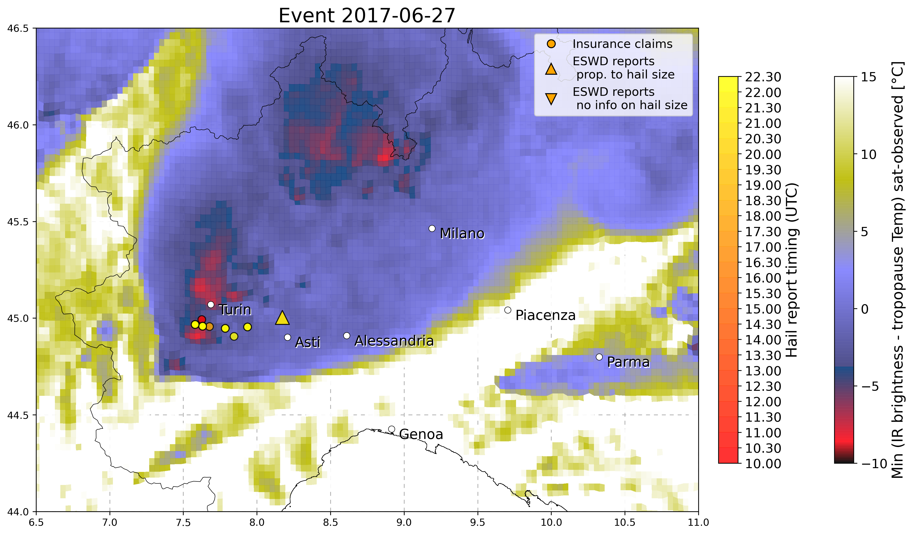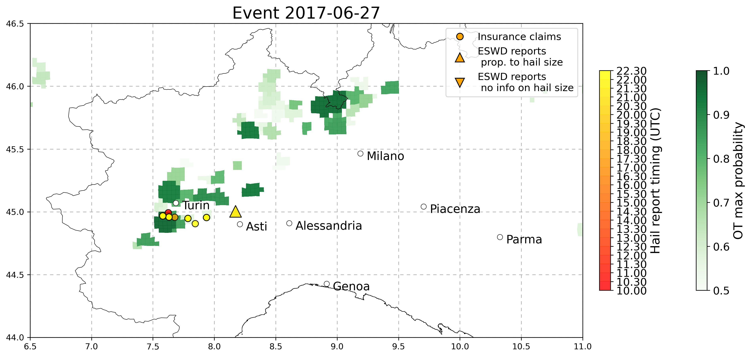

* 25 June 2017 Nord-Est Italy IS MISSING HERE! CHECK PLOTS (or hourly-based event later)

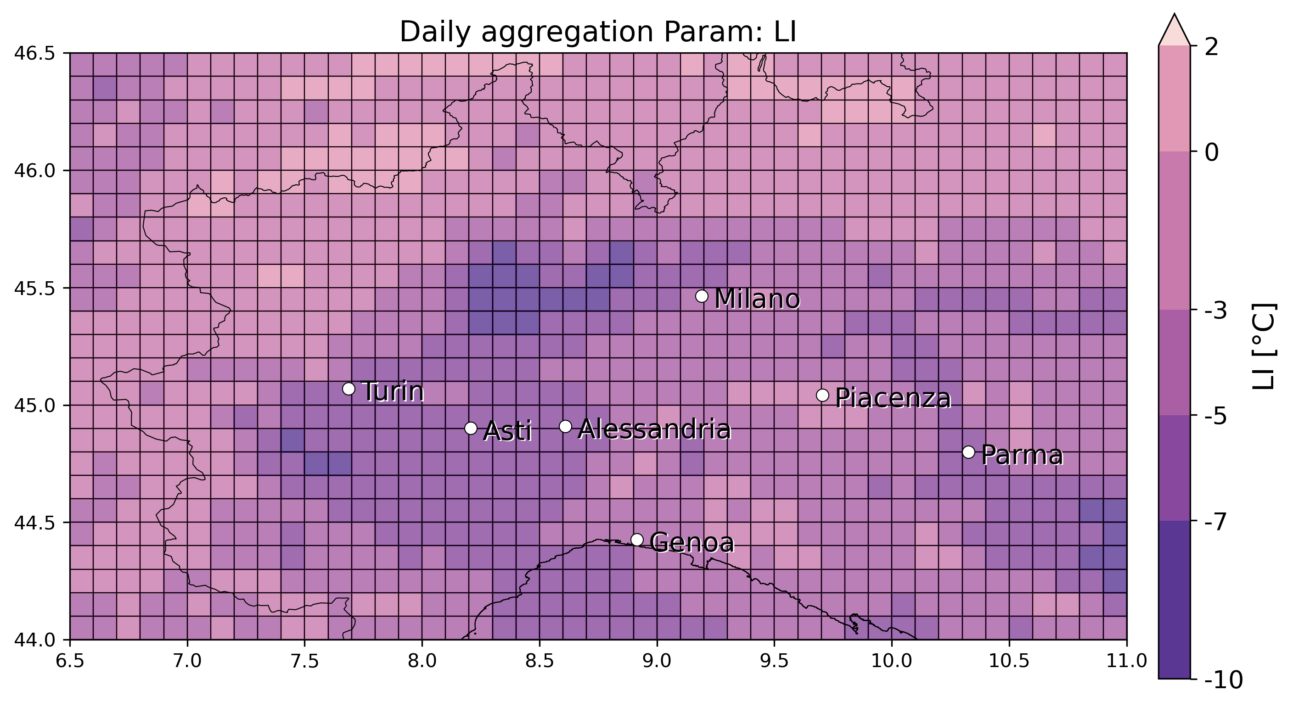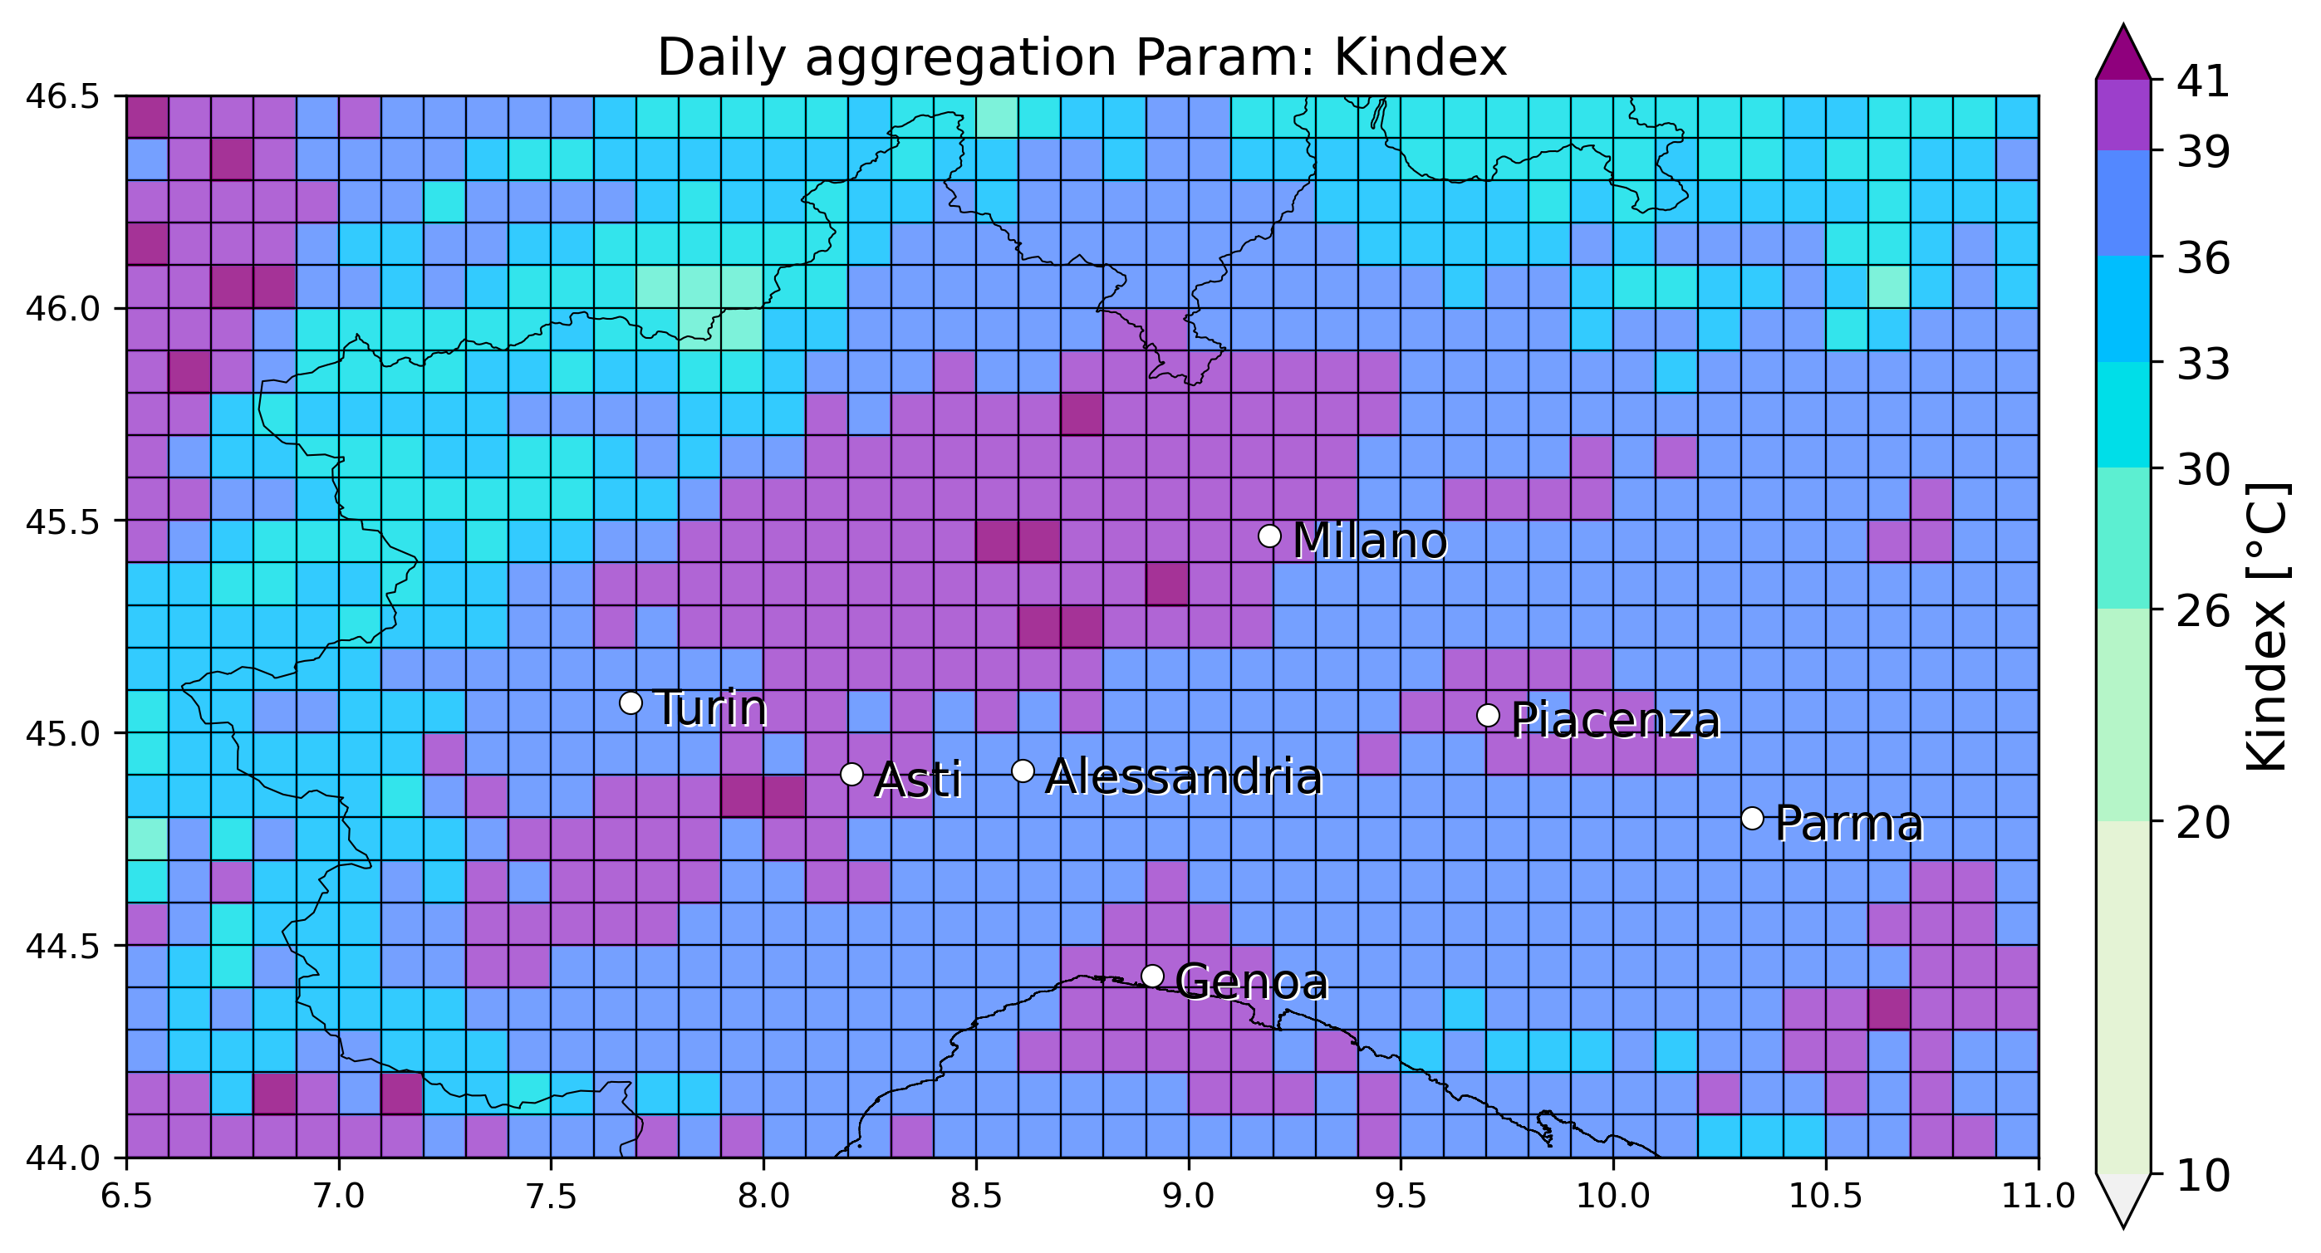

* 14 May 2017: Veneto-Emilia Romagna: multiple eswd reports (19.30), matching with OT detection, also LJ index match very well (the one issued in the range 19-20 (named “20” in LJ title)), a minimum <-5°C in SLI is also detected in the zone

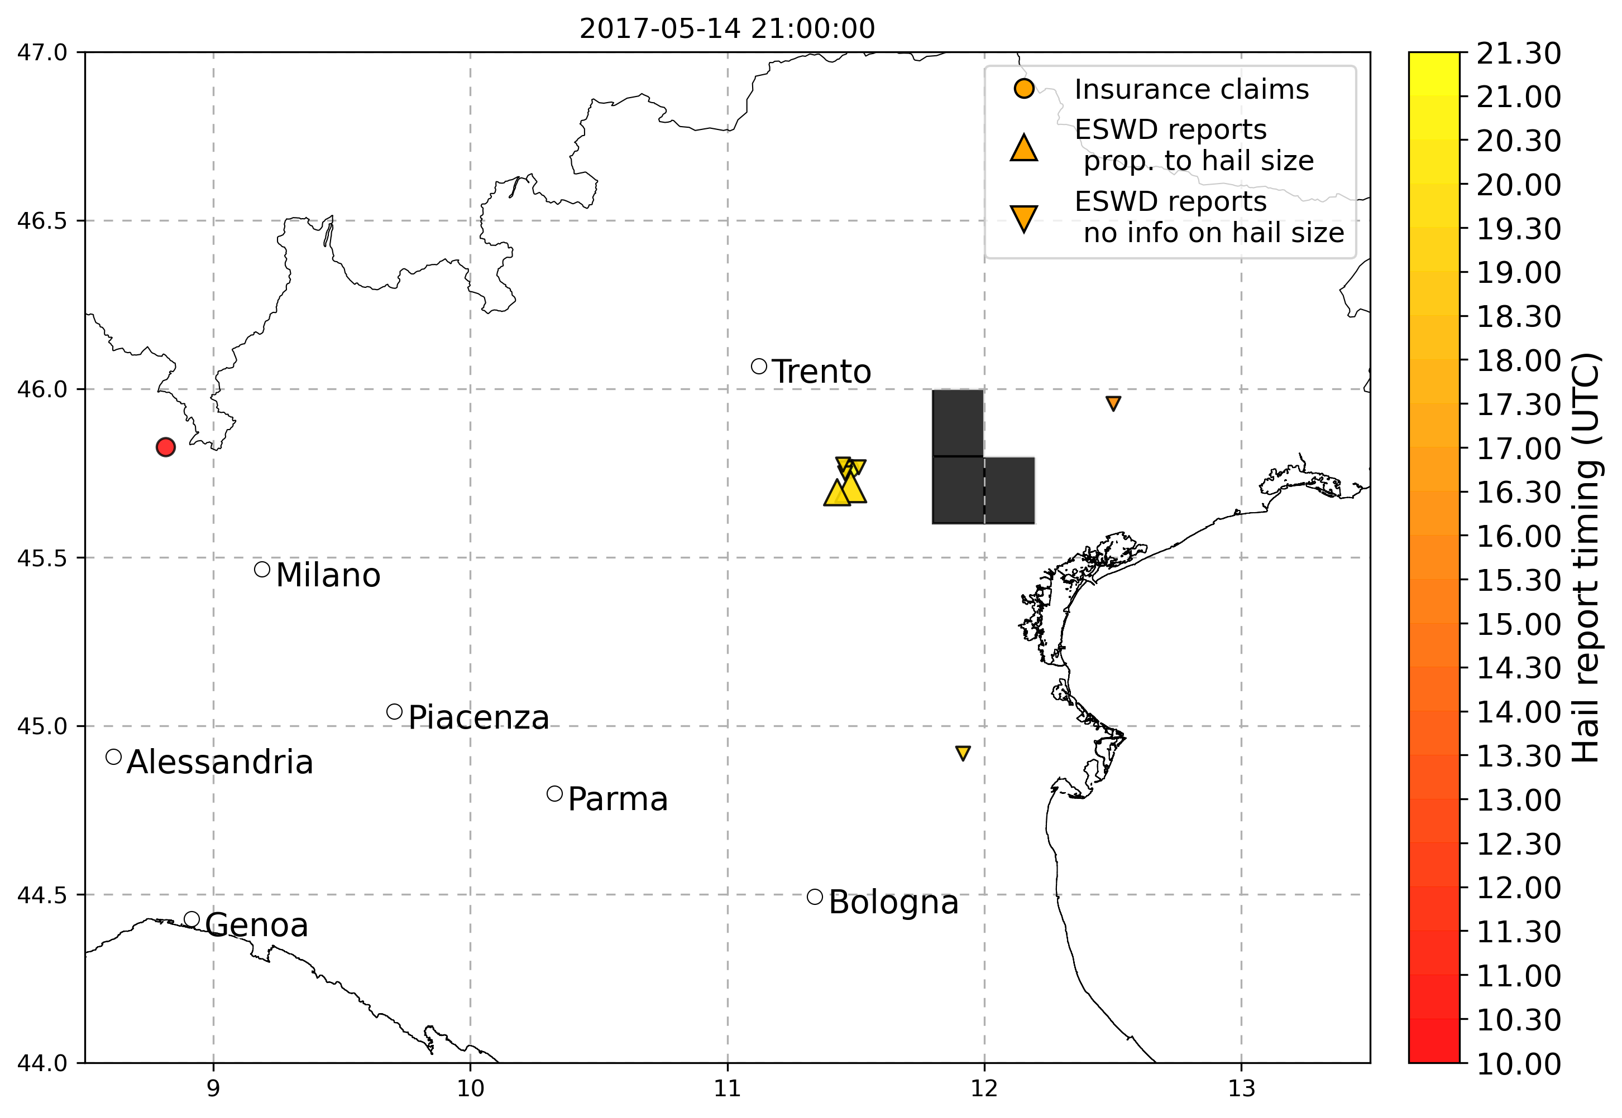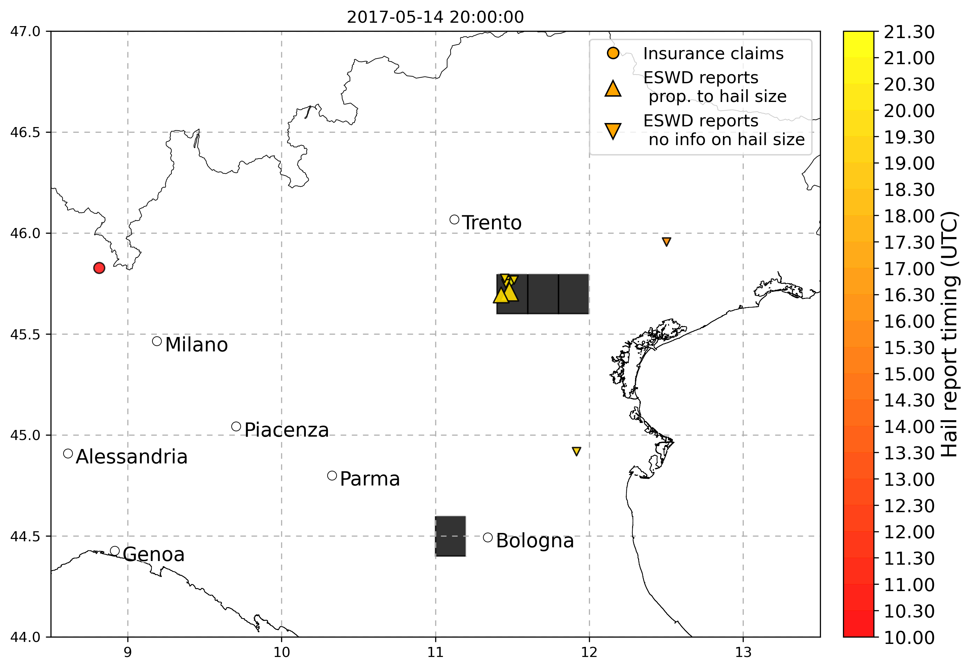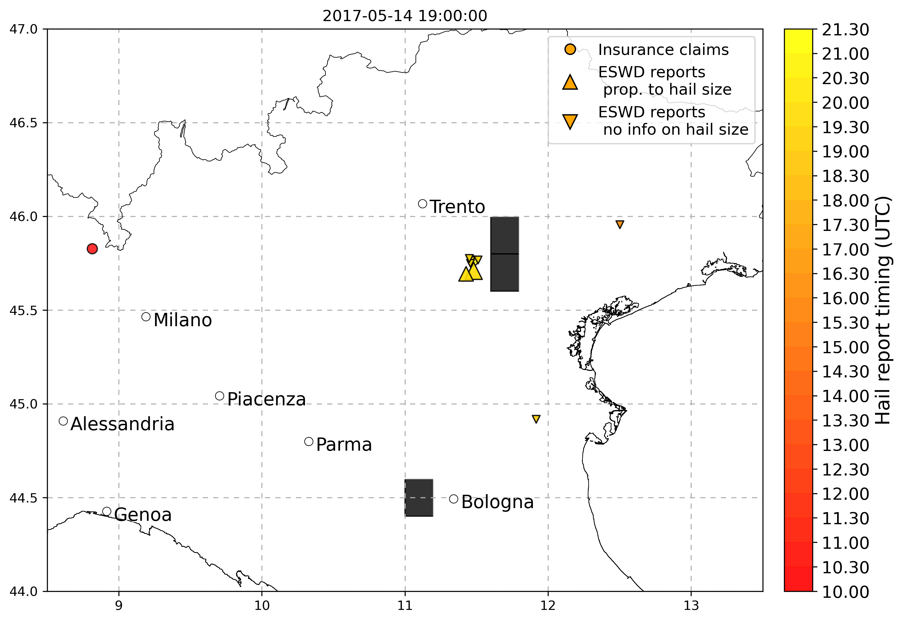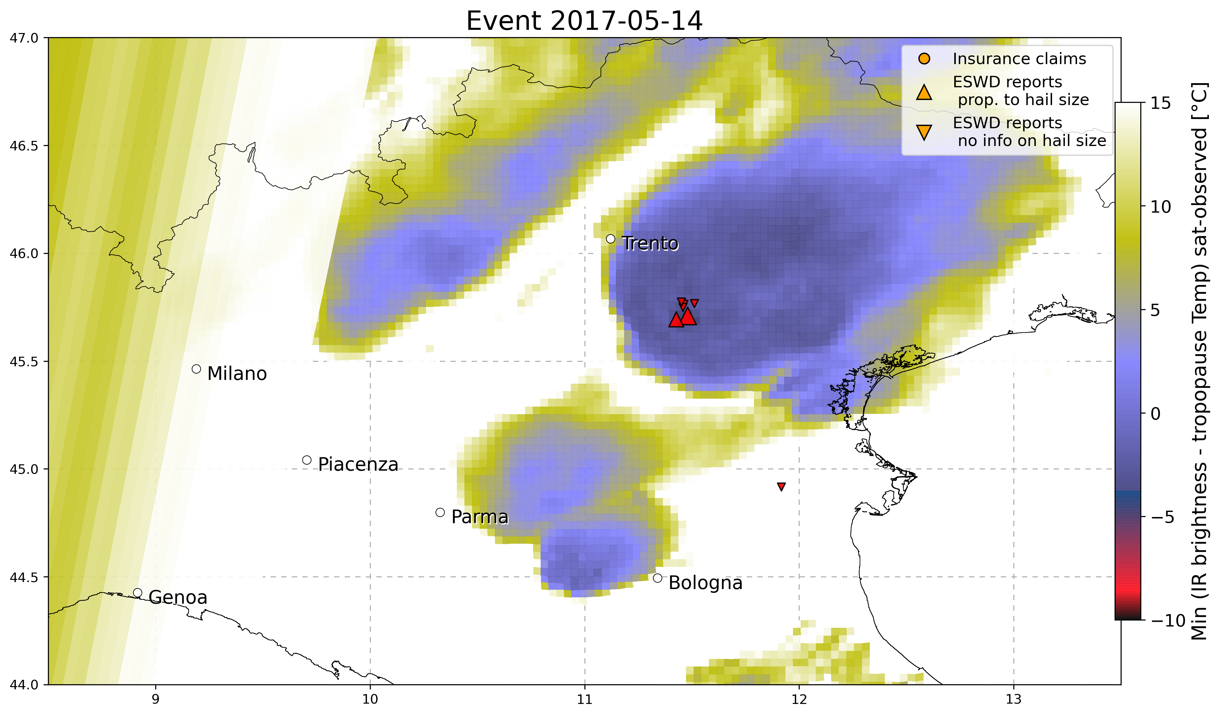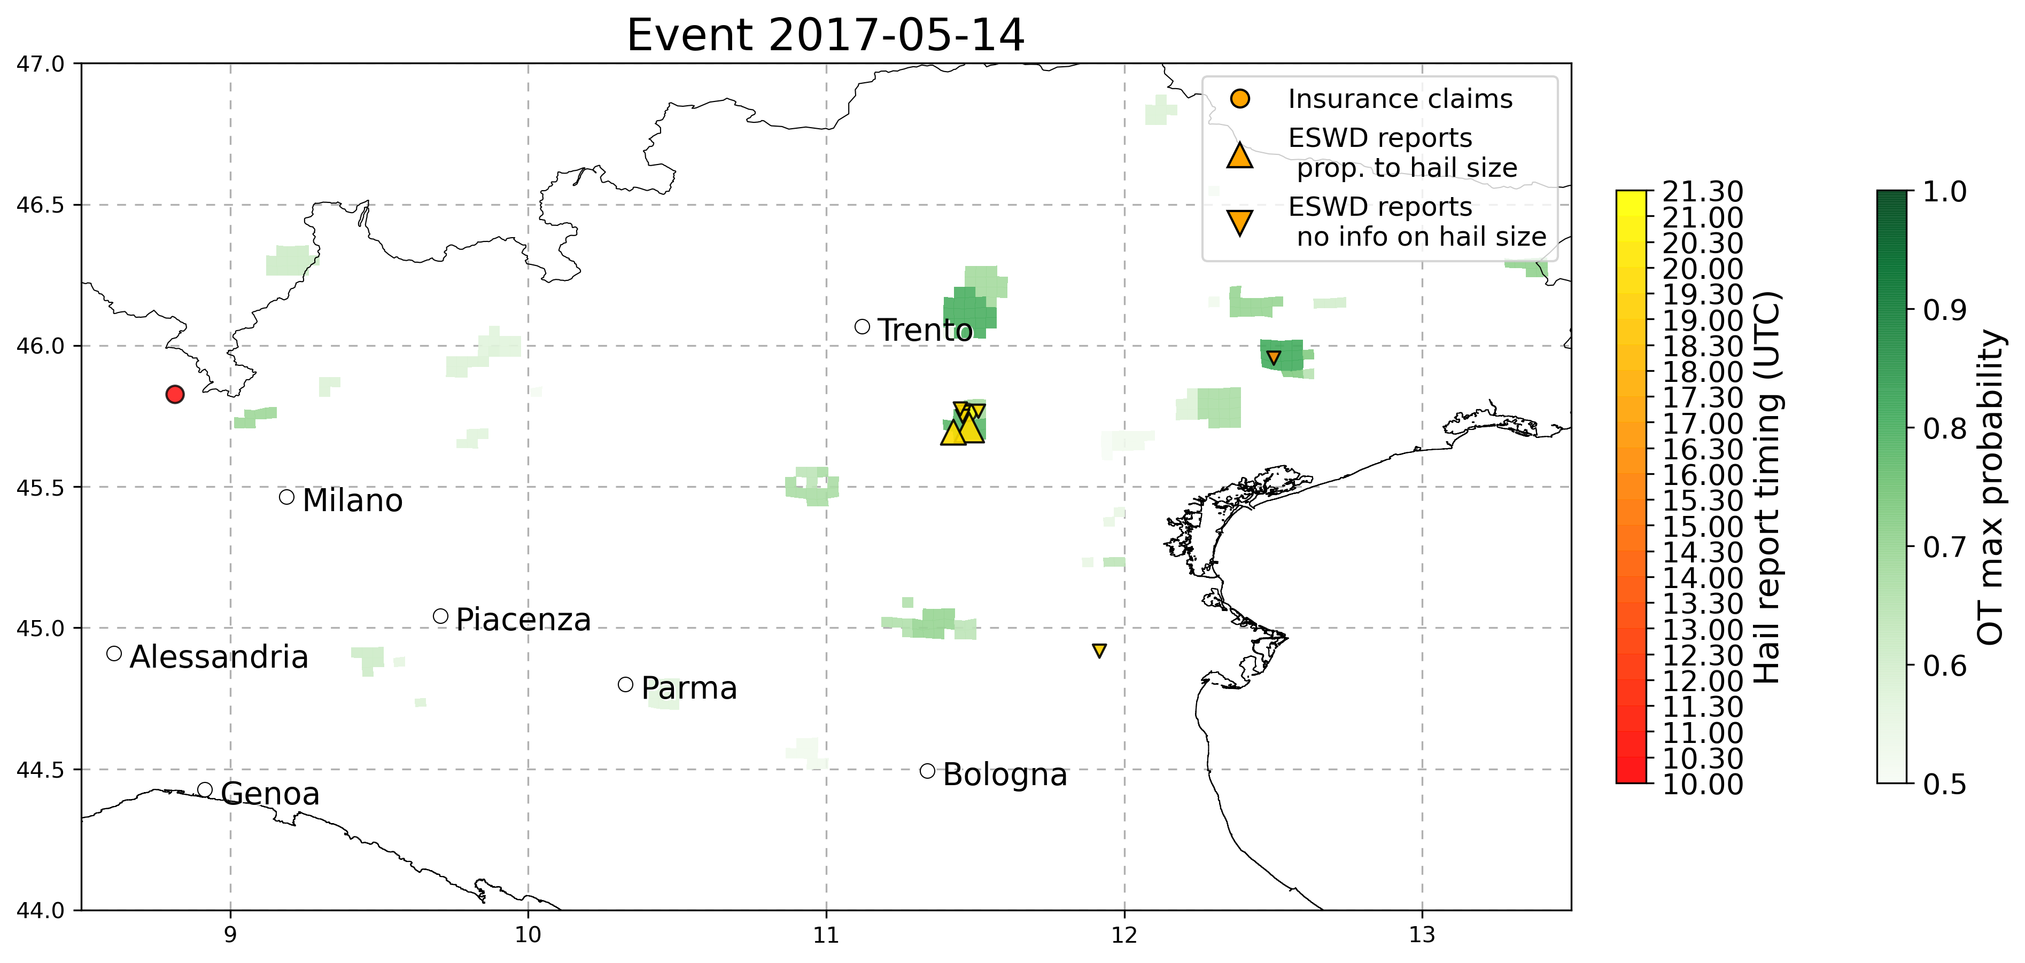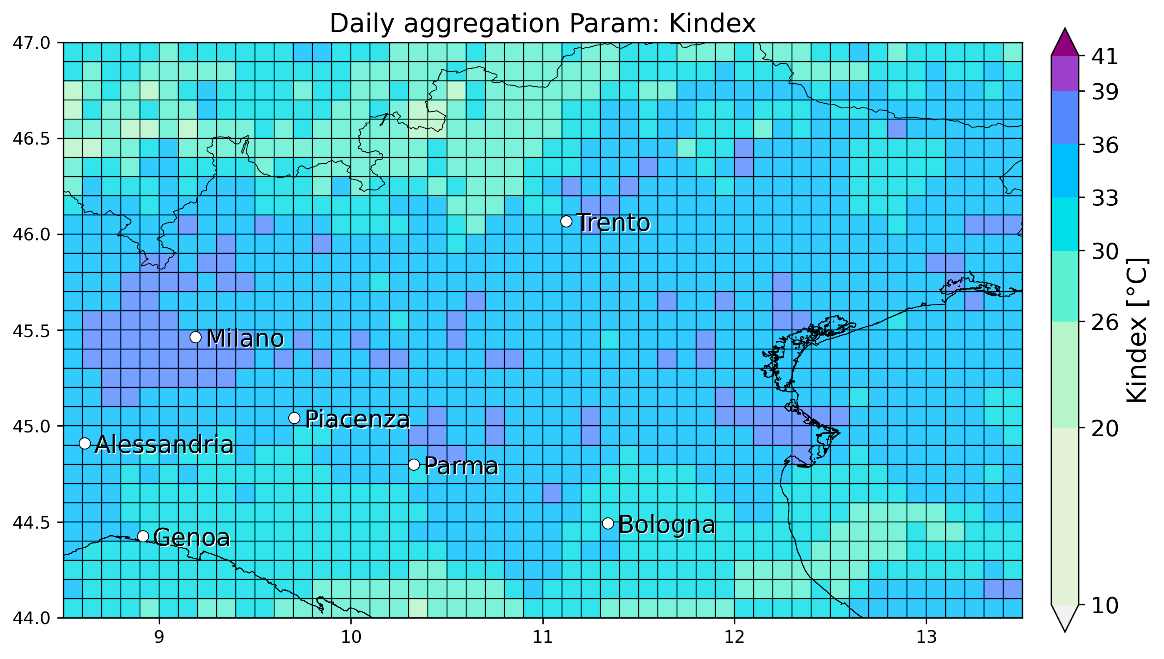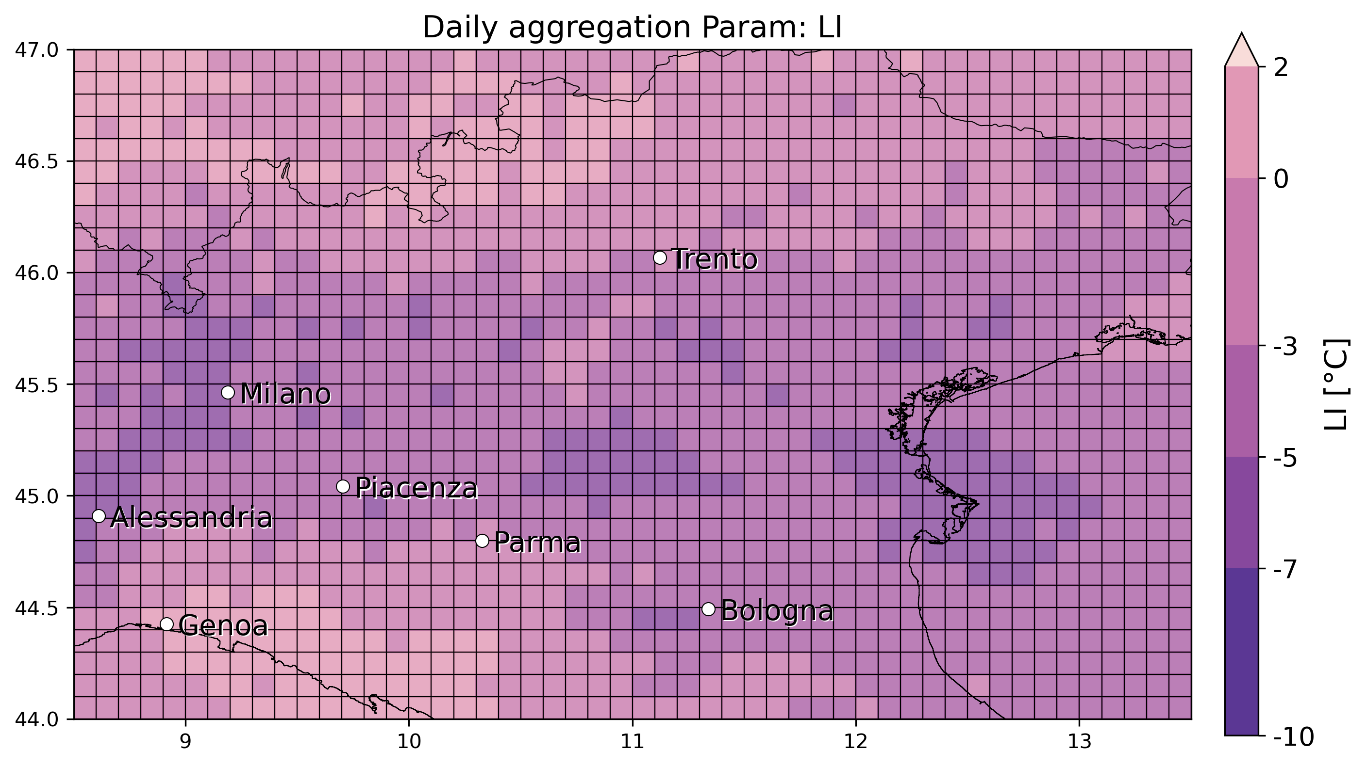

* 4 May 2017 – Treviso: 1 eswd report (2cm), missed by OT and also by LJ, furthermore also LI from SPHERA doesnt reach values low enough (>-5°C) -> event completely missed

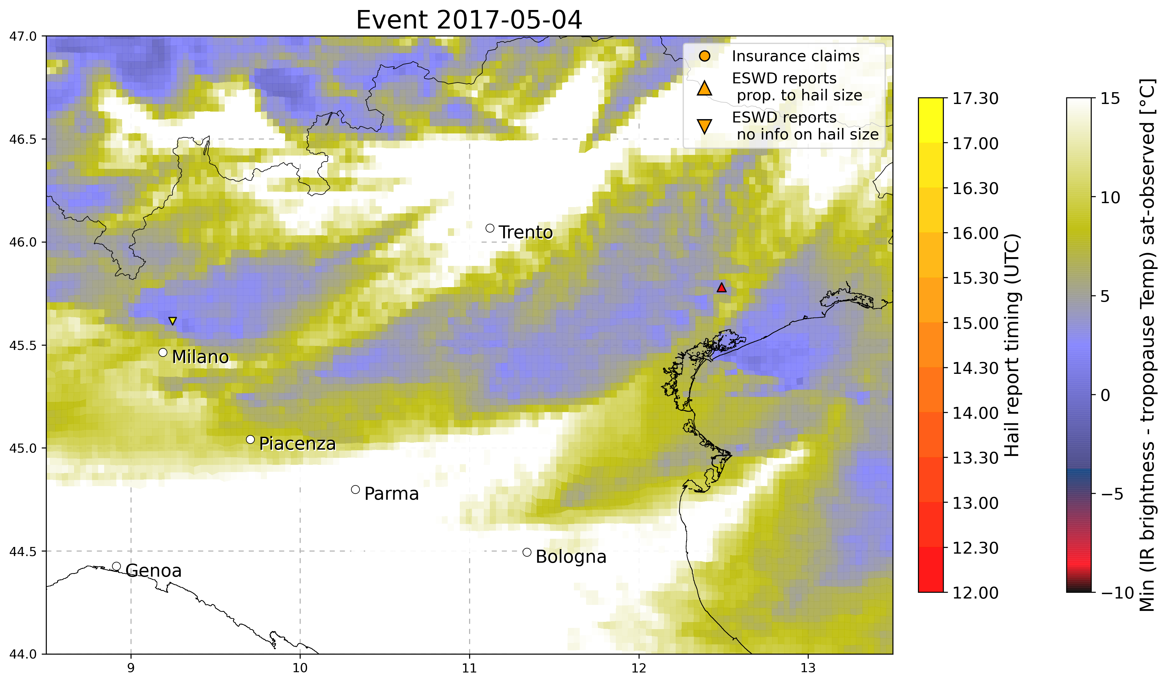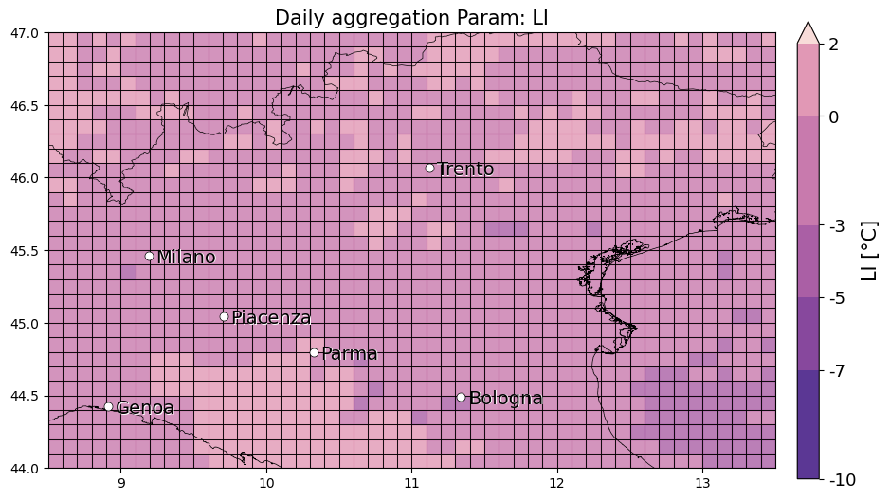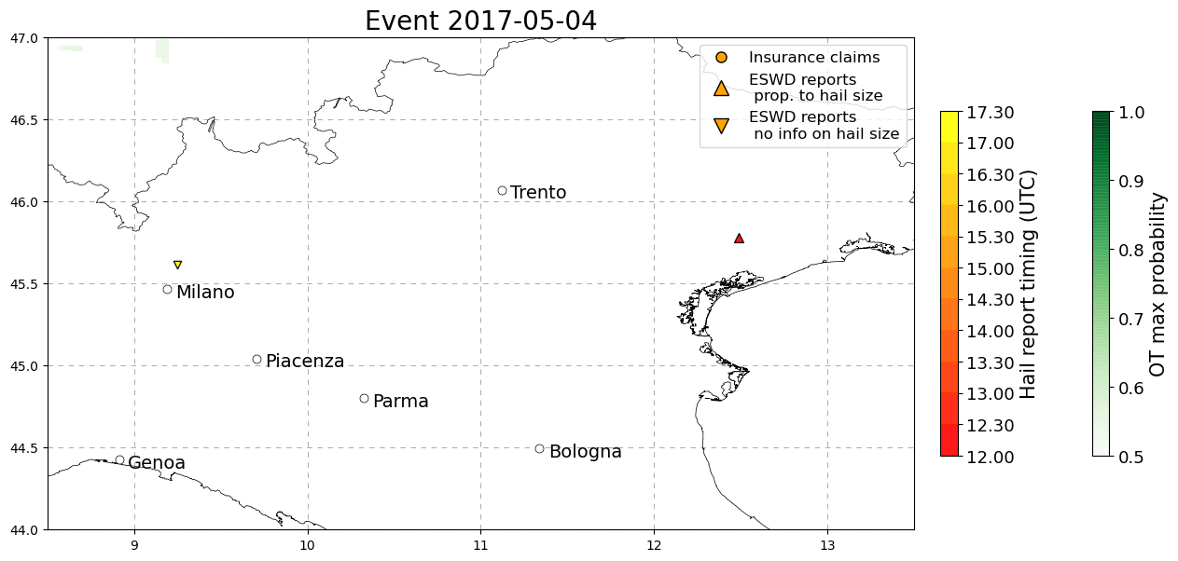

* 15 October 2016: Casalbordino (Chieti - Abruzzo) large hail 7cm 1 eswd report, very good agreement with OTS and LJ index at the correct timing, SLI and K index indicate favouring conditions for strong convection, while also in this case %VV700 do not give useful info (on a daily basis!)

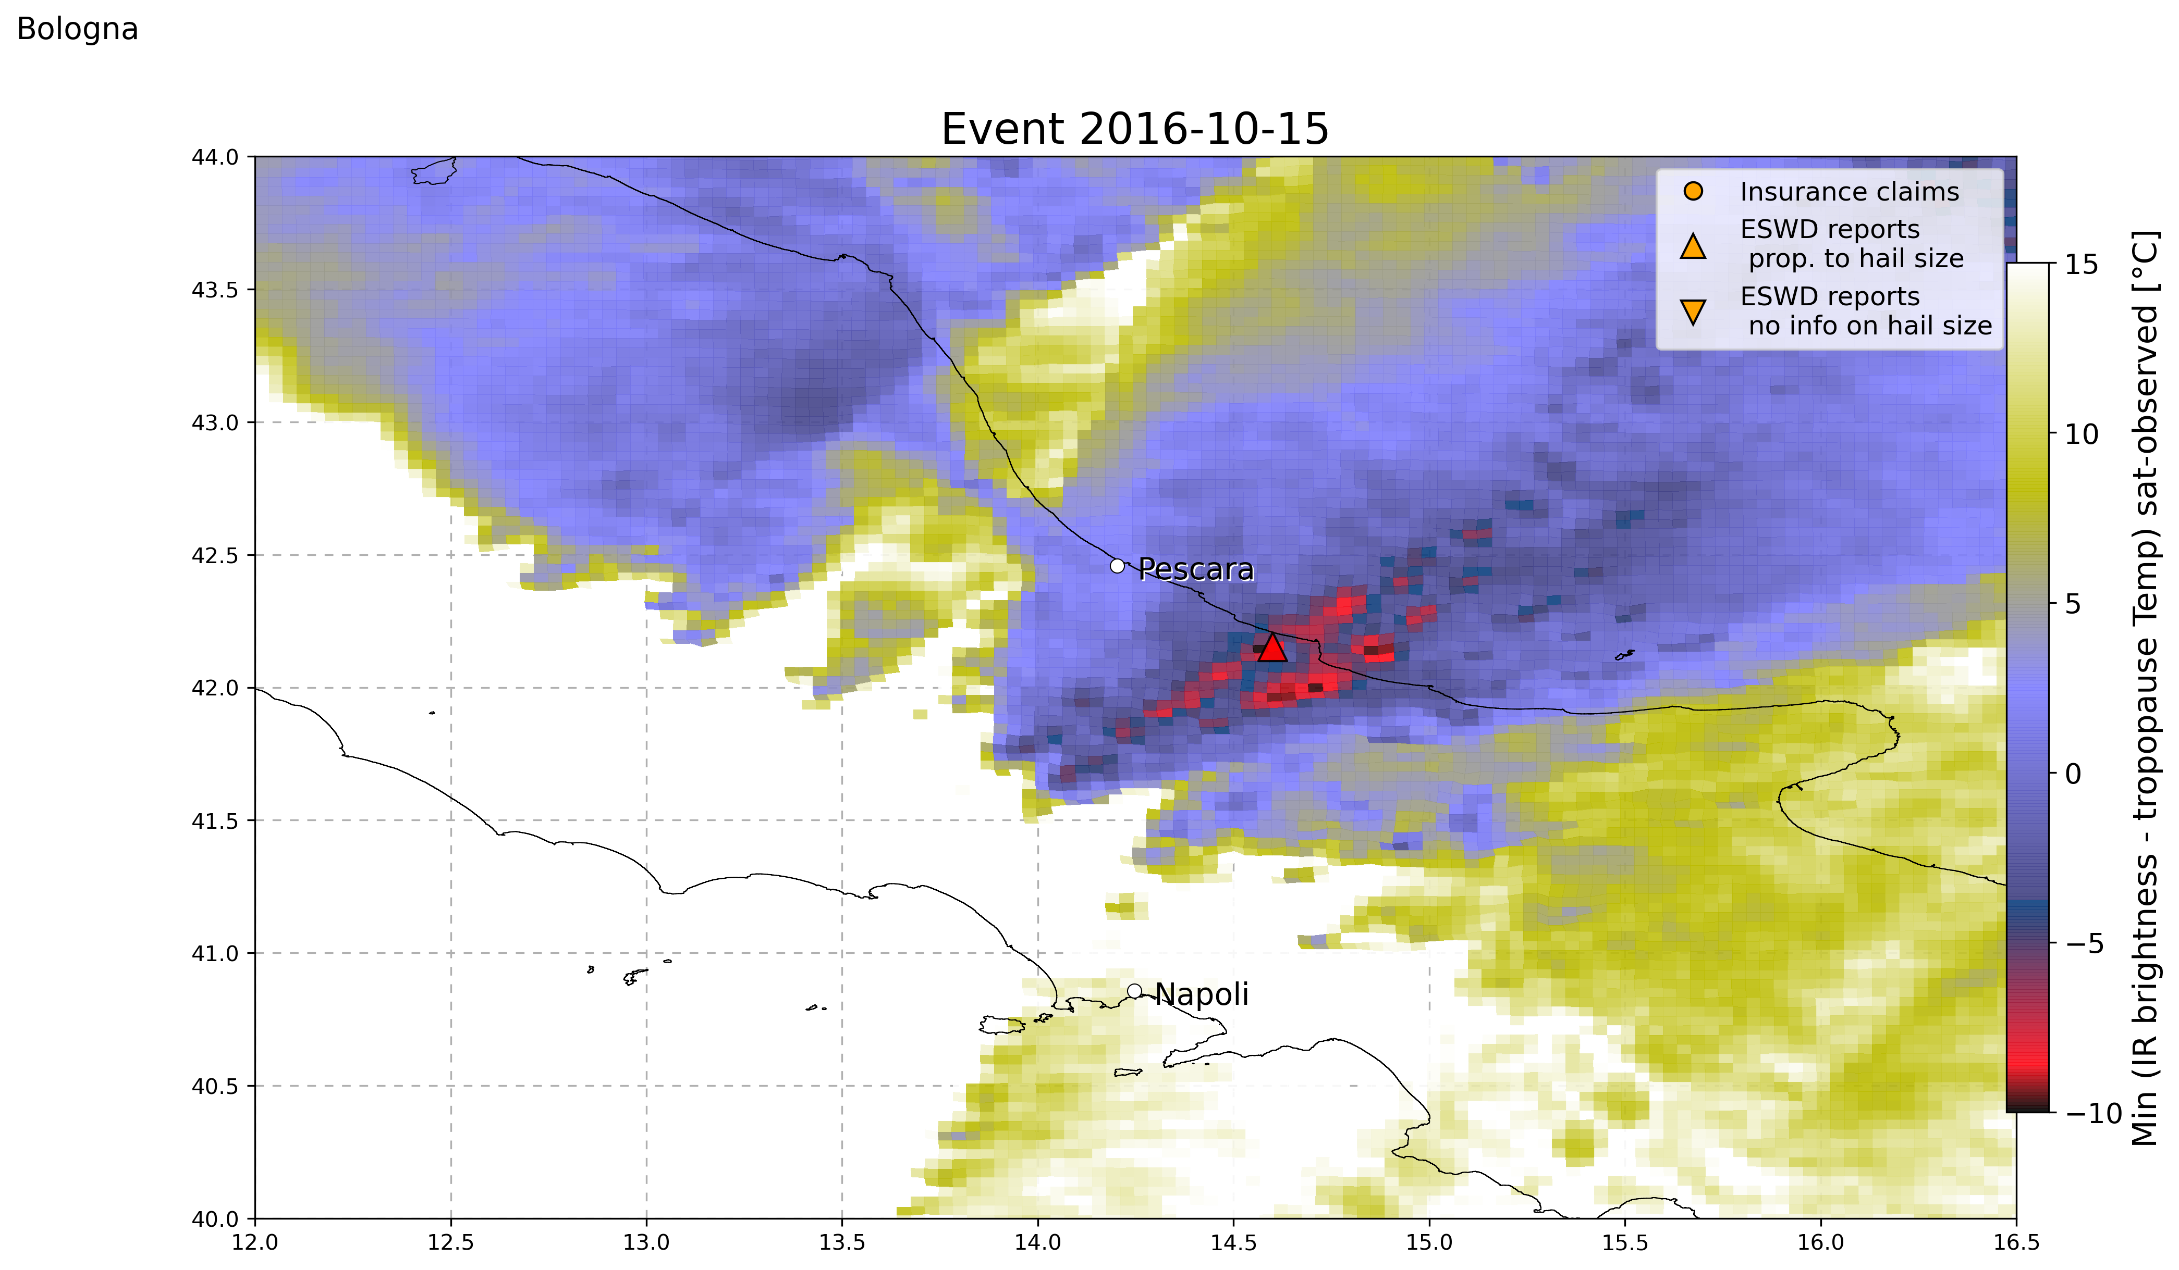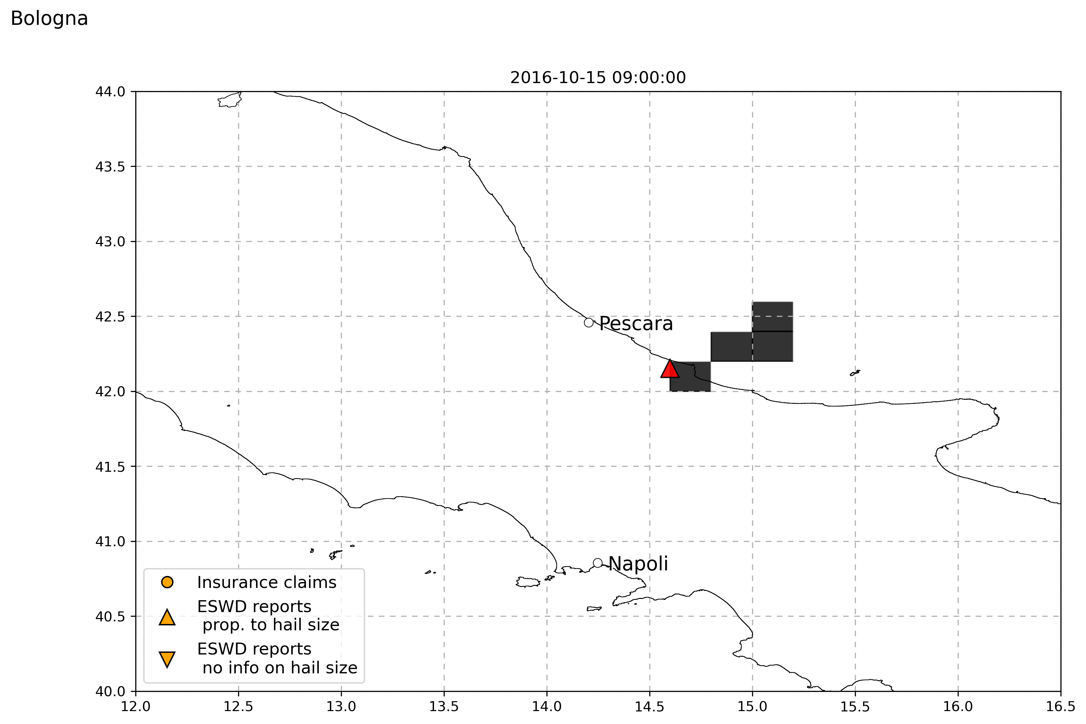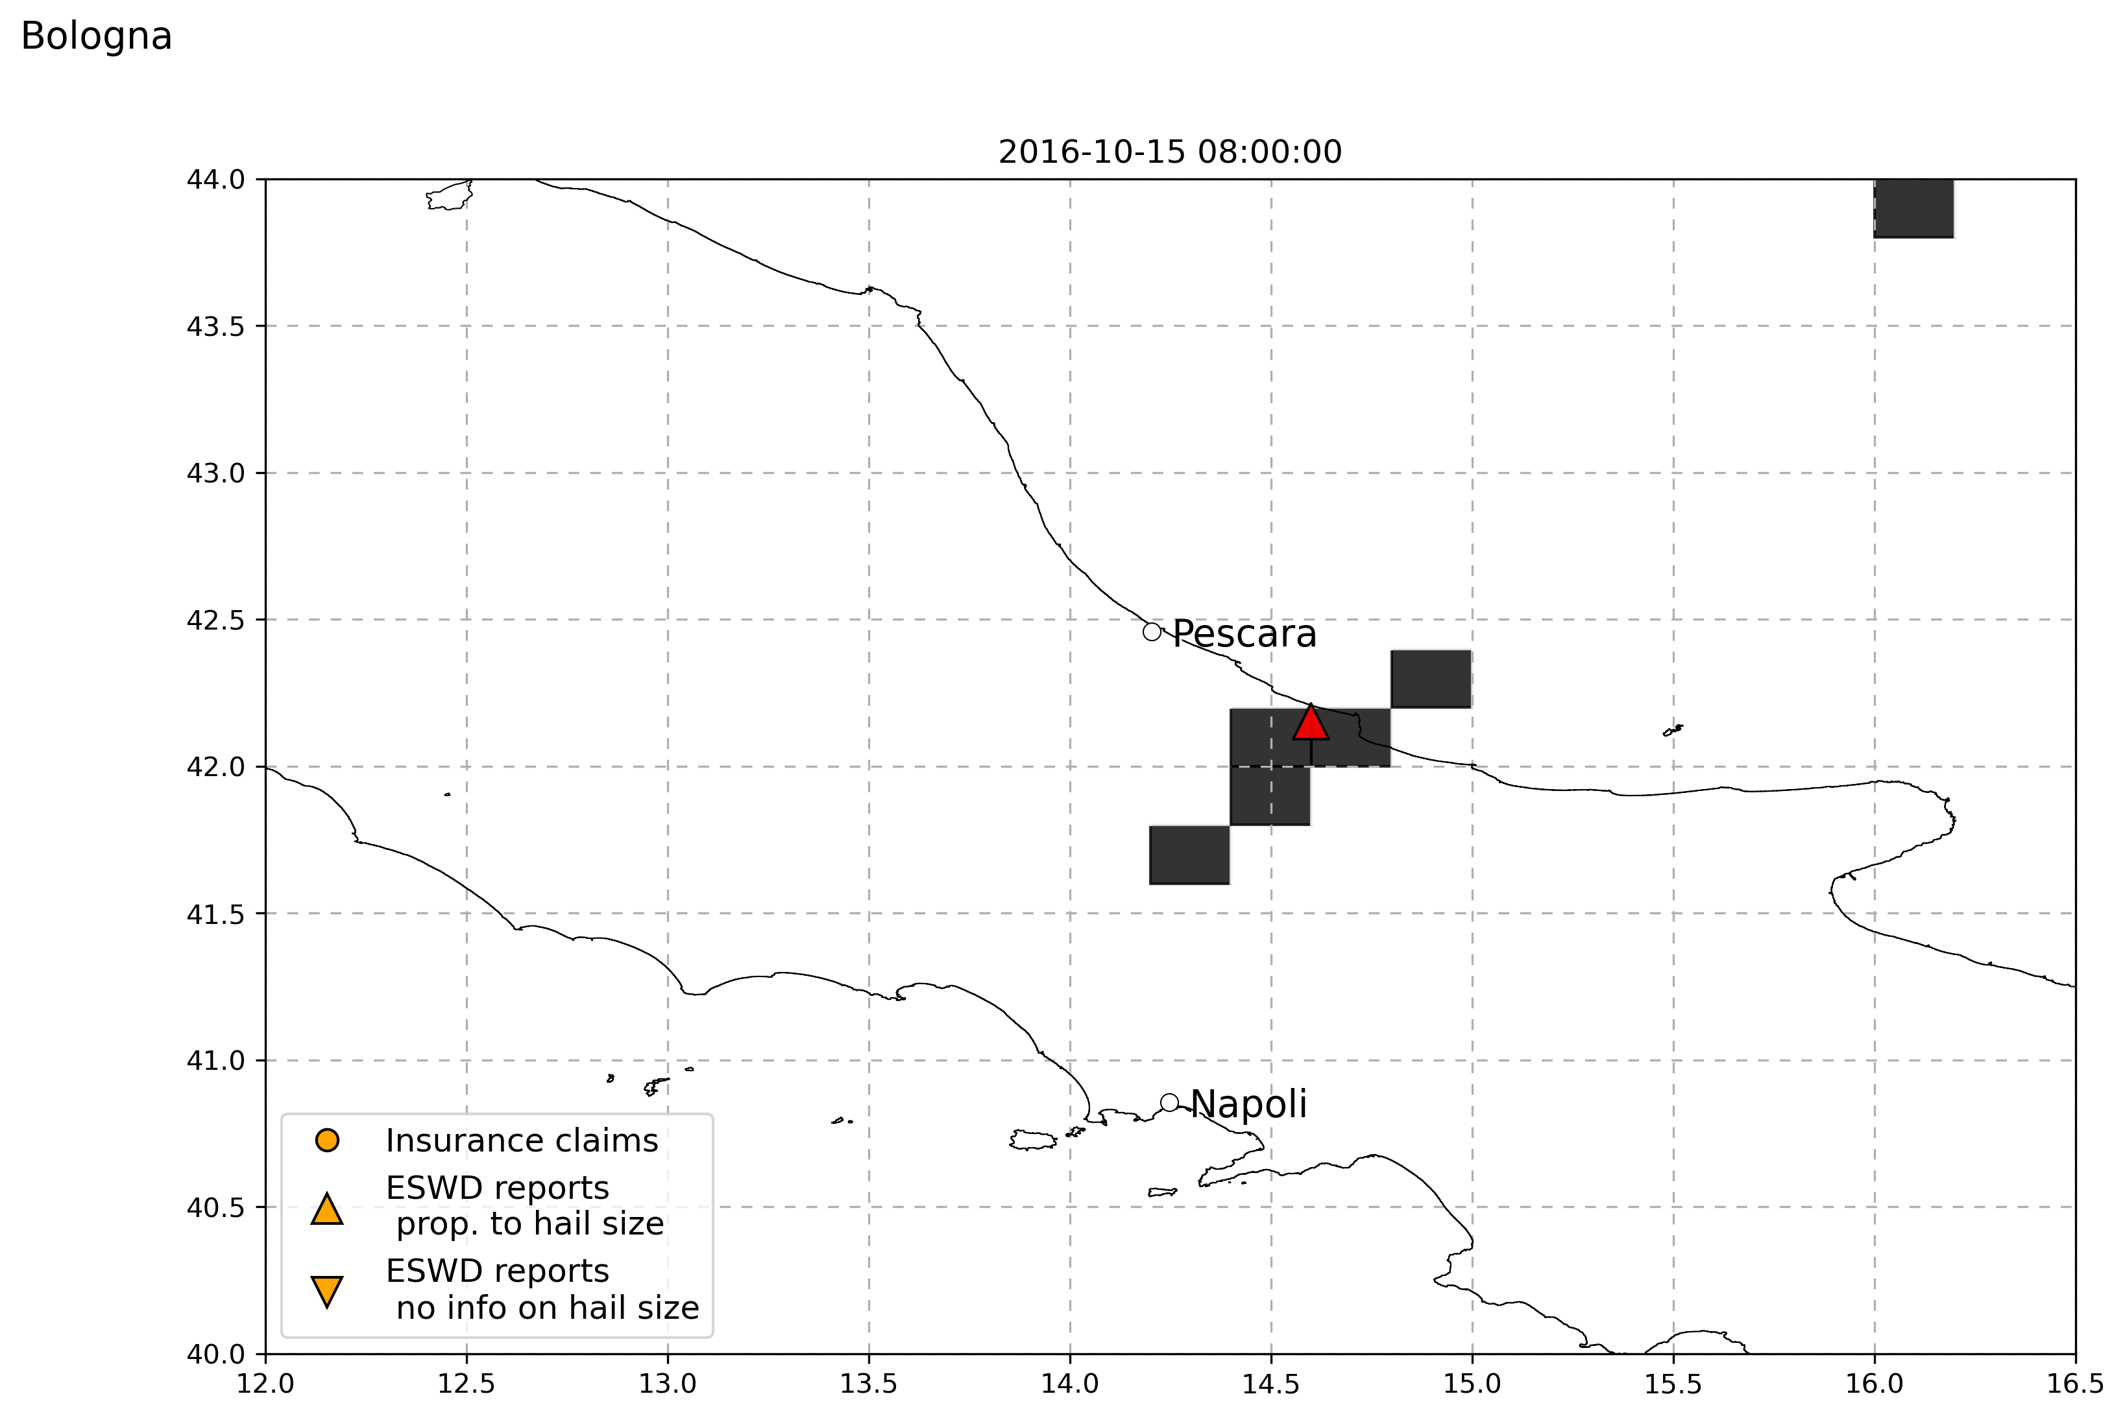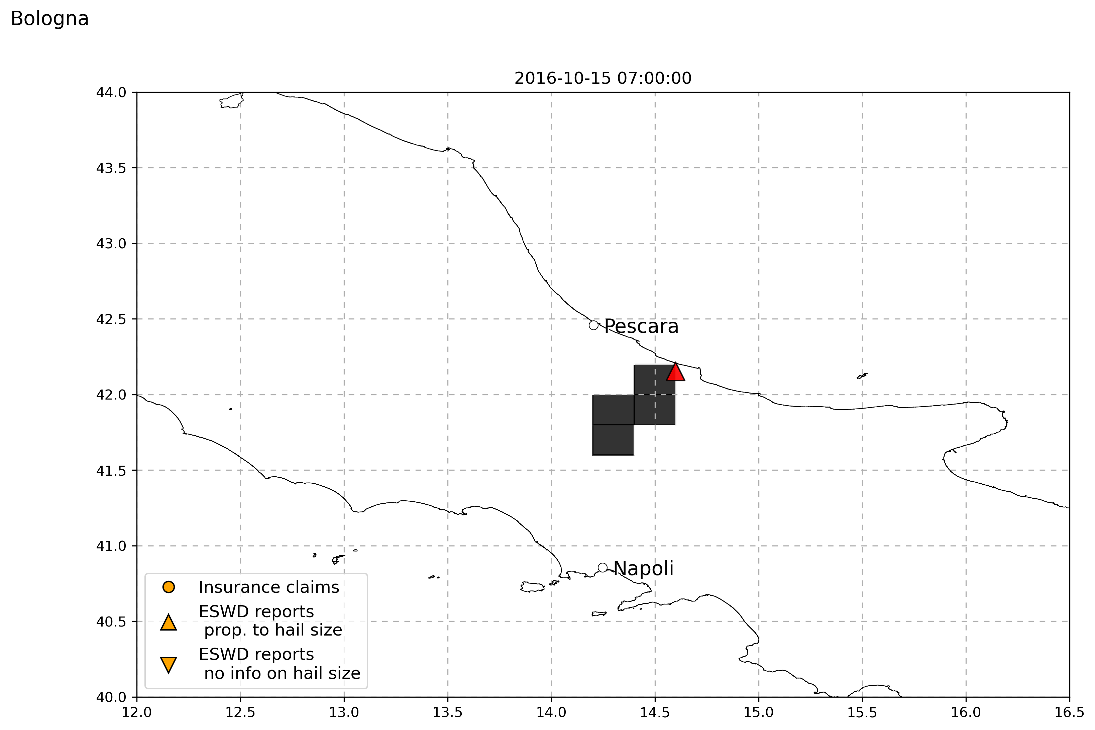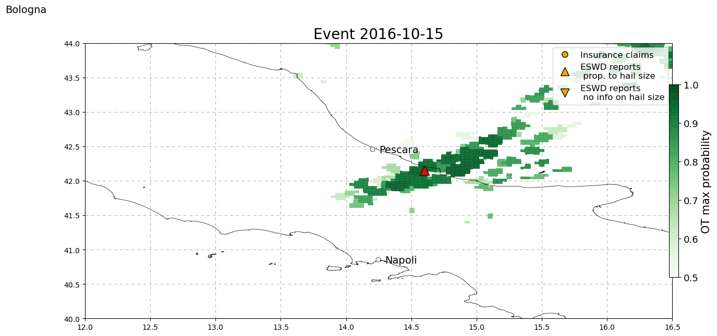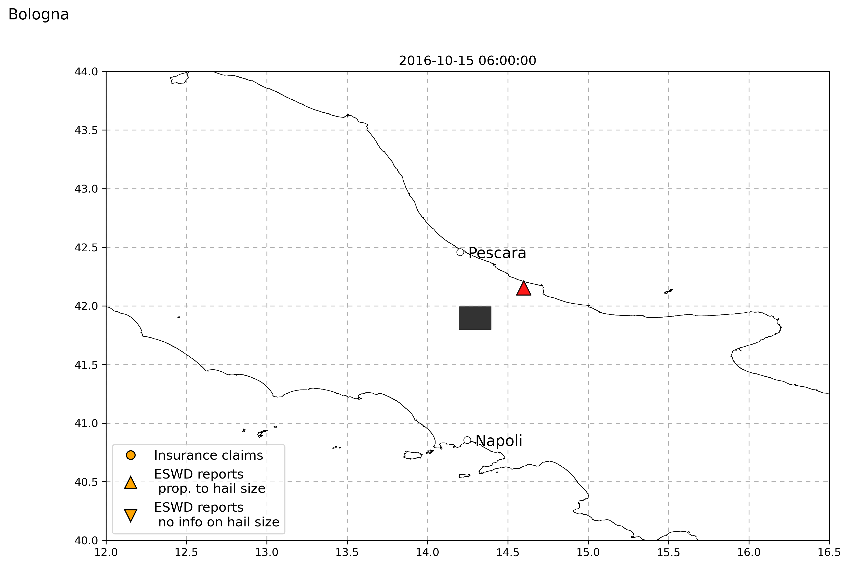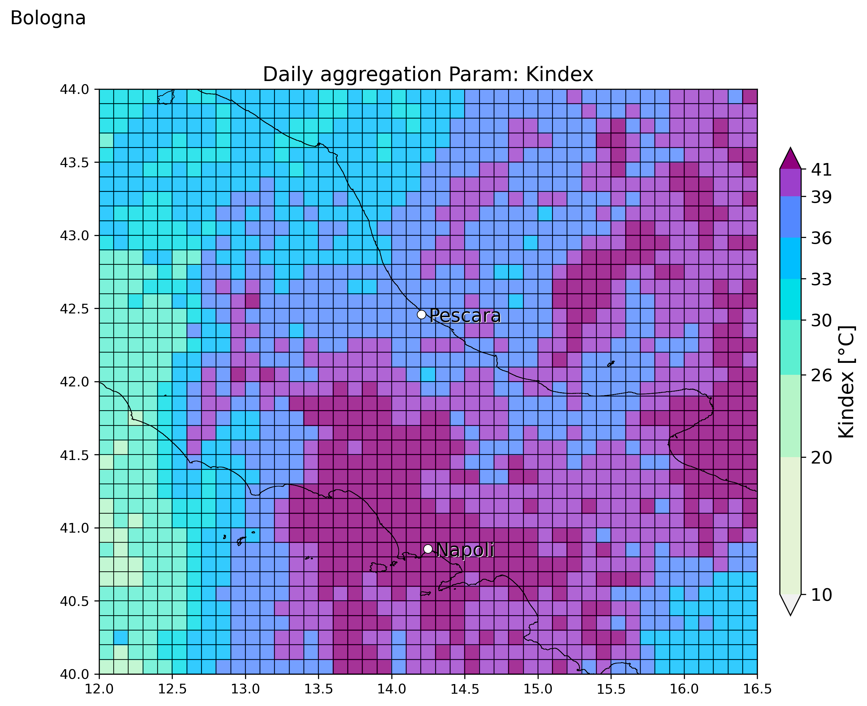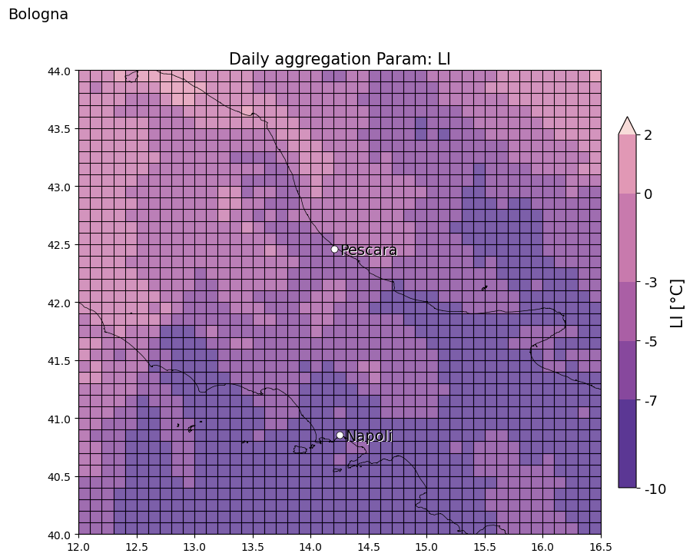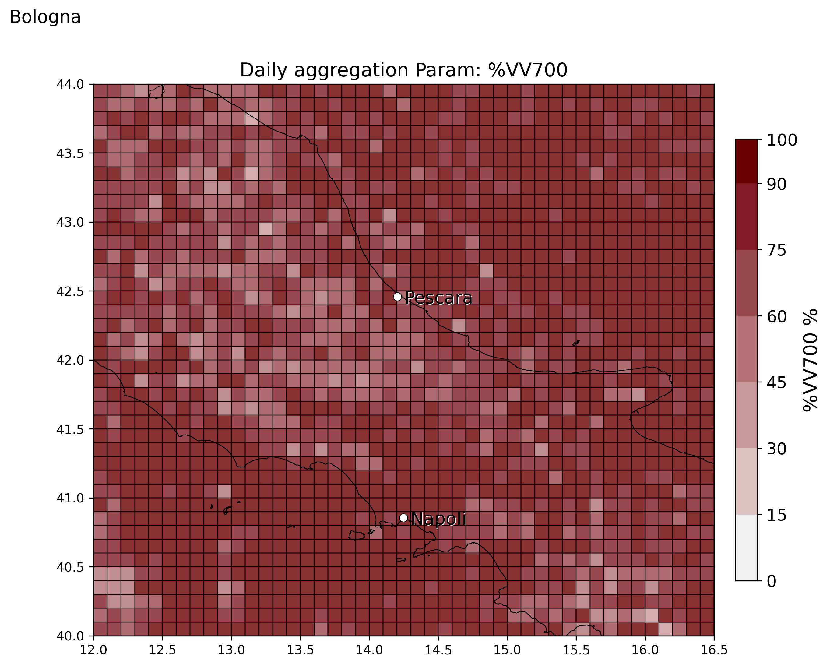

* 29 August 2016, Torino (20:10 UTC), good spatial/temporal match with OT and also with LJ! Good match also with SLI and K index, while also in this case %VV700 does not provide additional info. IN THE SAME DAY THERE IS ANOTHER EVENT NEAR GRAZ! (see below)

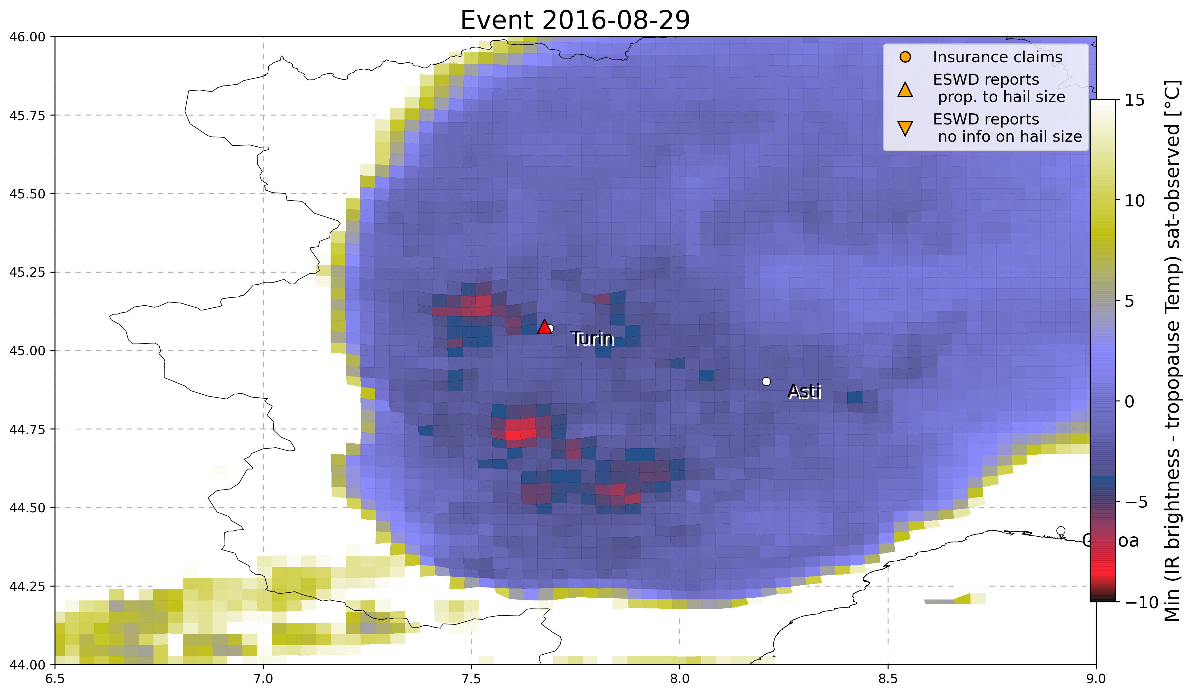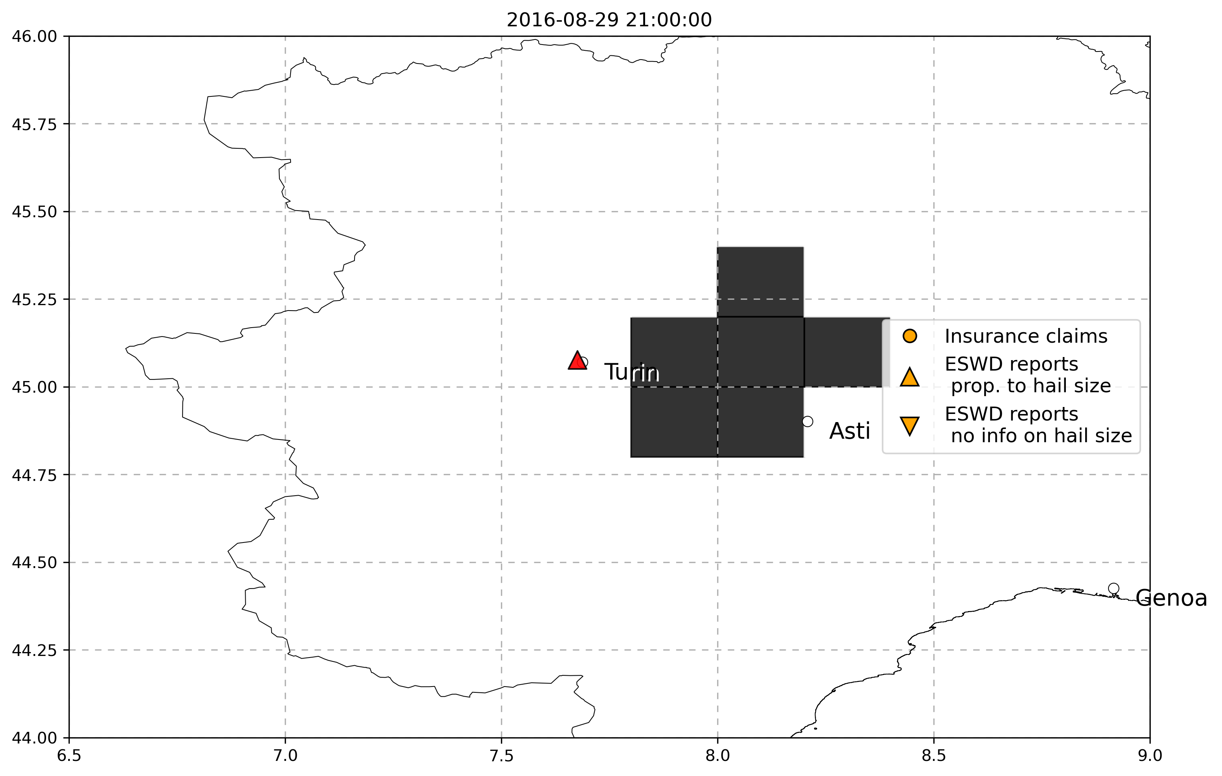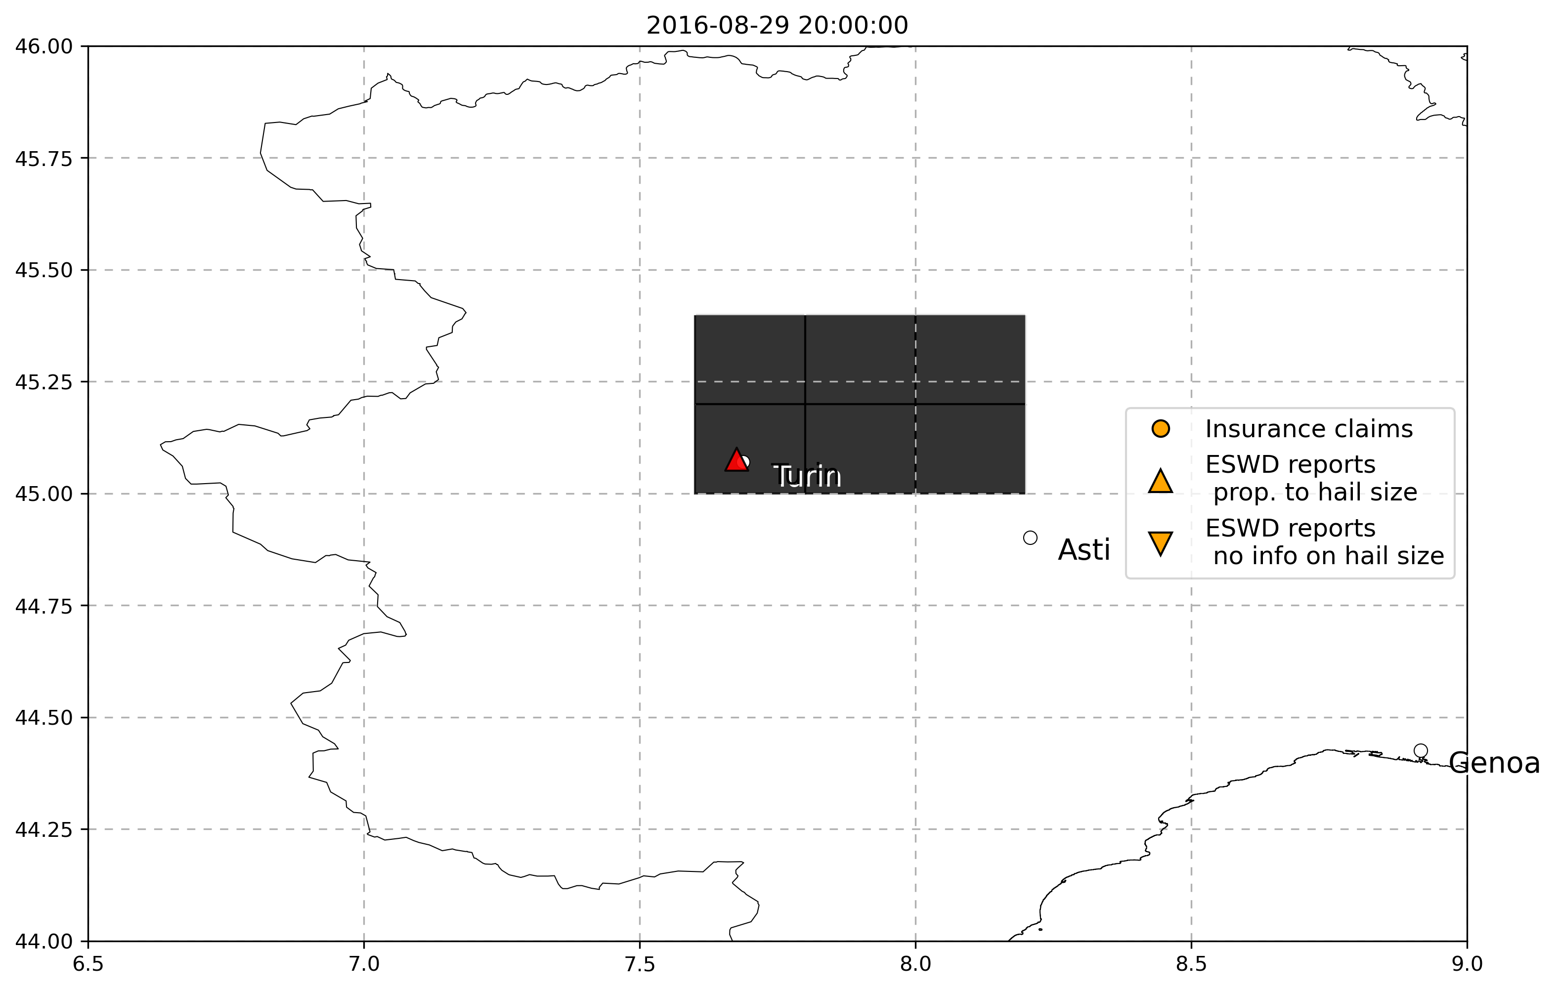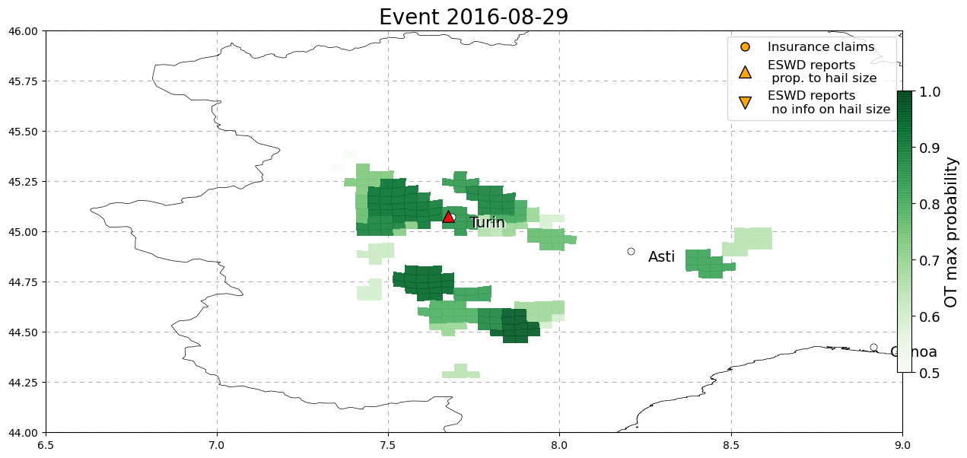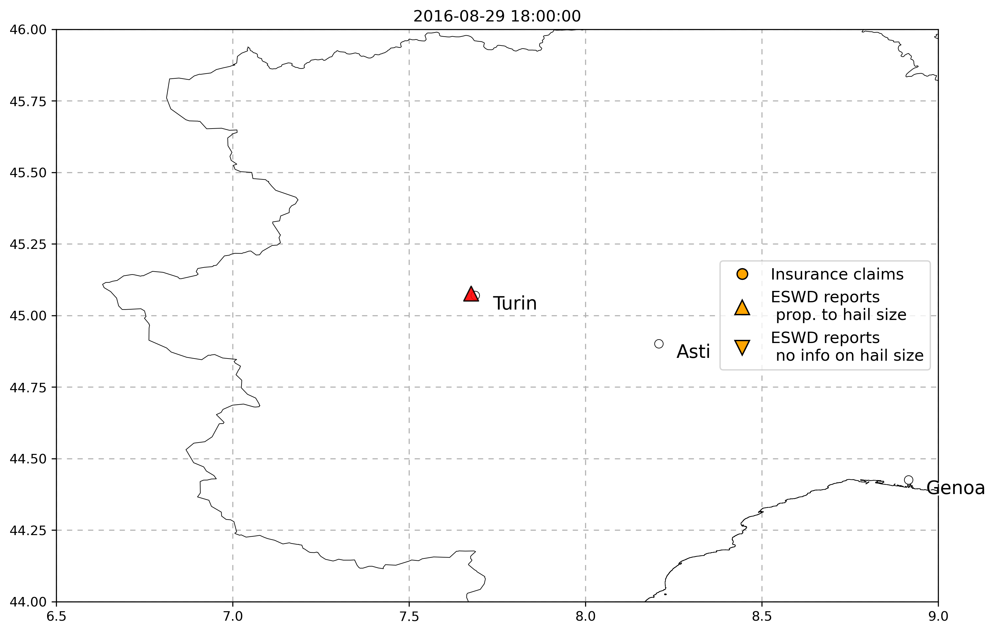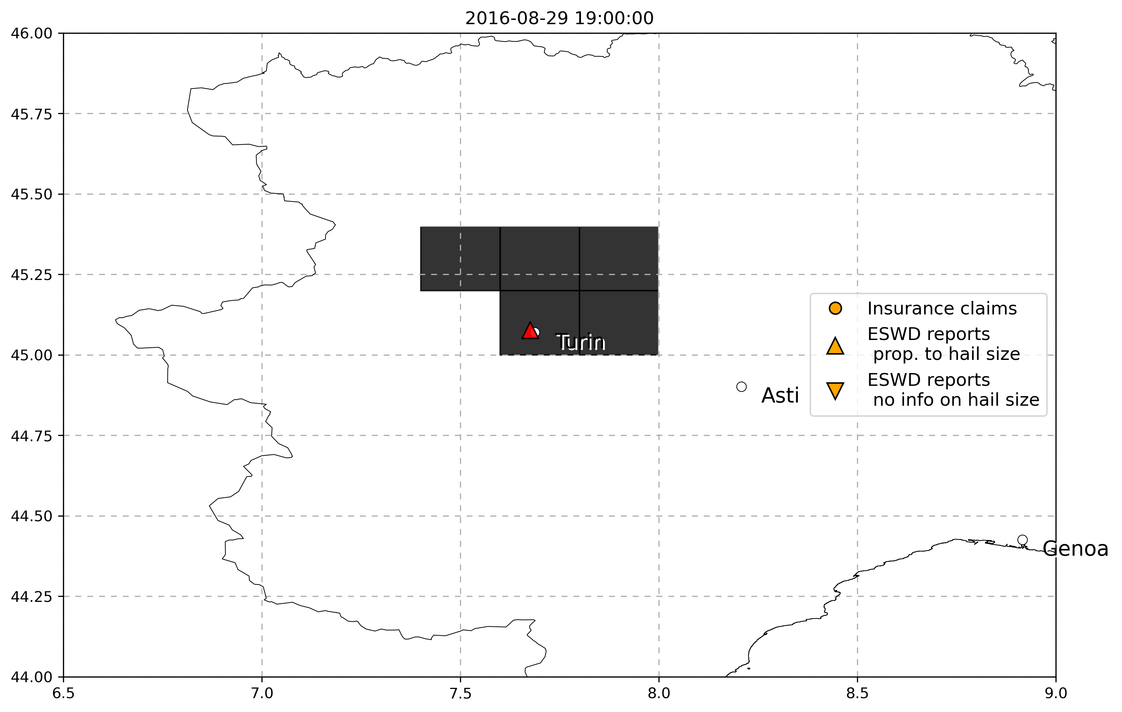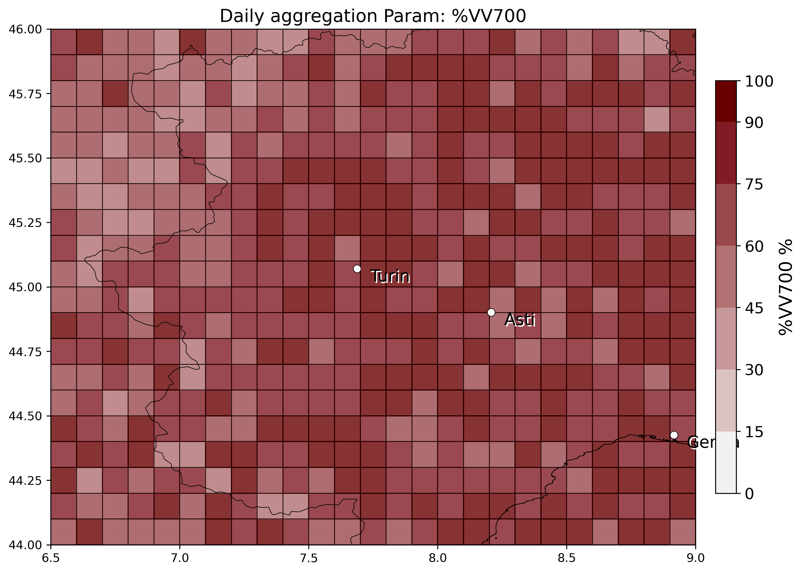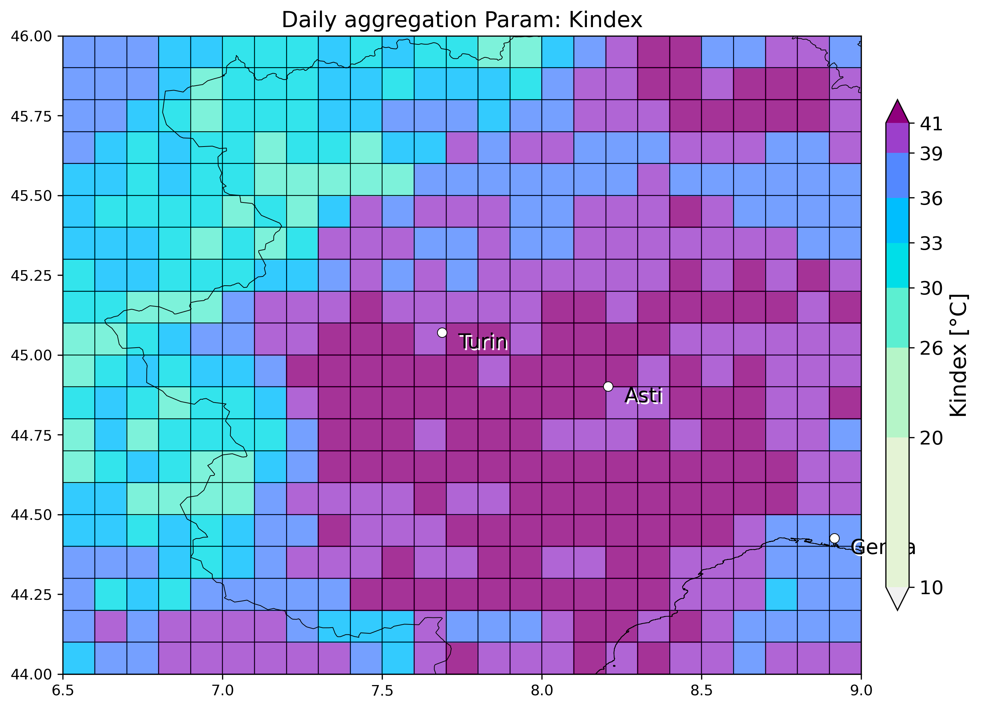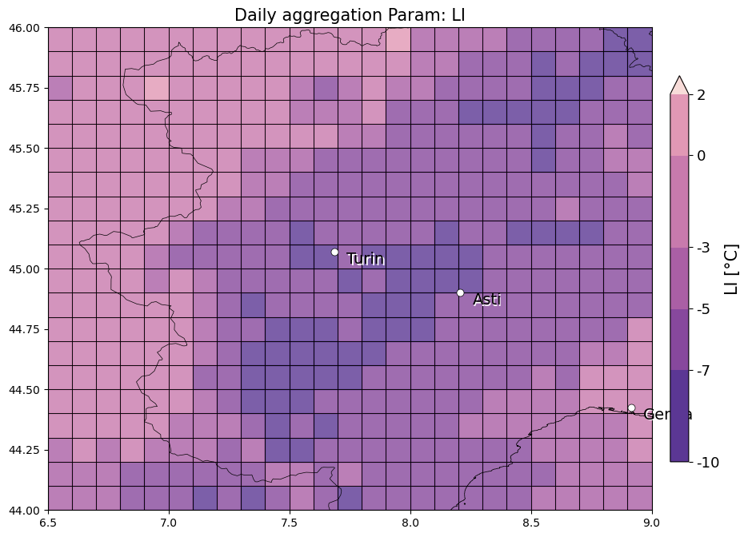

* 16 August 2016, Albenga (Savona): 1eswd report, missed by OT and also completely by LJ. SLI low value matches well with hail report (must be checked if at correct hourly timing), K index instead doesnt match

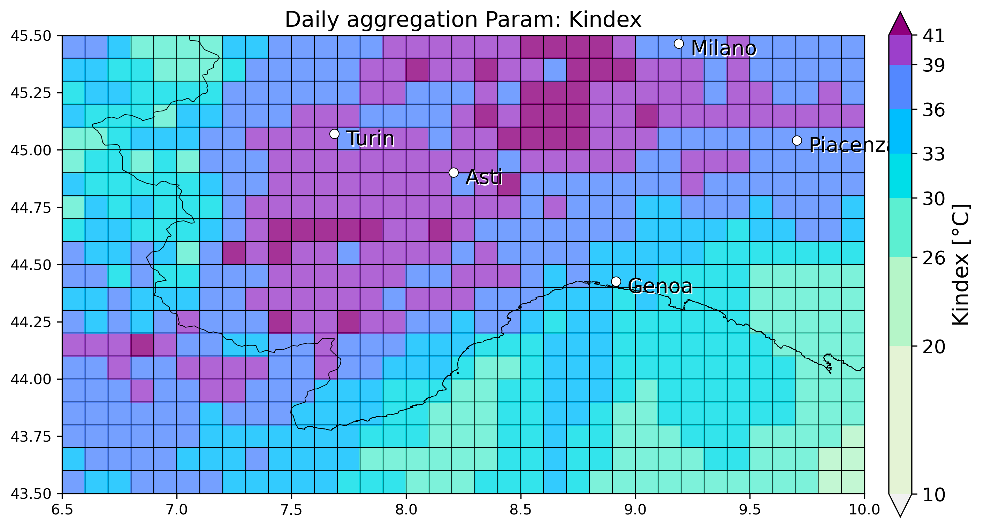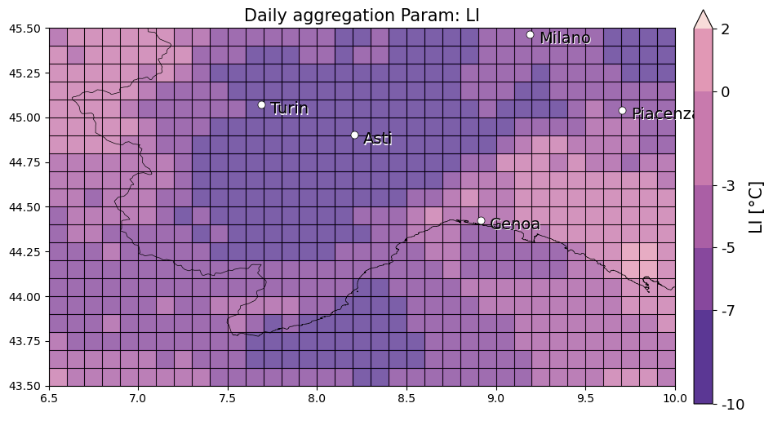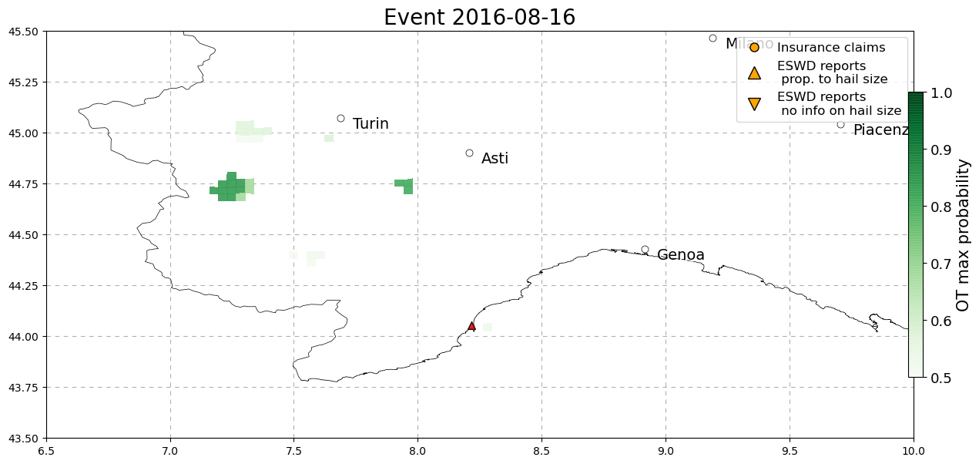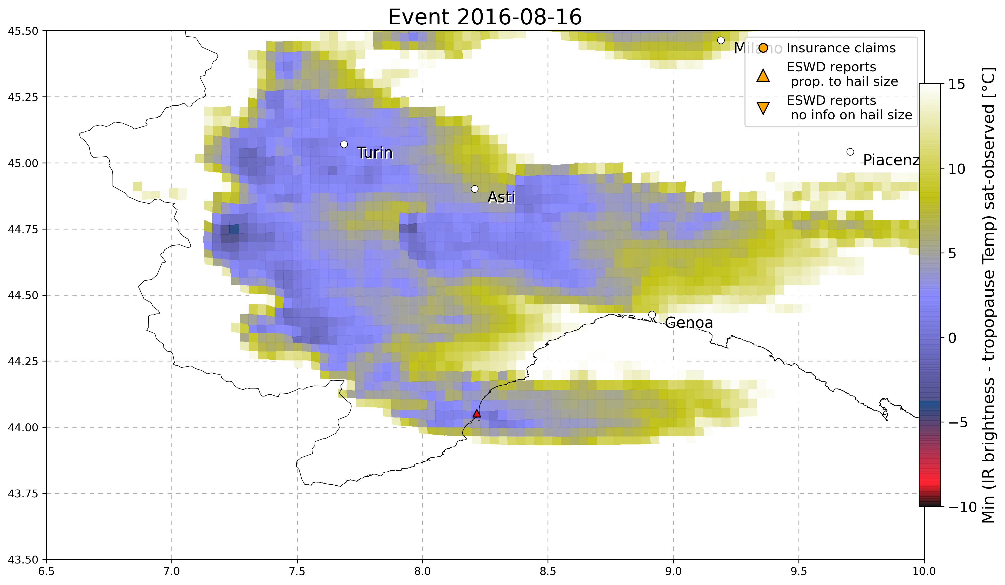

* 5 August 2016: Mondolfo (Pesaro-Urbino, Marche), circa 17UTC (4cm hail): good match with OT and also with LJ. SLI doesnt show a minimum peak right where the eswd report but K index instead does.

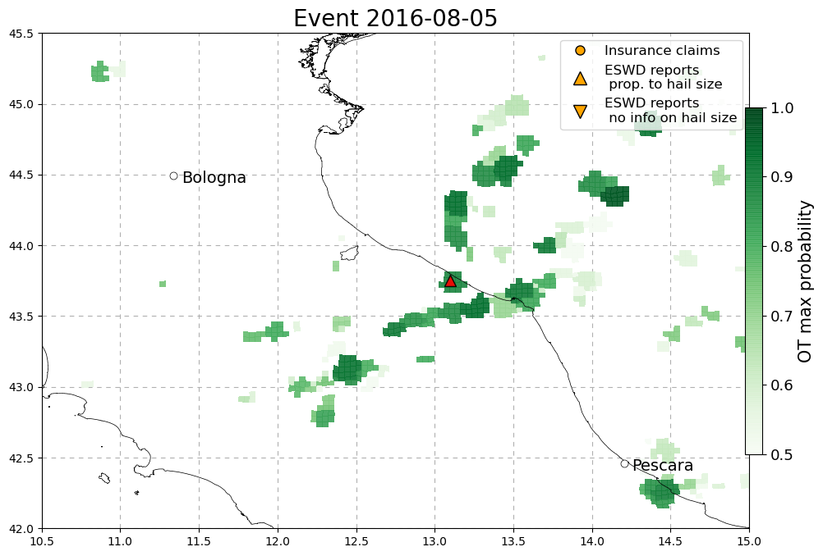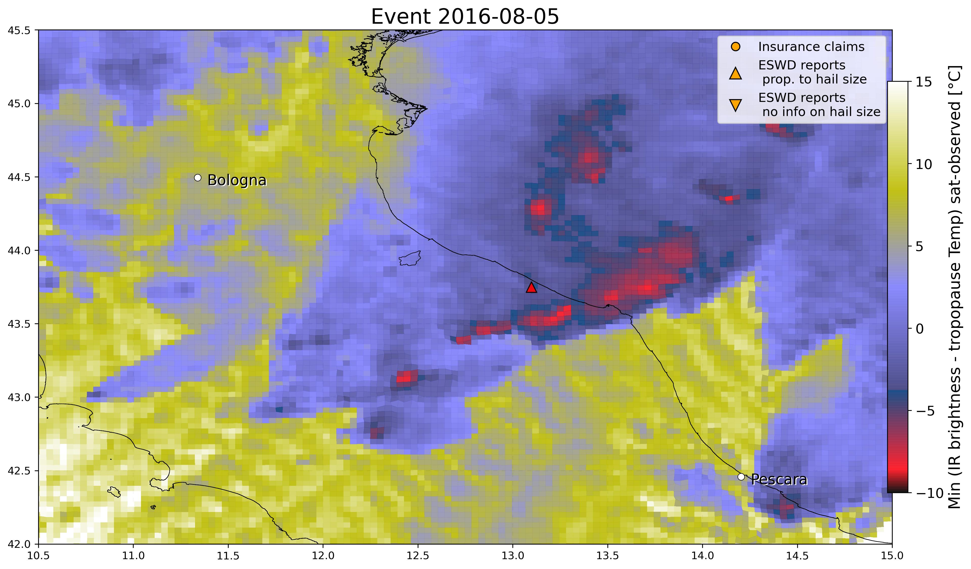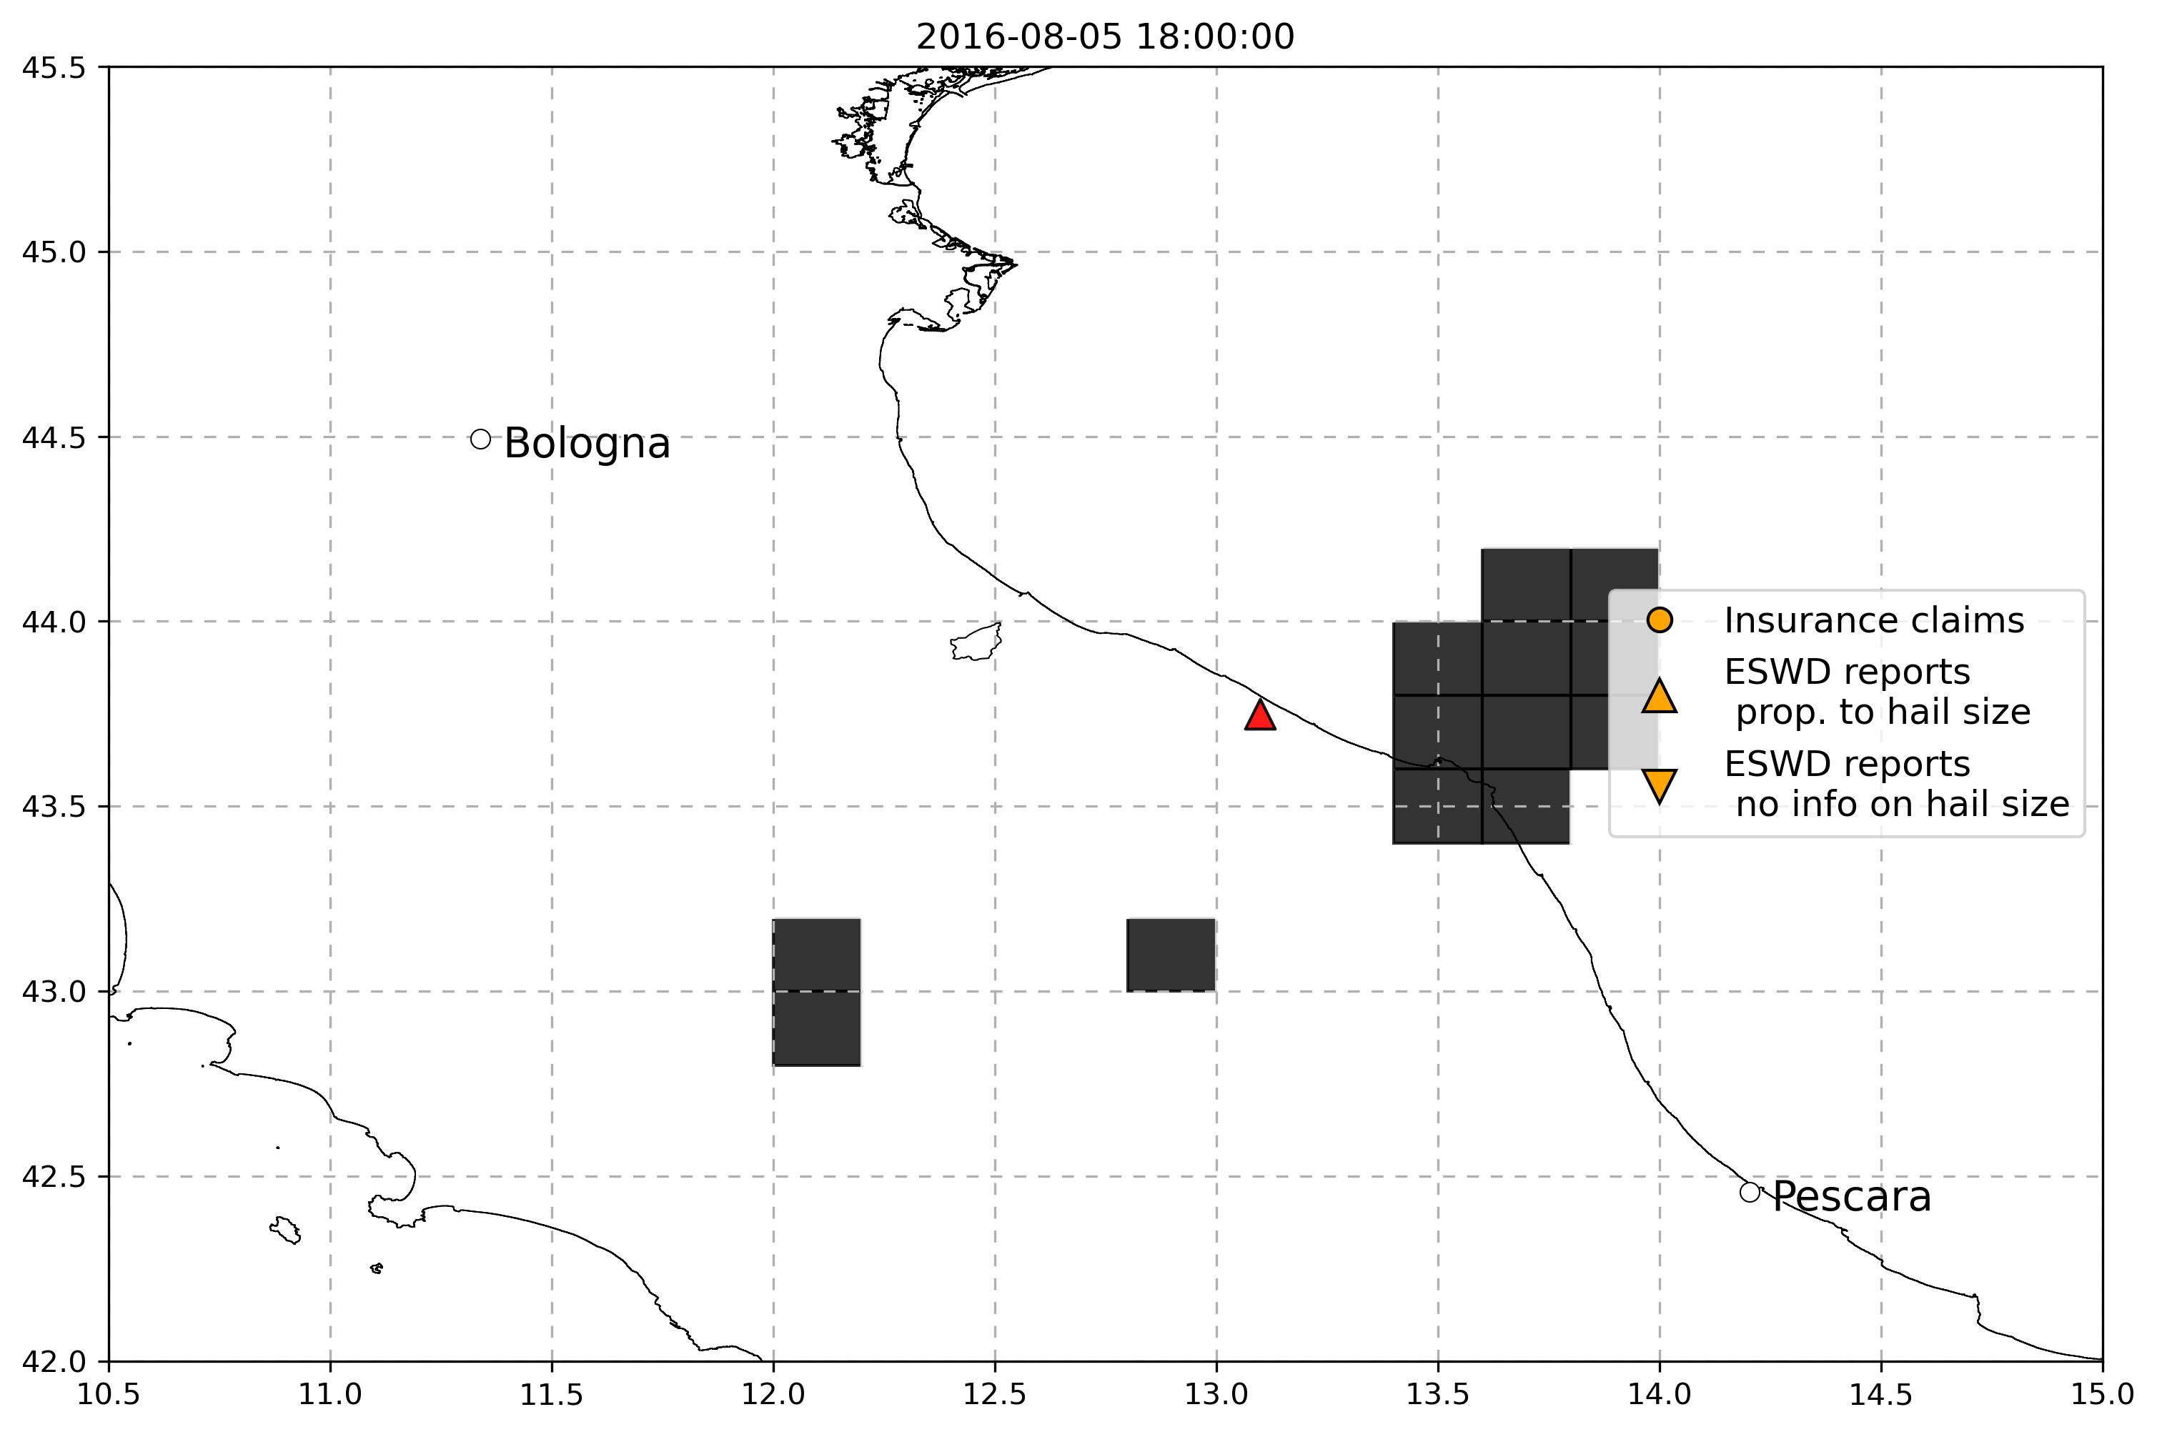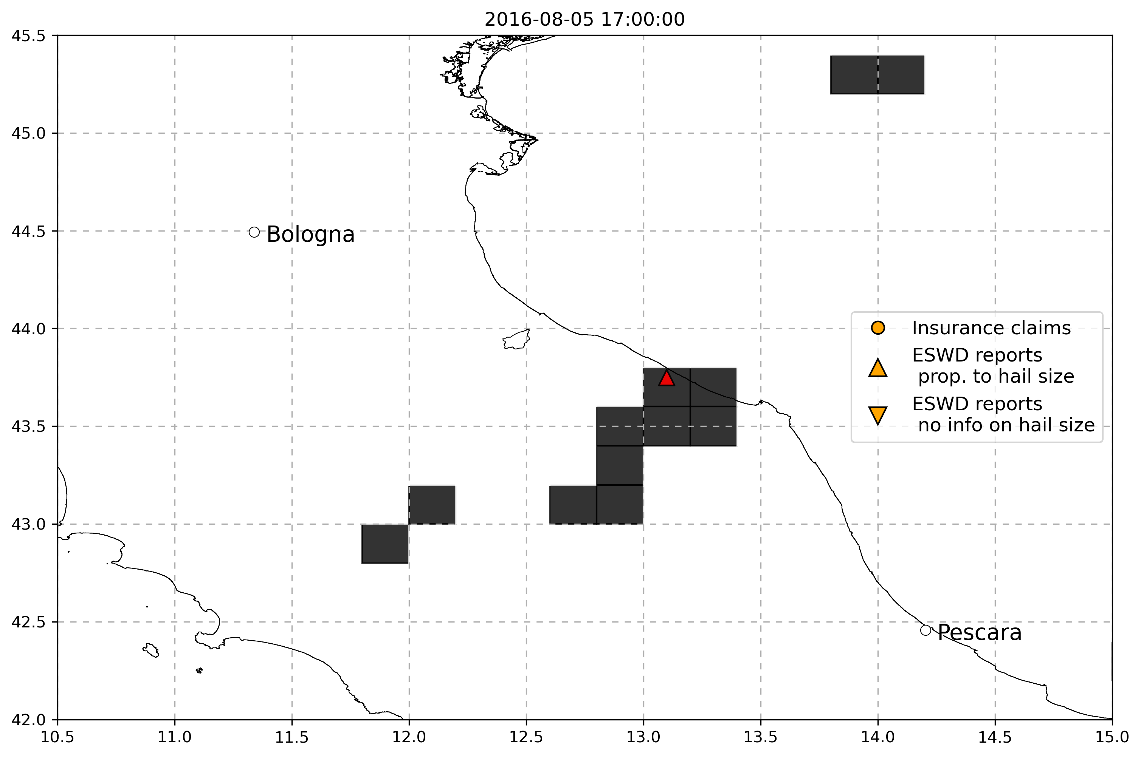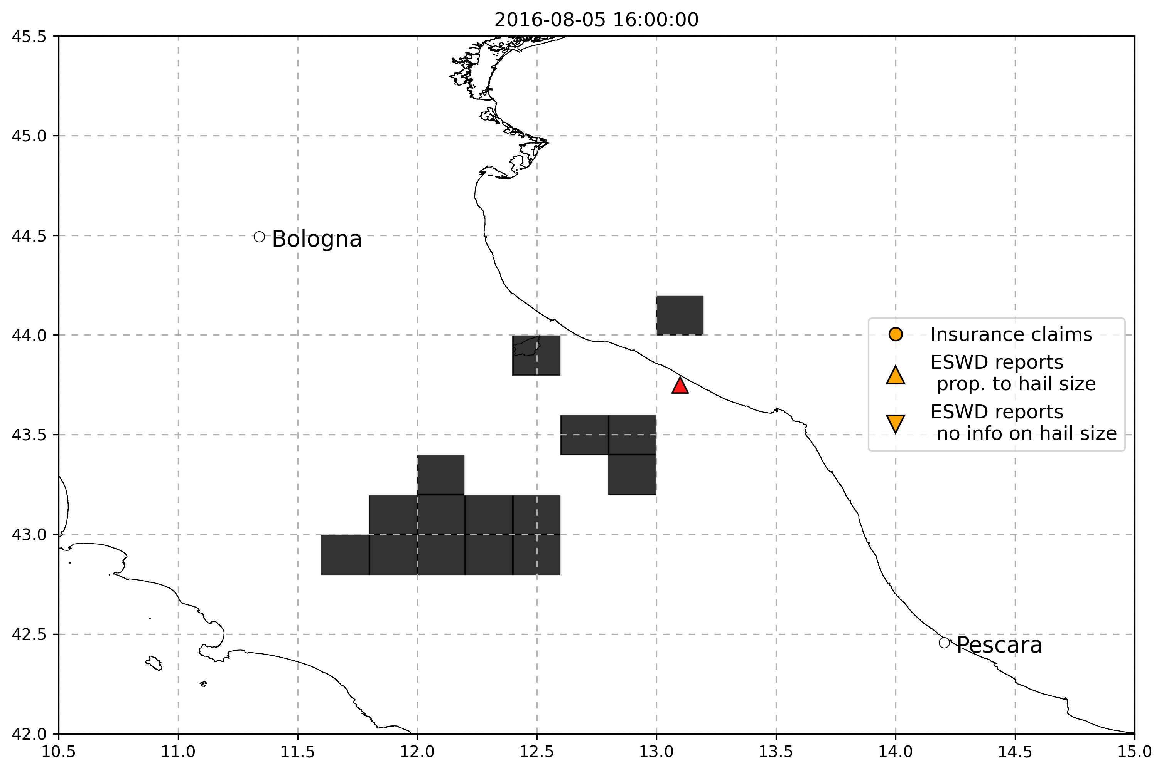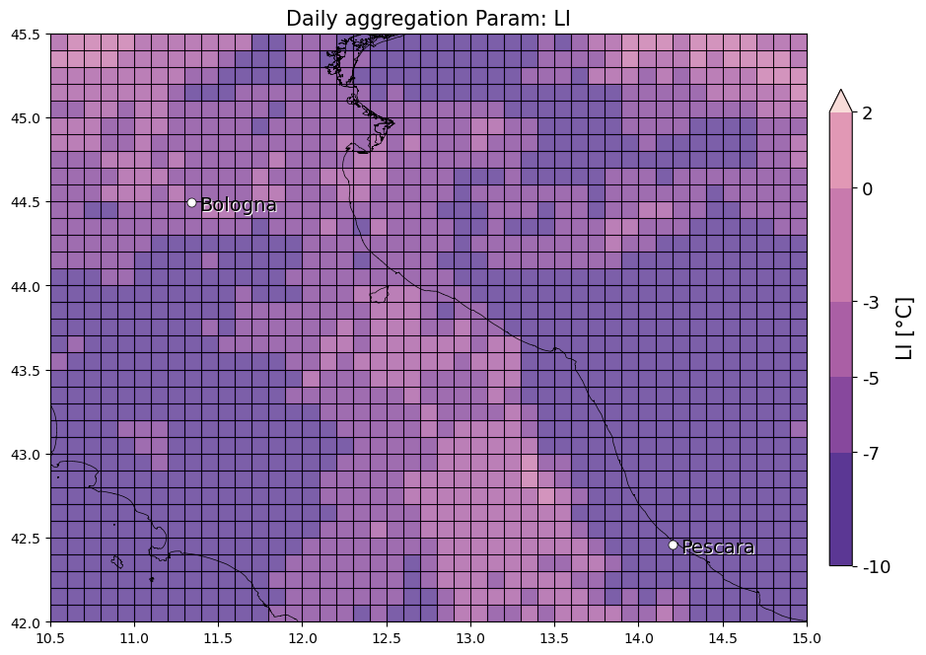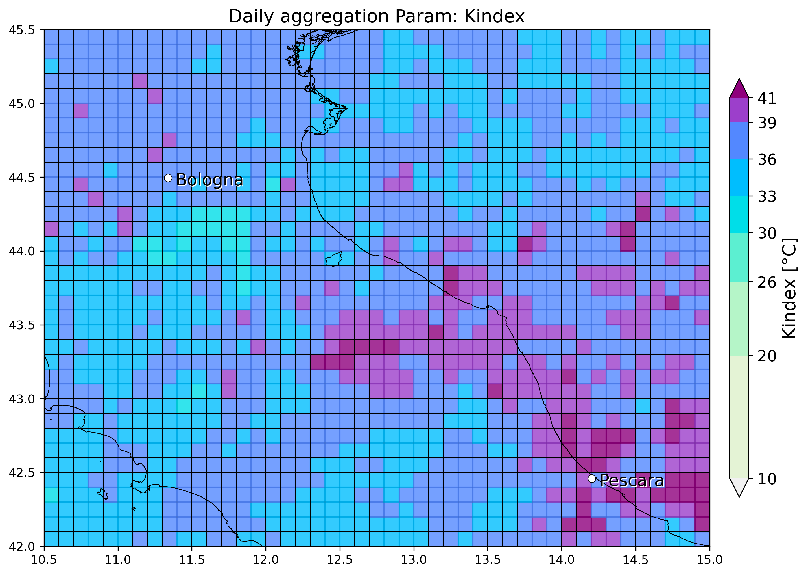

* 18 June 2016, Asiago (3cm, but large accumulation): 1 eswd report, no matching with neither OT, LJ or SPHERA proxies

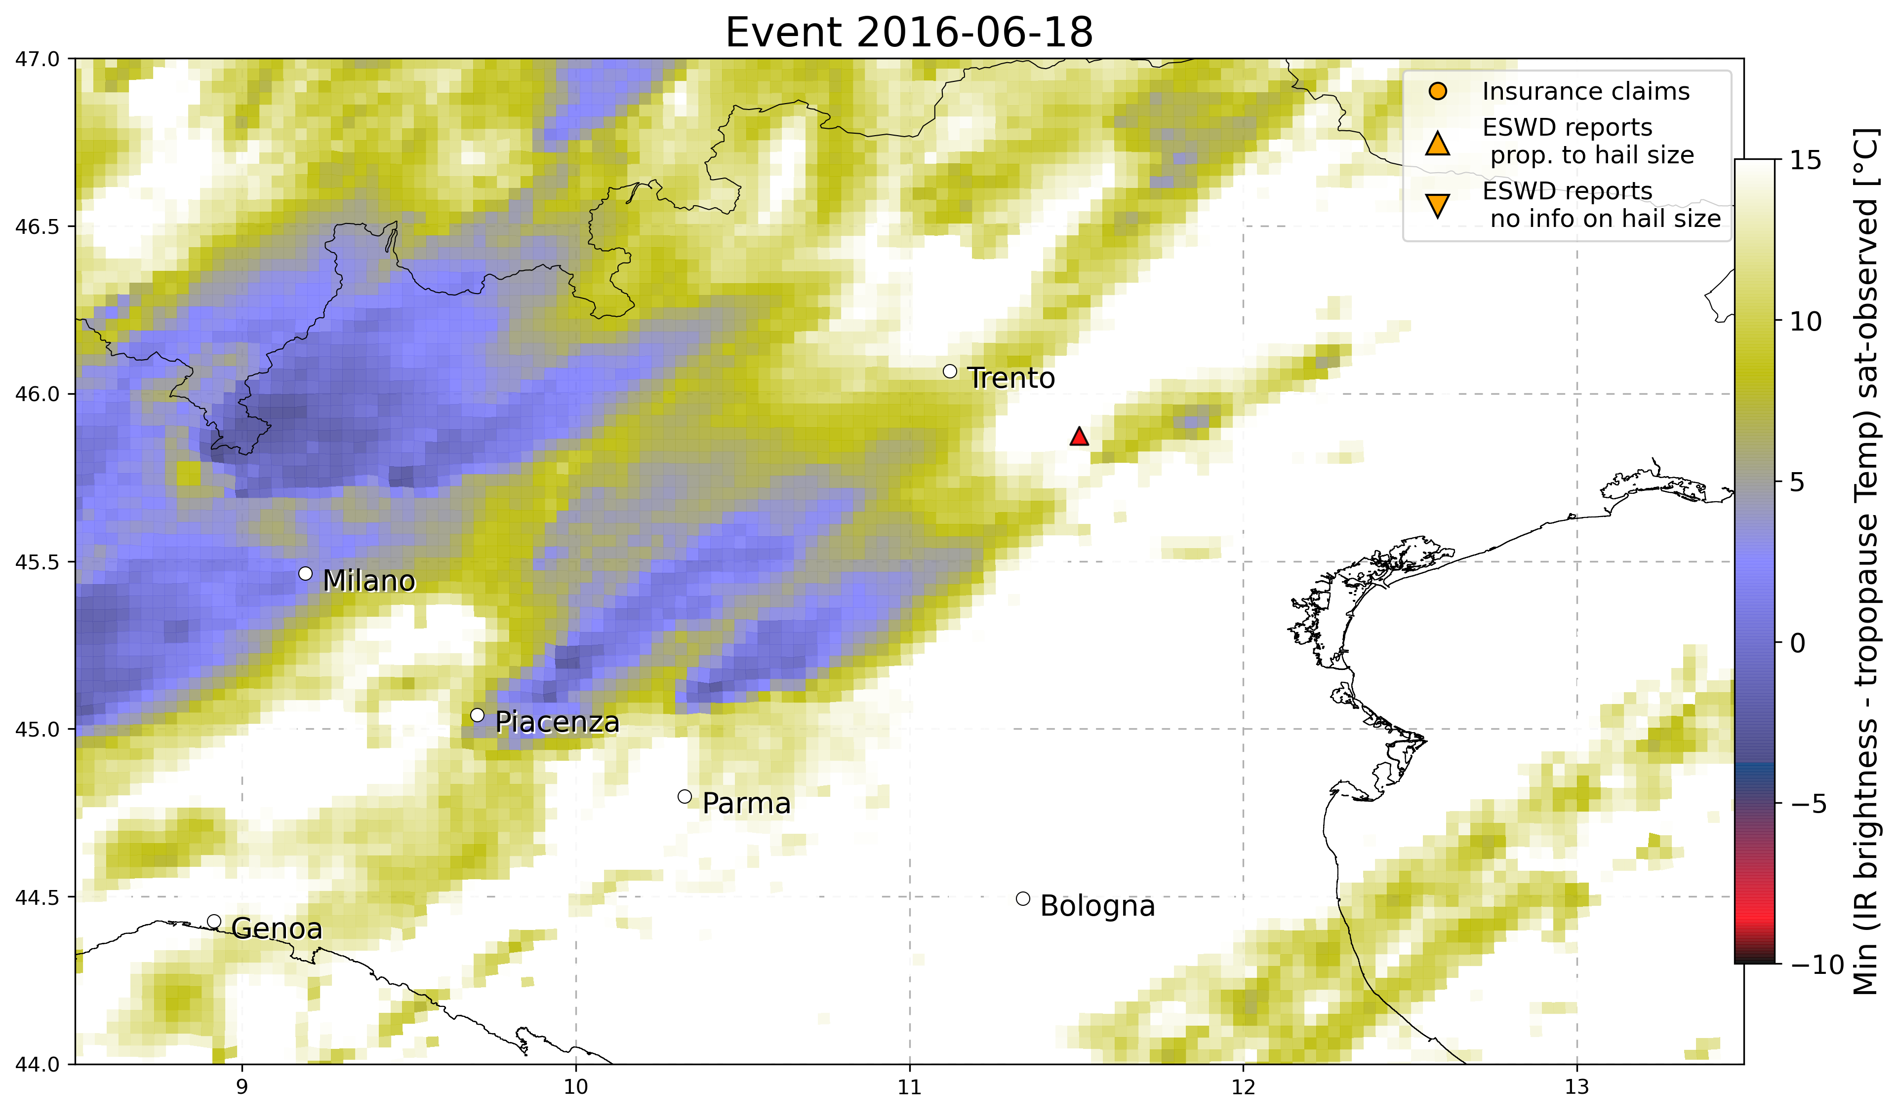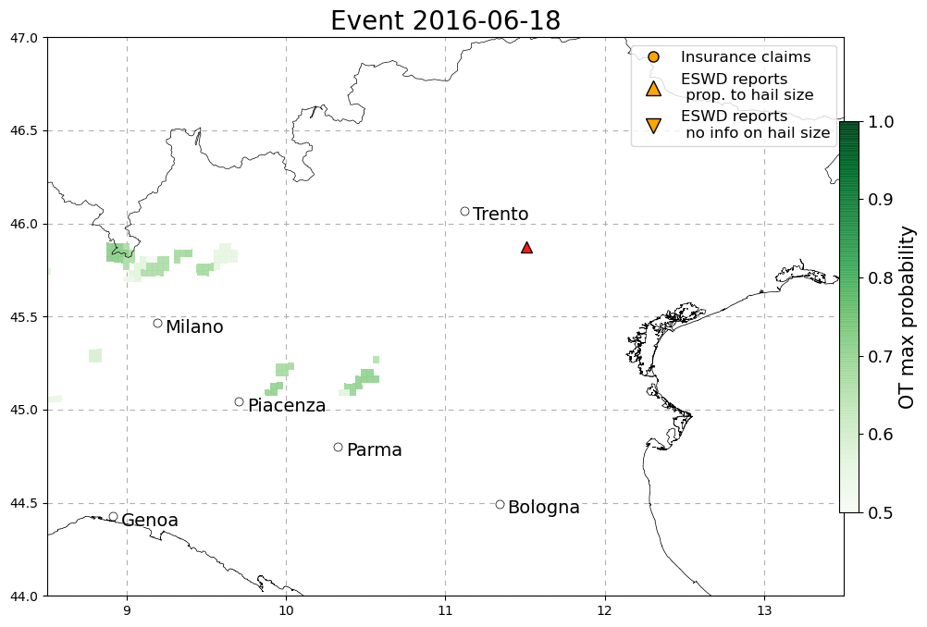

* 8 April 2016, Condove (Torino): 3cm hail with large accumulation, 1 eswd report, missed by OT, LJ and also SPHERA proxies do not show agreement (only %VV700 shows an isolated maximum close to the report location!)

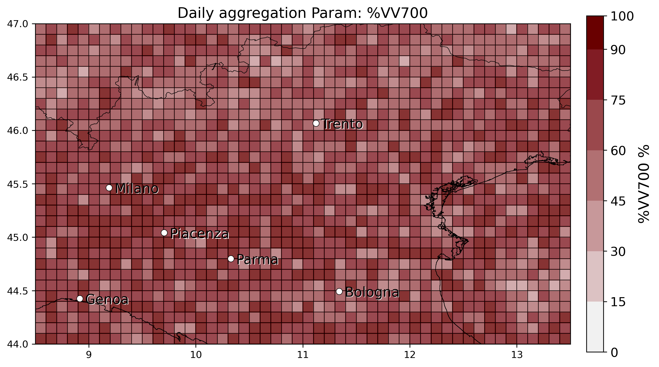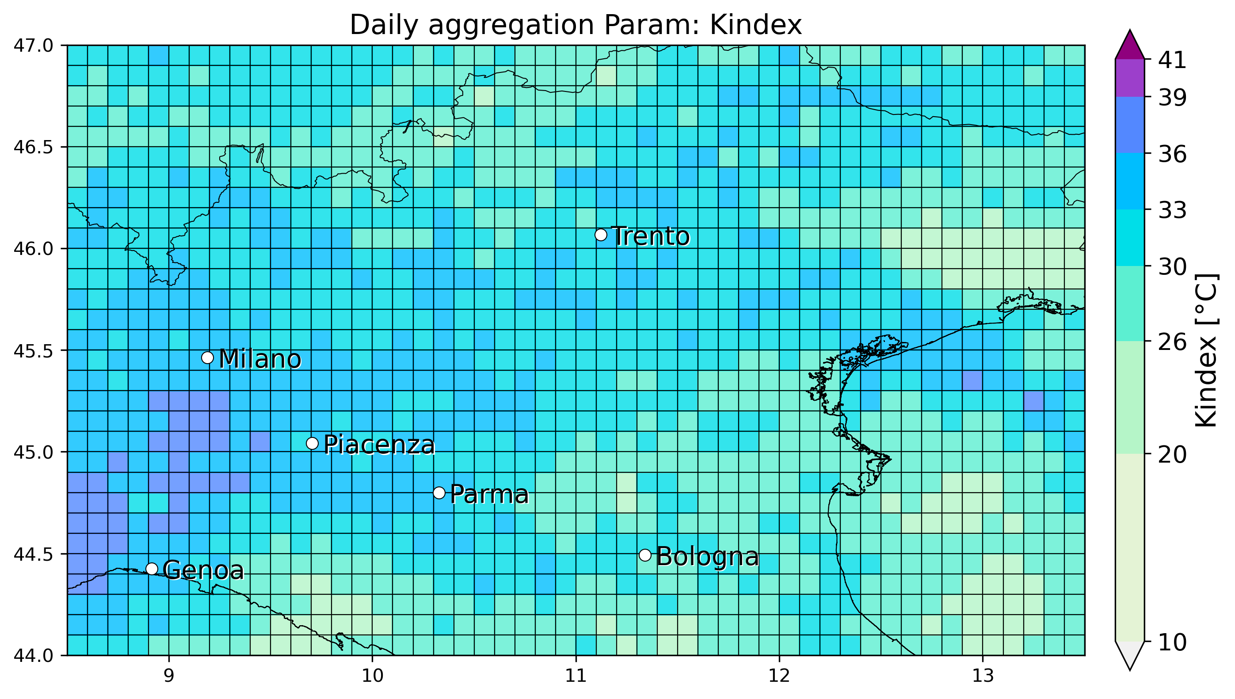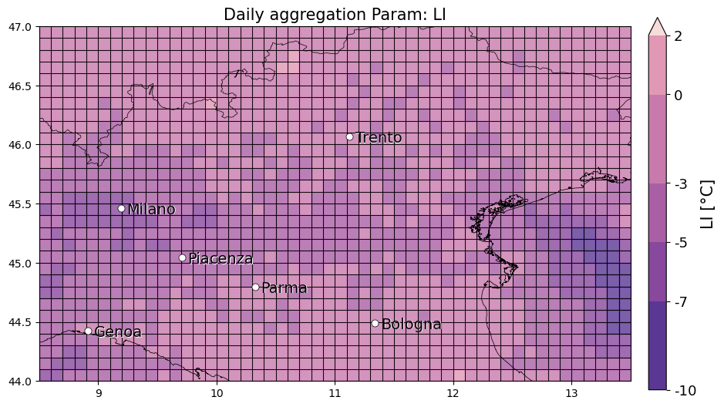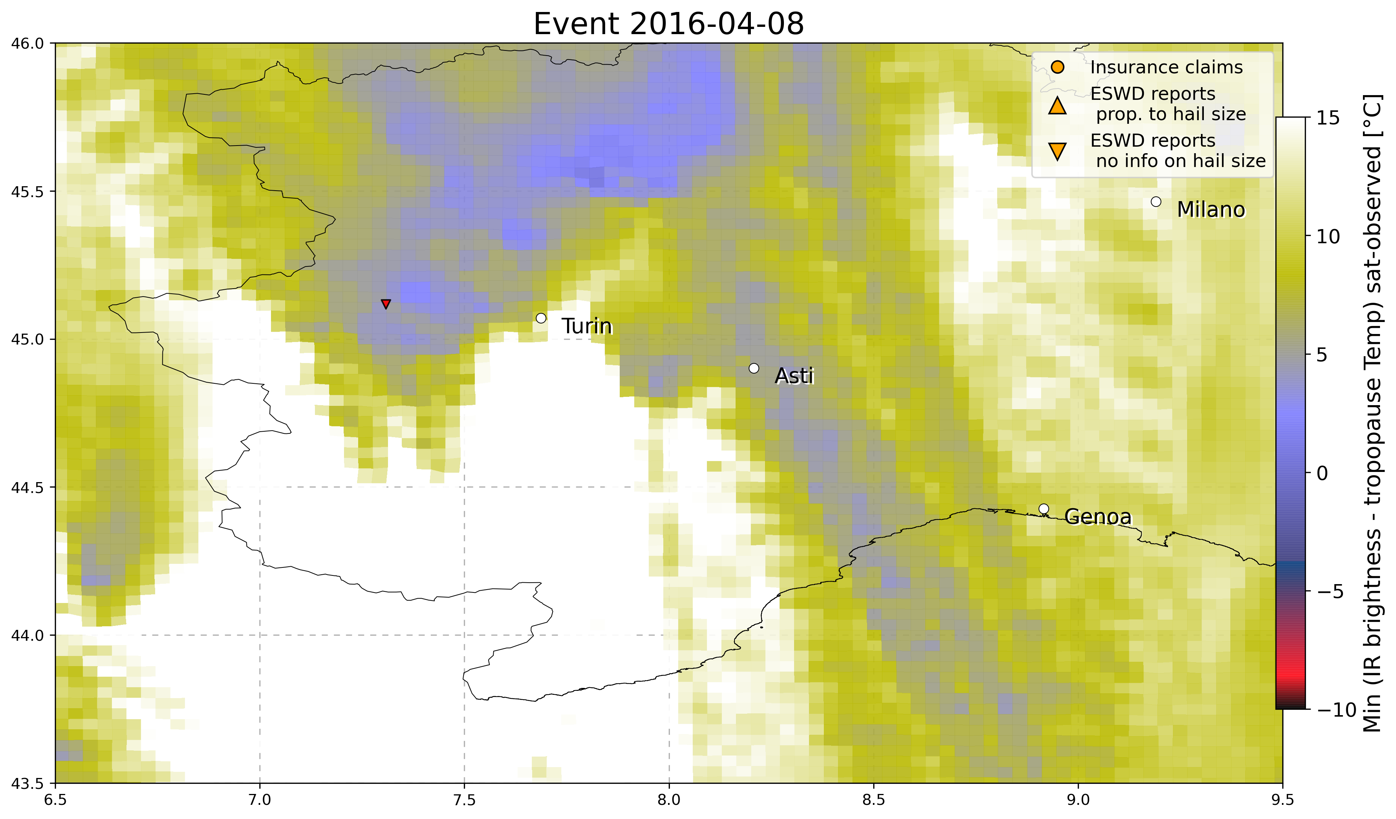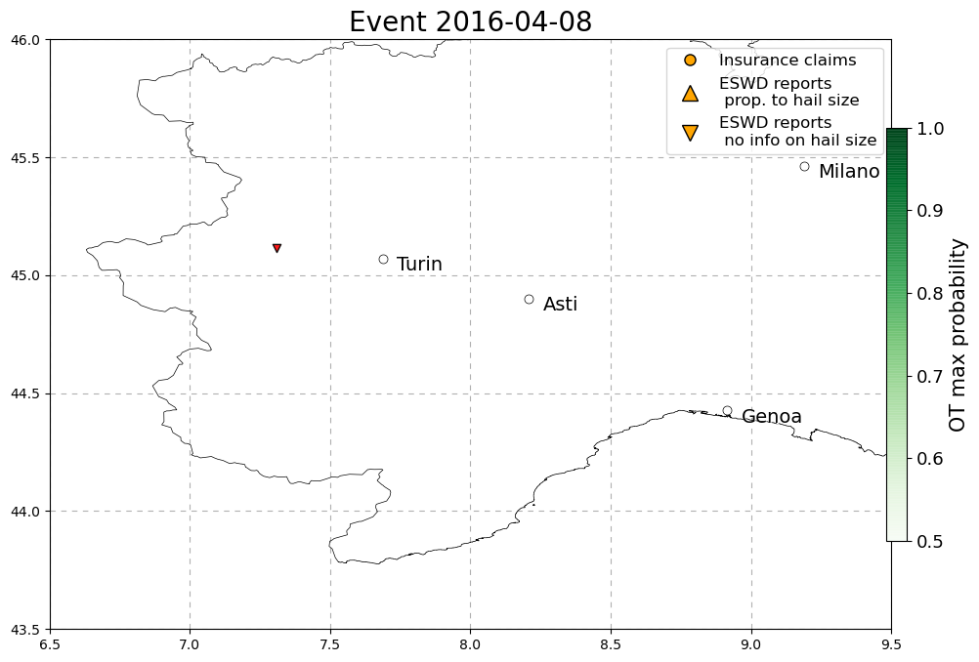

* 7 April 2016, Berbenno (Bergamo): small hail, 1 eswd report, missed by OT, LJ. LI shows a isolated minimum close to the report while the other 2 params do not (perhaps events in April are climatologically not related to convection strong enough for identify them with OT detections or LJ or reanalysis proxies describing hail-favouring conditions)

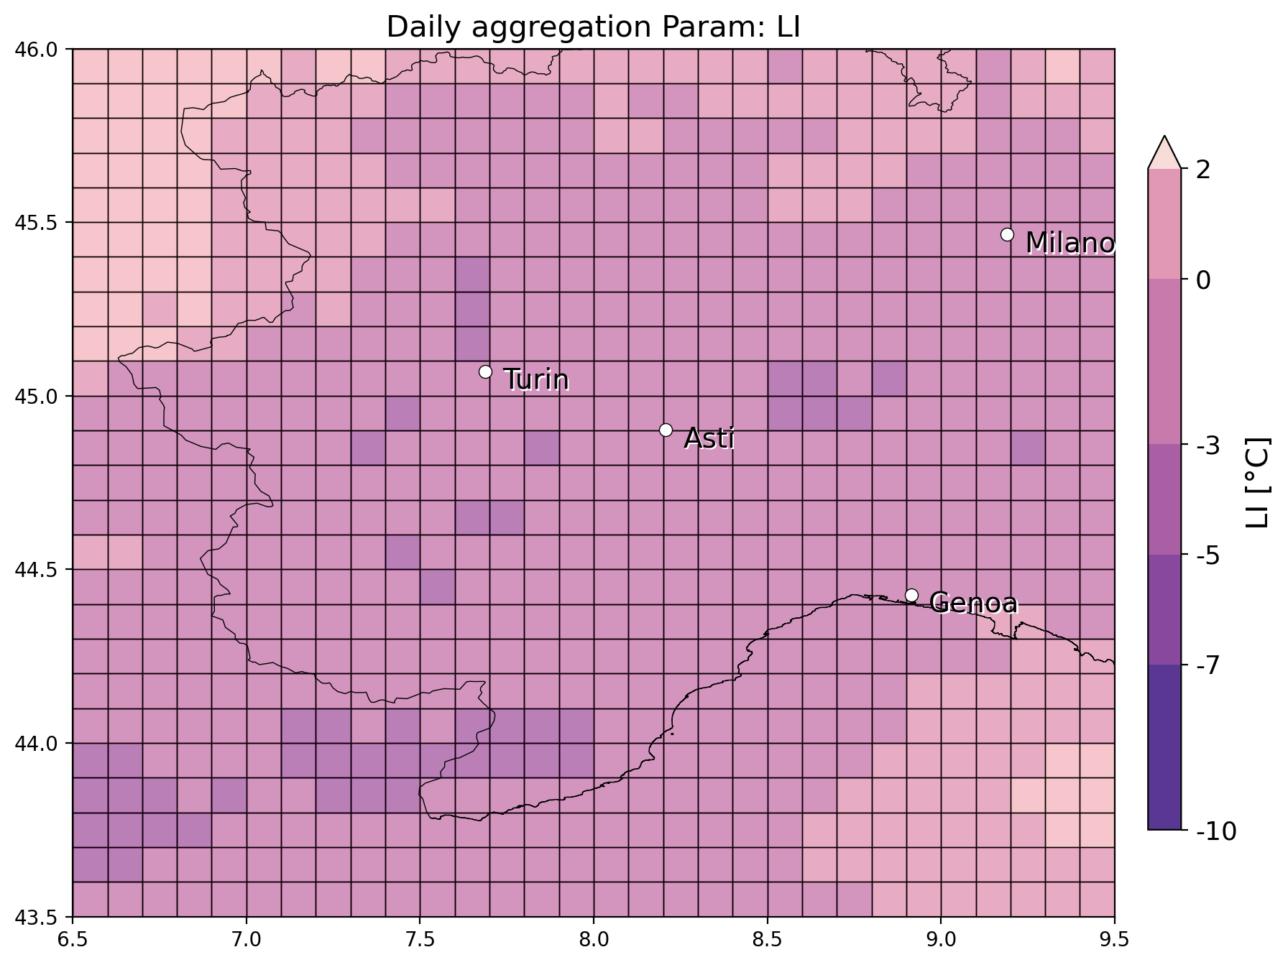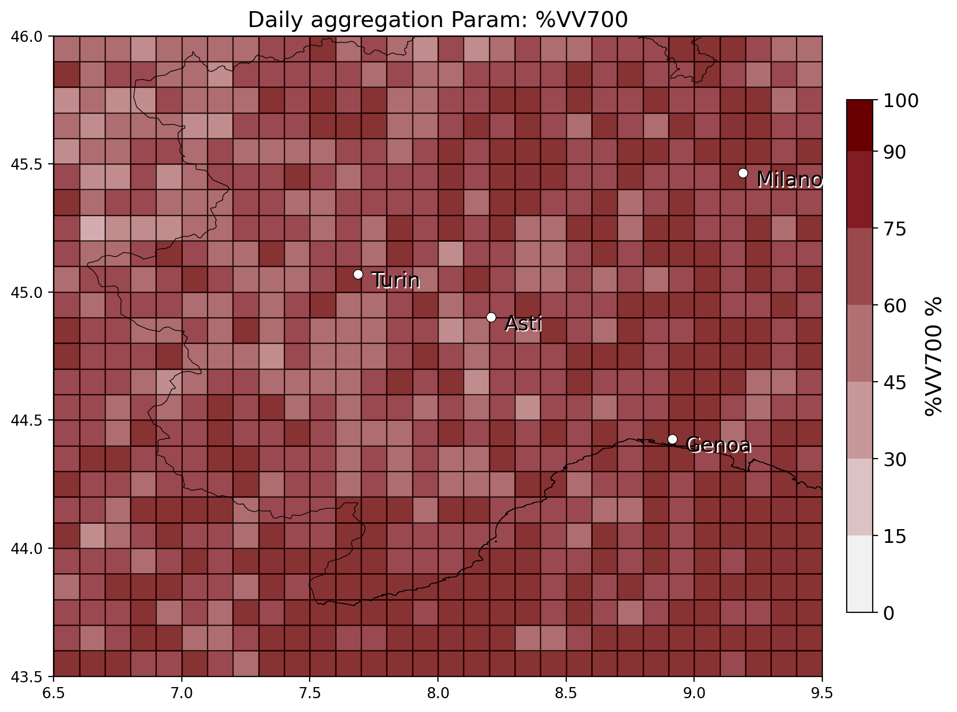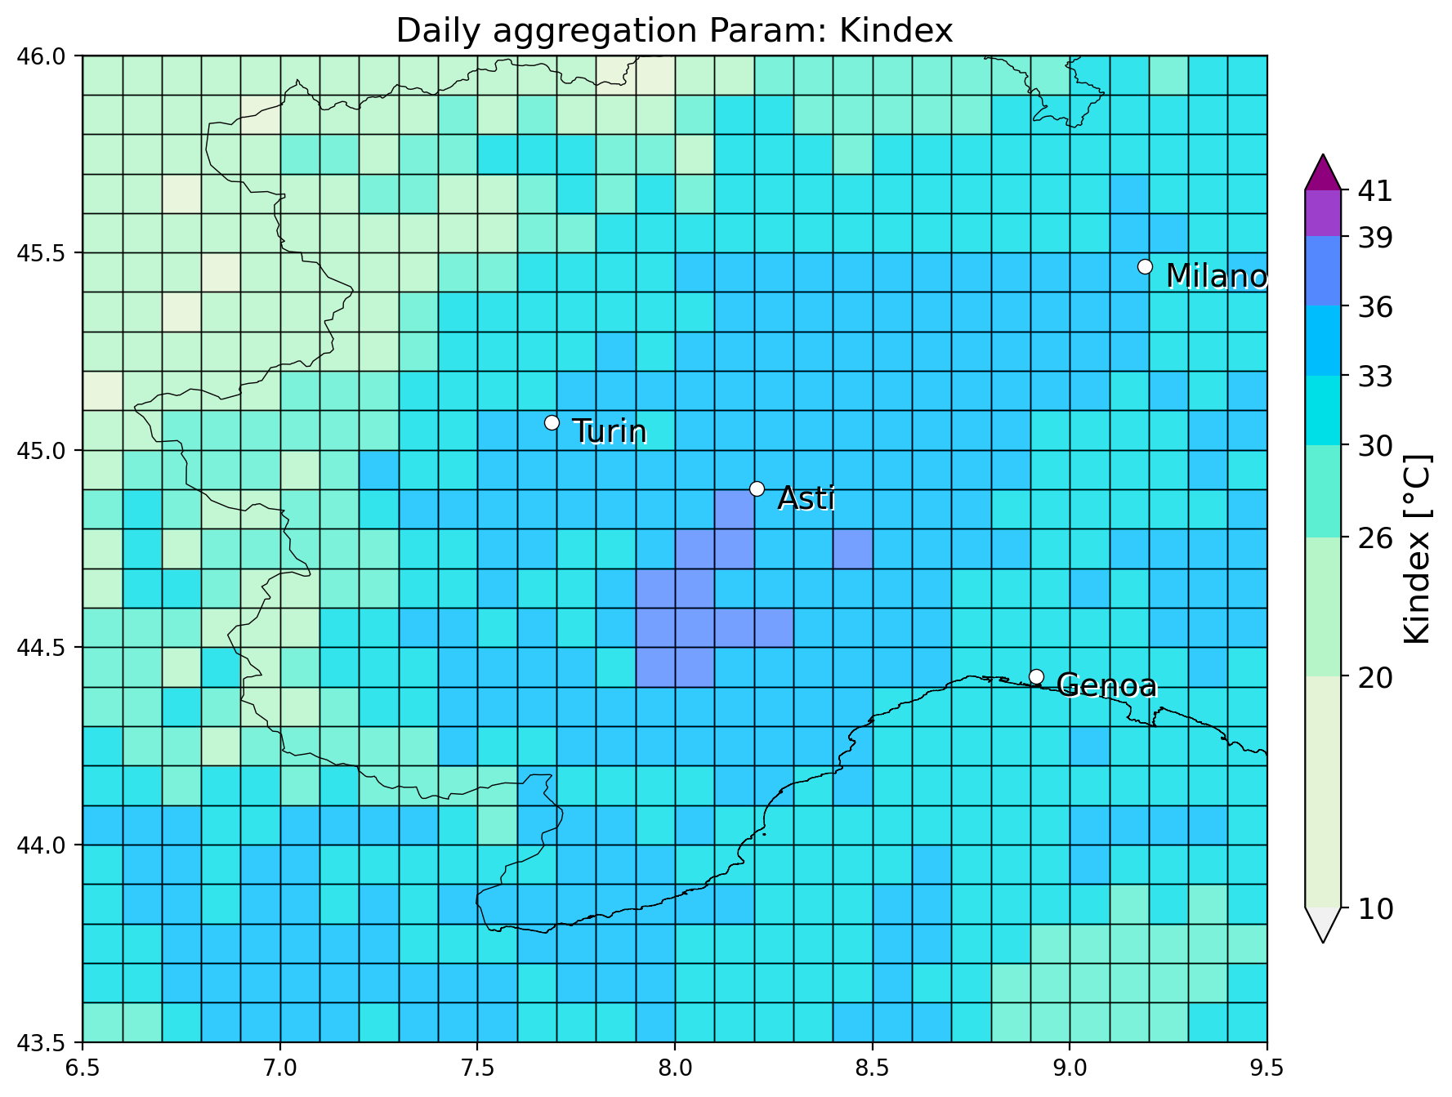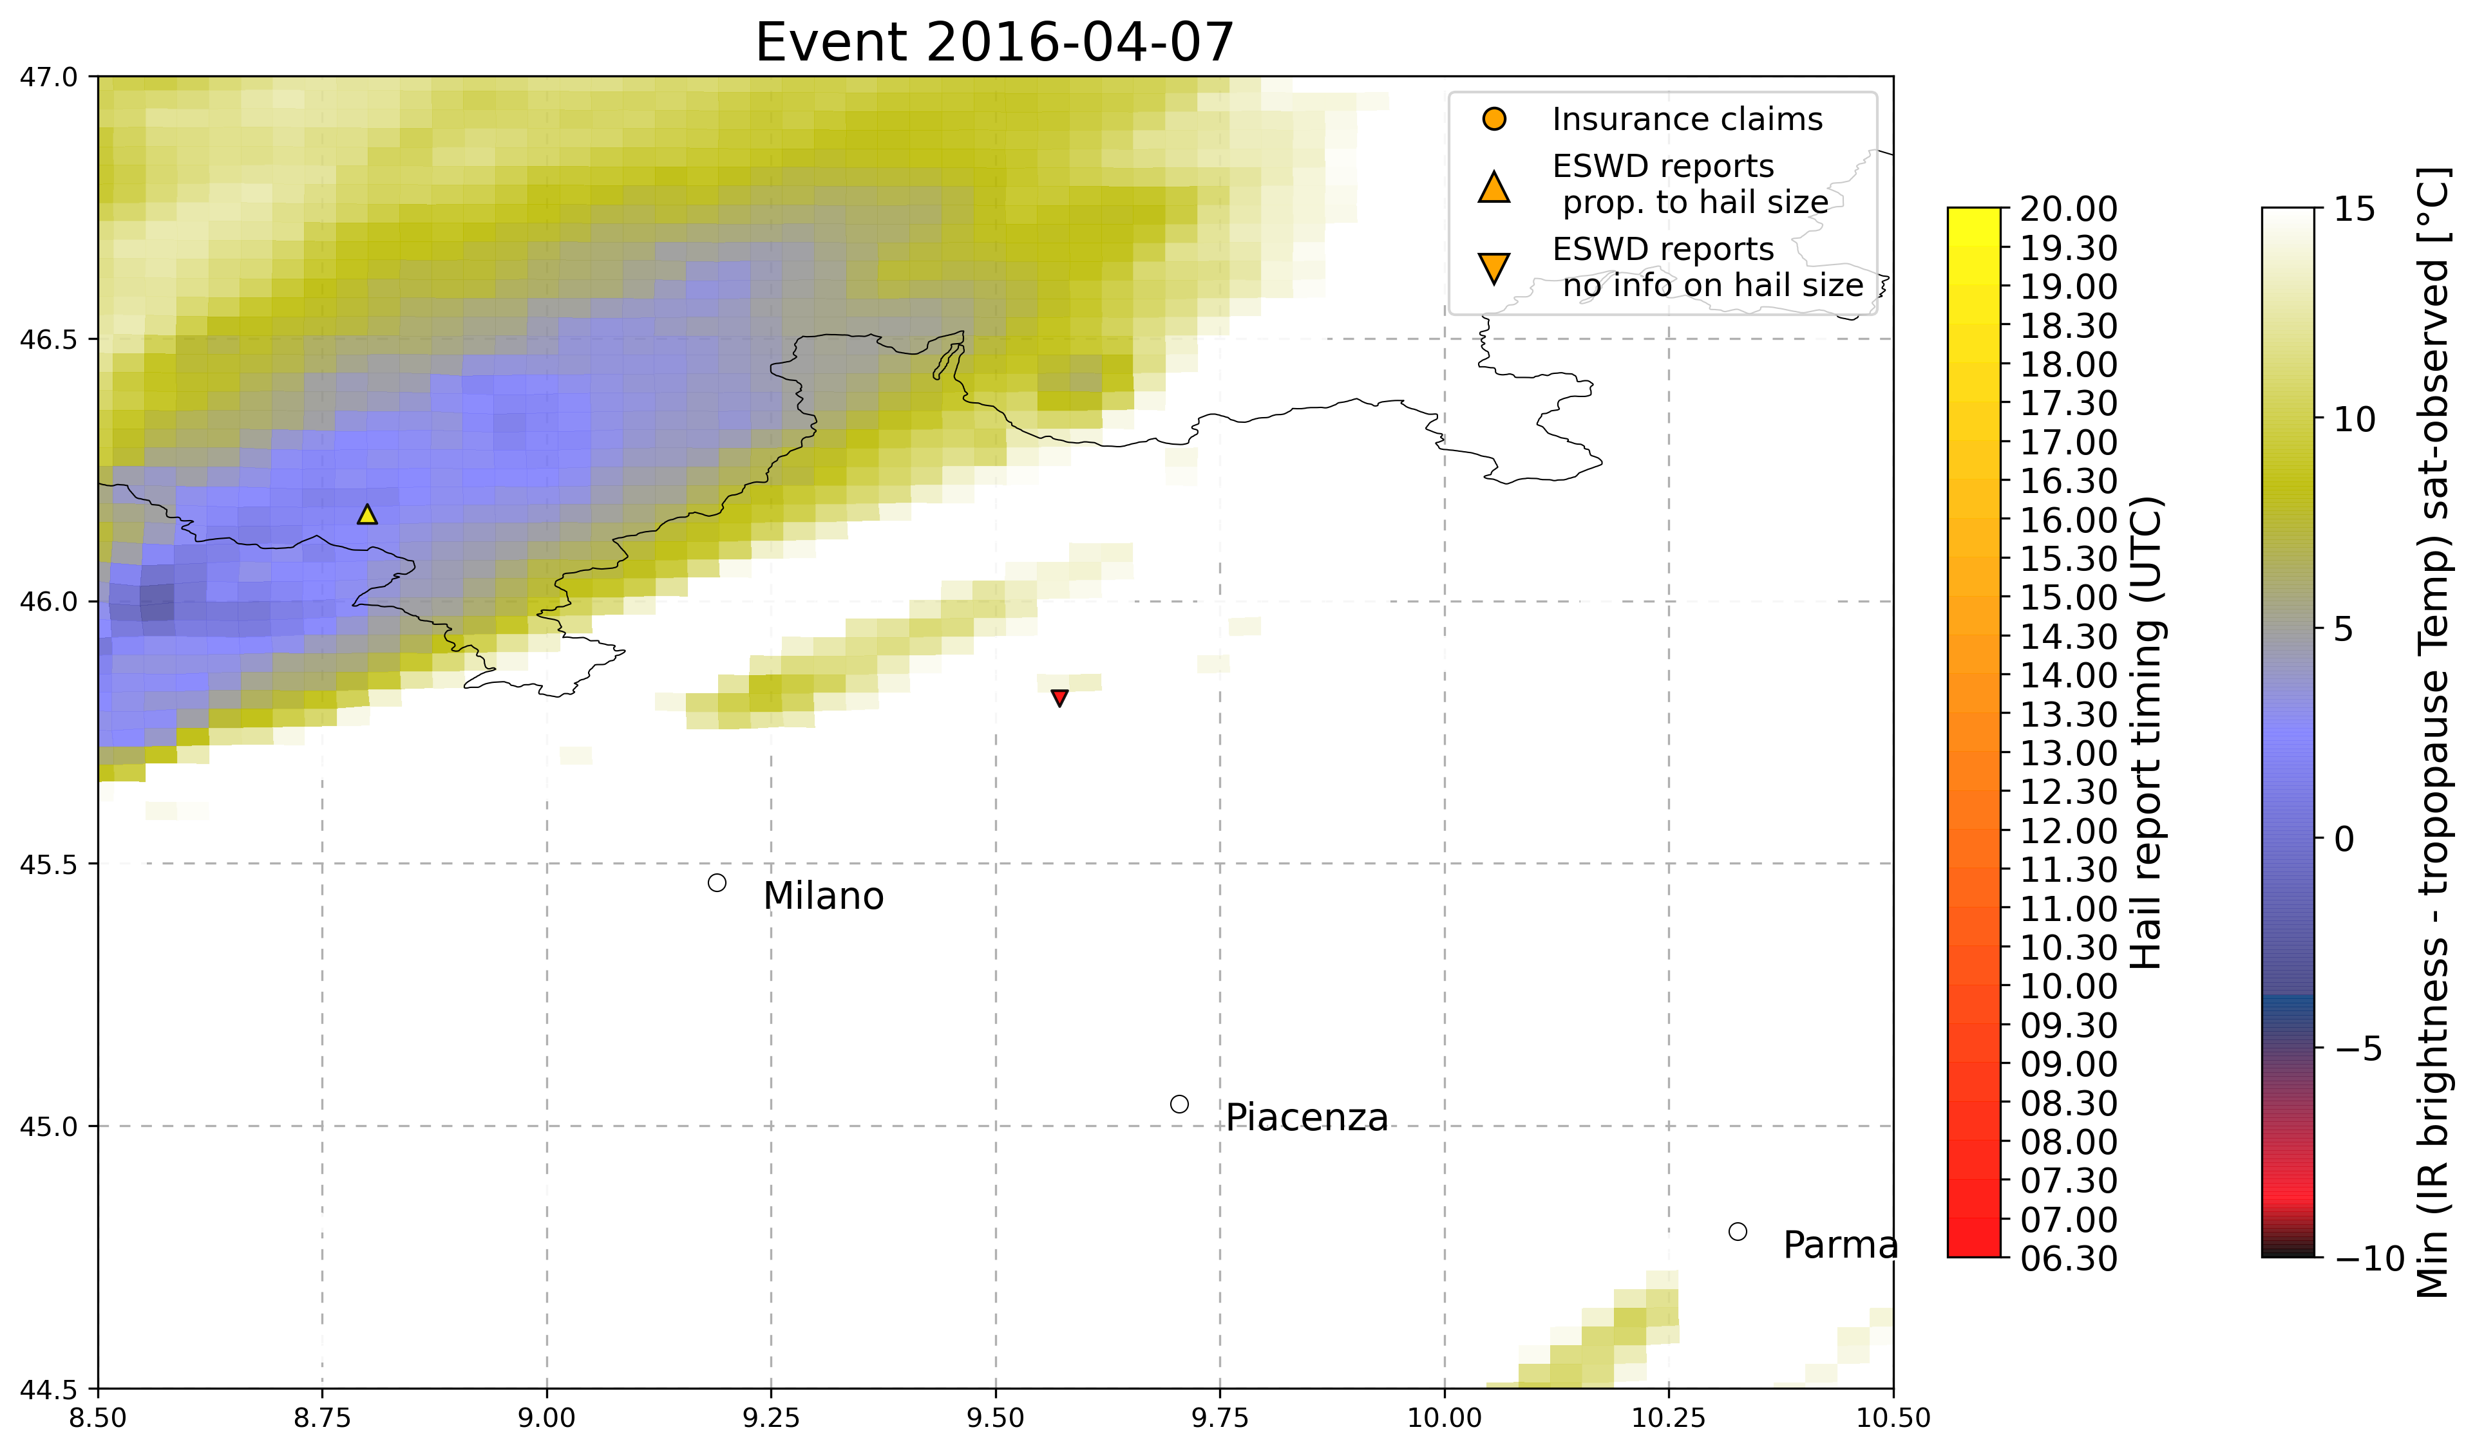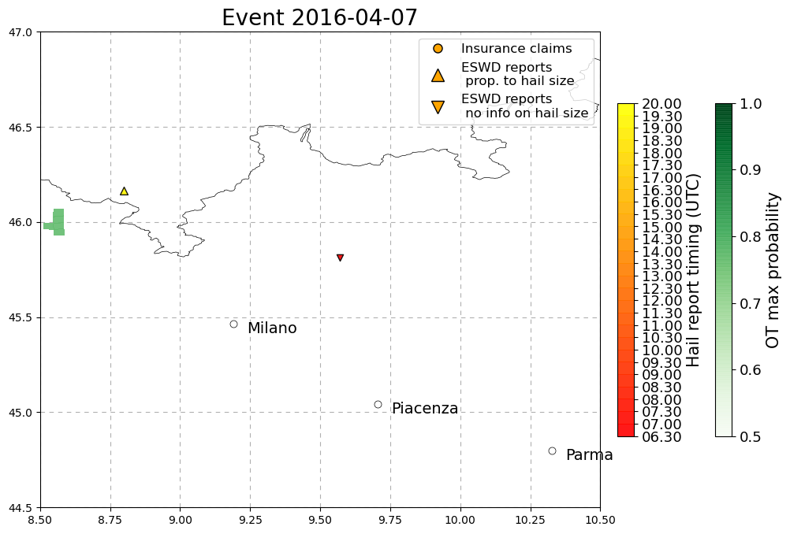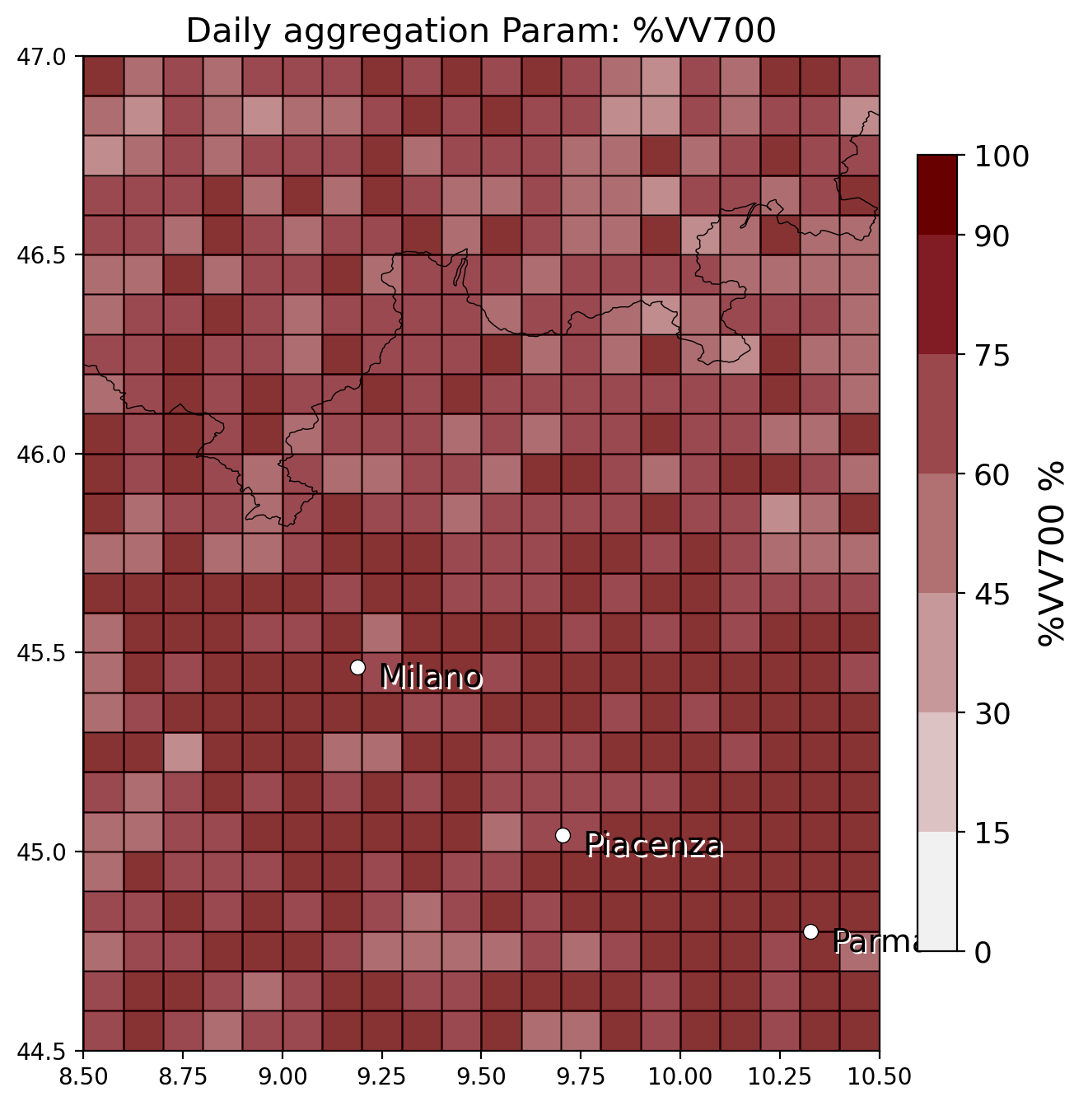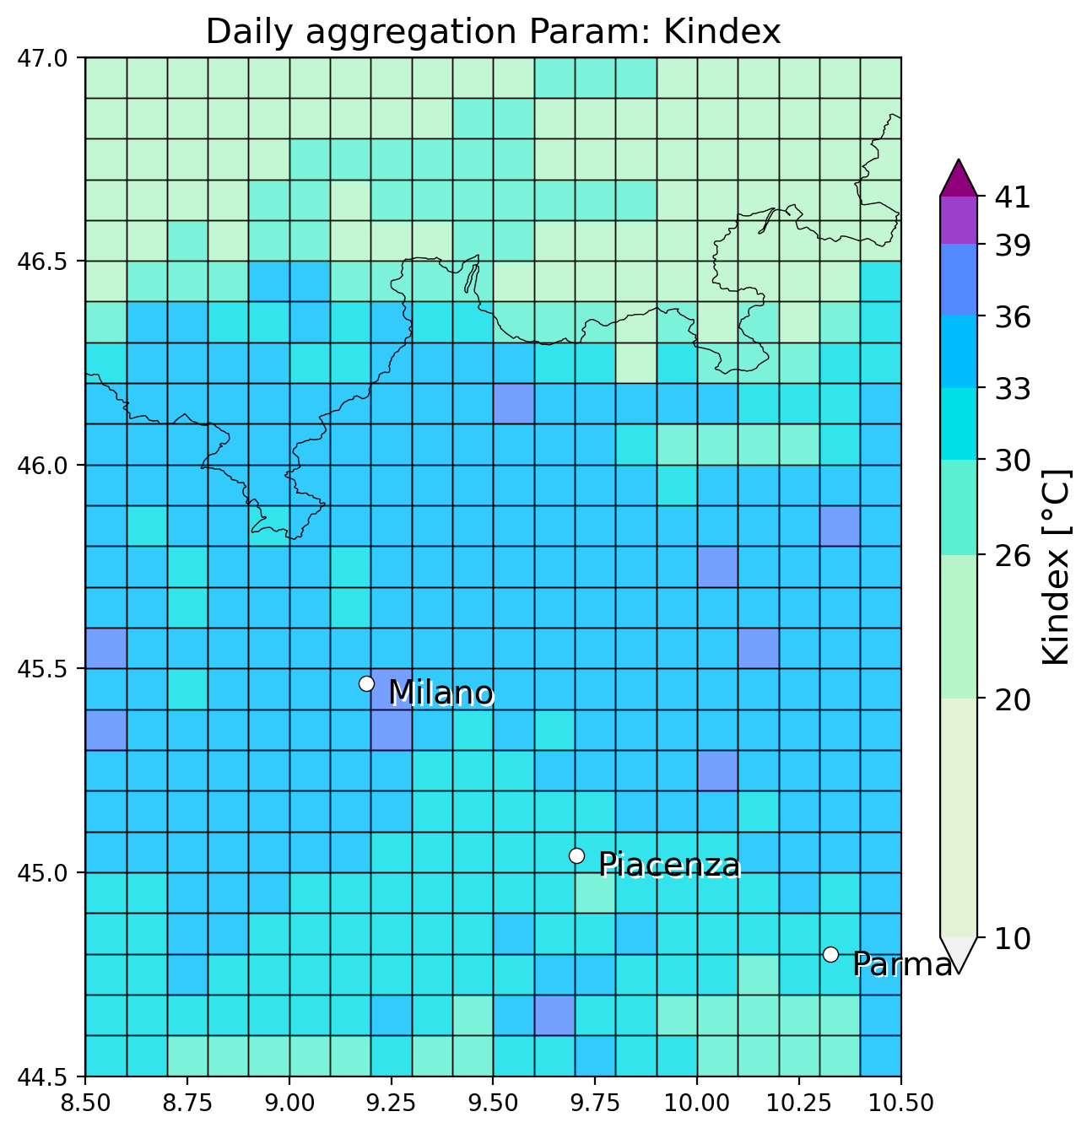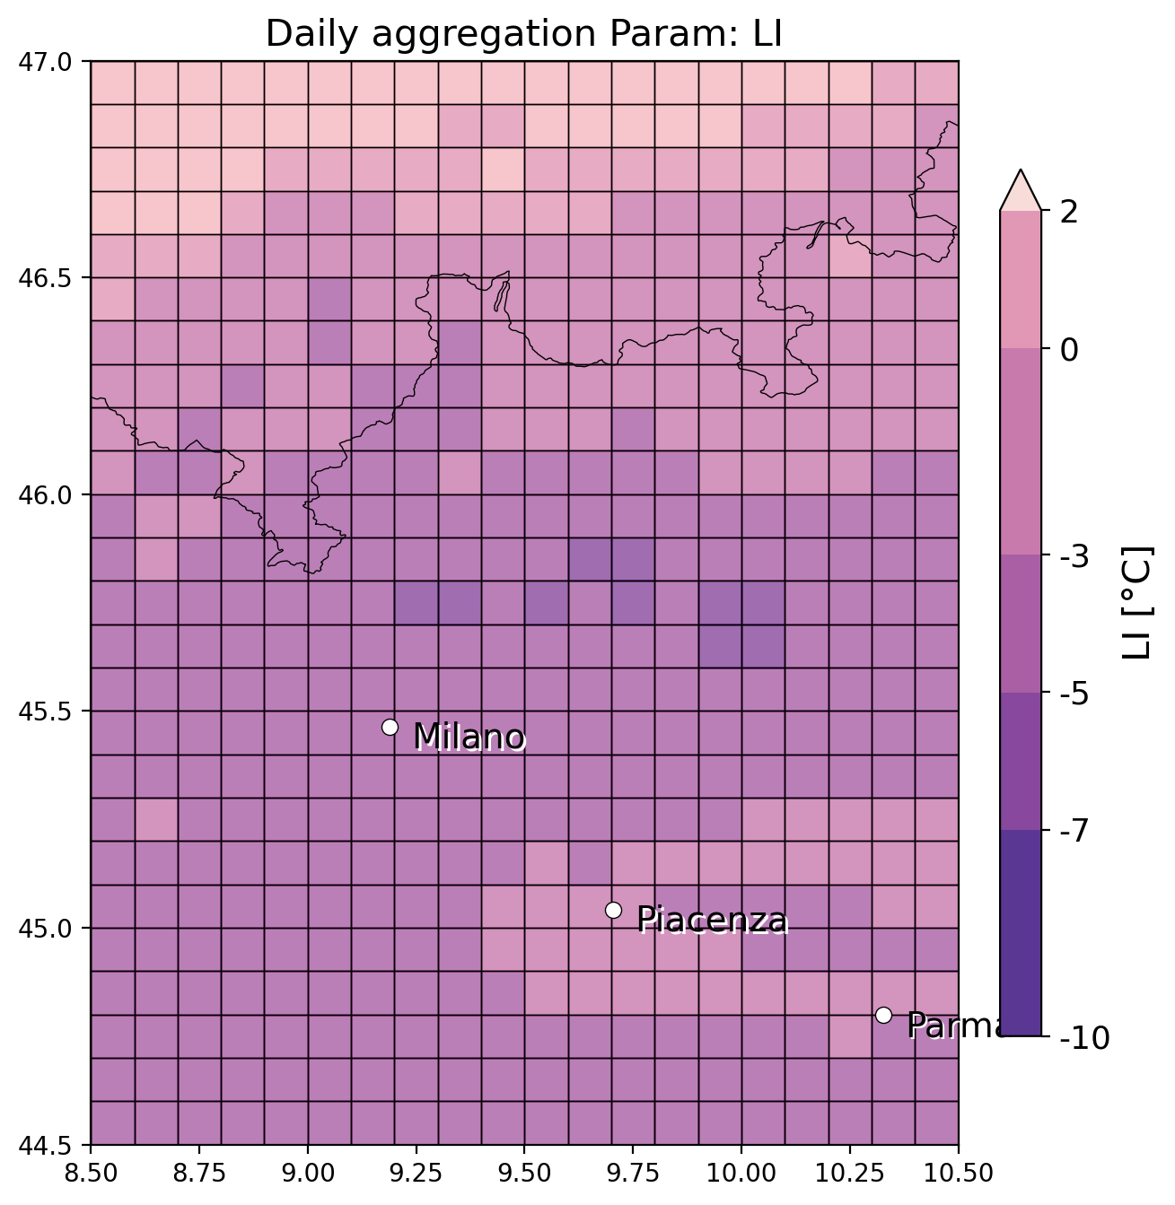

FOR COMPLETENESS HERE ADDED ALSO THE INITIAL SET OF 3 EVENTS:

* 29 October 2018, Alghero (Sardinia), 5cm hail, 1 eswd report several unipol reports, matching with OT for eswd report but majority of unipol reports not matched, LJ misses eswd report and majority of unipol but matches with some (BUT must check timing if correct!). SLI shows a localized minimum close by the eswd without matching it.

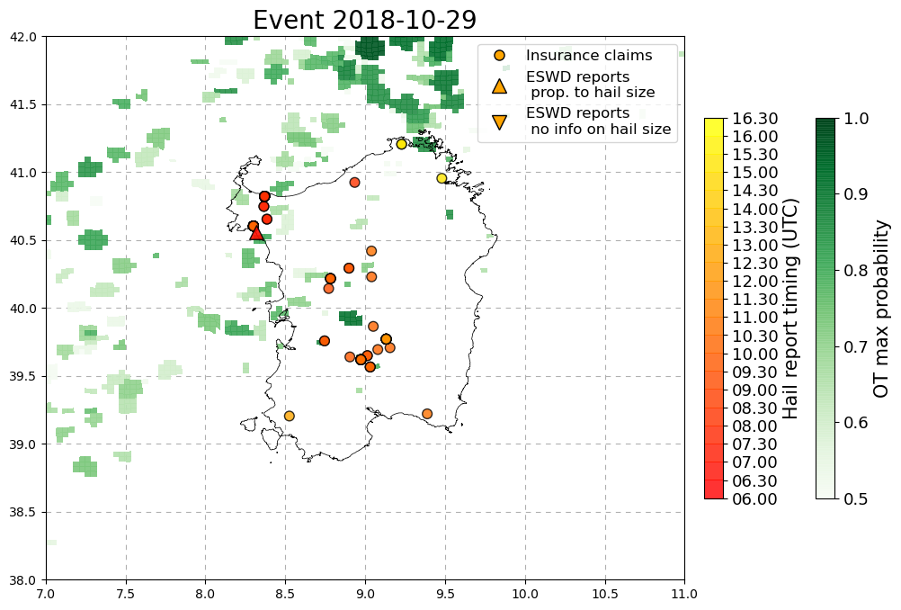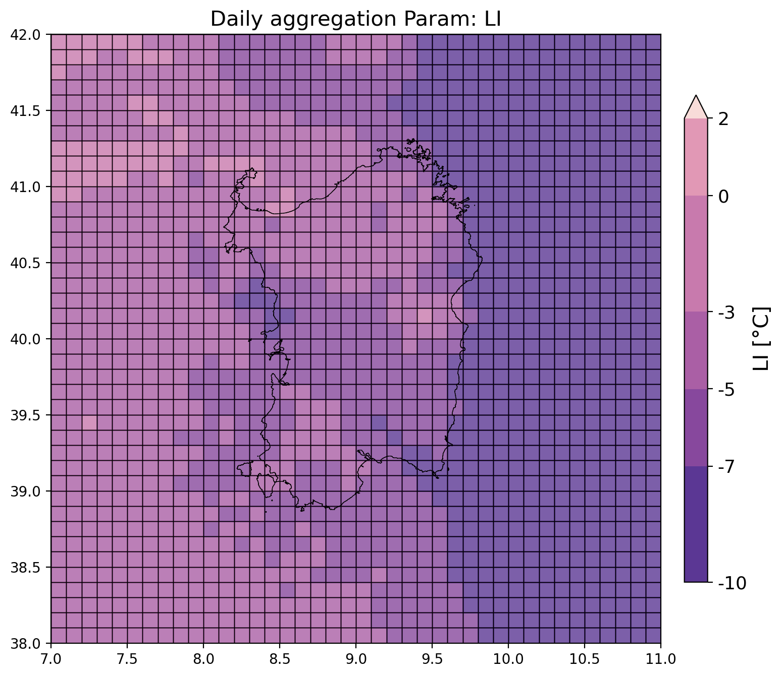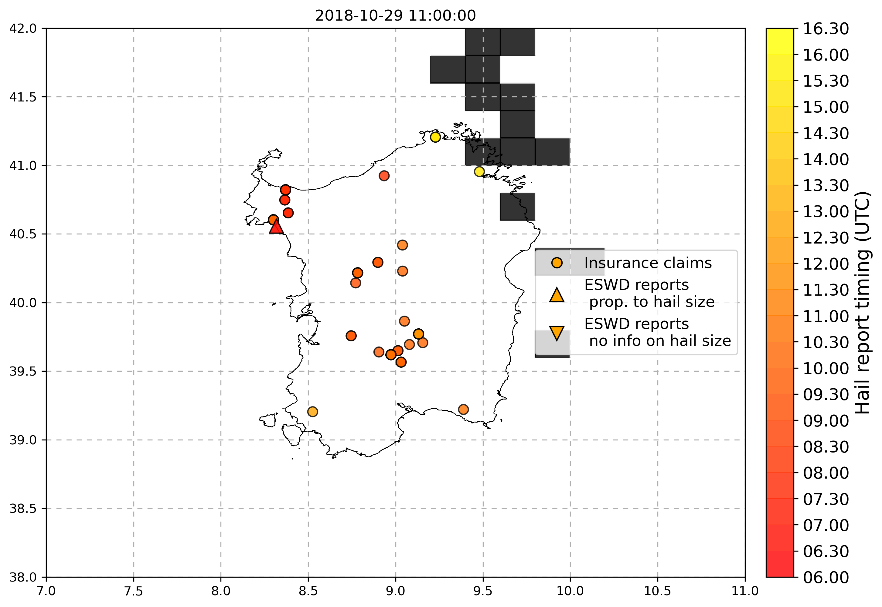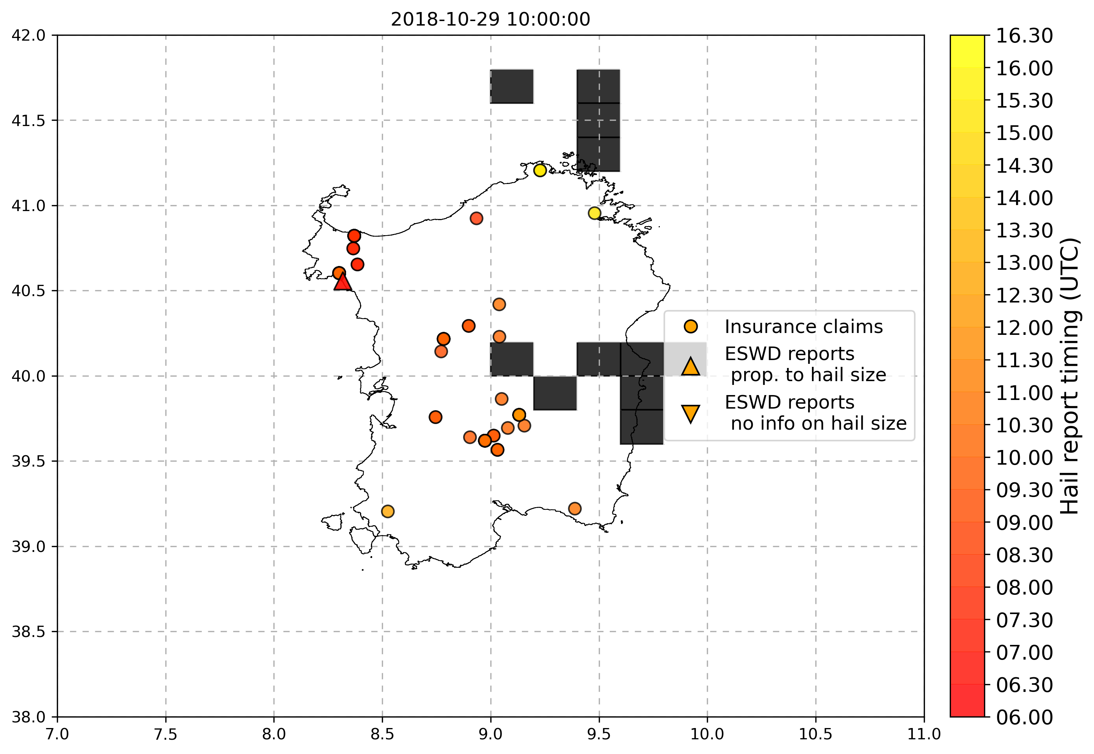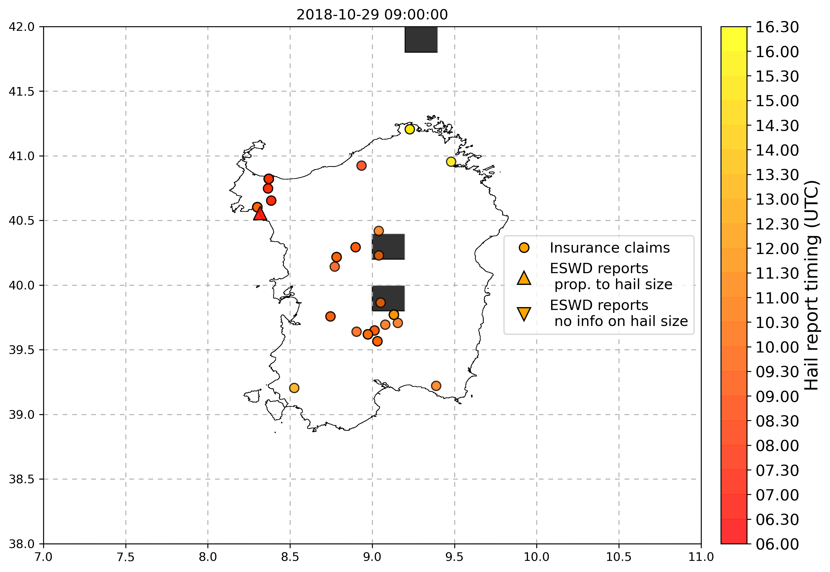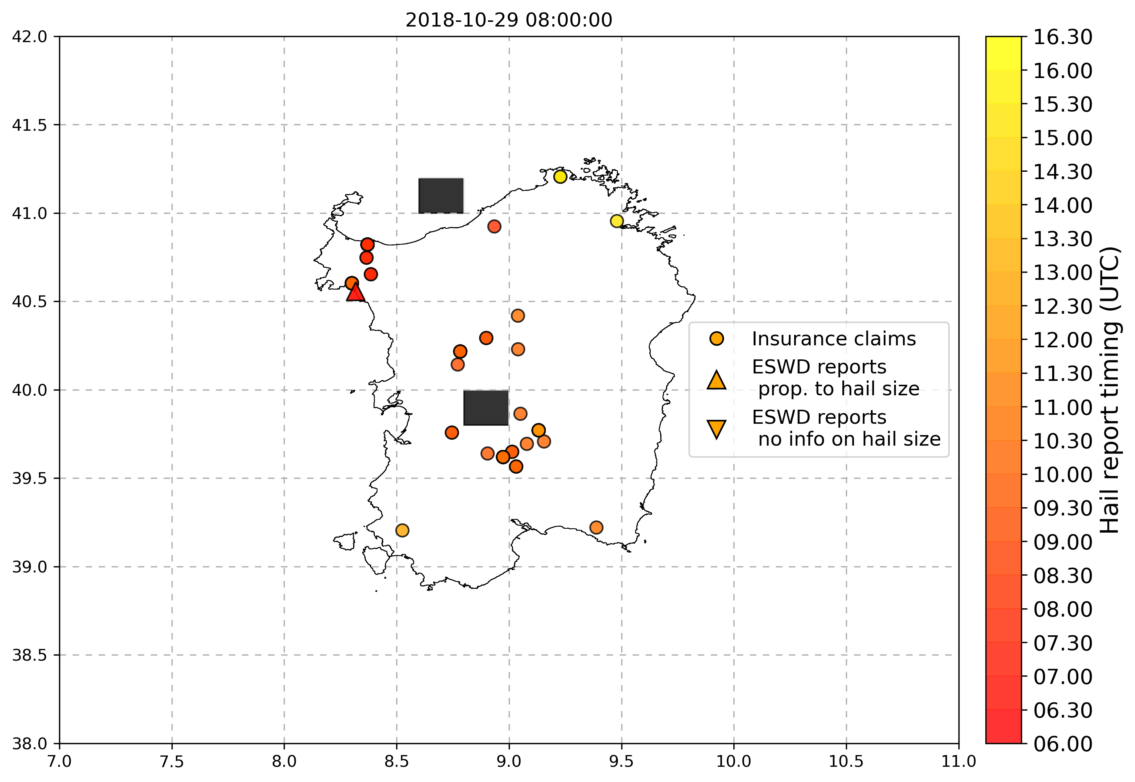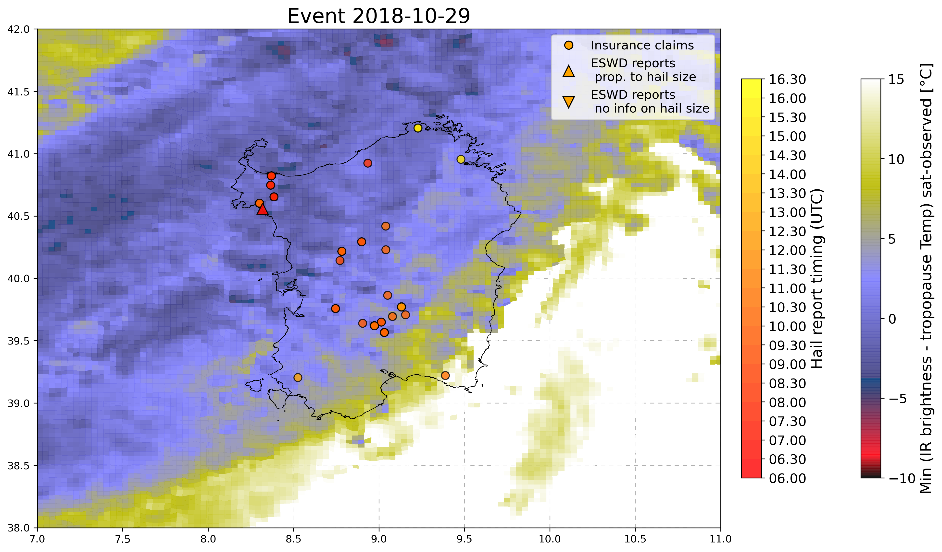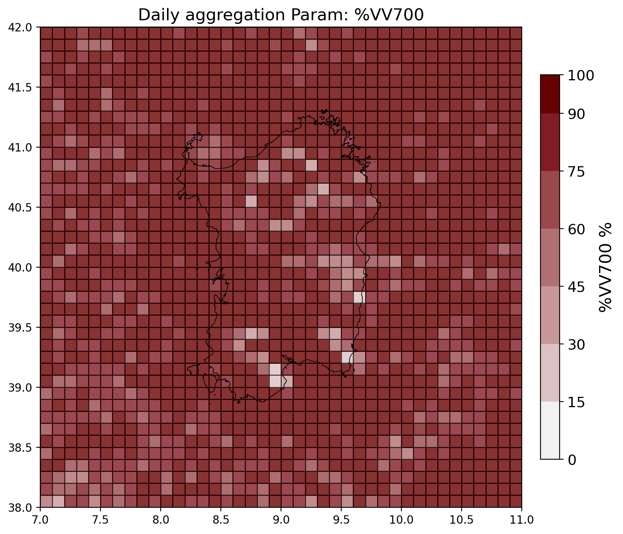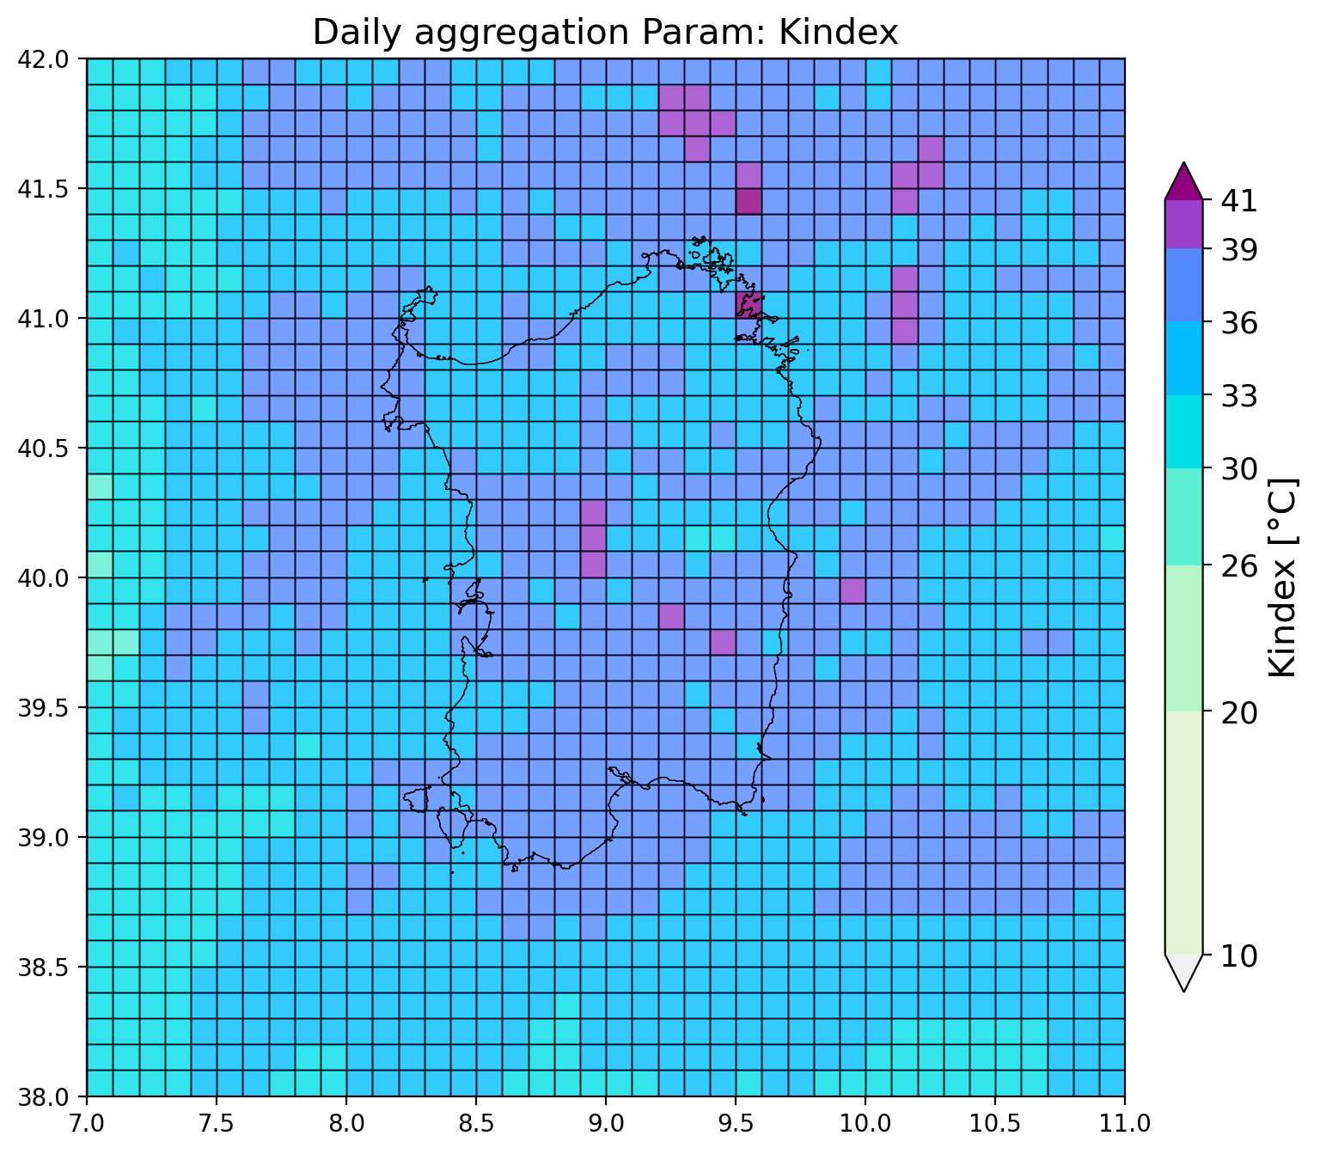

* 4/6/2018 in Parma (Noceto) 8cm hail + many other hailstorms in Italy with smaller hail (3cm): 7eswd reports and >300 unipol reports! Multiple matching of OT with all eswd reports and many unipol reports, also hourly LJ matches well with eswd reports. SLI shows good matching with deep convective spots where reports are issued!

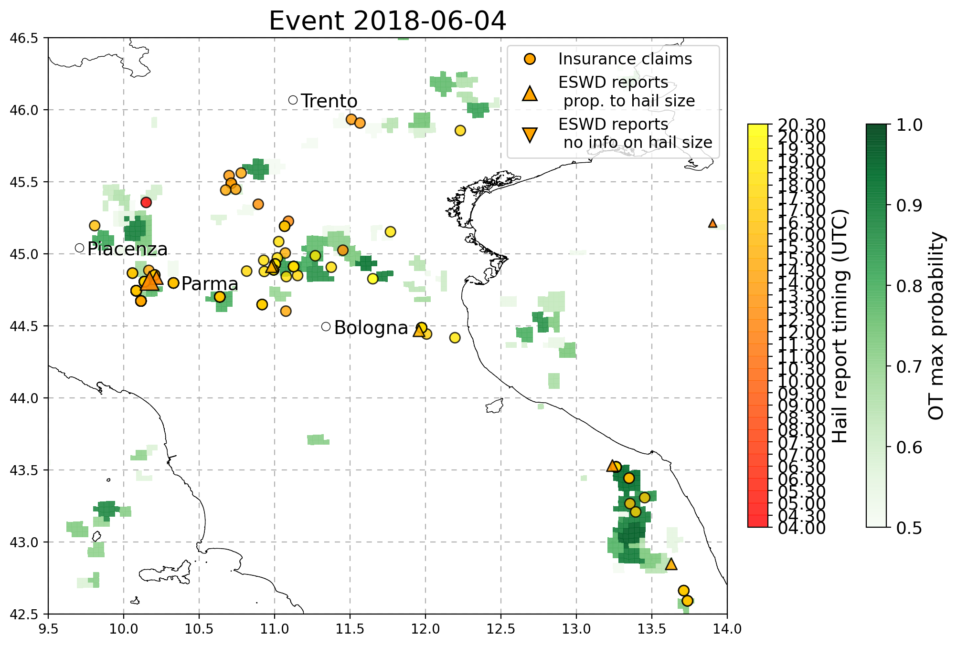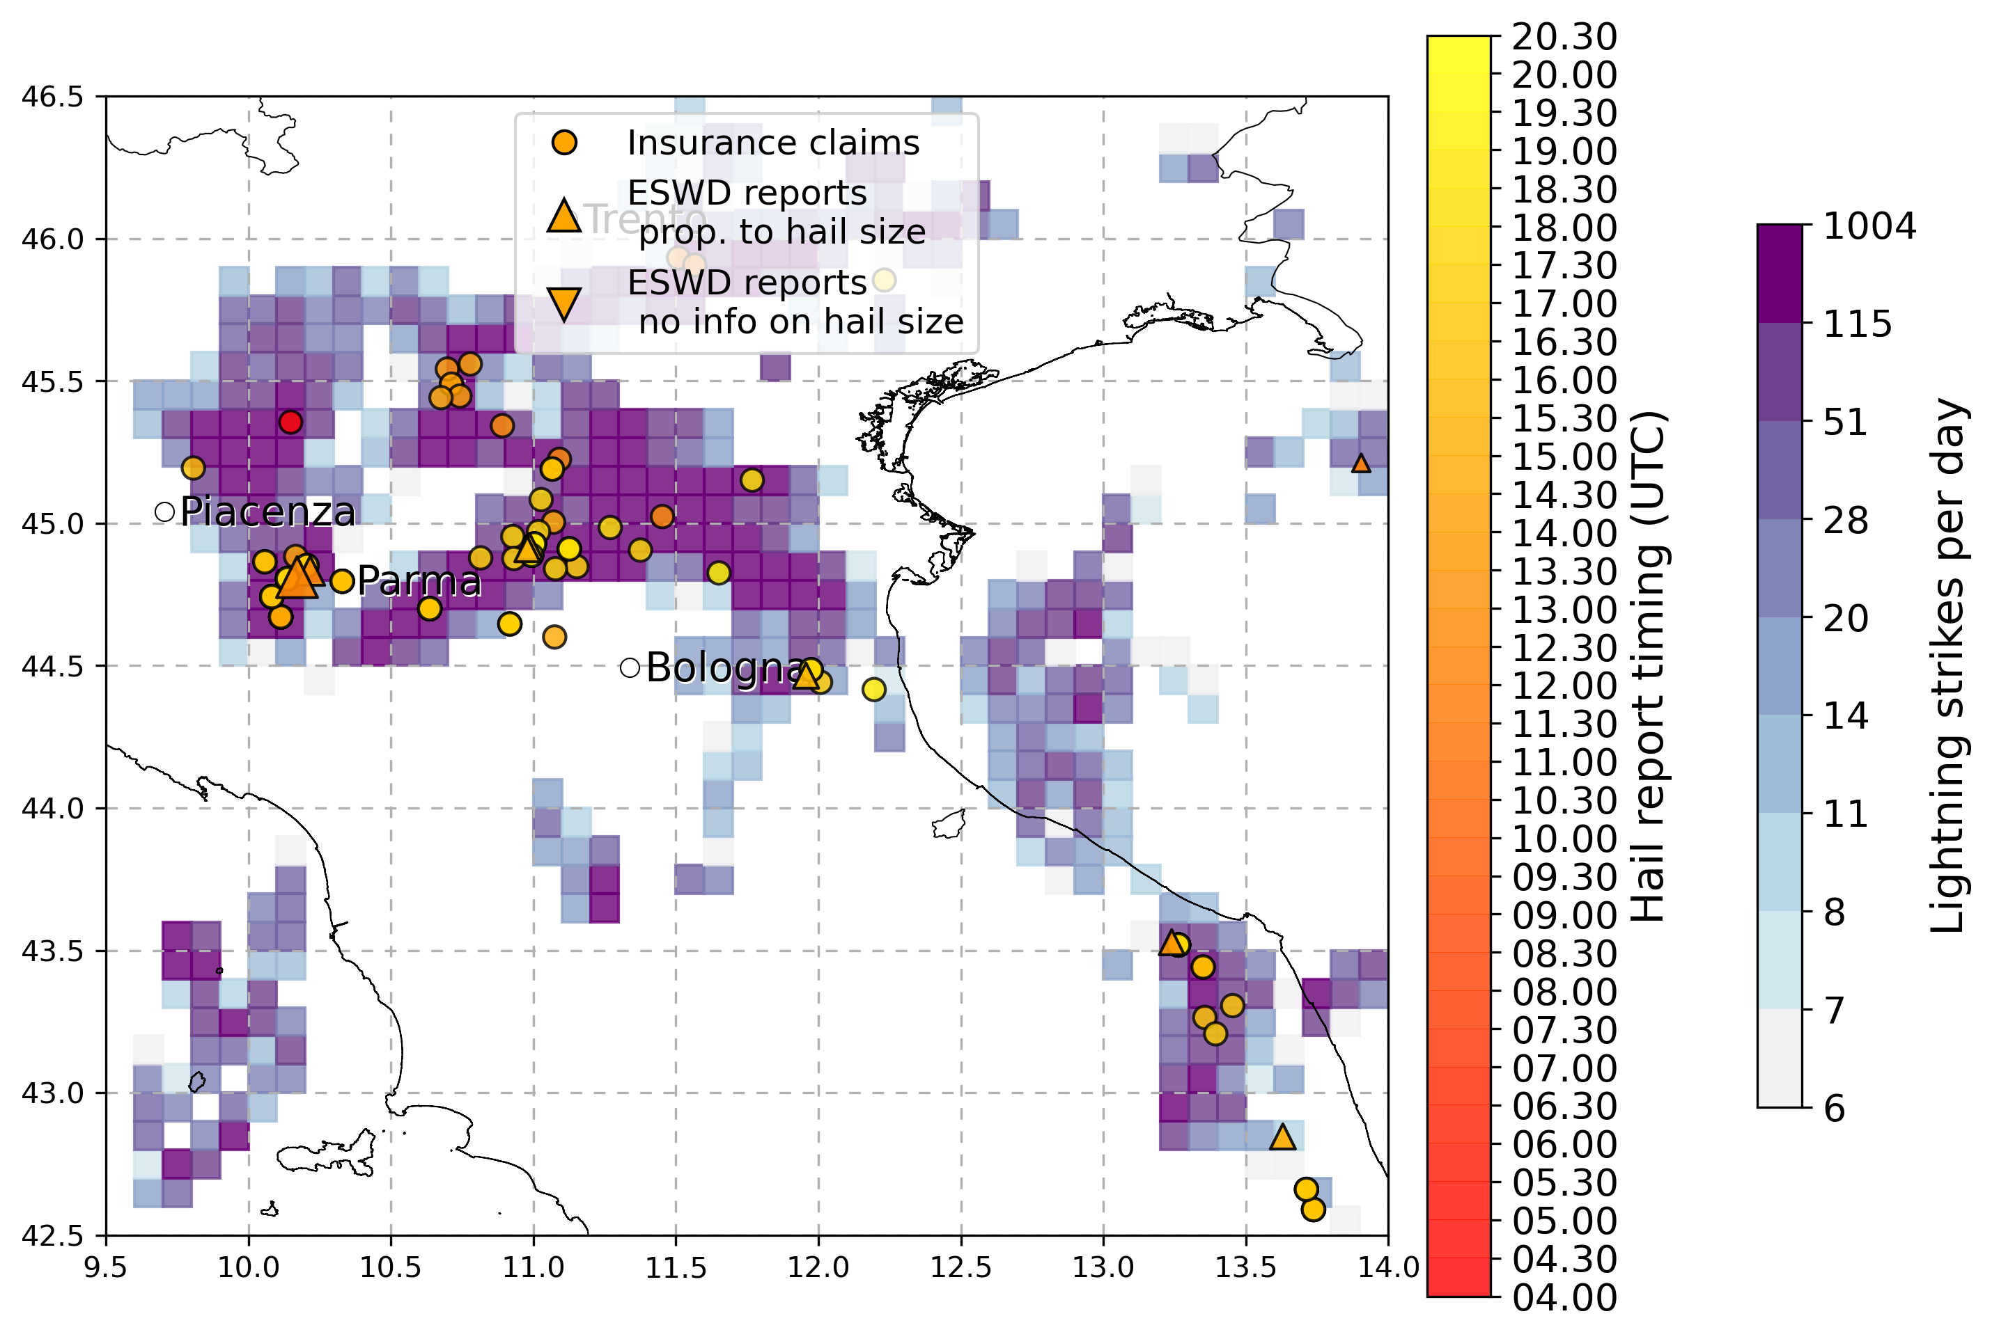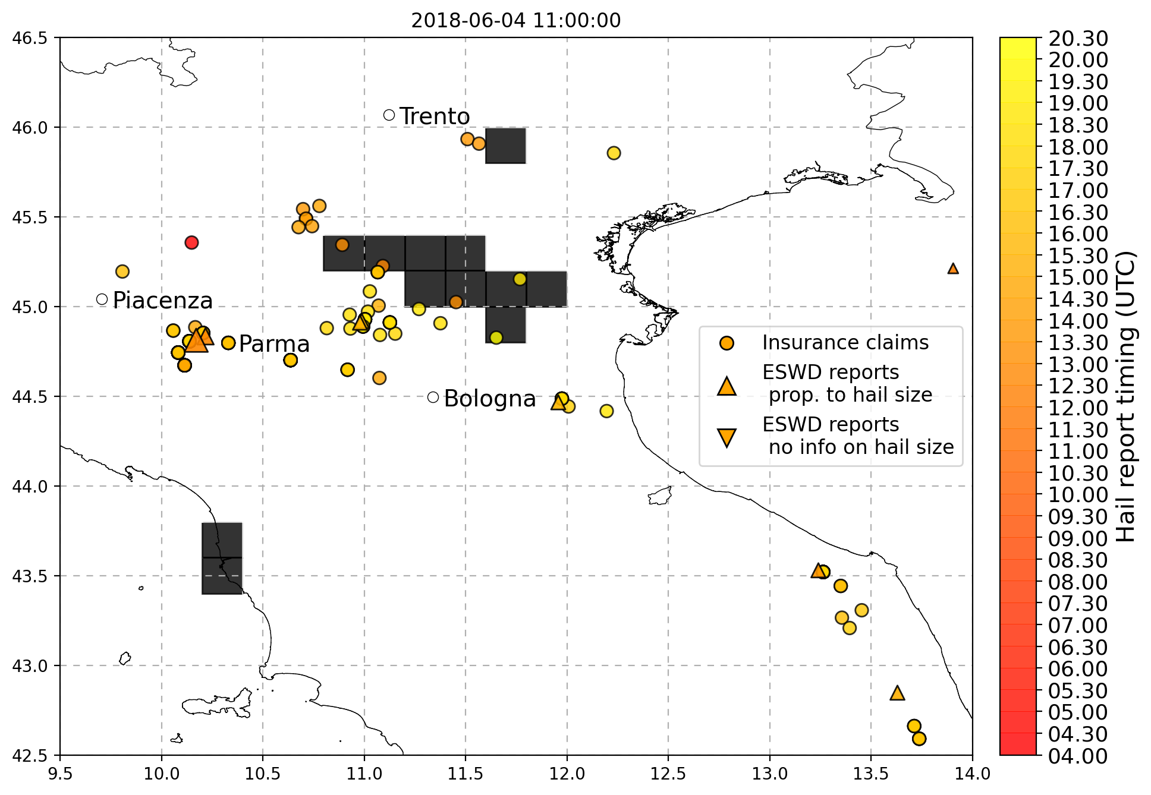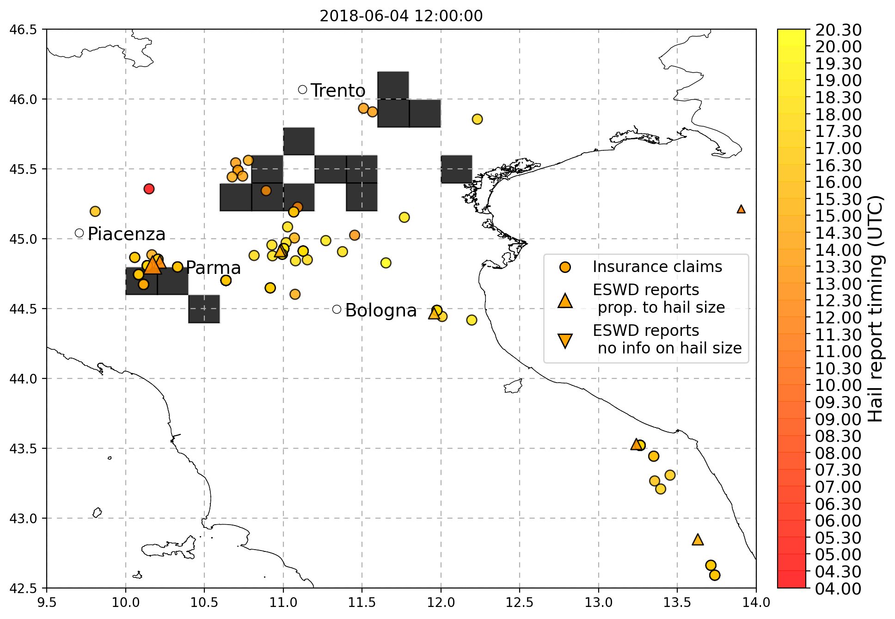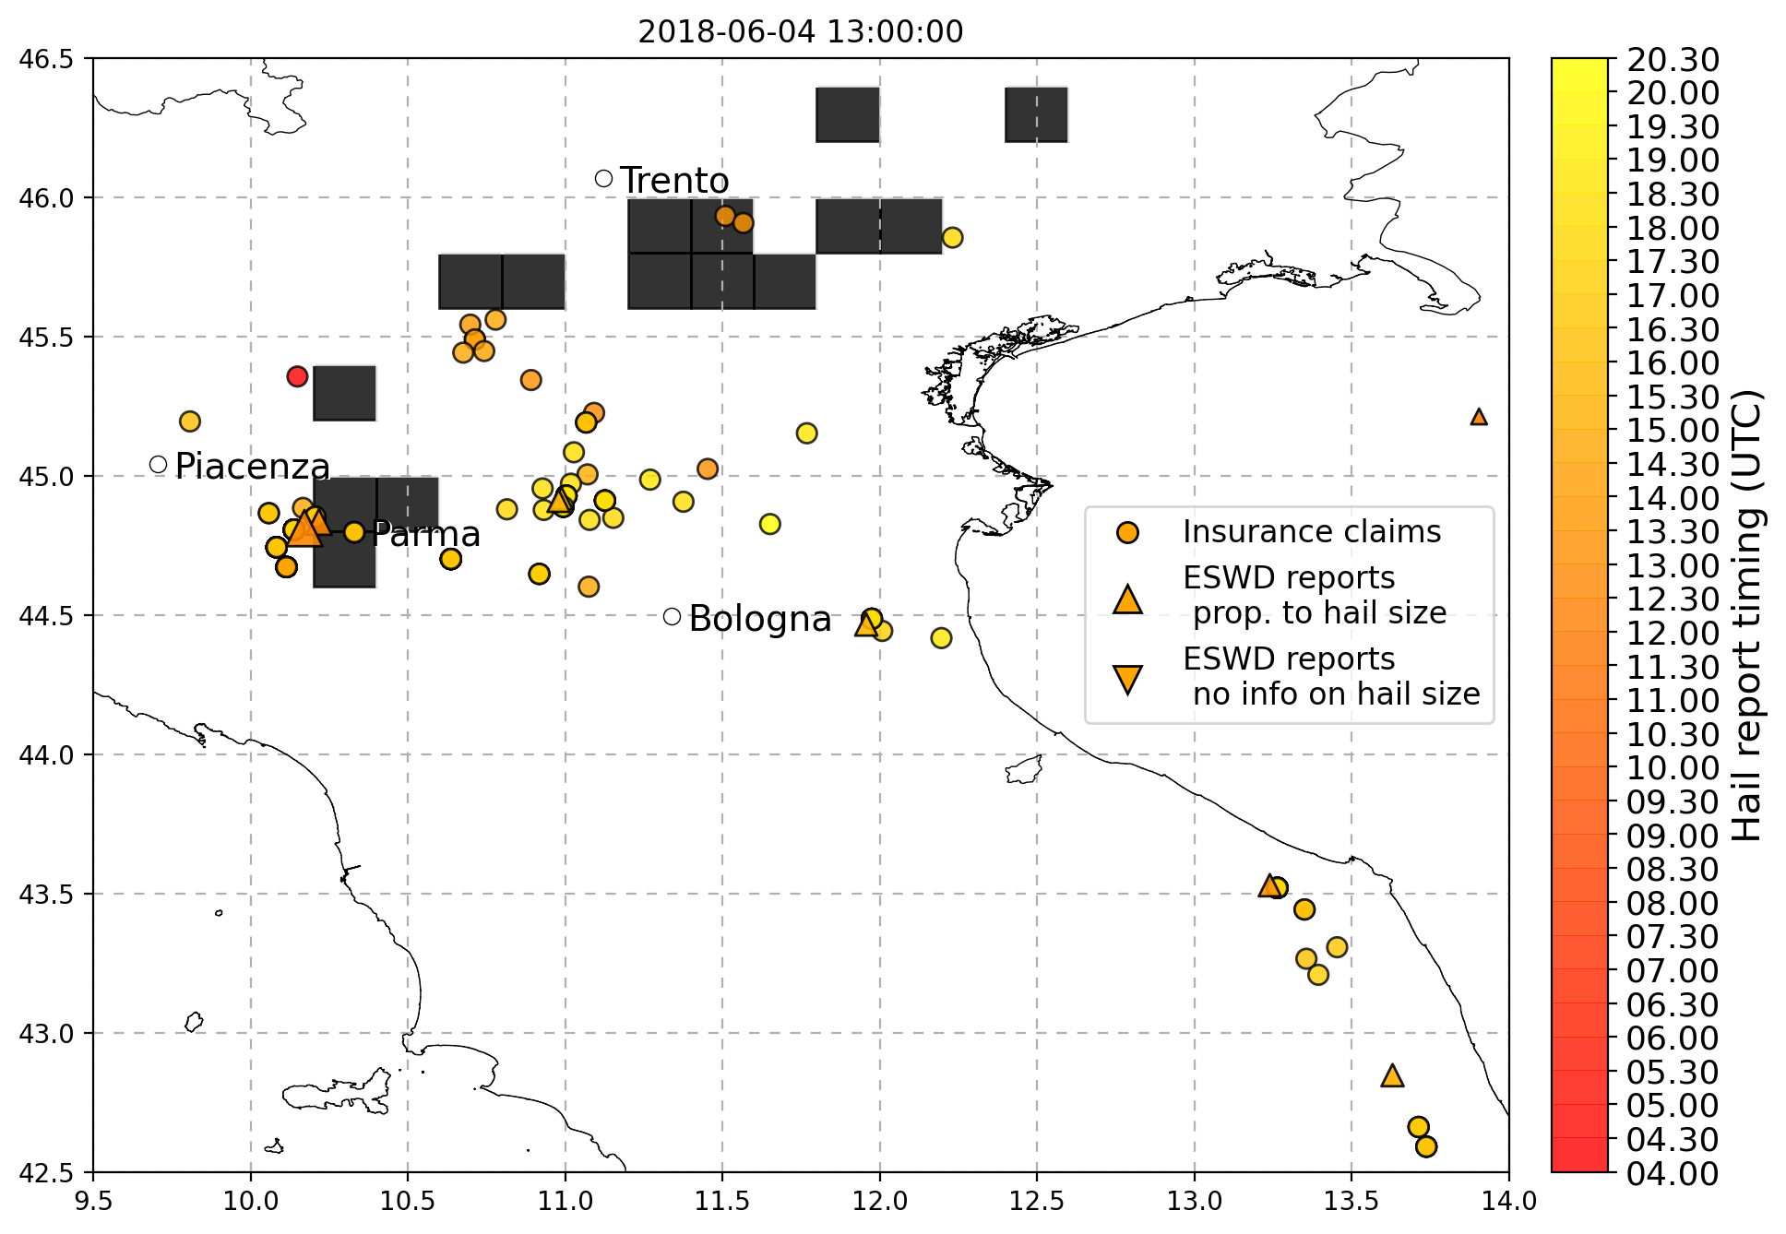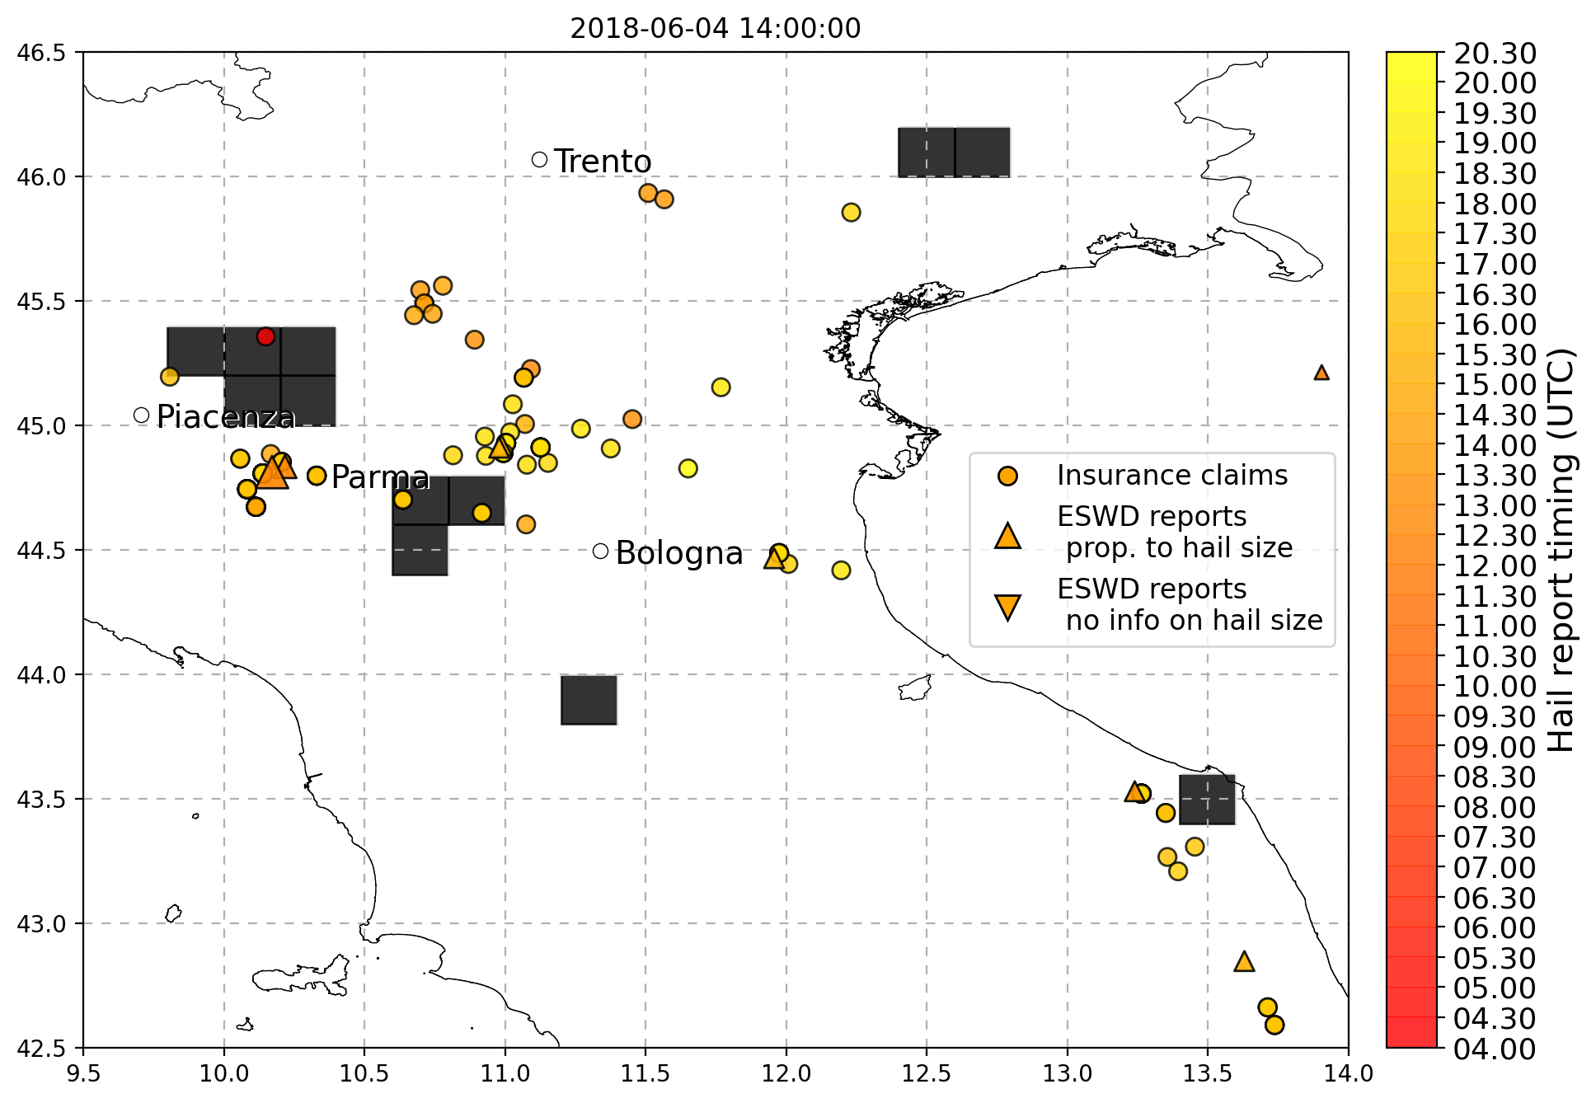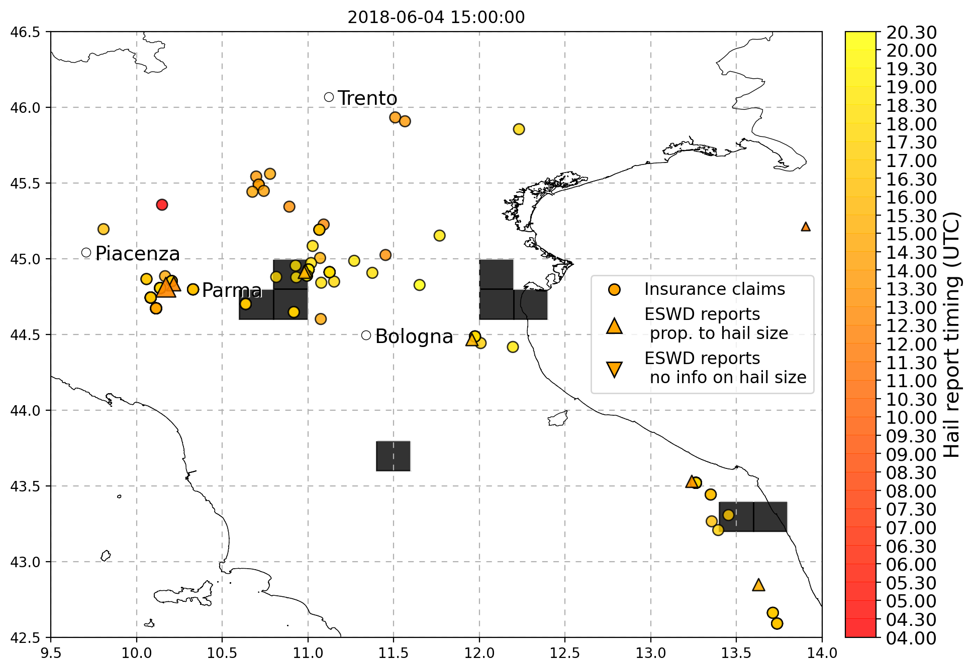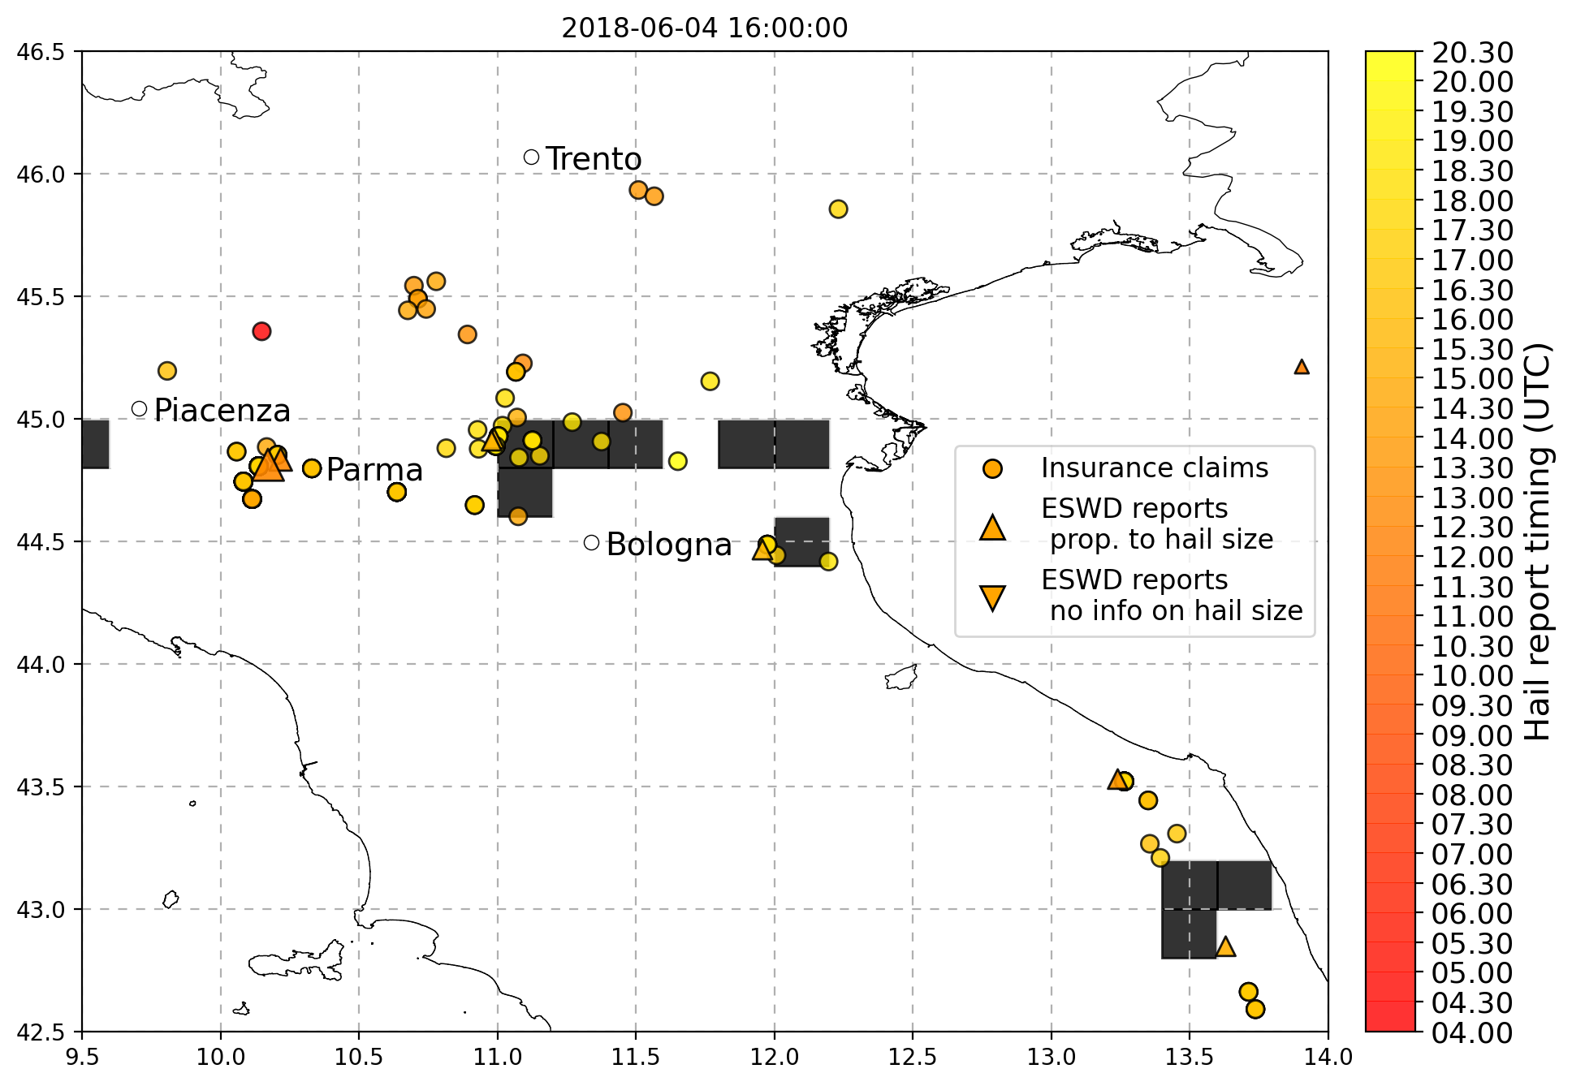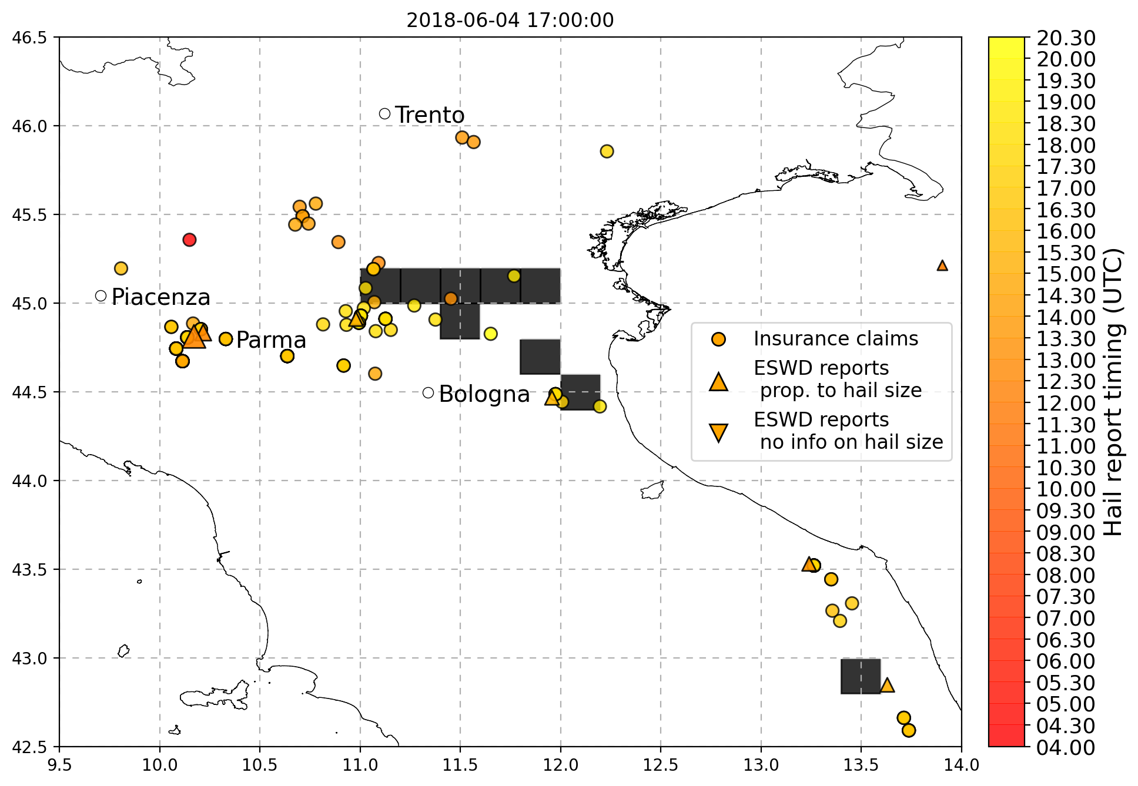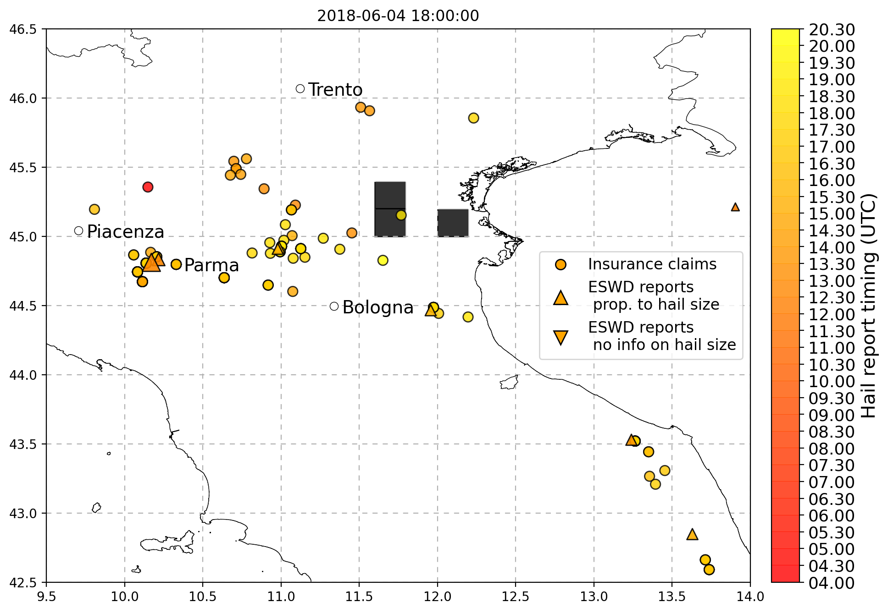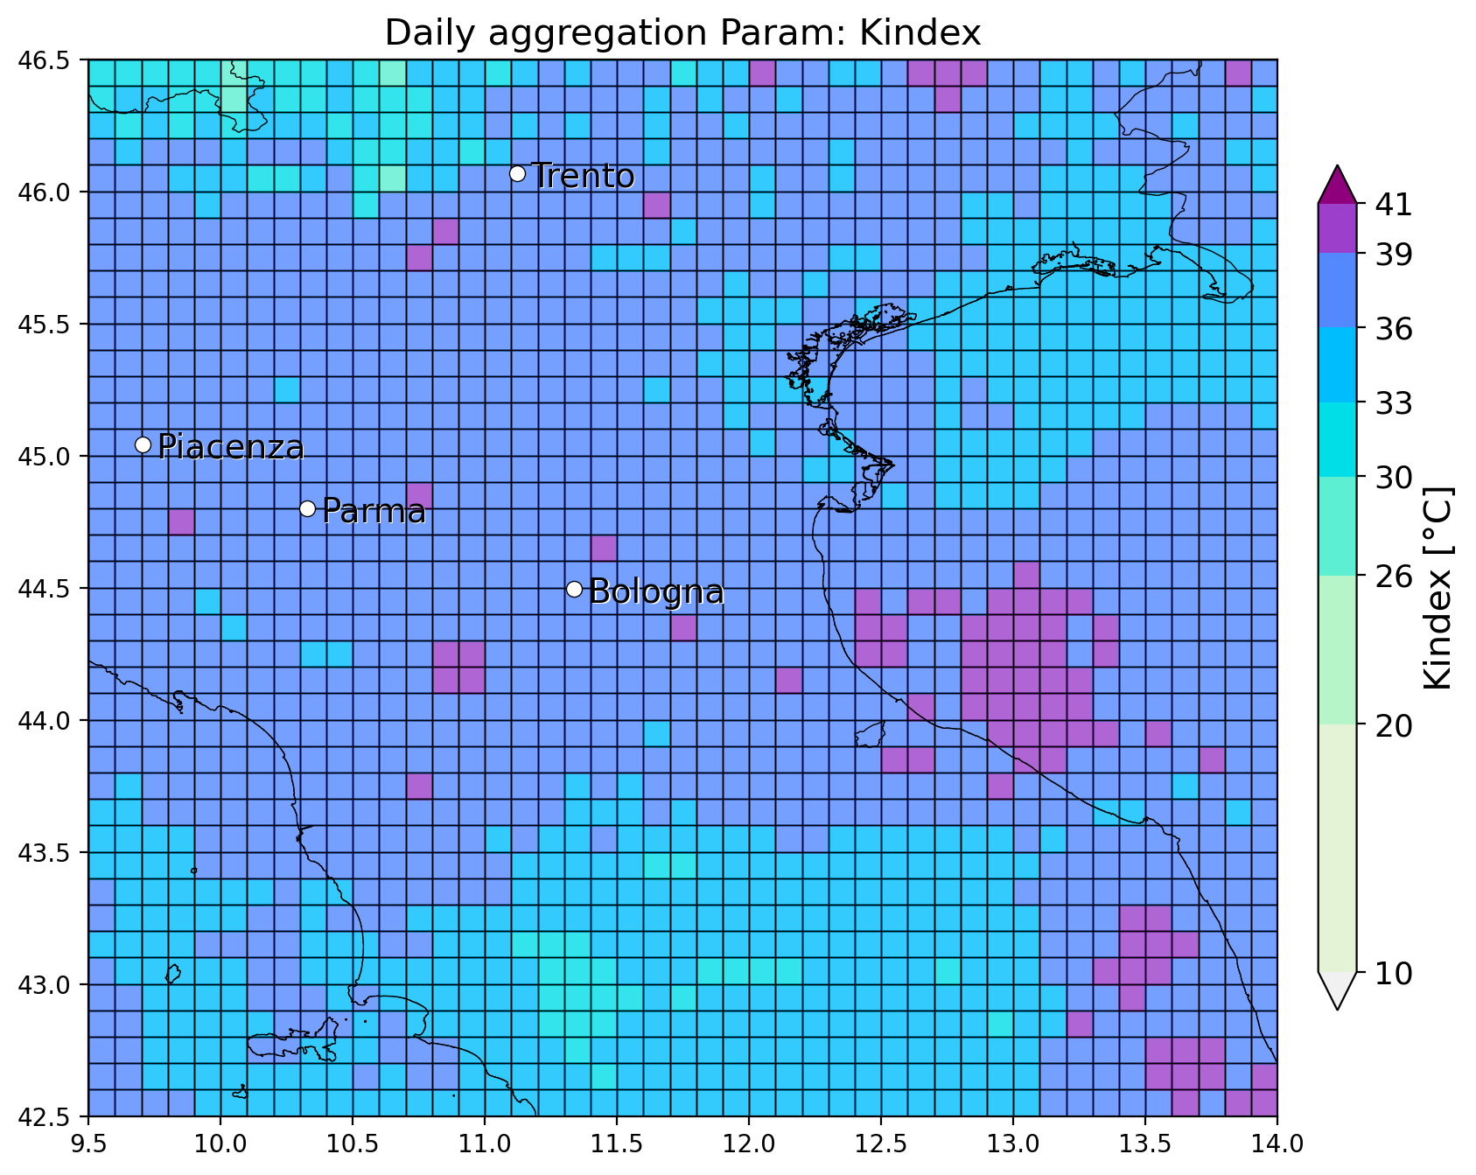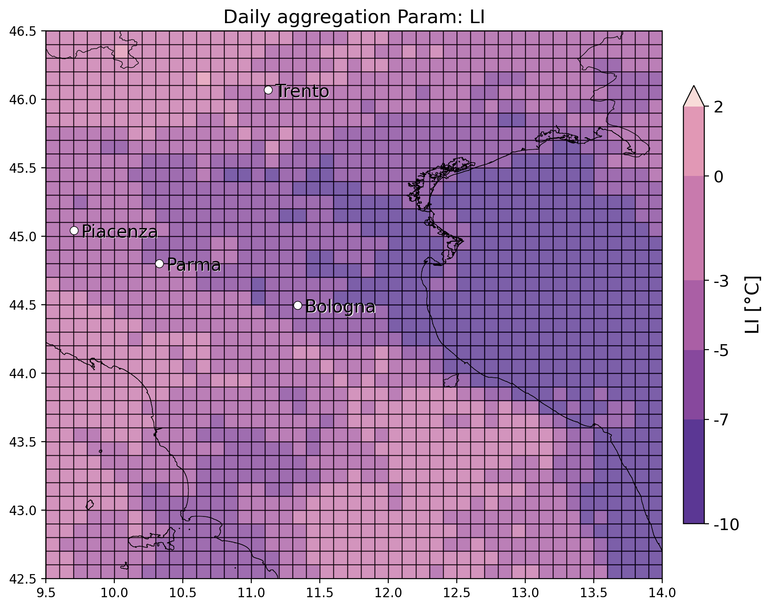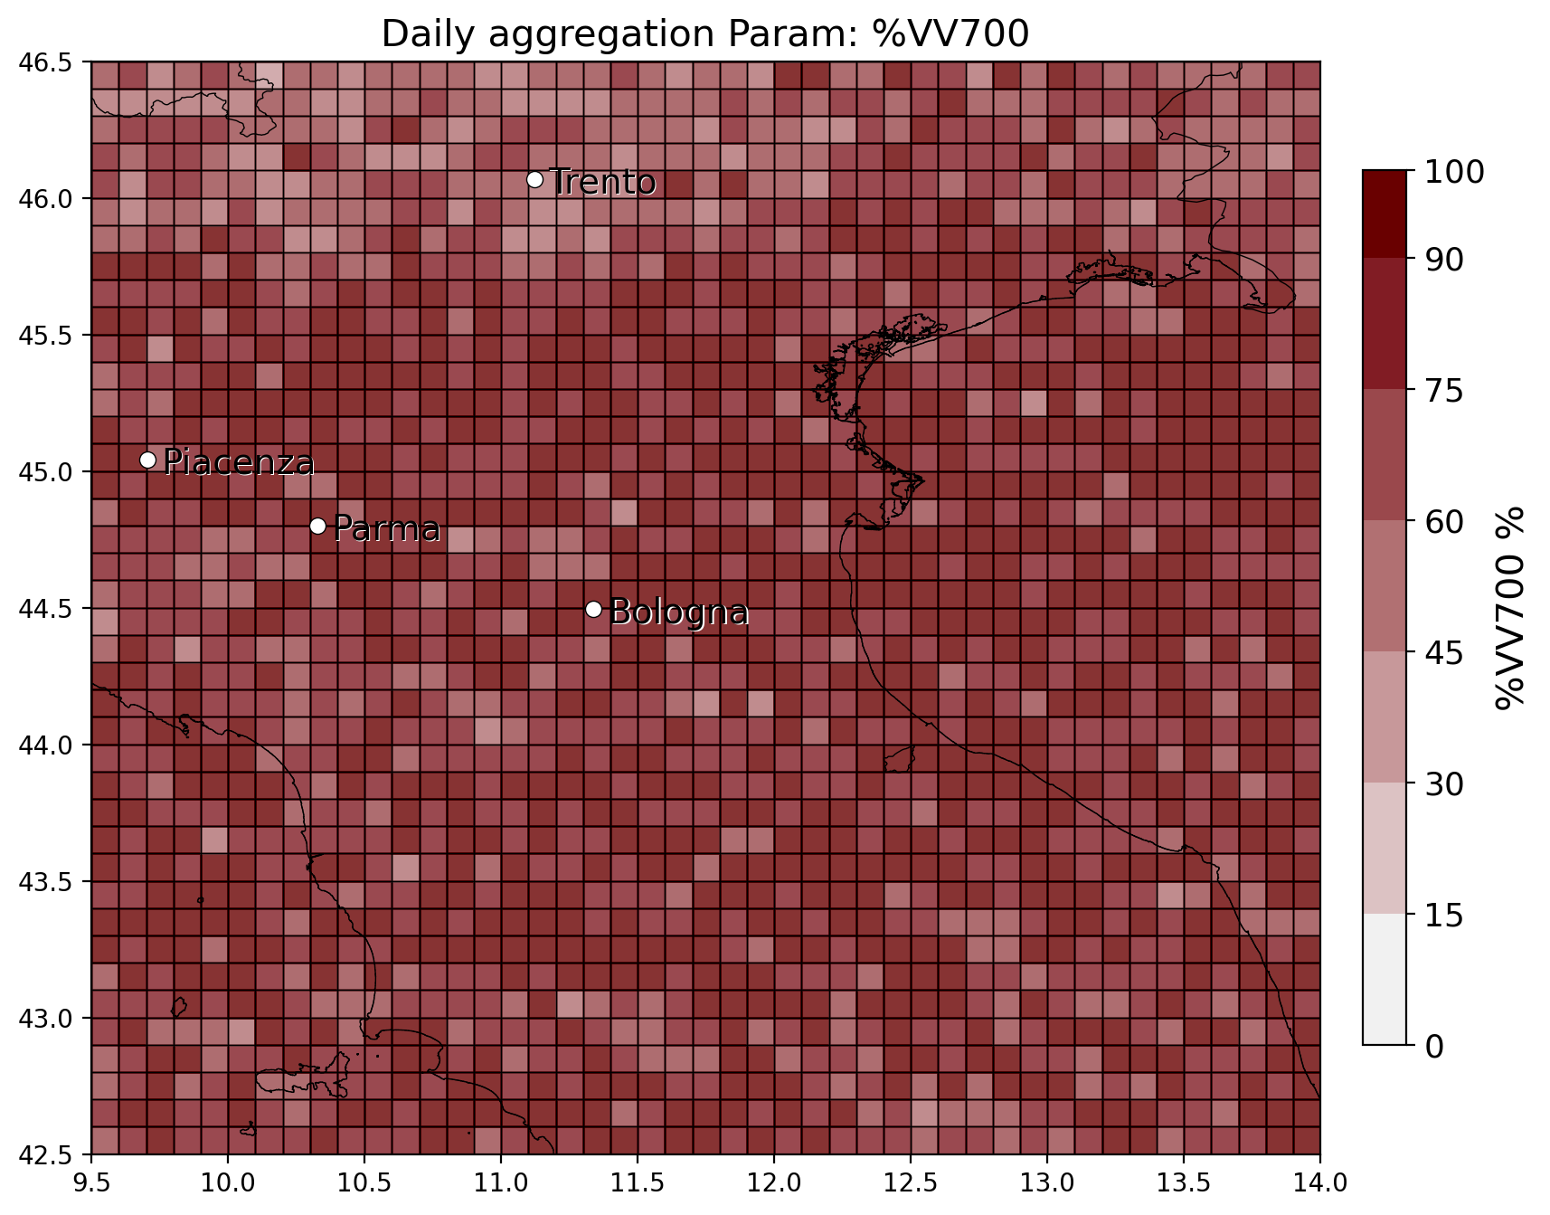

* 29/7/2017 in Piacenza (Pontenure), no eswd reports (but ARPAE flagged presence of hail!!) but OT matches with unipol reports. LJ matches well only with the unipol report between Asti and Piacenza. SLI and K index show potential for deep convection in the spots where reports are issued.

